Darkland v2.0 Readme

©Lucas Johnson, 2000

About Darkland
Darkland is an RPG built in BASIC for the TI-83+. It takes place in the Dark Ages. Your goal in it is to build up your character, either a soldier or an alchemist, and fight foes of increasing difficulty till you’re strong enough to fight a dragon that terrorizes the land. As you fight your way through the game, you get level-ups and money which you can use at the blacksmith to buy better weapons and armor, or at a master alchemist shop to buy a stronger philosopher’s stone or to increase your potion carrying capacity. Different foes you may face are bandits, mercenaries, wolves, bears, gargoyles, pegan witches, guards, and others.

History
Darkland is based on a 17-megabyte game called Darklands created by MPS Labs in 1991. This game was truly ahead of its time. Although not a very popular game, it had outstanding graphics for its time period. It also had a magnificent plot and unlike other games, was actually based on a real time period that actually happened: fourteenth century Germany. Still impressed with the breakthrough style, I continue to play it to this day.

Features and Screenshots
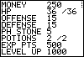
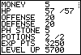
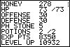
One of the major features in Darkland is the ability to build your character up through battle and by buying new weapons and armor at a blacksmith.

Another feature is its unique battle engine putting you just short of being there.
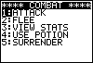
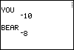
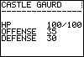

Upcoming Features
In later versions of Darkland, I will make the game more graphical since poor graphics are often what hurt RPGs the most, and a more compact code for optimum speed. If you have any other suggestions, please e-mail me at luke195rs@aol.com

