Phantasy Star V? Preview
(This is my rendition of Phantasy Star, I do not believe that it is considered copyright infringment) Jason D. Ralphs

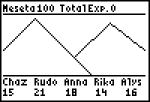
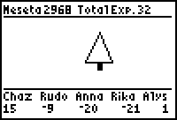
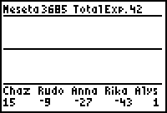
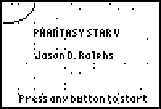
Zio, the villain from Phantasy Star IV is back, and is in need of being defeated, by you of course. I haven’t drawn him yet or I’d have a screenshot, but he was cool looking in number 4. So far there are three types of terrain: Forest, Mountain, and Ocean. There are samples of these terrains below, they will probably not be the drawings in the released version. Well as you can see I haven’t gotten all of the math worked out so far, I’ll probably release this In Febuary 2001 or the week before Phantasy Star Online comes out on Dreamcast. Anyone who reads this I would like to E-mail me at Elgenio14@hotmail.com and tell me what they think so far looking at these screenshots, I’m also a bit curious at how many downloads I might get. Feel free to e-mail me. There will be about 14 different enemies in the final version. 7 towns, they’re done, possibly more terrain types, this is a first person type of thing. All views are in First Person, like Shining in the Darkness, if you’ve ever played it. Charecters from 3 out of four episodes: Alys from 1, Rudo & Anna from 2, and Chaz and Rika from four. If you think there are better choices email me. For more information on Phantasy Star or Phantasy Star online, visit www.phantasystar.net or www.sega.com. Thank you.

