Ti-83 and Ti-83 Plus Tutorials written by Jason D. Ralphs

These tutorials were written especially for, but not limited to beginning programmers. In this tutorial you will learn everything you will need to know to start programming and then you can build off of that. If you already know how to program, these tutorials are either a waste of your time to read, or they will provide alternate uses of the programming commands and\or their syntax. This tutorial should have come with the programs that were used later in this tutorial; if it did not look on Ticalc.org or Basicguruonline.com for them.

Table of Contents:
1. Handy Syntax Guide
Chapter 1 “The Basics”
- Using simple commands
- Input and Output
- Storing as Basic Variables
- Using the various “Random Statements”
Chapter 2 “The Variables”
- Lists
- Matrices
- Pics
- Window
- Y Variables
- Strings
Chapter 3 “Conversions”
- List to Matrix
- Matrix to List
- String to Equation
Source Code to Challenges and Examples

Handy Syntax Guide

Pause: Waits for a user to press enter before continuing, :Pause
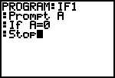
If: If ____ is true, do _____.

Then: If ____ is true, Then do _____ and _____ and ______.
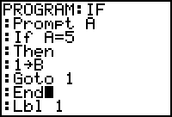
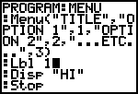
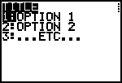
Menu(:

Syntax for Menu: Menu(“Title”,”1st Option”,Label number to go to,”2nd option”,label number to go to,…) This works for 7 options.
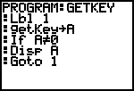
Getkey:

Output: Syntax: Output(Y,X,” “) On the home screen the coordinates are as follows: On the top row, after 9, it should read 10,11,12,13,14,15,16.

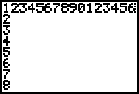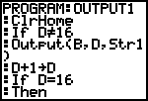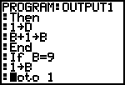

Clrhome: Clears home screen
ClrDraw: Clears Draw Screen
ClrTable: Clears Table
PlotsOn\PlotsOff: Turns Stats Plots on\off
FnOff\FnOn: Turns Function graphs off or on
Disp: Disp “ “ or Disp Variable, Displays either “ “ or a variable on the home screen.
Text(: Text(Ypxl,Xpxl,” “) or Text(Ypxl,Xpxl,Variable) Text is basically the same as output, but it uses pixels on the graph screen. Here are its coordinates.
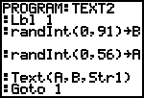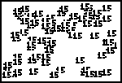

Line(: Draws a line on the graph screen. Line(X1,Y1,X2,Y2) or to erase a line, Line(X1,Y1,X2,Y2,0)
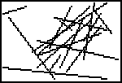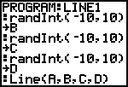

Prompt: Prompt Variable
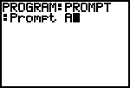

Input: Input “What you want displayed”,Variable to store response as… Or Input Variable. If Your input Var is a list, then you must use {}be fore and after the response, if it is a string then you must use “” before and after the response.
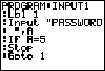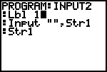

------------------------End of Syntax Guide----------------------------------------------------------

Chapter 1: “The Basics”
Sub Section 1 Using Simple Commands

First, I’d like to make sure that you know how to create a program, so I’ll walk you thru that. Turn your calculator on and get to the home screen, if you are not already there. Then press the PRGM button. Now in the program menu press right twice, or until you get to the “new” option. Now press Enter.
Now let’s name the program; lets name it “first”. You’ve made a program!
Before we continue I’d like to say that if you don’t know where to find the commands that I will instruct you to use, there is a Catalog buton on your calc with every command in alphabetic order. All you need to do to access it is press 2nd Zero. Then just select the command press enter and the calc will perform some quick copy & paste action.
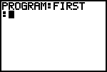
Lets begin your screen should look like this:
Now lets start programming. For the first line lets put Lbl 1; find the command Lbl and then press 1 after it and press enter. Now, I’d like you to build a program that asks for variable A and if variable A equals 5, it displays “Correct”. Click here for the answer.

Chapter 1
Sub Section 2 “Input and Output”
In this section you will learn how to use the input and output statements. The input and output in the title have hyperlinks to the Syntax guide. Why don’t you click there now. Now that you’ve been there why don’t we continue. I’d like to have you make another program. This time call it IO. Do the same as you did in FIRST, but this time have it OUTPUT correct and have it ask a question for A. Click here for the answer.

Chapter 1
Sub Section 3 “Storing as Basic variables”
After each statement such as, get(, Send(, Getcalc(, Input, or Prompt, there are always variables involved. So far we’ve only used Variable A, but you could have transposed Variable A with Any other letter of the alphabet or theta.

Chapter 1
Sub Section 4 Using the various Random Statements
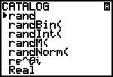
On your calc there are 5 different random statements. Here they are: The statement that I use most often is RandInt(. But before we get into these I’d like to give you their syntax. Rand gives you a non-terminating decimal and has no syntax. RandBin( is one of those commands that I don’t think I’ve ever used, so I don’t think I’ll go into that. RandM( Gives you a random matrice; syntax is RandM(rows,Columnes). RandInt(-,+)→ a variable, RandInt gives you a random interger between your given boundaries.

RandNorm( is another command I don’t think you’d ever use programming.

Chapter 2 “The Variables”
Sub Section 1 “Lists”
Lists are one of those really neat variables. They can be used for just about anything. You can even name your own. The pic to the far left shows how to name your own. The number being stored is how many storage spots that you want in it. On the Pic to the far right, the number in perenthesis next to the list is the location\storage spot in the list in question. Lists can be used for almost anything.
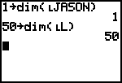
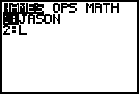
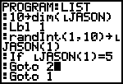

Chapter 2 “The Variables”
Sub Section 2 “Matrices”
A matrix is a grid of sorts. After you have mastered lists you should move on to matrices. Here is an example of a matrix. Matrices are used basically the same way as lists. You cannot, however, name your own matrices. Matrices are named [A],[B],[C],…
The two numbers in perenthesis after [A] in the pic to the far right are the coordinates of that matrix.
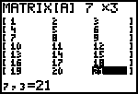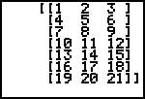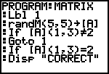

Chapter 2 “The Variables”
Sub Section 3 “Pics”
A pic is basically just a saved drawing. Like a .bmp. To use pics, first either draw or graph something. Then press 2nd PRGM to get into the draw menu. Press right twice and select 1. StorePic. Then press the number you want to store it as. To recall it do the same except select recallpic instead. This is used in programming the same way.
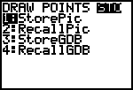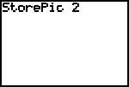

Chapter 2 “The Variables”
Sub Section 4 “Window”

Press the Window button on your calc. This is what you should see. I’m sure that you already know how to change the Window values that way, but I wanted you to see them. For those of you who don’t know what these numbers mean, they are the boundaries for the graph screen. Now press the VARS button on your calc and select window. You should see the same variables. In a program you can define all of these variables.
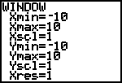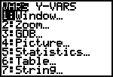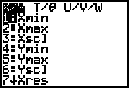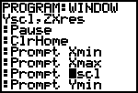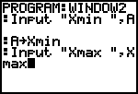

Chapter 2 “The Variables”
Sub Section 5 “Y Variables”

The Y Variables are the variables that let you graph Y= Functions.
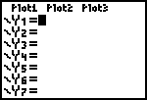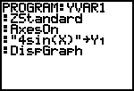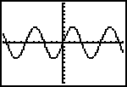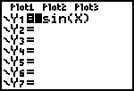

Chapter 2 “The Variables”
Sub Section 6 “Strings”

Strings are like documents. You can save them and load them. Or convert them, we get to that later.
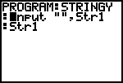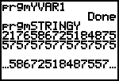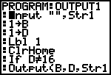

Chapter 3 “Conversions”
Sub Section 1 “List to Matrix”

In the Final chapter already… These are just some helpful conversions.
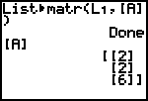

Chapter 3 “Conversions”
Sub Section 2 “Matrix to List”
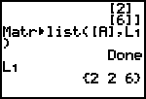

Chapter 3 “Conversions”
Sub Section 3 “Strings to Equation”
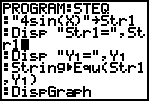

That is the end of the tutorial: All source code is Below.

Source Code
Prgm: First
Lbl 1
Prompt A
If A=5
Disp "CORRECT"
If Aø5
Goto 1

Prgm: Getkey
Lbl 1
getKeyüA
If Aø0
Disp A
Goto 1

Prgm: If
Prompt A
If A=5
Then
1üB
Goto 1
End
Lbl 1
Disp B
Lbl 2
Stop

Prgm: If1
Prompt A
If A=0
Stop

Prgm: Input1
Lbl 1
Input "PASSWORD: ",A
If A=5
Stop
Goto 1

Prgm: Input 2
Lbl 1
Input "",Str1
Str1

Prgm: IO
Lbl 1
Input "A ",A
If A=5
Output(1,1,"CORRECT"
Goto 1

Prgm: Line1
ClrDraw
AxesOff
Lbl 1
randInt(-10,10)→A
randInt(-10,10)→B
randInt(-10,10)→C
randInt(-10,10)→D
Line(A,B,C,D)
Goto 1

Prgm: List
10→dim(lJASON)
Lbl 1
randInt(1,10)→lJASON(1)
If lJASON(1)=5
Goto 2
Goto 1
Lbl 2
Disp "CORRECT"

Prgm: Matrix
Lbl 1
randM(5,5)→[A]
If [A](1,3)ø2
Goto 1
If [A](1,3)=2
Disp "CORRECT

Prgm: Menu
Menu("TITLE","OPTION 1",1,"OPTION 2",2,"...ETC...",3)
Lbl 1
Disp "HI"
Stop
Lbl 2
Disp "BYE"
Stop
Lbl 3
Disp "STOP"
Stop

Prgm: Output1
Input "",Str1
1→B
1→D
Lbl 1
ClrHome
If Dø16
Output(B,D,Str1)
D+1üD
If D=16
Then
1→D
B+1→B
End
If B=9
1→B
Goto 1

Prgm: OutputCD
ClrHome
Output(1,1,"1234567890123456")
Output(2,1,2)
Output(3,1,3)
Output(4,1,4)
Output(5,1,5)
Output(6,1,6)
Output(7,1,7)
Output(8,1,8)
Pause

Prgm: Prompt
Prompt A

Prgm: STEQ
"4sin(X)"üStr1
Disp "Str1=",Str1
Disp "Y=",Y
StringåEqu(Str1,Y)
DispGraph

Prgm: Stringy
Input "",Str1
Str1

Prgm: Text1
ClrDraw
Text(0,0,"0"
Text(56,0,"56"
Text(0,87,"91"

Prgm: Text2
FnOff
PlotsOff
RectGC
CoordOff
GridOff
AxesOff
LabelOff
ExprOff
Input "",Str1
ClrDraw
Lbl 1
randInt(0,91)üB
randInt(0,56)üA
Text(A,B,Str1)
Goto 1

Prgm: Window
Lbl 1
ClrHome
Disp Xmin,Xmax,Xscl,Ymin,Ymax,ZYscl,ZXres
Pause
ClrHome
Prompt Xmin
Prompt Xmax
Prompt Xscl
Prompt Ymin
Prompt Ymax
Prompt Yscl
Prompt Xres
Goto 1

Prgm: Yvar
ZStandard
AxesOn
"4sin(X)"üY
DispGraph

