SMR NDT Inspection Robot – Weekly Report
Objective: | Development of an SMR (Small Modular Reactor) NDT Inspection Robot
Date: | 2026. 7. 16
Contributor | Tae-Young Park

Robot Development Progress
- UI Design
- User interface design
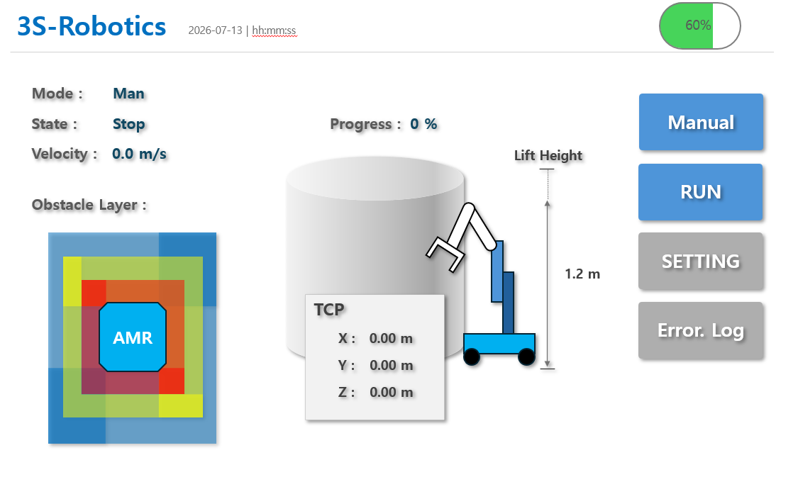
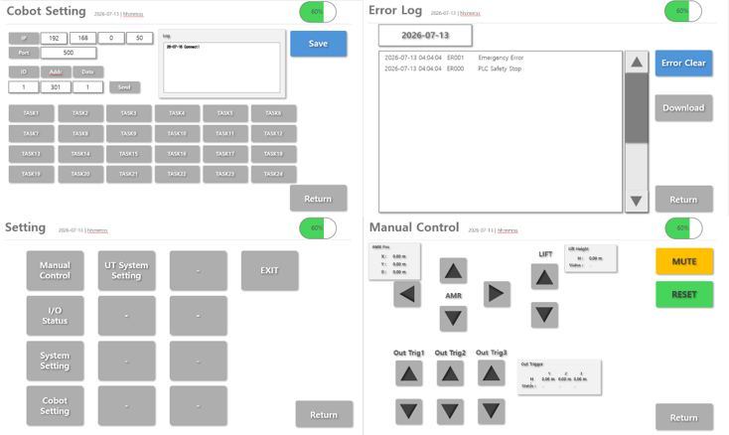

- Preparation of Discussion Materials for Eroun Solution
- Electrical System Concept and Configuration Diagram
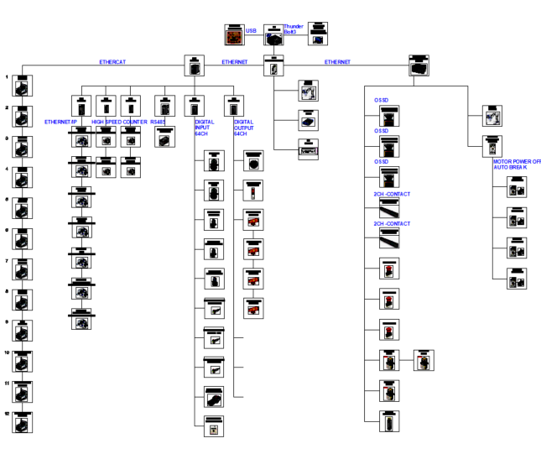
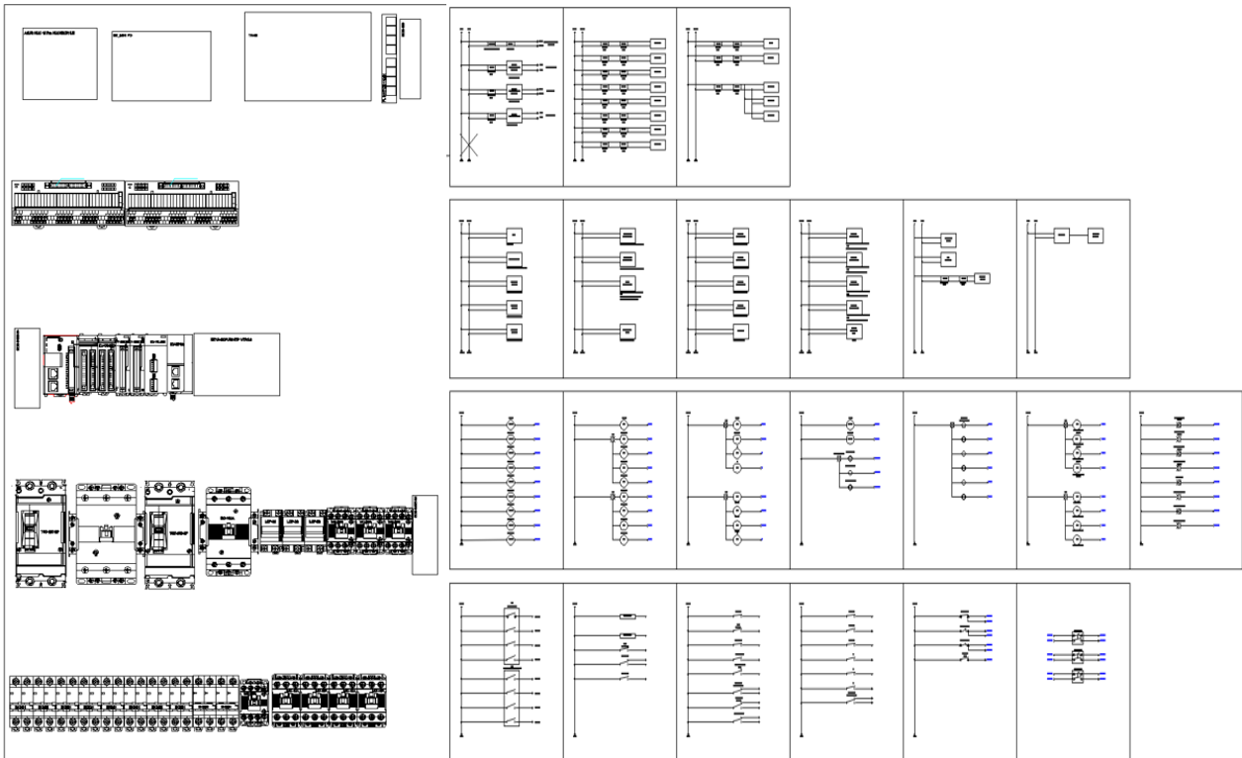

- Development Schedule
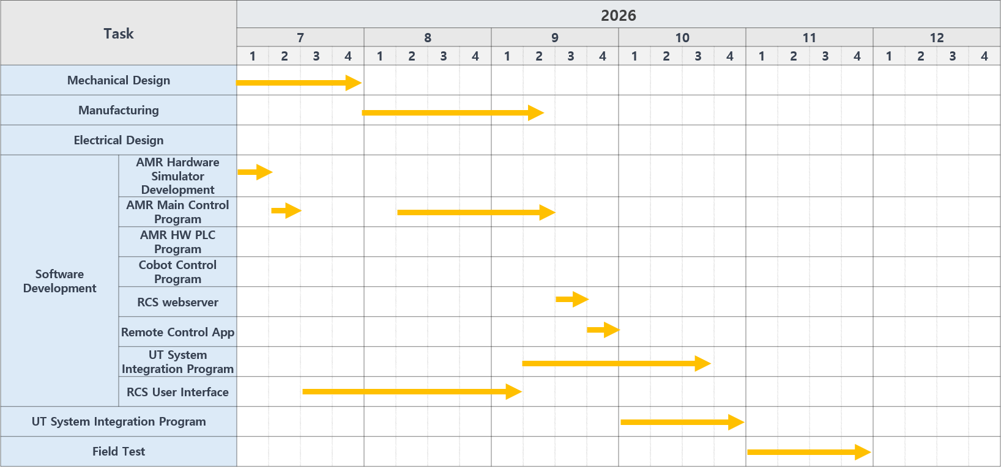
The above schedule is subject to change depending on work priorities.

