Russell Bennett

03/01/2020

Foundations of Programming (Python)

Assignment #6

# Introduction

This assignment tasked us with modifying last week’s assignment to utilize functions. We were provided with code which was functional yet omitted many necessary functions to be fully operational.

# Drafting the code

I first relocated all the code which was previously in the main body to functions as prompted by the comments in the code we were provided. This process required minor modifications to the code including changing variable names such that the functions correctly referenced the variable being passed in. These modifications are depicted “delete_inventory” and “add_inventory” within Figure 1 and “write_file” within Figure 2.

﻿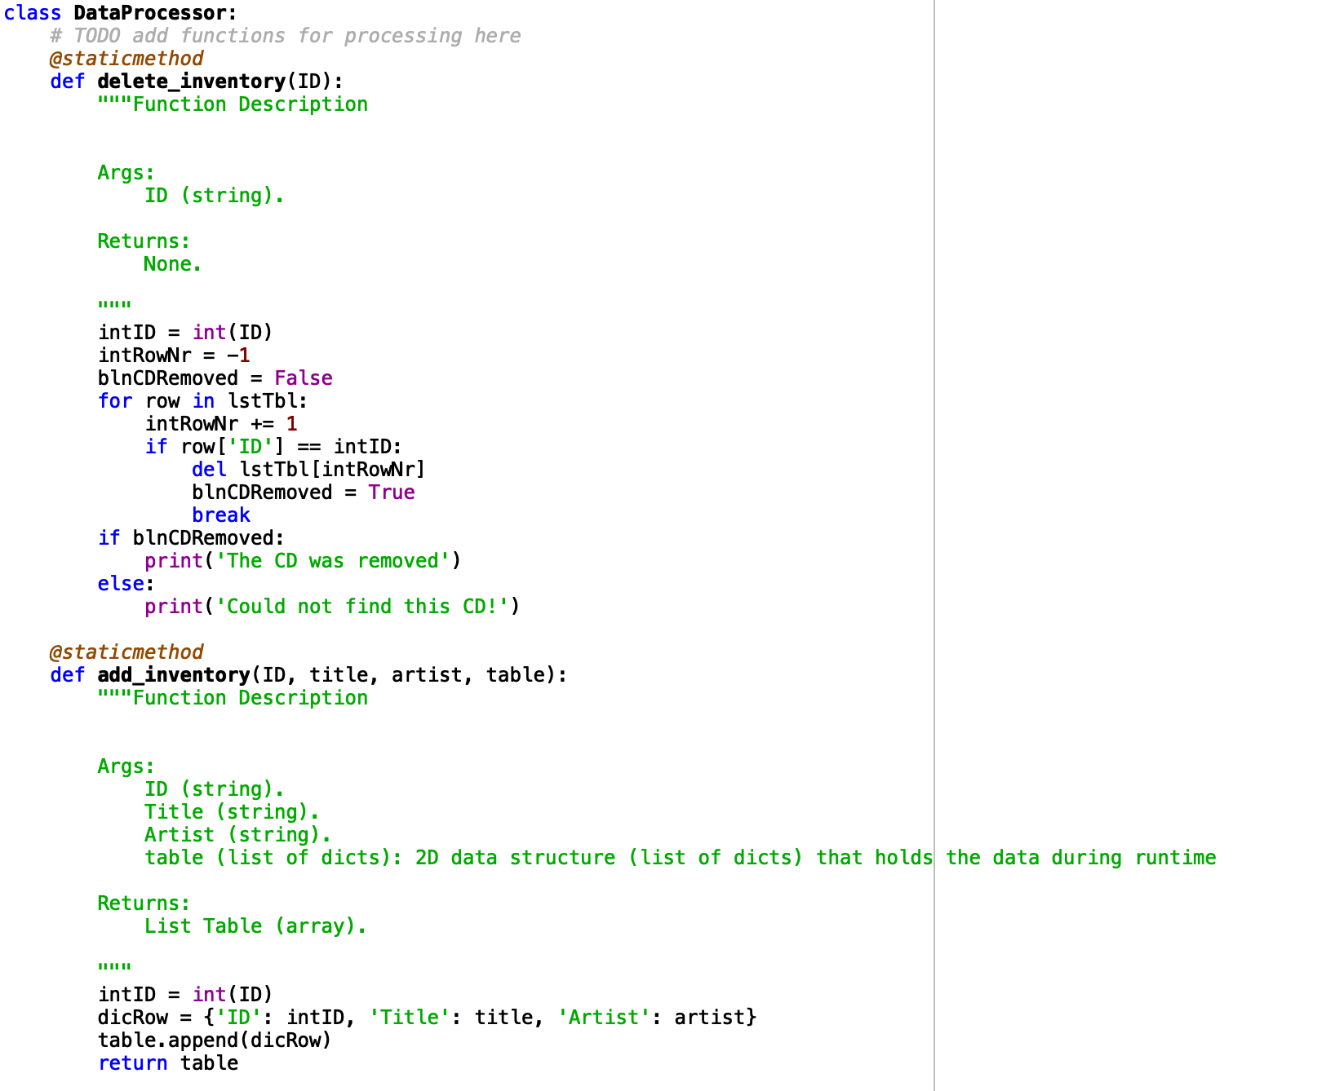

Figure 1. Python script – Data Processor Functions

On first run of the code I noticed I got an error when the program tried to open a text file which did not yet exist so I added the error handling functionality as depicted in “read_file” within Figure 2.

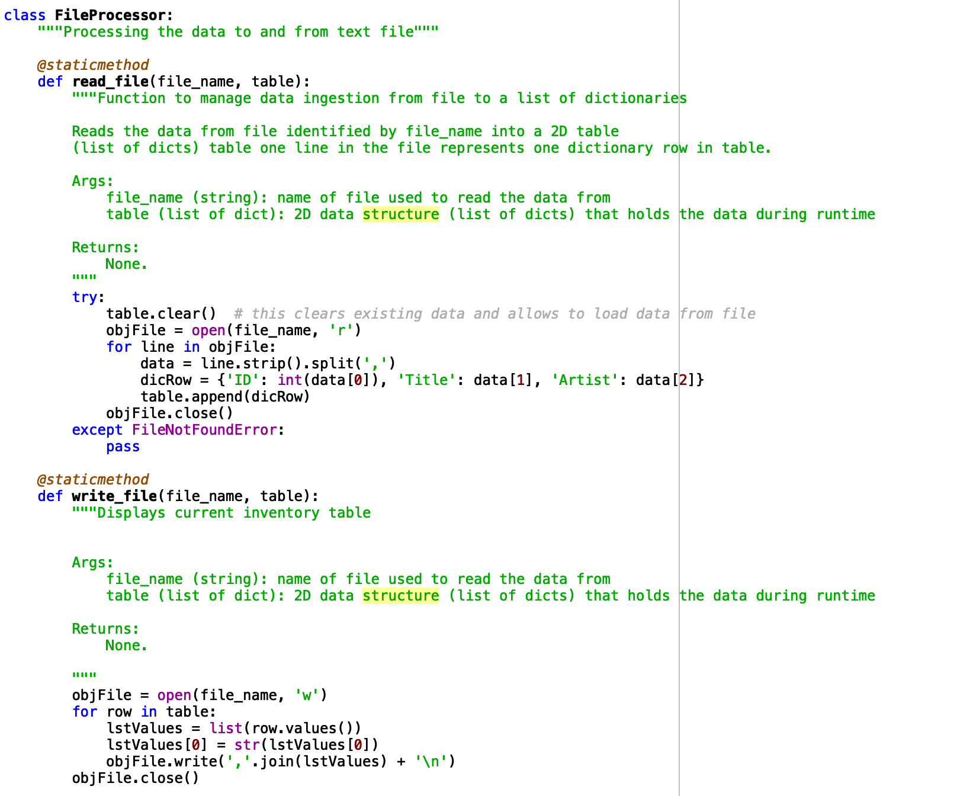

Figure 2. Python script – File Processor Functions

The next step I took was to add IO functions to handle the user interface side of the Data Processor functions. It is within these functions that I also included provisions to handle the scenario which the user assigns a non-integer value to “ID” which previously forced the program to exit with an error. These functions are shown in Figure 3.

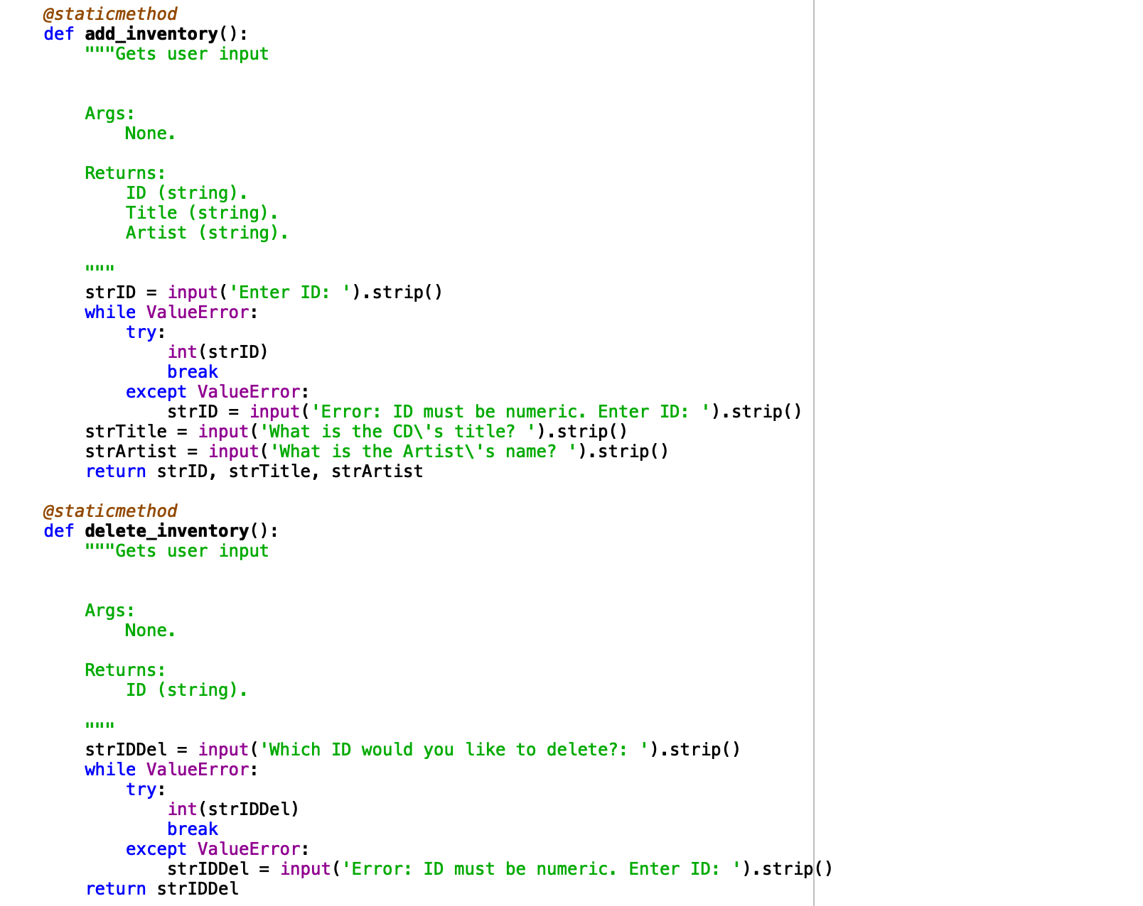

Figure 3. Python script – IO Functions

Figure 4 below depicts the main code body with modification to call the created functions rather than handle the execution within as before.

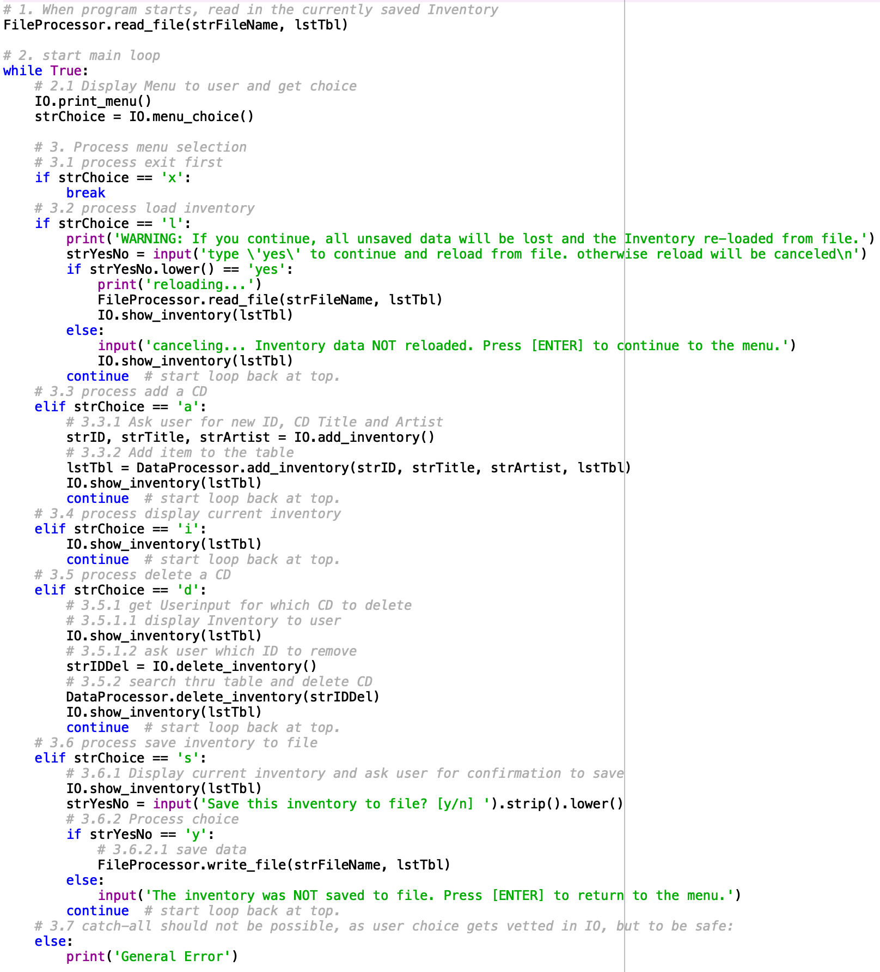

Figure 4. Python script – Main Code

# Executing the code

I executed my code through both Spyder and Mac’s Terminal as depicted by Figures 5 and 6 respectively.

1. runfile('/Users/russellbennett/Documents/uw/python/week_6/Assignment06/CDInventory.py', wdir='/Users/russellbennett/Documents/uw/python/week_6/Assignment06')
2. Menu
4. [l] load Inventory **from** file
5. [a] Add CD
6. [i] Display Current Inventory
7. [d] delete CD **from** Inventory
8. [s] Save Inventory to file
9. [x] exit

12. Which operation would you like to perform? [l, a, i, d, s **or** x]: l
14. WARNING: If you **continue**, all unsaved data will be lost **and** the Inventory re-loaded **from** file.
16. type 'yes' to **continue** **and** reload **from** file. otherwise reload will be canceled
17. yes
18. reloading...
19. ======= The Current Inventory: =======
20. ID      CD Title (by: Artist)
22. ======================================
23. Menu
25. [l] load Inventory **from** file
26. [a] Add CD
27. [i] Display Current Inventory
28. [d] delete CD **from** Inventory
29. [s] Save Inventory to file
30. [x] exit

33. Which operation would you like to perform? [l, a, i, d, s **or** x]: a

36. Enter ID: Q
38. Error: ID must be numeric. Enter ID: 1
40. What **is** the CD's title? Hello
42. What **is** the Artist's name? World
43. ======= The Current Inventory: =======
44. ID      CD Title (by: Artist)
46. 1       Hello (by:World)
47. ======================================
48. Menu
50. [l] load Inventory **from** file
51. [a] Add CD
52. [i] Display Current Inventory
53. [d] delete CD **from** Inventory
54. [s] Save Inventory to file
55. [x] exit

58. Which operation would you like to perform? [l, a, i, d, s **or** x]: a

61. Enter ID: 2
63. What **is** the CD's title? Hello
65. What **is** the Artist's name? World
66. ======= The Current Inventory: =======
67. ID      CD Title (by: Artist)
69. 1       Hello (by:World)
70. 2       Hello (by:World)
71. ======================================
72. Menu
74. [l] load Inventory **from** file
75. [a] Add CD
76. [i] Display Current Inventory
77. [d] delete CD **from** Inventory
78. [s] Save Inventory to file
79. [x] exit

82. Which operation would you like to perform? [l, a, i, d, s **or** x]: d
84. ======= The Current Inventory: =======
85. ID      CD Title (by: Artist)
87. 1       Hello (by:World)
88. 2       Hello (by:World)
89. ======================================
91. Which ID would you like to delete?: 2
92. The CD was removed
93. ======= The Current Inventory: =======
94. ID      CD Title (by: Artist)
96. 1       Hello (by:World)
97. ======================================
98. Menu
100. [l] load Inventory **from** file
101. [a] Add CD
102. [i] Display Current Inventory
103. [d] delete CD **from** Inventory
104. [s] Save Inventory to file
105. [x] exit

108. Which operation would you like to perform? [l, a, i, d, s **or** x]: s
110. ======= The Current Inventory: =======
111. ID      CD Title (by: Artist)
113. 1       Hello (by:World)
114. ======================================
116. Save this inventory to file? [y/n] y
117. Menu
119. [l] load Inventory **from** file
120. [a] Add CD
121. [i] Display Current Inventory
122. [d] delete CD **from** Inventory
123. [s] Save Inventory to file
124. [x] exit

127. Which operation would you like to perform? [l, a, i, d, s **or** x]: x

Figure 5. Spyder Execution

1. (base) Russells-MBP:Assignment06 russellbennett$ python CDInventory.py
2. Menu
4. [l] load Inventory **from** file
5. [a] Add CD
6. [i] Display Current Inventory
7. [d] delete CD **from** Inventory
8. [s] Save Inventory to file
9. [x] exit
11. Which operation would you like to perform? [l, a, i, d, s **or** x]: l
13. WARNING: If you **continue**, all unsaved data will be lost **and** the Inventory re-loaded **from** file.
14. type 'yes' to **continue** **and** reload **from** file. otherwise reload will be canceled
15. yes
16. reloading...
17. ======= The Current Inventory: =======
18. ID  CD Title (by: Artist)
20. 1   Hello (by:World)
21. ======================================
22. Menu
24. [l] load Inventory **from** file
25. [a] Add CD
26. [i] Display Current Inventory
27. [d] delete CD **from** Inventory
28. [s] Save Inventory to file
29. [x] exit
31. Which operation would you like to perform? [l, a, i, d, s **or** x]: a
33. Enter ID: 2
34. What **is** the CD's title? Hello
35. What **is** the Artist's name? World
36. ======= The Current Inventory: =======
37. ID  CD Title (by: Artist)
39. 1   Hello (by:World)
40. 2   Hello (by:World)
41. ======================================
42. Menu
44. [l] load Inventory **from** file
45. [a] Add CD
46. [i] Display Current Inventory
47. [d] delete CD **from** Inventory
48. [s] Save Inventory to file
49. [x] exit
51. Which operation would you like to perform? [l, a, i, d, s **or** x]: i
53. ======= The Current Inventory: =======
54. ID  CD Title (by: Artist)
56. 1   Hello (by:World)
57. 2   Hello (by:World)
58. ======================================
59. Menu
61. [l] load Inventory **from** file
62. [a] Add CD
63. [i] Display Current Inventory
64. [d] delete CD **from** Inventory
65. [s] Save Inventory to file
66. [x] exit
68. Which operation would you like to perform? [l, a, i, d, s **or** x]: s
70. ======= The Current Inventory: =======
71. ID  CD Title (by: Artist)
73. 1   Hello (by:World)
74. 2   Hello (by:World)
75. ======================================
76. Save this inventory to file? [y/n] y
77. Menu
79. [l] load Inventory **from** file
80. [a] Add CD
81. [i] Display Current Inventory
82. [d] delete CD **from** Inventory
83. [s] Save Inventory to file
84. [x] exit
86. Which operation would you like to perform? [l, a, i, d, s **or** x]: x
88. (base) Russells-MBP:Assignment06 russellbennett$

Figure 6. Terminal Execution

The resulting text file is depicted in Figure 7.

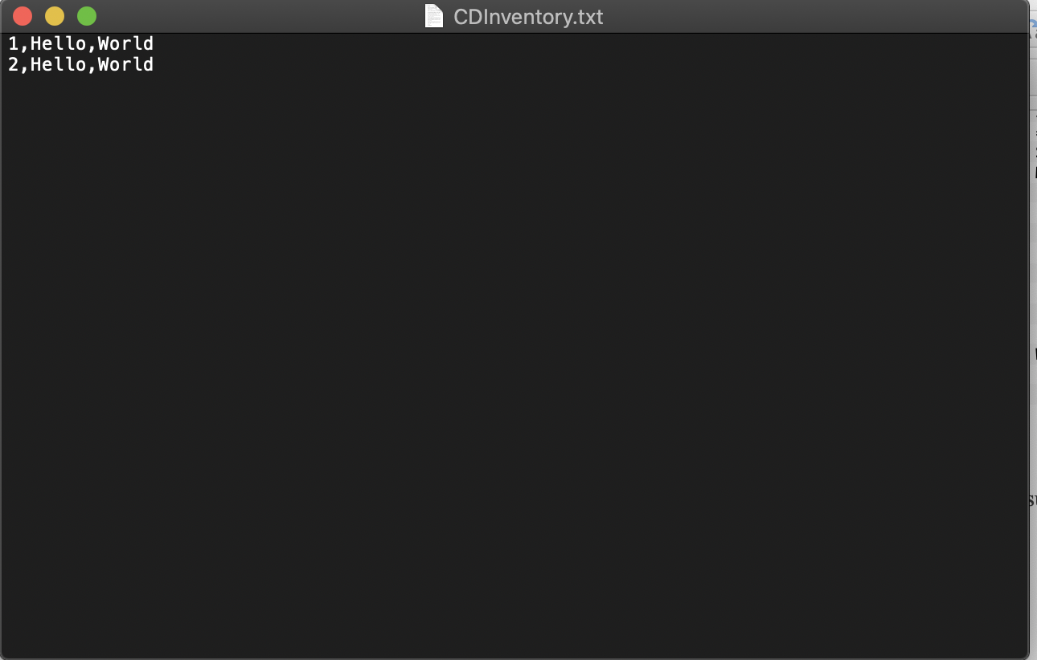

Figure 7. Text File

# Summary

This assignment successfully taught us about functions as well as working with others code. I enjoyed the many aspects of this project and breaking it down into manageable chunks before bringing it all back together at the end.

Github Link: