Russell Bennett

03/05/2020

Foundations of Programming (Python)

Assignment #7

# Introduction

This assignment tasked us with modifying last week’s assignment to handle error exception types and to utilize pythons pickling functionality. We built upon last week’s code to accomplish these tasks.

# Drafting the code

I had actually already handled the error exceptions in last week’s assignment so I first started this assignment by incorporating the feedback I received on that assignment. This included modifying the delete_inventory function to also accept a table which would be passed from the main body of the code. This mirrors what my add_inventory function already did. This is depicted in Figure 1.

﻿

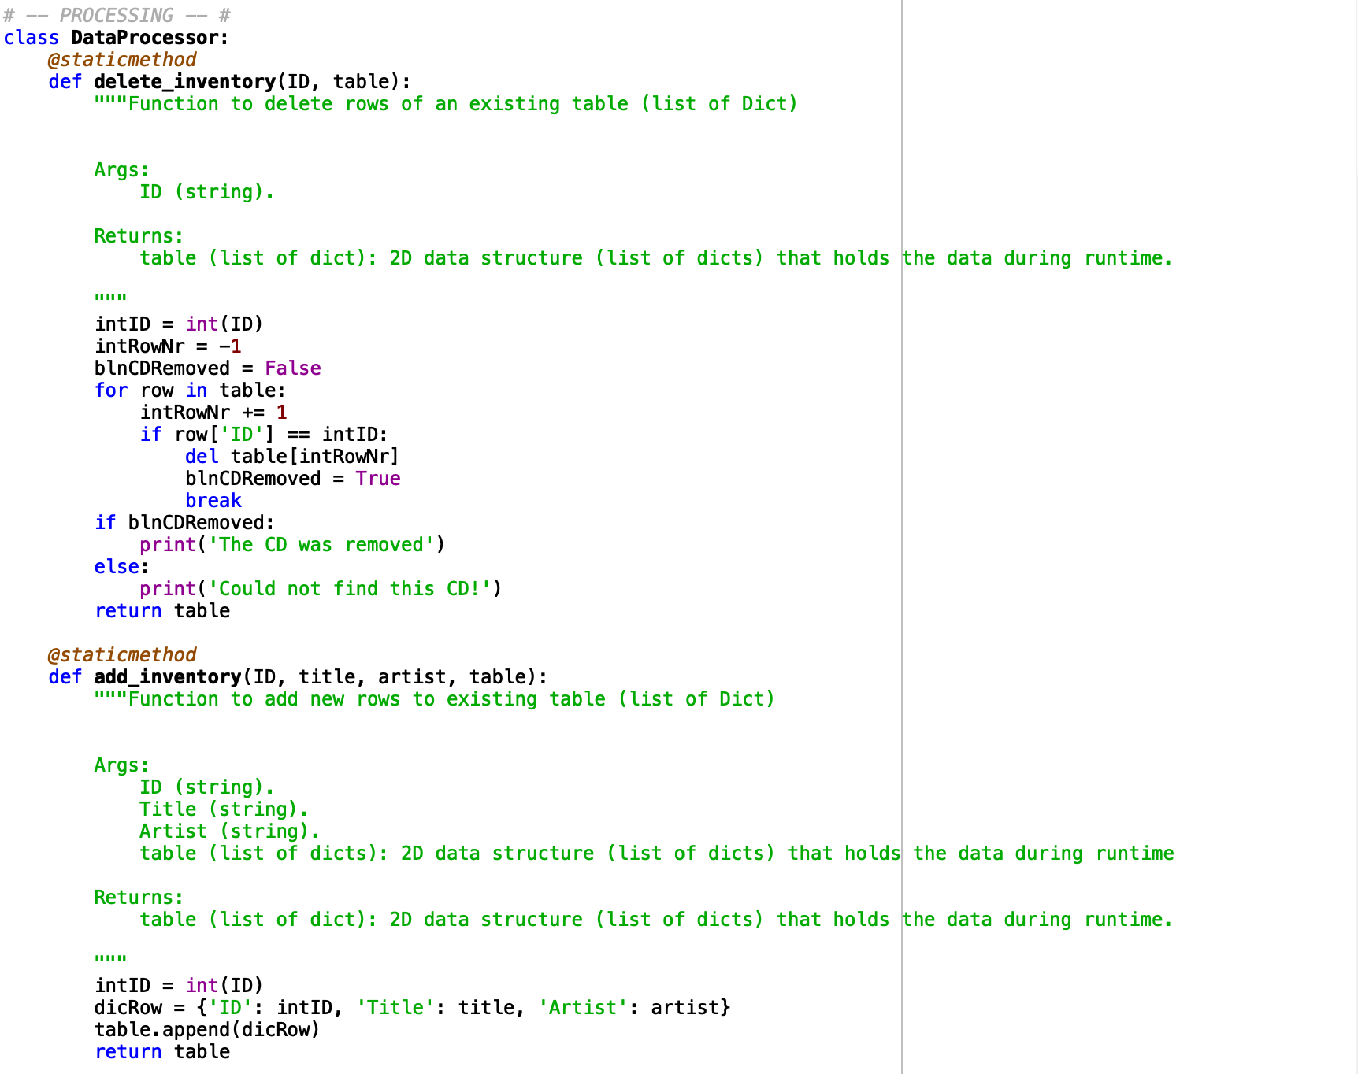

Figure 1. Python script – Data Processor Functions

User type errors when the program was expecting an integer but was passed a string were handled in the add / delete IO functions as depicted in Figure 2.

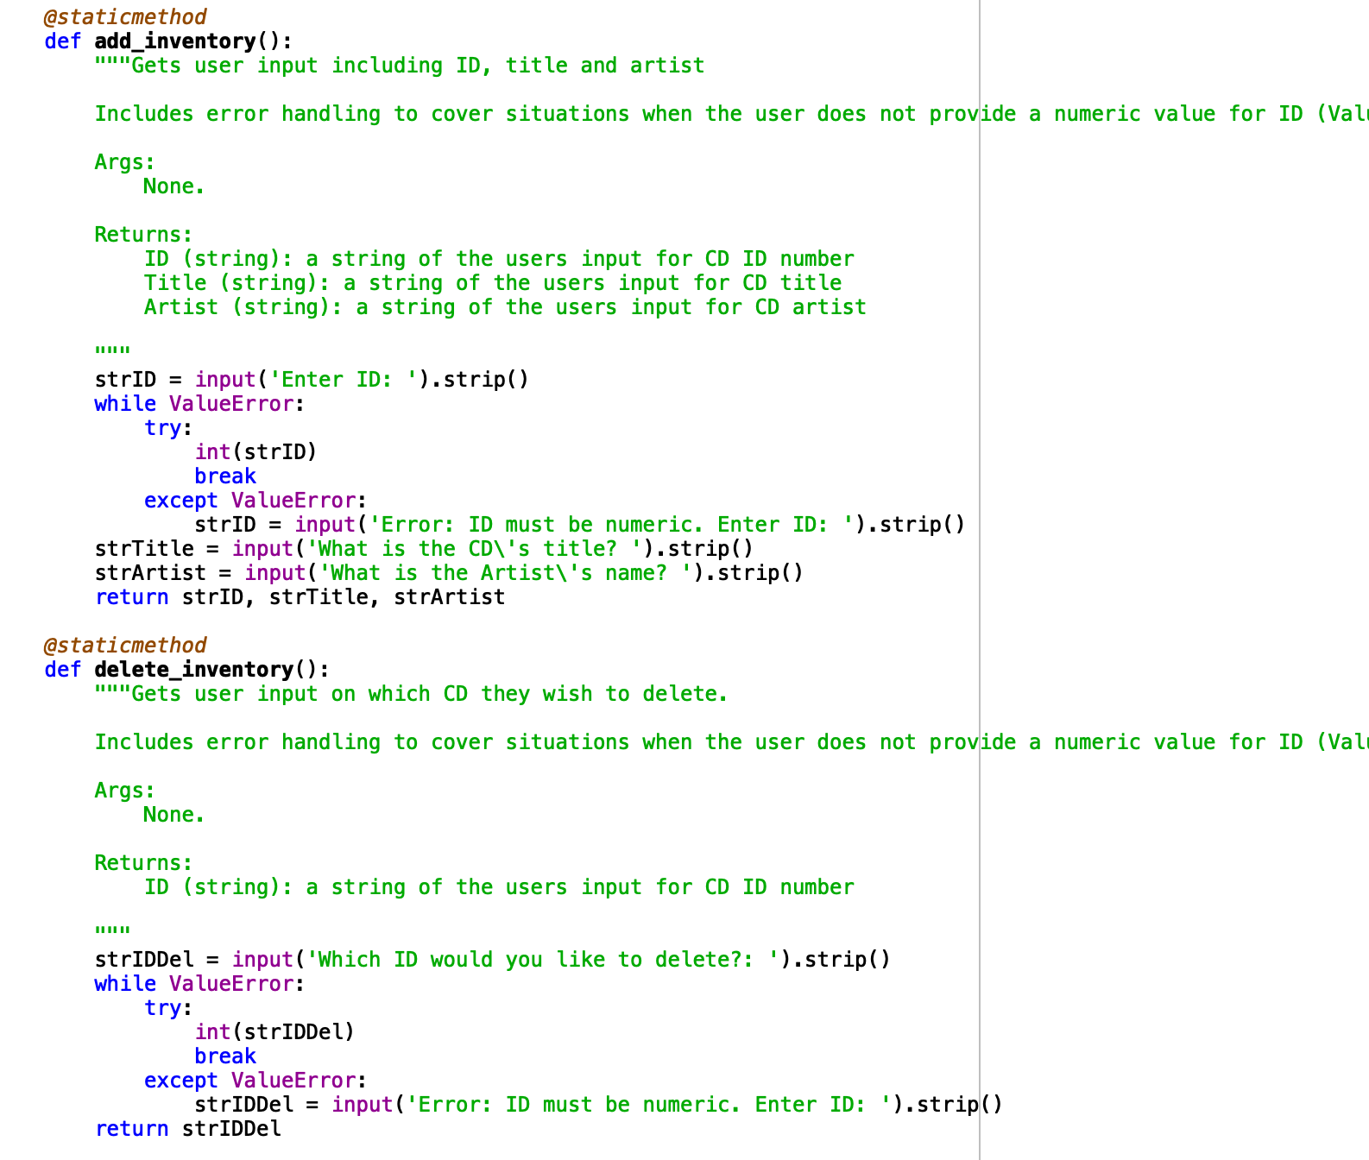

Figure 2. Python script – TypeError Handling

IO error handling was caught in the read_file function to read from a binary file. This is also where I incorporated use of pickling. Similarly, the write_file function was modified to write to a binary file. This is depicted in Figure 3.

Pickling references:

Python Programming for the Absolut Beginner, 3rd Edition

* Primary source for determining syntax of reading and writing binary files

Data Camp (<https://www.datacamp.com/community/tutorials/pickle-python-tutorial>)

* Good secondary source of information on what pickling is doing and how to implement.

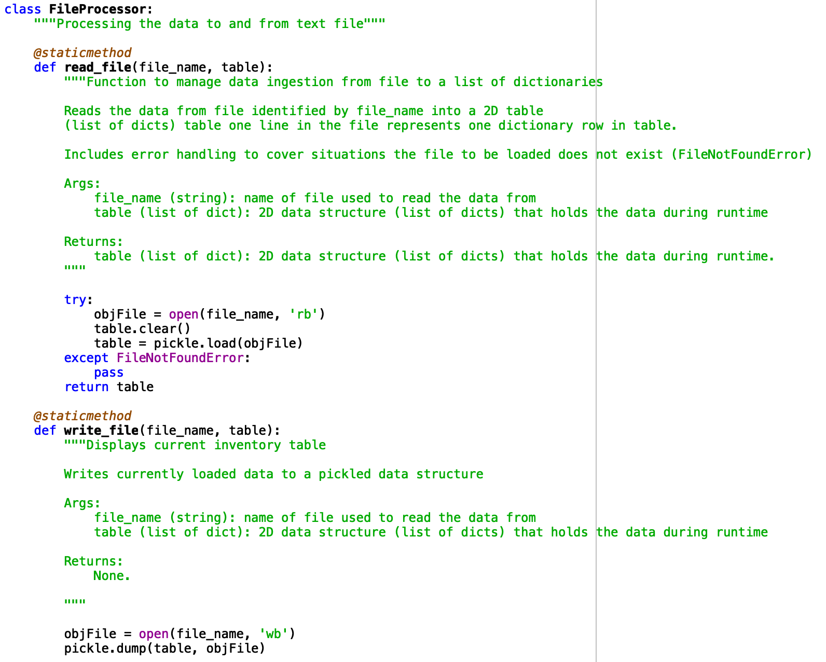

Figure 3. Python script – Pickling Functionality

Figure 4 below depicts the main code body with modifications to the read and delete functions to pass the table to the functions, similar to how I had my add function set up.

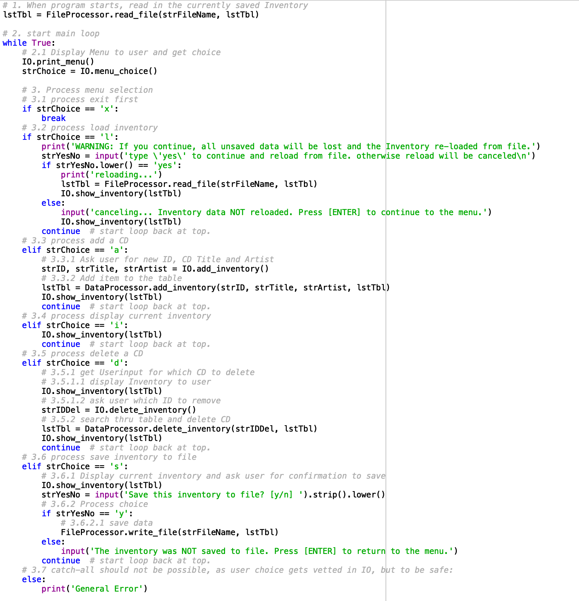

Figure 4. Python script – Main Code

# Executing the code

I executed my code through both Spyder and Mac’s Terminal as depicted by Figures 5 and 6 respectively.

1. runfile('/Users/russellbennett/Documents/uw/python/week_7/Assignment07/CDInventory.py', wdir='/Users/russellbennett/Documents/uw/python/week_7/Assignment07')
2. Menu
4. [l] load Inventory **from** file
5. [a] Add CD
6. [i] Display Current Inventory
7. [d] delete CD **from** Inventory
8. [s] Save Inventory to file
9. [x] exit

12. Which operation would you like to perform? [l, a, i, d, s **or** x]: i
14. ======= The Current Inventory: =======
15. ID      CD Title (by: Artist)
17. ======================================
18. Menu
20. [l] load Inventory **from** file
21. [a] Add CD
22. [i] Display Current Inventory
23. [d] delete CD **from** Inventory
24. [s] Save Inventory to file
25. [x] exit

28. Which operation would you like to perform? [l, a, i, d, s **or** x]: a

31. Enter ID: s
33. Error: ID must be numeric. Enter ID: 1
35. What **is** the CD's title? Hello
37. What **is** the Artist's name? World
38. ======= The Current Inventory: =======
39. ID      CD Title (by: Artist)
41. 1       Hello (by:World)
42. ======================================
43. Menu
45. [l] load Inventory **from** file
46. [a] Add CD
47. [i] Display Current Inventory
48. [d] delete CD **from** Inventory
49. [s] Save Inventory to file
50. [x] exit

53. Which operation would you like to perform? [l, a, i, d, s **or** x]: a

56. Enter ID: 2
58. What **is** the CD's title? National
60. What **is** the Artist's name? Parks
61. ======= The Current Inventory: =======
62. ID      CD Title (by: Artist)
64. 1       Hello (by:World)
65. 2       National (by:Parks)
66. ======================================
67. Menu
69. [l] load Inventory **from** file
70. [a] Add CD
71. [i] Display Current Inventory
72. [d] delete CD **from** Inventory
73. [s] Save Inventory to file
74. [x] exit

77. Which operation would you like to perform? [l, a, i, d, s **or** x]: a

80. Enter ID: Python
82. Error: ID must be numeric. Enter ID: 1
84. What **is** the CD's title? Python
86. What **is** the Artist's name? Rocks
87. ======= The Current Inventory: =======
88. ID      CD Title (by: Artist)
90. 1       Hello (by:World)
91. 2       National (by:Parks)
92. 1       Python (by:Rocks)
93. ======================================
94. Menu
96. [l] load Inventory **from** file
97. [a] Add CD
98. [i] Display Current Inventory
99. [d] delete CD **from** Inventory
100. [s] Save Inventory to file
101. [x] exit

104. Which operation would you like to perform? [l, a, i, d, s **or** x]: d
106. ======= The Current Inventory: =======
107. ID      CD Title (by: Artist)
109. 1       Hello (by:World)
110. 2       National (by:Parks)
111. 1       Python (by:Rocks)
112. ======================================
114. Which ID would you like to delete?: 1
115. The CD was removed
116. ======= The Current Inventory: =======
117. ID      CD Title (by: Artist)
119. 2       National (by:Parks)
120. 1       Python (by:Rocks)
121. ======================================
122. Menu
124. [l] load Inventory **from** file
125. [a] Add CD
126. [i] Display Current Inventory
127. [d] delete CD **from** Inventory
128. [s] Save Inventory to file
129. [x] exit

132. Which operation would you like to perform? [l, a, i, d, s **or** x]: i
134. ======= The Current Inventory: =======
135. ID      CD Title (by: Artist)
137. 2       National (by:Parks)
138. 1       Python (by:Rocks)
139. ======================================
140. Menu
142. [l] load Inventory **from** file
143. [a] Add CD
144. [i] Display Current Inventory
145. [d] delete CD **from** Inventory
146. [s] Save Inventory to file
147. [x] exit

150. Which operation would you like to perform? [l, a, i, d, s **or** x]: s
152. ======= The Current Inventory: =======
153. ID      CD Title (by: Artist)
155. 2       National (by:Parks)
156. 1       Python (by:Rocks)
157. ======================================
159. Save this inventory to file? [y/n] y
160. Menu
162. [l] load Inventory **from** file
163. [a] Add CD
164. [i] Display Current Inventory
165. [d] delete CD **from** Inventory
166. [s] Save Inventory to file
167. [x] exit

170. Which operation would you like to perform? [l, a, i, d, s **or** x]: x

Figure 5. Spyder Execution

1. (base) Russells-MBP:Assignment07 russellbennett$ python CDInventory.py
2. Menu
4. [l] load Inventory **from** file
5. [a] Add CD
6. [i] Display Current Inventory
7. [d] delete CD **from** Inventory
8. [s] Save Inventory to file
9. [x] exit
11. Which operation would you like to perform? [l, a, i, d, s **or** x]: l
13. WARNING: If you **continue**, all unsaved data will be lost **and** the Inventory re-loaded **from** file.
14. type 'yes' to **continue** **and** reload **from** file. otherwise reload will be canceled
15. yes
16. reloading...
17. ======= The Current Inventory: =======
18. ID  CD Title (by: Artist)
20. 2   National (by:Parks)
21. 1   Python (by:Rocks)
22. ======================================
23. Menu
25. [l] load Inventory **from** file
26. [a] Add CD
27. [i] Display Current Inventory
28. [d] delete CD **from** Inventory
29. [s] Save Inventory to file
30. [x] exit
32. Which operation would you like to perform? [l, a, i, d, s **or** x]: a
34. Enter ID: 3
35. What **is** the CD's title? Pickling
36. What **is** the Artist's name? Rocks
37. ======= The Current Inventory: =======
38. ID  CD Title (by: Artist)
40. 2   National (by:Parks)
41. 1   Python (by:Rocks)
42. 3   Pickling (by:Rocks)
43. ======================================
44. Menu
46. [l] load Inventory **from** file
47. [a] Add CD
48. [i] Display Current Inventory
49. [d] delete CD **from** Inventory
50. [s] Save Inventory to file
51. [x] exit
53. Which operation would you like to perform? [l, a, i, d, s **or** x]: d
55. ======= The Current Inventory: =======
56. ID  CD Title (by: Artist)
58. 2   National (by:Parks)
59. 1   Python (by:Rocks)
60. 3   Pickling (by:Rocks)
61. ======================================
62. Which ID would you like to delete?: e
63. Error: ID must be numeric. Enter ID: 2
64. The CD was removed
65. ======= The Current Inventory: =======
66. ID  CD Title (by: Artist)
68. 1   Python (by:Rocks)
69. 3   Pickling (by:Rocks)
70. ======================================
71. Menu
73. [l] load Inventory **from** file
74. [a] Add CD
75. [i] Display Current Inventory
76. [d] delete CD **from** Inventory
77. [s] Save Inventory to file
78. [x] exit
80. Which operation would you like to perform? [l, a, i, d, s **or** x]: s
82. ======= The Current Inventory: =======
83. ID  CD Title (by: Artist)
85. 1   Python (by:Rocks)
86. 3   Pickling (by:Rocks)
87. ======================================
88. Save this inventory to file? [y/n] y
89. Menu
91. [l] load Inventory **from** file
92. [a] Add CD
93. [i] Display Current Inventory
94. [d] delete CD **from** Inventory
95. [s] Save Inventory to file
96. [x] exit
98. Which operation would you like to perform? [l, a, i, d, s **or** x]: x
100. (base) Russells-MBP:Assignment07 russellbennett$

Figure 6. Terminal Execution

In this case my output file is .dat meaning I cannot simply open in it a text editor so I can’t show the contents. I guess this brings up the point that if the intent of an assignment is to produce a readable text file the pickling method should not be used or at least the code should also output a text file on request.

# Summary

This assignment successfully taught us about error handling and the joys of pickling. I enjoyed the aspects of pickling very much!

Github Link: