Russell Bennett

03/16/2020

Foundations of Programming (Python)

Assignment #8

# Introduction

This assignment tasked us with rewriting the code we have been working on the previous few weeks for object oriented programming.

# Drafting the code

This assignment caused me a lot of headache. What felt like an endless stream of errors kept coming and I couldn’t lock down what was causing them.

The first error I couldn’t get past was “RecursionError: maximum recursion depth exceeded”. After failing to figure it out via google I had to reach out to Doug for assistance. It turned out I needed to make my attribute names private. I do not yet grasp why this is but intend to do more research into the matter (assignment is due in an hour at this point…)

The second error I kept encountering was "AttributeError: 'NoneType' object has no attribute 'append'". Another email to Doug pointed me in the right direction on why these errors occur which helped me identify the root cause in assignment of the list to a none type.

The final bug which I haven’t been able to sort out relates to not understanding how to dynamically assign instances of class objects. For instance I understand that after initializing a data class with appropriate constructs, attributes and properties I can create instantiate class objects like in the example below sourced from: <https://realpython.com/python3-object-oriented-programming/>.

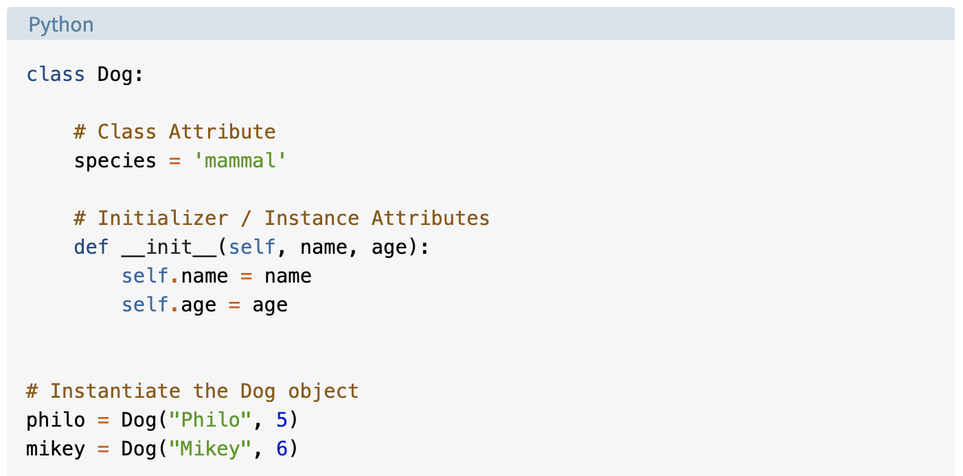

Figure 1. Instantiation of class object example

What I do not understand is how to do this dynamically. In this assignment I do not know how many CD instances the user will want to add so I cannot instantiate the objects like the example above. What I tried to do was create a class object called “cd_instance” then append that object to a list before using that same class object again with different inputs. What I found in my testing however was it would override all class presently loaded. Help understanding how this is done would be appreciated.

My CD data class code is depicted in figure 2 below. Notice the __ creating private attributes.

﻿

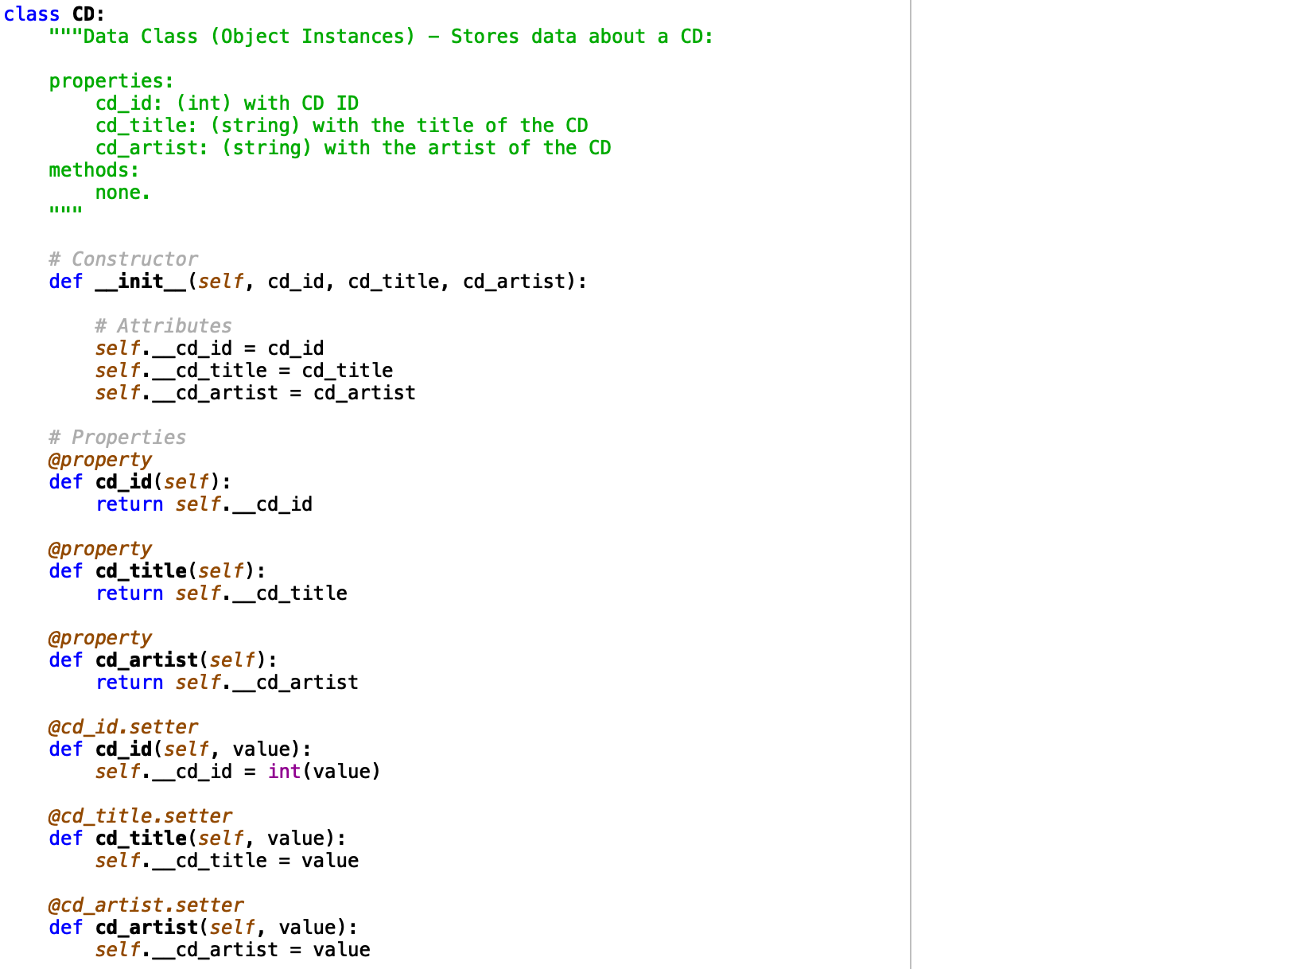

Figure 2. Python script – CD data class

I utilized the File IO class to handle reading, writing, adding and deleting functionality of the database. This is depicted in Figure 3 below. The add_inventory function is where my bug currently resides.

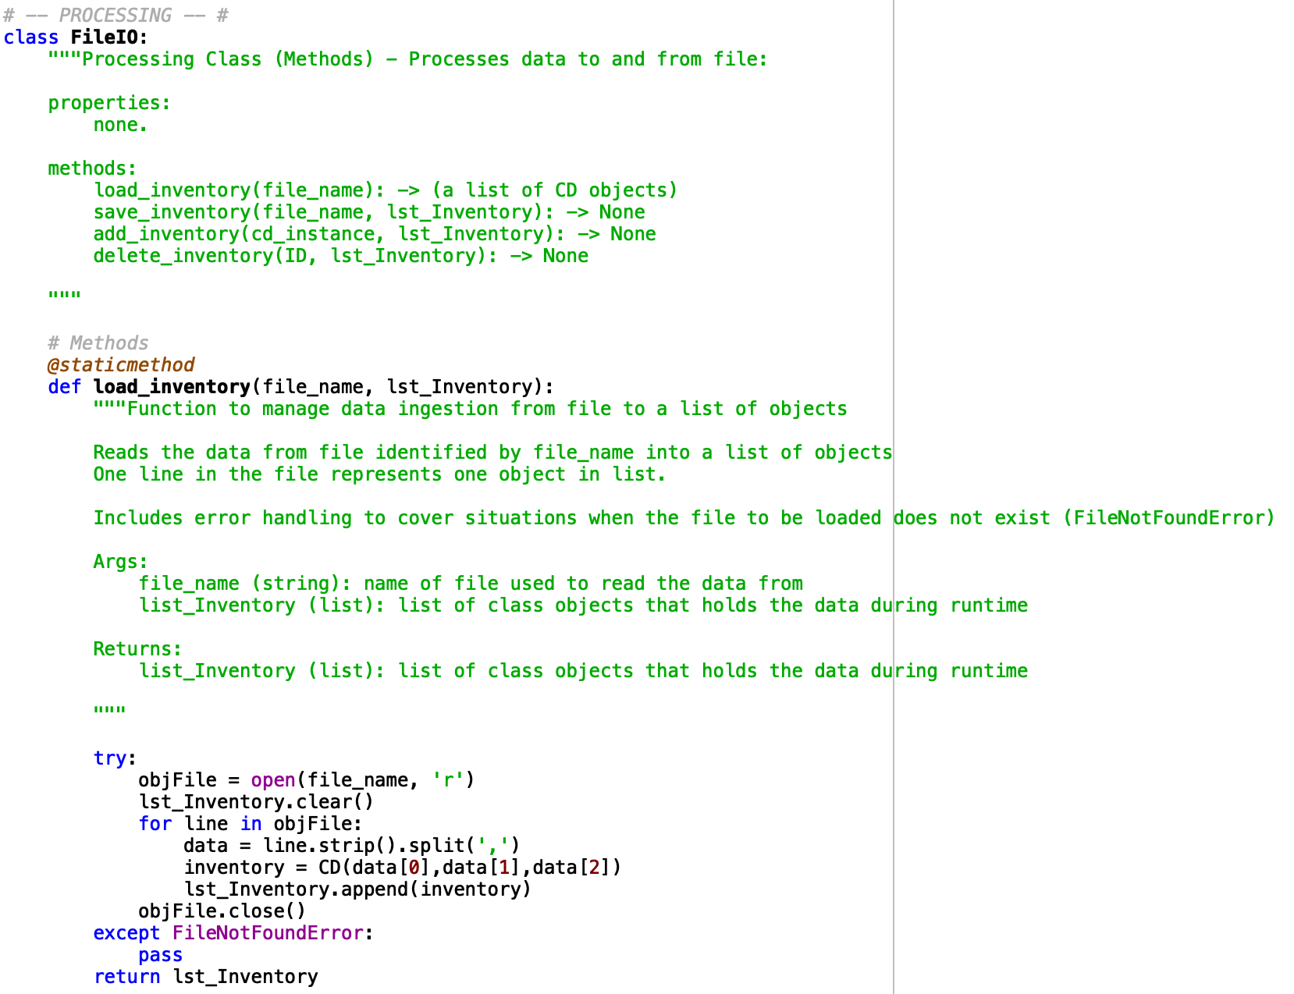

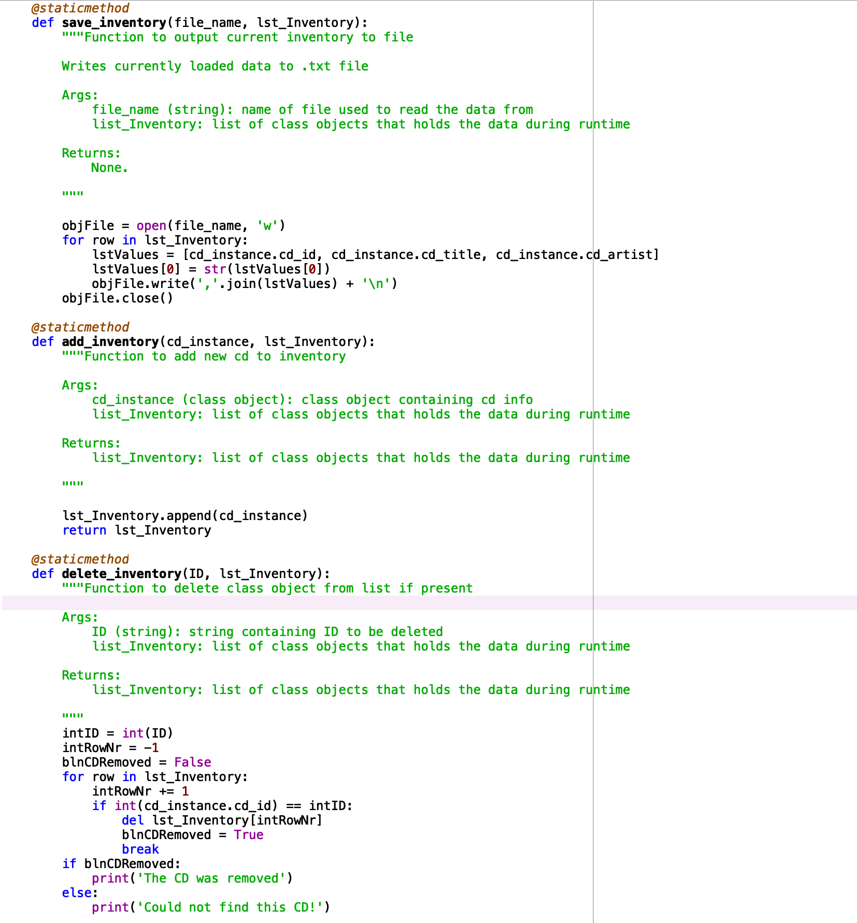

Figure 3. Python script – FileIO Class

My class IO functions handled the user interface and were largely left the same from previous weeks with the exception of some variable names. This is depicted in Figure 4.

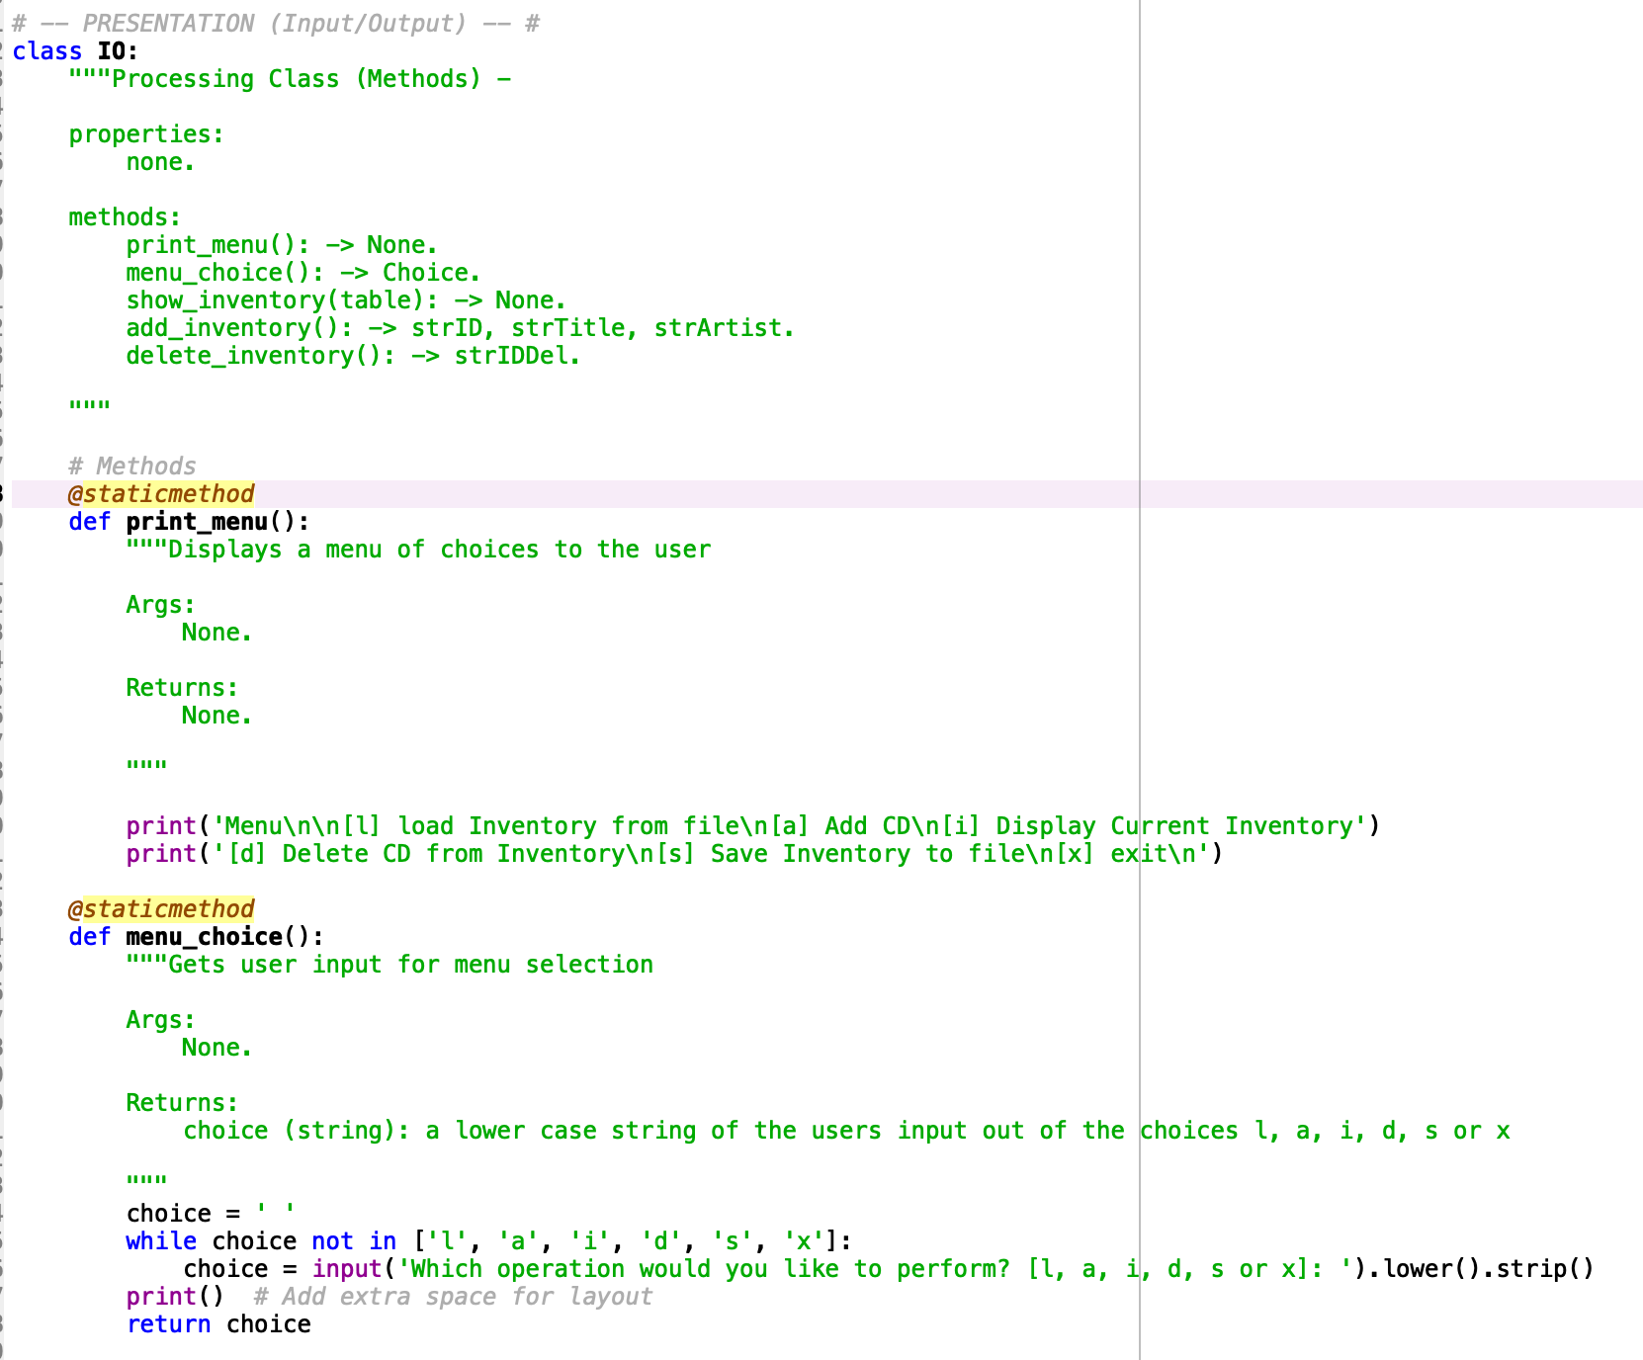

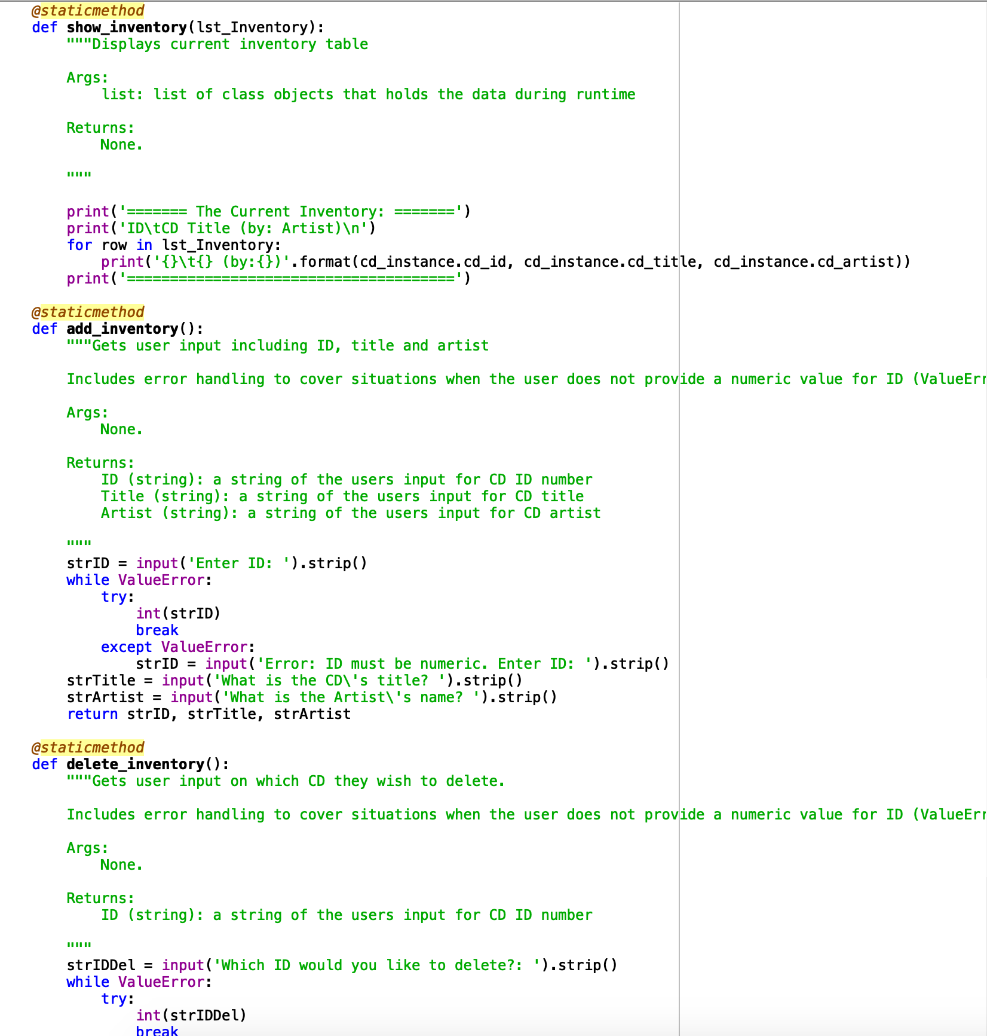

Figure 4. Python script – Class IO

Figure 5 below depicts the main code body.

﻿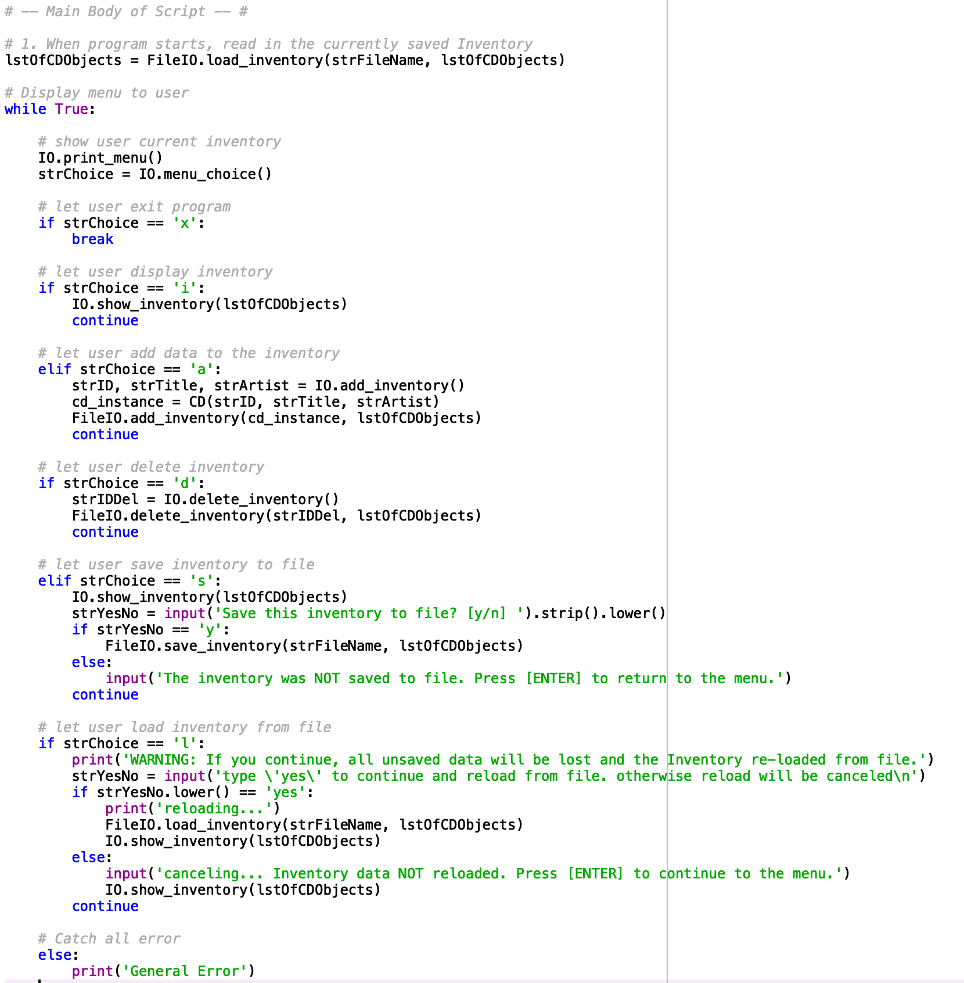

Figure 5. Python script – Main Code

# Executing the code

I executed my code through both Spyder and Mac’s Terminal as depicted by Figures 6 and 7 respectively.

1. runfile('/Users/russellbennett/Documents/uw/python/week_8/Assignment08/CDInventory.py', wdir='/Users/russellbennett/Documents/uw/python/week_8/Assignment08')
2. Menu
4. [l] load Inventory **from** file
5. [a] Add CD
6. [i] Display Current Inventory
7. [d] Delete CD **from** Inventory
8. [s] Save Inventory to file
9. [x] exit

12. Which operation would you like to perform? [l, a, i, d, s **or** x]: i
14. ======= The Current Inventory: =======
15. ID      CD Title (by: Artist)
17. 2       df (by:c)
18. 2       df (by:c)
19. ======================================
20. Menu
22. [l] load Inventory **from** file
23. [a] Add CD
24. [i] Display Current Inventory
25. [d] Delete CD **from** Inventory
26. [s] Save Inventory to file
27. [x] exit

30. Which operation would you like to perform? [l, a, i, d, s **or** x]: d

33. Which ID would you like to delete?: 2
34. The CD was removed
35. Menu
37. [l] load Inventory **from** file
38. [a] Add CD
39. [i] Display Current Inventory
40. [d] Delete CD **from** Inventory
41. [s] Save Inventory to file
42. [x] exit

45. Which operation would you like to perform? [l, a, i, d, s **or** x]: i
47. ======= The Current Inventory: =======
48. ID      CD Title (by: Artist)
50. 2       df (by:c)
51. ======================================
52. Menu
54. [l] load Inventory **from** file
55. [a] Add CD
56. [i] Display Current Inventory
57. [d] Delete CD **from** Inventory
58. [s] Save Inventory to file
59. [x] exit

62. Which operation would you like to perform? [l, a, i, d, s **or** x]: a

65. Enter ID: 3
67. What **is** the CD's title? hello
69. What **is** the Artist's name? world
70. Menu
72. [l] load Inventory **from** file
73. [a] Add CD
74. [i] Display Current Inventory
75. [d] Delete CD **from** Inventory
76. [s] Save Inventory to file
77. [x] exit

80. Which operation would you like to perform? [l, a, i, d, s **or** x]: i
82. ======= The Current Inventory: =======
83. ID      CD Title (by: Artist)
85. 3       hello (by:world)
86. 3       hello (by:world)
87. ======================================
88. Menu
90. [l] load Inventory **from** file
91. [a] Add CD
92. [i] Display Current Inventory
93. [d] Delete CD **from** Inventory
94. [s] Save Inventory to file
95. [x] exit

98. Which operation would you like to perform? [l, a, i, d, s **or** x]: s
100. ======= The Current Inventory: =======
101. ID      CD Title (by: Artist)
103. 3       hello (by:world)
104. 3       hello (by:world)
105. ======================================
107. Save this inventory to file? [y/n] y
108. Menu
110. [l] load Inventory **from** file
111. [a] Add CD
112. [i] Display Current Inventory
113. [d] Delete CD **from** Inventory
114. [s] Save Inventory to file
115. [x] exit

118. Which operation would you like to perform? [l, a, i, d, s **or** x]: x

Figure 6. Spyder Execution

1. (base) Russells-MBP:Assignment08 russellbennett$ python CDInventory.py
2. Menu
4. [l] load Inventory **from** file
5. [a] Add CD
6. [i] Display Current Inventory
7. [d] Delete CD **from** Inventory
8. [s] Save Inventory to file
9. [x] exit
11. Which operation would you like to perform? [l, a, i, d, s **or** x]: a
13. Enter ID: 1
14. What **is** the CD's title? d
15. What **is** the Artist's name? f
16. Menu
18. [l] load Inventory **from** file
19. [a] Add CD
20. [i] Display Current Inventory
21. [d] Delete CD **from** Inventory
22. [s] Save Inventory to file
23. [x] exit
25. Which operation would you like to perform? [l, a, i, d, s **or** x]: i
27. ======= The Current Inventory: =======
28. ID  CD Title (by: Artist)
30. 1   d (by:f)
31. 1   d (by:f)
32. 1   d (by:f)
33. ======================================
34. Menu
36. [l] load Inventory **from** file
37. [a] Add CD
38. [i] Display Current Inventory
39. [d] Delete CD **from** Inventory
40. [s] Save Inventory to file
41. [x] exit
43. Which operation would you like to perform? [l, a, i, d, s **or** x]: a
45. Enter ID: 2
46. What **is** the CD's title? df
47. What **is** the Artist's name? df
48. Menu
50. [l] load Inventory **from** file
51. [a] Add CD
52. [i] Display Current Inventory
53. [d] Delete CD **from** Inventory
54. [s] Save Inventory to file
55. [x] exit
57. Which operation would you like to perform? [l, a, i, d, s **or** x]: i
59. ======= The Current Inventory: =======
60. ID  CD Title (by: Artist)
62. 2   df (by:df)
63. 2   df (by:df)
64. 2   df (by:df)
65. 2   df (by:df)
66. ======================================
67. Menu
69. [l] load Inventory **from** file
70. [a] Add CD
71. [i] Display Current Inventory
72. [d] Delete CD **from** Inventory
73. [s] Save Inventory to file
74. [x] exit
76. Which operation would you like to perform? [l, a, i, d, s **or** x]: s
78. ======= The Current Inventory: =======
79. ID  CD Title (by: Artist)
81. 2   df (by:df)
82. 2   df (by:df)
83. 2   df (by:df)
84. 2   df (by:df)
85. ======================================
86. Save this inventory to file? [y/n] y
87. Menu
89. [l] load Inventory **from** file
90. [a] Add CD
91. [i] Display Current Inventory
92. [d] Delete CD **from** Inventory
93. [s] Save Inventory to file
94. [x] exit
96. Which operation would you like to perform? [l, a, i, d, s **or** x]: x
98. (base) Russells-MBP:Assignment08 russellbennett$

Figure 7. Terminal Execution

The output file is depicted in Figure 8.

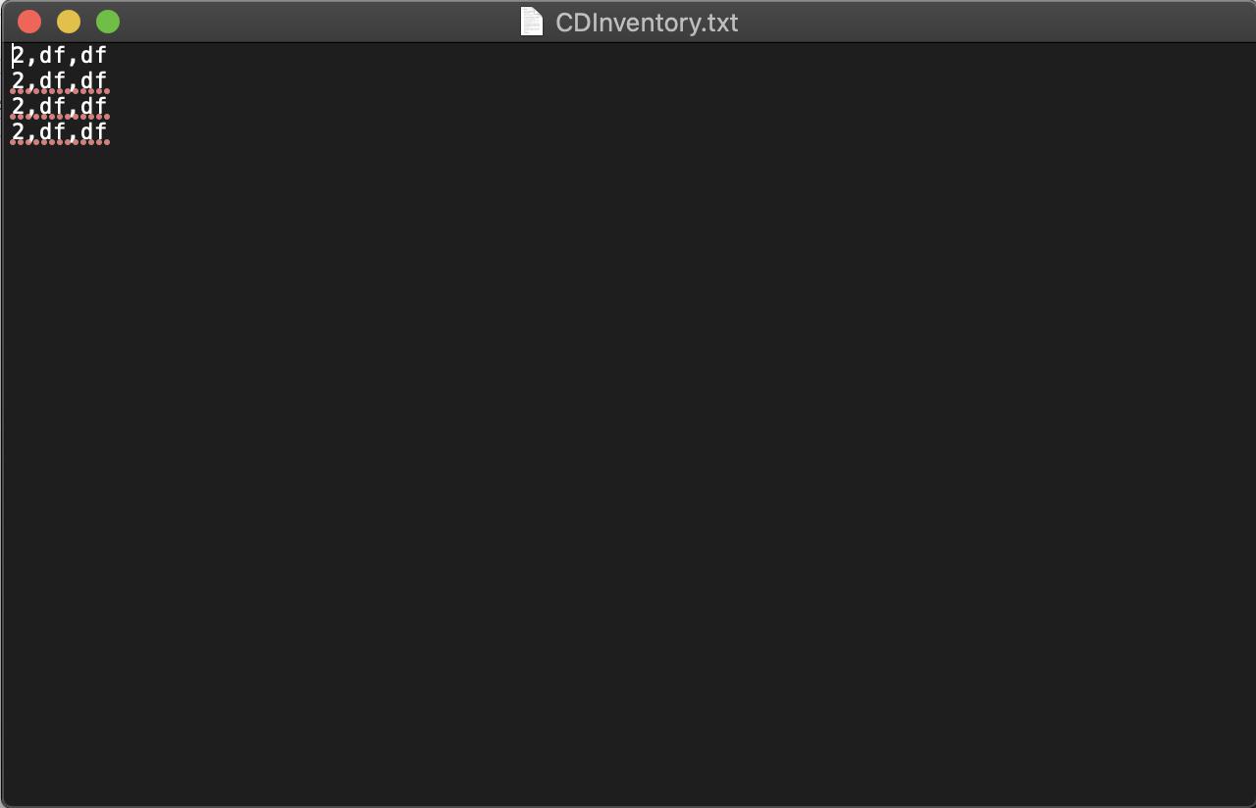

Figure 8. Text output file

# Summary

This assignment introduced us to object oriented programming which I require much more practice in to be proficient.

Github Link: