Russell Bennett

03/23/2020

Foundations of Programming (Python)

Assignment #9

# Introduction

This assignment tasked us with splitting code we had previously broken out solely by classes into separate modules in conjunction with object-oriented programming.

# Drafting the code

Though still struggling to fully comprehend all the aspects of object oriented programming, I did find this assignment easier than last weeks. The one main hang up I had early on was how to handle storing tracks for each CD. Initially my thought process assumed I would have to create and edit a new file for each CD to house its tracks. It wasn’t until watching the video covering lab B which gave instruction for adding a CD id to the track file that I was able to simplify the assignment and proceed.

I modelled the track class after the CD class as it essentially requires the same functionality but with different variables. This is depicted in Figure 1.

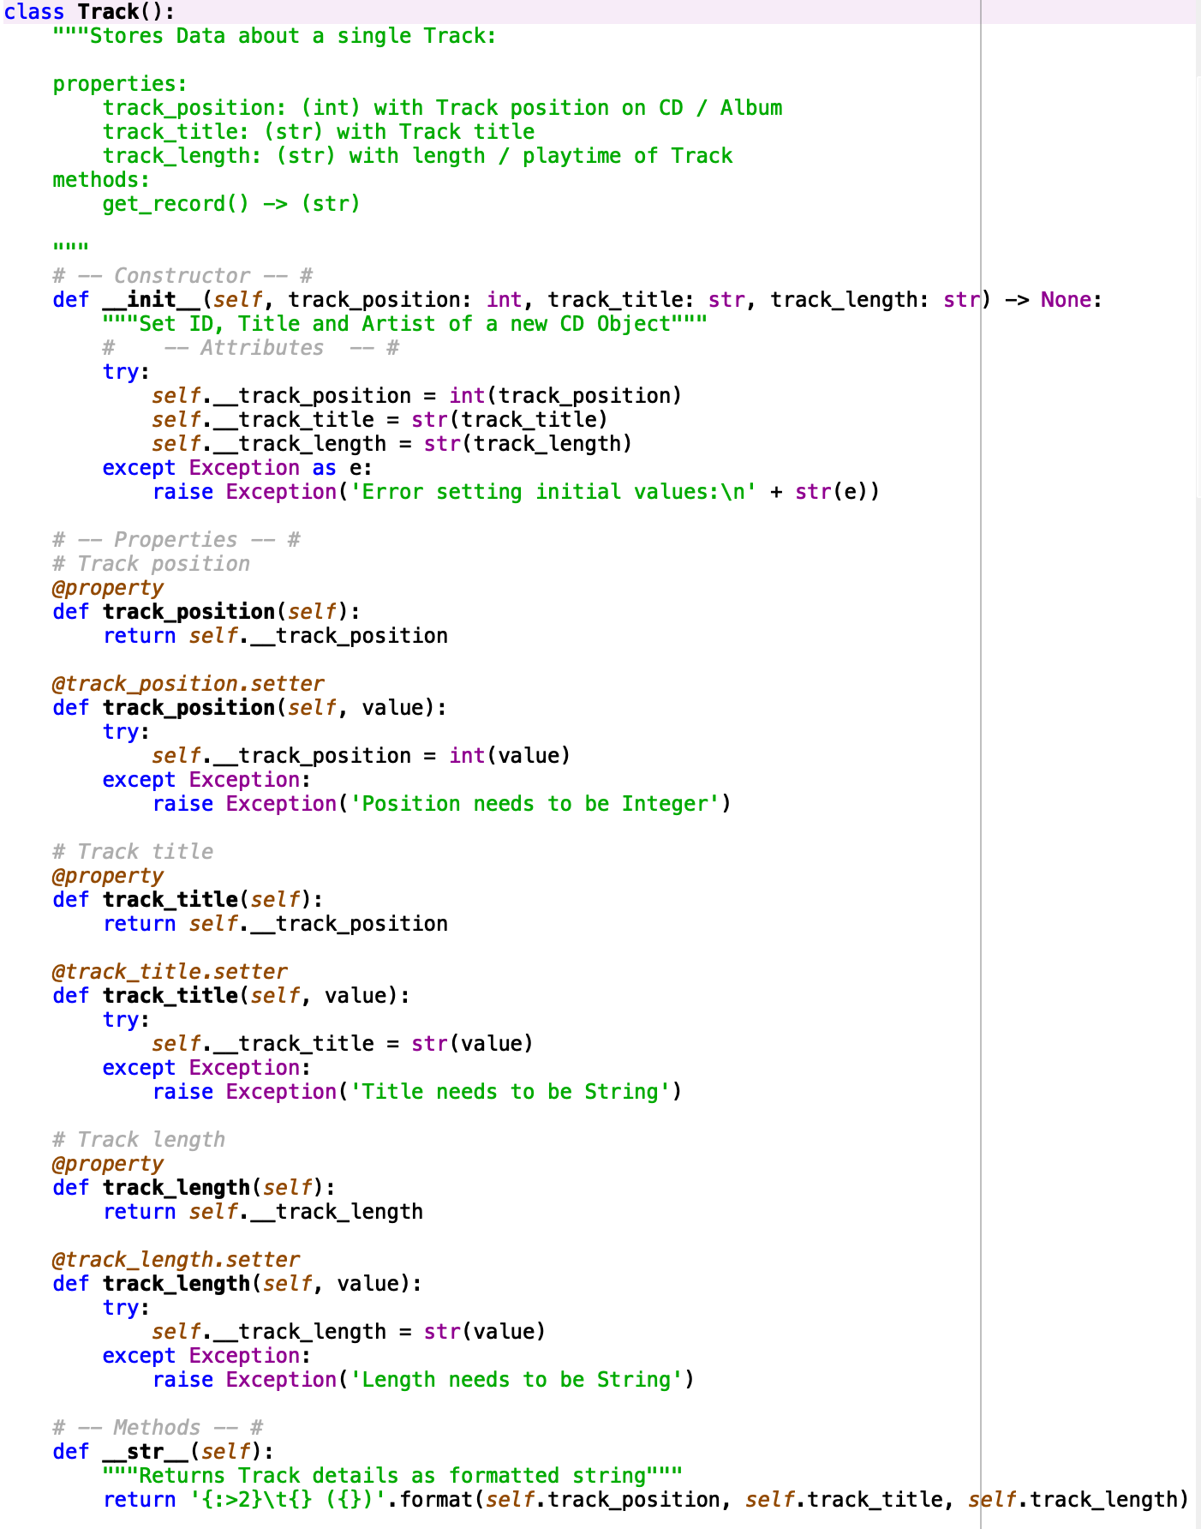

Figure 1. Data Classes

The IO class was the most challenging for me to understand. I heavily referenced the available material to draft the code then spent a large amount of time logically working my way through it to understand its functionality. I am at a point know where I understand what it is doing. My IO class is depicted in Figure 2.

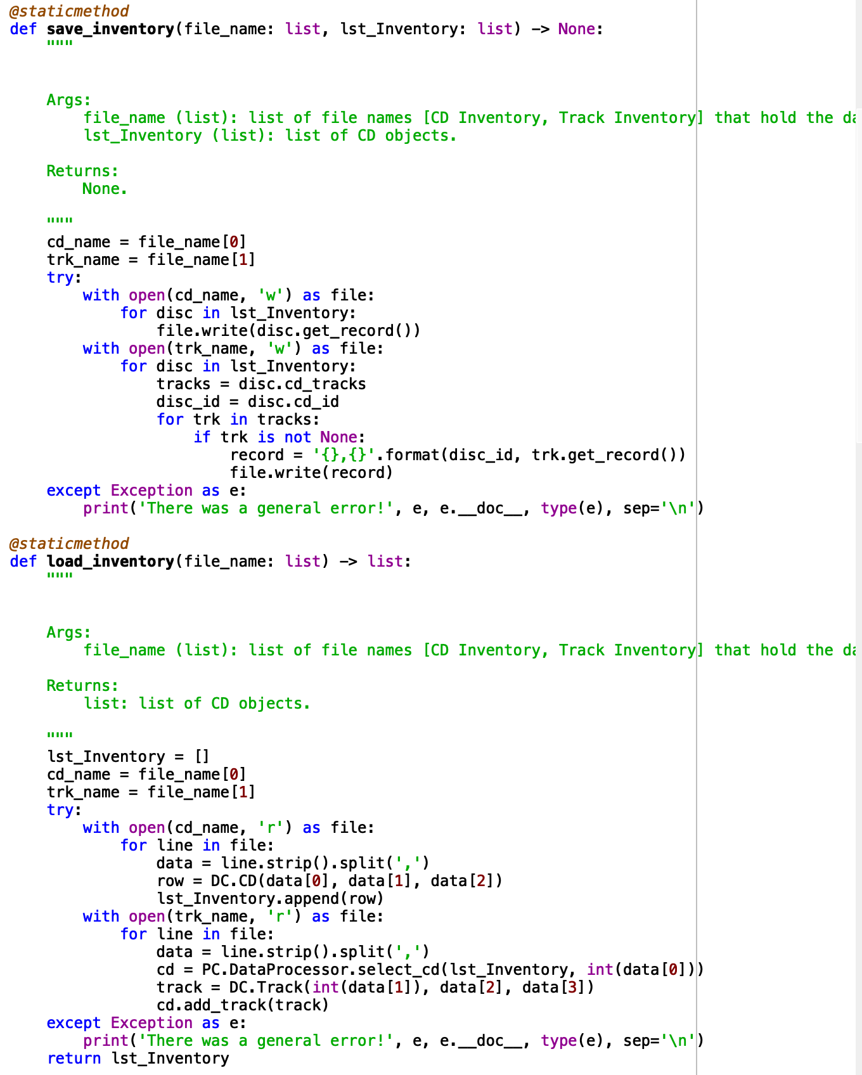

Figure 2. IO Classes

The processing class was fairly straight forward with only needing to pass info into the objects. This is depicted in Figure 3.

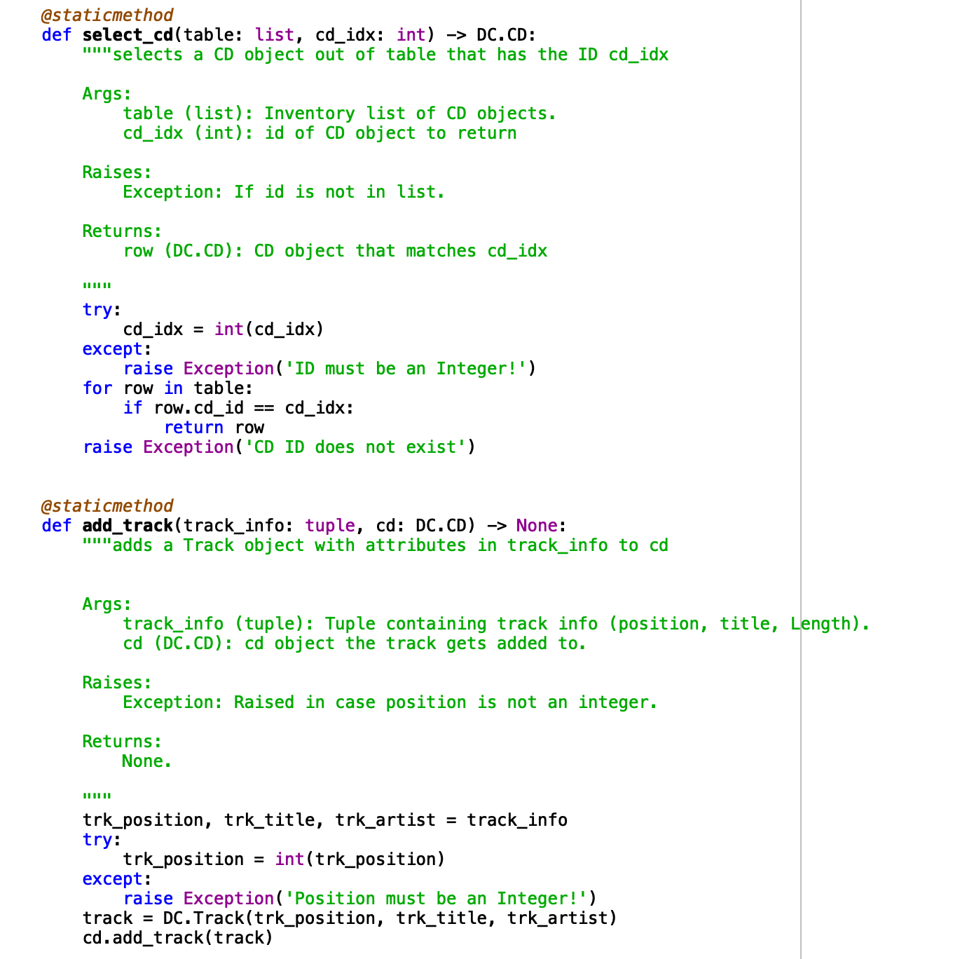

Figure 3. Processing Classes

Figure 4 below depicts the main code body.

﻿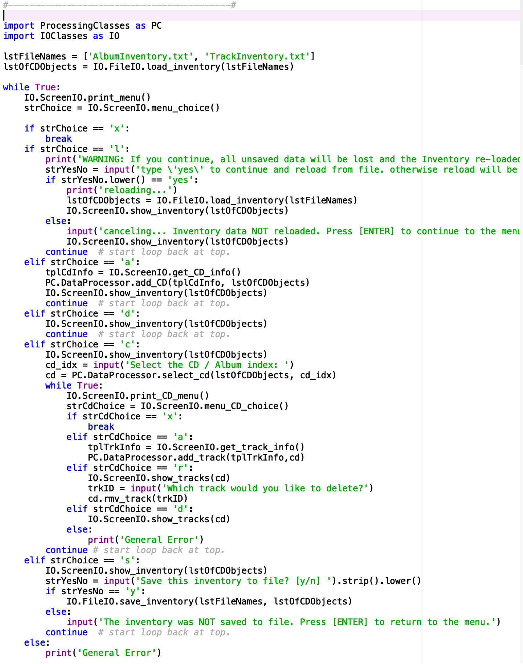

Figure45. Python script – Main Code

# Executing the code

I executed my code through both Spyder and Mac’s Terminal as depicted by Figures 5 and 6 respectively.

1. Reloaded modules: ProcessingClasses, DataClasses, IOClasses
2. Main Menu
4. [l] load Inventory **from** file
5. [a] Add CD / Album
6. [d] Display Current Inventory
7. [c] Choose CD / Album
8. [s] Save Inventory to file
9. [x] exit

12. Which operation would you like to perform? [l, a, d, c, s **or** x]: l
14. WARNING: If you **continue**, all unsaved data will be lost **and** the Inventory re-loaded **from** file.
16. type 'yes' to **continue** **and** reload **from** file. otherwise reload will be canceledyes
17. reloading...
18. ======= The Current Inventory: =======
19. ID      CD Title (by: Artist)
21. 1      Hello (by: World)
22. ======================================
23. Main Menu
25. [l] load Inventory **from** file
26. [a] Add CD / Album
27. [d] Display Current Inventory
28. [c] Choose CD / Album
29. [s] Save Inventory to file
30. [x] exit

33. Which operation would you like to perform? [l, a, d, c, s **or** x]: a

36. Enter ID: 2
38. What **is** the CD's title? Hi
40. What **is** the Artist's name? World
41. ======= The Current Inventory: =======
42. ID      CD Title (by: Artist)
44. 1      Hello (by: World)
45. 2      Hi (by: World)
46. ======================================
47. Main Menu
49. [l] load Inventory **from** file
50. [a] Add CD / Album
51. [d] Display Current Inventory
52. [c] Choose CD / Album
53. [s] Save Inventory to file
54. [x] exit

57. Which operation would you like to perform? [l, a, d, c, s **or** x]: c
59. ======= The Current Inventory: =======
60. ID      CD Title (by: Artist)
62. 1      Hello (by: World)
63. 2      Hi (by: World)
64. ======================================
66. Select the CD / Album index: 2
67. CD Sub Menu
69. [a] Add track
70. [d] Display cd / Album details
71. [r] Remove track
72. [x] exit to Main Menu
74. Which operation would you like to perform? [a, d, r **or** x]: Rock
76. Which operation would you like to perform? [a, d, r **or** x]: a

79. Enter Position on CD / Album: 1
81. What **is** the Track's title? Rock
83. What **is** the Track's length? 3
84. CD Sub Menu
86. [a] Add track
87. [d] Display cd / Album details
88. [r] Remove track
89. [x] exit to Main Menu
91. Which operation would you like to perform? [a, d, r **or** x]: d
93. ====== Current CD / Album: ======
94. 2      Hi (by: World)
95. =================================
96. 1      1 (3)
98. =================================
99. CD Sub Menu
101. [a] Add track
102. [d] Display cd / Album details
103. [r] Remove track
104. [x] exit to Main Menu
106. Which operation would you like to perform? [a, d, r **or** x]: r
108. ====== Current CD / Album: ======
109. 2      Hi (by: World)
110. =================================
111. 1      1 (3)

Figure 5. Spyder Execution

1. (base) Russells-MBP:Assignment_09 russellbennett$ python CD_Inventory.py
2. Main Menu
4. [l] load Inventory **from** file
5. [a] Add CD / Album
6. [d] Display Current Inventory
7. [c] Choose CD / Album
8. [s] Save Inventory to file
9. [x] exit
11. Which operation would you like to perform? [l, a, d, c, s **or** x]: l
13. WARNING: If you **continue**, all unsaved data will be lost **and** the Inventory re-loaded **from** file.
14. type 'yes' to **continue** **and** reload **from** file. otherwise reload will be canceledyes
15. reloading...
16. ======= The Current Inventory: =======
17. ID  CD Title (by: Artist)
19. 1  Hello (by: World)
20. ======================================
21. Main Menu
23. [l] load Inventory **from** file
24. [a] Add CD / Album
25. [d] Display Current Inventory
26. [c] Choose CD / Album
27. [s] Save Inventory to file
28. [x] exit
30. Which operation would you like to perform? [l, a, d, c, s **or** x]: a
32. Enter ID: 2
33. What **is** the CD's title? Hi
34. What **is** the Artist's name? Bob
35. ======= The Current Inventory: =======
36. ID  CD Title (by: Artist)
38. 1  Hello (by: World)
39. 2  Hi (by: Bob)
40. ======================================
41. Main Menu
43. [l] load Inventory **from** file
44. [a] Add CD / Album
45. [d] Display Current Inventory
46. [c] Choose CD / Album
47. [s] Save Inventory to file
48. [x] exit
50. Which operation would you like to perform? [l, a, d, c, s **or** x]: c
52. ======= The Current Inventory: =======
53. ID  CD Title (by: Artist)
55. 1  Hello (by: World)
56. 2  Hi (by: Bob)
57. ======================================
58. Select the CD / Album index: 1
59. CD Sub Menu
61. [a] Add track
62. [d] Display cd / Album details
63. [r] Remove track
64. [x] exit to Main Menu
65. Which operation would you like to perform? [a, d, r **or** x]: a
67. Enter Position on CD / Album: 1
68. What **is** the Track's title? Rock
69. What **is** the Track's length? 2:03
70. CD Sub Menu
72. [a] Add track
73. [d] Display cd / Album details
74. [r] Remove track
75. [x] exit to Main Menu
76. Which operation would you like to perform? [a, d, r **or** x]: x
78. Main Menu
80. [l] load Inventory **from** file
81. [a] Add CD / Album
82. [d] Display Current Inventory
83. [c] Choose CD / Album
84. [s] Save Inventory to file
85. [x] exit
87. Which operation would you like to perform? [l, a, d, c, s **or** x]: s
89. ======= The Current Inventory: =======
90. ID  CD Title (by: Artist)
92. 1  Hello (by: World)
93. 2  Hi (by: Bob)
94. ======================================
95. Save this inventory to file? [y/n] y
96. There was a general error!
97. 'CD' object has no attribute '_CD__tracks'
98. Attribute **not** found.
99. <**class** 'AttributeError'>
100. Main Menu
102. [l] load Inventory **from** file
103. [a] Add CD / Album
104. [d] Display Current Inventory
105. [c] Choose CD / Album
106. [s] Save Inventory to file
107. [x] exit
109. Which operation would you like to perform? [l, a, d, c, s **or** x]: x
111. (base) Russells-MBP:Assignment_09 russellbennett$

Figure 6. Terminal Execution

The output file is depicted in Figure 7.

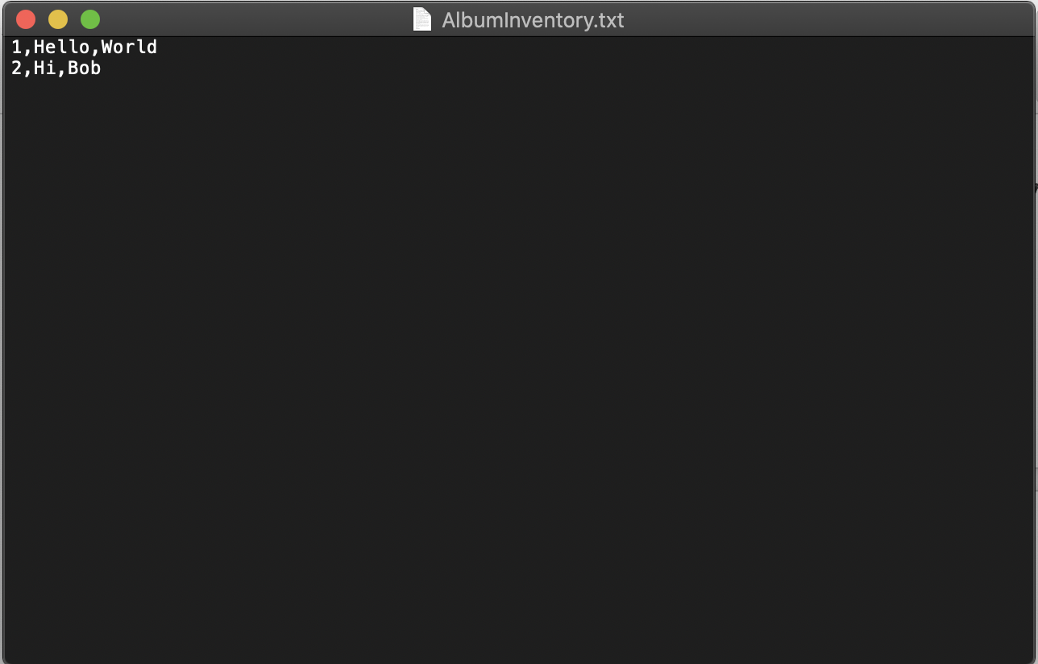

Figure 7. Text output file

# Summary

More great practice with OOP. I still feel its one of those concepts that is just going to take time with to get proficient at.

Github Link: