Russell Bennett

02/23/2020

Foundations of Programming (Python)

Assignment #5

# Introduction

This assignment tasked us with modifying last week’s assignment to utilize dictionaries instead of lists as well as adding the additional functionality of reading in a file and deleting entries.

# Drafting the code

For this assignment we were provided with working code that utilized lists. I first modified this code such that it utilized dictionaries and tested it to ensure it was working correctly. This involved modifying the add data, display data, and save data sections represented in Figures 1 through 3 respectively. Note the addition of structured error handling to handle the condition when the user inputs a variable which cannot be cast to an integer for the ID.

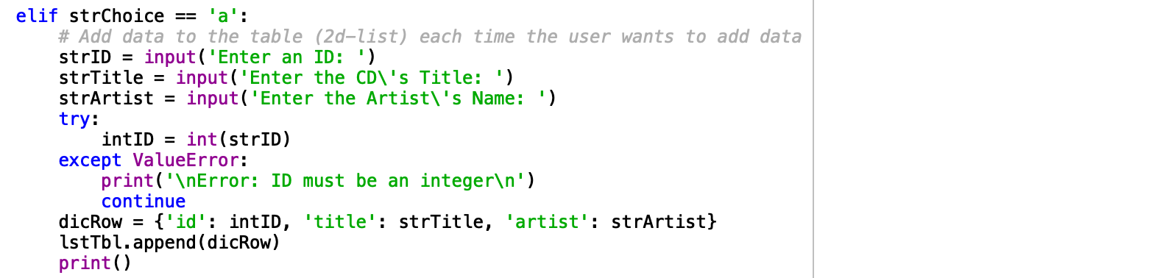

Figure 1. Python script – Add Data to Table

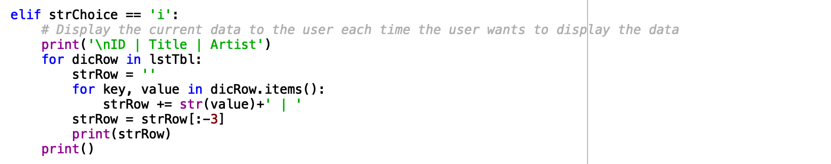

Figure 2. Python script – Display Current Data

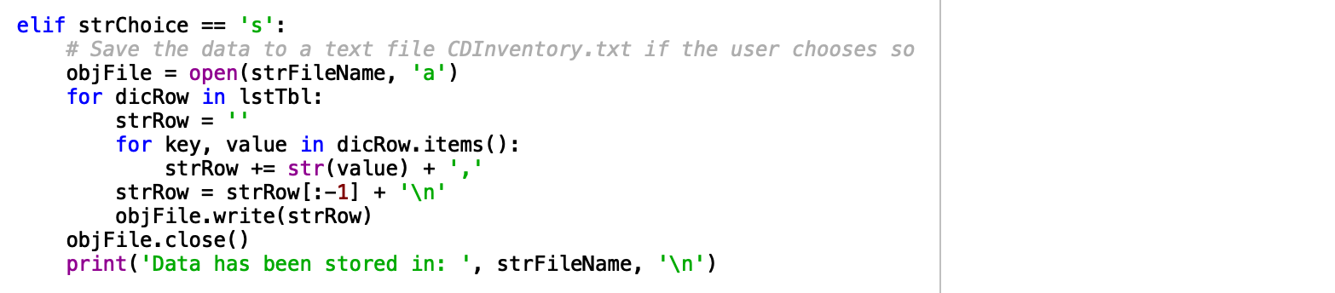

Figure 3. Python script – Save Data to .txt File

Next, I added the functionality to read in a data from a text file. To do this I first read in each line as a list using the “,” to indicate the different items in the list followed by assigning those items to their respective dictionary locations and appending them to the table. This is depicted in Figure 4 below.

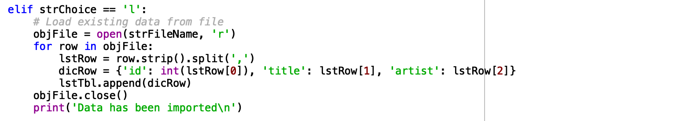

Figure 4. Python script – Load Existing Data

Finally, I added the functionality to delete data stored in the table. Initially I used the .clear() function with dictionaries however this simply left and empty dictionary in my table so I instead used the .remove() function to delete the table row and resultantly the dictionary within. This is depicted in Figure 5 below.

I am aware of one bug in this code which I wasn’t able to fix in a reasonable amount of time. It involves instances where more than one table row includes a dictionary of the same ID. In this instance the delete function will remove all instances of that ID minus 1. i.e. if there are four rows in the table of dictionaries with ID = 1 and you tell the computer to delete dictionaries with an ID = 1, three instances will be deleted with one remaining. I imagine this has something to do with the interaction of the for loop with deleting table rows but I wasn’t able to determine a solution.

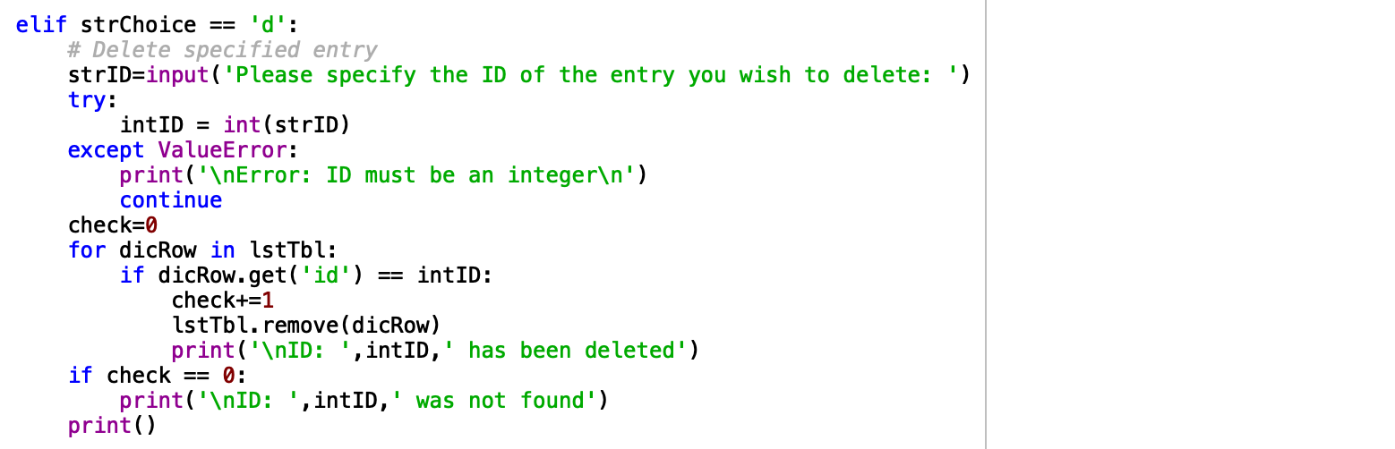

Figure 5. Python script – Delete Data

# Executing the code

I executed my code through both Spyder and Mac’s Terminal as depicted by Figures 6 and 7 respectively.

1. runfile('/Users/russellbennett/Documents/uw/python/week_5/Assignment05/CDInventory.py', wdir='/Users/russellbennett/Documents/uw/python/week_5/Assignment05')
2. The Magic CD Inventory
4. [l] load Inventory **from** file
5. [a] Add CD
6. [i] Display Current Inventory
7. [d] delete CD **from** Inventory
8. [s] Save Inventory to file
9. [x] exit
11. l, a, i, d, s **or** x: a

14. Enter an ID: 1
16. Enter the CD's Title: Hello
18. Enter the Artist's Name: World
20. [l] load Inventory **from** file
21. [a] Add CD
22. [i] Display Current Inventory
23. [d] delete CD **from** Inventory
24. [s] Save Inventory to file
25. [x] exit
27. l, a, i, d, s **or** x: a

30. Enter an ID: 2
32. Enter the CD's Title: Hello
34. Enter the Artist's Name: World
36. [l] load Inventory **from** file
37. [a] Add CD
38. [i] Display Current Inventory
39. [d] delete CD **from** Inventory
40. [s] Save Inventory to file
41. [x] exit
43. l, a, i, d, s **or** x: i

46. ID | Title | Artist
47. 1 | Hello | World
48. 2 | Hello | World
50. [l] load Inventory **from** file
51. [a] Add CD
52. [i] Display Current Inventory
53. [d] delete CD **from** Inventory
54. [s] Save Inventory to file
55. [x] exit
57. l, a, i, d, s **or** x: d

60. Please specify the ID of the entry you wish to delete: 1
62. ID:  1  has been deleted
64. [l] load Inventory **from** file
65. [a] Add CD
66. [i] Display Current Inventory
67. [d] delete CD **from** Inventory
68. [s] Save Inventory to file
69. [x] exit
71. l, a, i, d, s **or** x: s
73. Data has been stored **in**:  CDInventory.txt
75. [l] load Inventory **from** file
76. [a] Add CD
77. [i] Display Current Inventory
78. [d] delete CD **from** Inventory
79. [s] Save Inventory to file
80. [x] exit
82. l, a, i, d, s **or** x: x

Figure 6. Spyder Execution

1. (base) Russells-MBP:Assignment05 russellbennett$ python CDInventory.py
2. The Magic CD Inventory
4. [l] load Inventory **from** file
5. [a] Add CD
6. [i] Display Current Inventory
7. [d] delete CD **from** Inventory
8. [s] Save Inventory to file
9. [x] exit
10. l, a, i, d, s **or** x: l
12. Data has been imported
14. [l] load Inventory **from** file
15. [a] Add CD
16. [i] Display Current Inventory
17. [d] delete CD **from** Inventory
18. [s] Save Inventory to file
19. [x] exit
20. l, a, i, d, s **or** x: i

23. ID | Title | Artist
24. 2 | Hello | World
26. [l] load Inventory **from** file
27. [a] Add CD
28. [i] Display Current Inventory
29. [d] delete CD **from** Inventory
30. [s] Save Inventory to file
31. [x] exit
32. l, a, i, d, s **or** x: a
34. Enter an ID: 1
35. Enter the CD's Title: Hello
36. Enter the Artist's Name: World
38. [l] load Inventory **from** file
39. [a] Add CD
40. [i] Display Current Inventory
41. [d] delete CD **from** Inventory
42. [s] Save Inventory to file
43. [x] exit
44. l, a, i, d, s **or** x: a
46. Enter an ID: 3
47. Enter the CD's Title: Hello
48. Enter the Artist's Name: World
50. [l] load Inventory **from** file
51. [a] Add CD
52. [i] Display Current Inventory
53. [d] delete CD **from** Inventory
54. [s] Save Inventory to file
55. [x] exit
56. l, a, i, d, s **or** x: d
58. Please specify the ID of the entry you wish to delete: 2
60. ID:  2  has been deleted
62. [l] load Inventory **from** file
63. [a] Add CD
64. [i] Display Current Inventory
65. [d] delete CD **from** Inventory
66. [s] Save Inventory to file
67. [x] exit
68. l, a, i, d, s **or** x: i

71. ID | Title | Artist
72. 1 | Hello | World
73. 3 | Hello | World
75. [l] load Inventory **from** file
76. [a] Add CD
77. [i] Display Current Inventory
78. [d] delete CD **from** Inventory
79. [s] Save Inventory to file
80. [x] exit
81. l, a, i, d, s **or** x: s
83. Data has been stored **in**:  CDInventory.txt
85. [l] load Inventory **from** file
86. [a] Add CD
87. [i] Display Current Inventory
88. [d] delete CD **from** Inventory
89. [s] Save Inventory to file
90. [x] exit
91. l, a, i, d, s **or** x: x

Figure 7. Terminal Execution

The resulting text file is depicted in Figure 8. Note that the file includes both executions of the code.

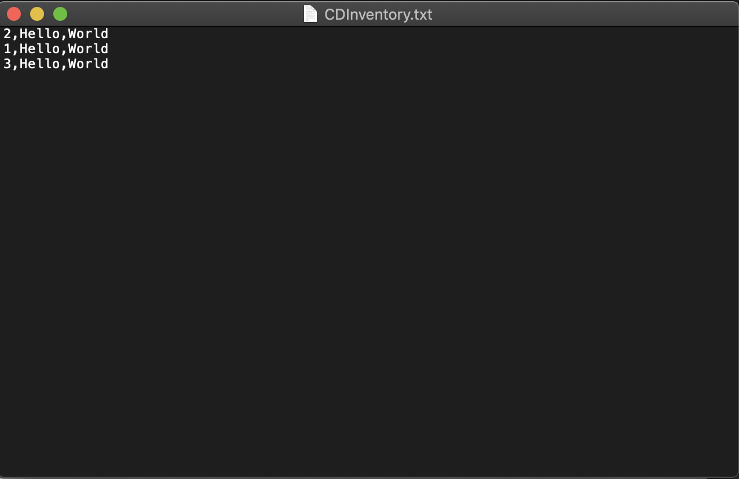Figure 8. Text File

# Summary

This assignment successfully taught us about dictionaries as well as working with others code. I enjoyed the many aspects of this project and breaking it down into manageable chunks before bringing it all back together at the end.

Github Link: