CHAPTER III

METHODOLOGY

3.1 Analysis

This section describes the comprehensive processes that occur within the BookSmart system during user interaction. Operating under the Holy Name University Bookstore, the system coordinates interactions among seven primary actors. These actors include the Bookstore Manager, who acts as the system administrator with full oversight, the Bookstore Staff and Working Students, who manage daily fulfillment, queue coordination, and inventory tasks, and the users, which consist of Teachers, Students, Parents, and Risographers. The system's architecture is built around seven core processes: Manage Account, Manage Orders, Manage Job Orders, Manage Appointment, Manage Payments, Manage Inventory, and Manage Reports. To visually map out these interactions and workflows, a Use Case Diagram and an Activity Diagram are utilized to illustrate the high level relationships and accessibility between each actor and the system. It demonstrates how the Manager has broad access across all seven modules, Staff and Working Students manage operational and transactional modules, and the users interact specifically with the modules necessary for registering, ordering, and scheduling.
The Manage Account, the system serves as the initial security gateway, ensuring that all users are properly registered and authenticated prior to accessing any system functionalities. This module enforces strict role based access control to maintain operational order. The Bookstore Manager, acting as the Administrator, logs into the system, accesses the account management module, and is responsible for creating accounts for Bookstore Staff, Working Student, and Risographer by entering their specific employee details. The system validates this information, creates the account, and allows the manager to dynamically activate or deactivate employee statuses as needed. Meanwhile, Students, Parents, and Teachers interact with the system by accessing the registration page and entering their required information, utilizing their institutional credentials. Upon form submission, the system evaluates the input, if the data is invalid, an error message is triggered, but if valid, the new account is created and saved to the database. Once the data is saved, users have the ability to edit their profile information as needed.
The Manage Orders, this process standardizes the pre ordering workflow for bookstore items. Students, Parents, and Teachers log in and browse the available bookstore items. When a user selects a product to view, the system instantly checks real time product availability. If the stock is insufficient, the user is notified; if available, the user can proceed to pre order the item. The system validates stock availability, automatically calculates the total amount, generates a unique transaction reference number for tracking, and reserves the selected item in the database. The order is placed in a "Pending" status until payment verification is completed. The Bookstore Manager retains the ability to view or modify if necessary..
The Manage Job Orders caters specifically to Teachers requesting Riso printing services for departmental needs, such as test questionnaires. After logging in and being authenticated by the system, a Teacher creates a digital Job Order Slip by entering their department details, the description/purpose, and any additional notes. Once submitted, the system routes the request to the bookstore's two designated Risographers for initial review. The digital form is then automatically forwarded to the respective departmental call center (e.g., CAS or COECS) for auditing.If the job order is deemed invalid at any stage of the review or audit, it is rejected; the system updates the request status accordingly, and the reviewer modifies the job order to include a note explaining the reason for rejection. Conversely, once the departmental call center audits and approves the request, the system notifies the Risographers to execute the printing run. After the documents are printed, the Risographer modifies the job order in the system to mark it as "processed." The teacher receives an automated notification to come to the bookstore to claim their printed questionnaires. Finally, the job order is officially marked as completed so the expenses can be accurately charged to the specific departmental accounts.
The Manage Appointment process digitally controls the customer flow within the bookstore. Users, including Students, Parents, or Teachers, log in and select an available date and time slot for pickup. The system verifies schedule availability; if the slot is unavailable, the user is prompted to select a new time. Once a valid schedule is selected, the system saves the appointment, updates the status to "Confirmed," and sends a confirmation to the user. Upon arrival at the bookstore, the user joins the digital queue, prompting the system to generate a specific queue number and set their initial status to "Waiting." Bookstore Staff monitor the system and call the next queue number, updating the system status to "Processing." The staff then view the order details tied to that queue number, prepare the physical items, and verify them against the customer's Official Receipt (OR). Finally, the items are released to the customer, and the system status is finalized as "Completed."
The Manage Payments module seamlessly handles the final transaction steps while guaranteeing financial transparency. To do this, the system evaluates the generated Order Slip and distinguishes the workflow based on the total purchase amount. If the total is under ₱100, the user pays directly at the bookstore counter, where the Bookstore Staff accepts the cash payment and issues a receipt. If the order is ₱100 or higher, the user is instead directed to pay at the Finance Office teller. The user retrieves an Official Receipt from the teller and presents it to the Bookstore Staff. Once the staff views the receipt, the payment workflow merges with the appointment release phase, and the user receives their physical items. Post-transaction, this module also handles user evaluations. Users can create and submit feedback, which the system saves to the database before notifying the Admin. The Bookstore Admin then reviews the submission to determine if it is appropriate, choosing to either retain or remove the feedback, and the system updates the Feedback List accordingly.
The Manage Inventory process ensures real-time accuracy of stock levels for the Bookstore, Souvenir Shop, and Riso services. The workflow begins with the Bookstore Manager logging into the system. The system validates their Admin role and specifically checks if the user is authorized to access reports. Upon successful verification, the Manager can access the Inventory Section, prompting the system to display the current stock levels. The system then dynamically manages these levels based on real-time transaction statuses: if a new order is placed, the reserve quantity increases; if an order is released to a customer, the available stock decreases. Finally, the system executes an automated update to the inventory record in the database. To further maintain operational efficiency, the manager can also utilize this module to log new stock arrivals and set customized reorder points, prompting the system to generate an inventory log.
The Manage Reports process is restricted to managerial control to provide insights into sales performance, stock availability, and operational efficiency. The workflow begins when the Bookstore Manager / Bookstore Staff / Working Student logs into the system. The system strictly validates their Admin role and explicitly checks if the user is authorized to access reports. If authorized, the manager selects a specific report type. Specifically, the manager can choose to generate daily revenue reports, order status summaries, inventory stock reports, or payment source breakdowns. This selection prompts the system to gather all relevant transaction and inventory data and organize it into a standardized report format. After reviewing the compiled data on-screen, the manager reaches a decision point: Export or Print. If they choose to export, the report remains viewable on-screen; if they choose to print, the system generates a printable, audit-ready copy. Finally, both pathways converge, allowing the manager to view the final report.
Each user has different capabilities. For the Bookstore Manager, will have the capable to:
● Manage user accounts and role assignments.
● Approve high level transactions and system overrides.
● Oversee payment verification and financial compliance.
● Monitor inventory accuracy across operational units.
● Generate and review comprehensive financial and operational reports.

The Bookstore Staff & Working Students will have the capability to:
● Validate and record Official Receipts (OR) from the teller.
● Process transactions below ₱100.
● Confirm pre-orders.
● Manage queue progression and service flow.
● Update and reconcile inventory records.
● Assist in preparing reserved items for release.
● Support queue coordination during peak hours.
● Assist in inventory organization with limited system privileges.

The Teachers will have the capability to:
● Register and access accounts.
● Place departmental or personal orders.
● Schedule appointments for pickup.
● Join the queue during item release.
The Students / Parents
● Register and manage their accounts.
● Generate digital Order Slips for pre-orders.
● Book and reschedule appointments for item pickup.
● Join the digital queue upon arrival.
● Monitor order status and receive notifications.
Risographer
● Review and validate incoming digital Job Order Slips submitted by Teachers for initial processing.
● Monitor the audit status of job orders routed to departmental call centers (e.g., CAS, COECS).
● Update job order statuses in the system, including adding explanatory notes for rejected or modified requests.
● Execute approved Riso printing runs for departmental needs once audit clearance is received.
● Mark completed printing tasks as "processed" to trigger automated pickup notifications for Teachers.
● Facilitate the automatic deduction of consumed Riso materials (such as paper and ink) from the bookstore's centralized inventory.
● Manage the digital queue of pending, active, and completed Riso printing requests.
Overall, the main function of the system is to:
● Digitize and manage the queuing and appointment process;
● Allow online pre-ordering and inventory monitoring of bookstore items;
● Provide real-time communication and alerts;
● Collect and Manage User Feedback
● Generate Comprehensive Analytics and Reports
● Automate Supplier and Restock Management

3.1.1 Use Case Diagram
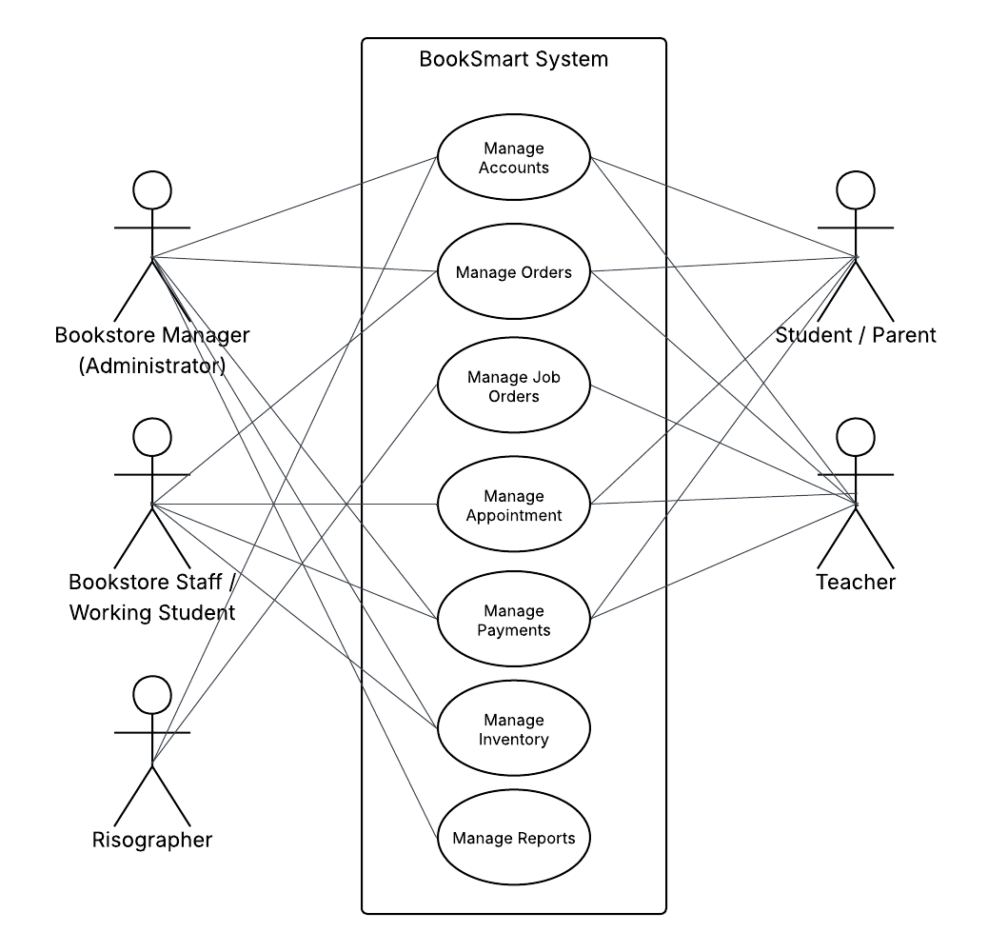

Use Case Diagram for BookSmart: A Web-Based Queuing, Tracking, and Pre-Ordering System for Bookstore of Holy Name University

3.1.2. Activity Diagram

3.1.2.1 Manage Account (Bookstore Manager, Bookstore Staff, Working Student, Risographer)
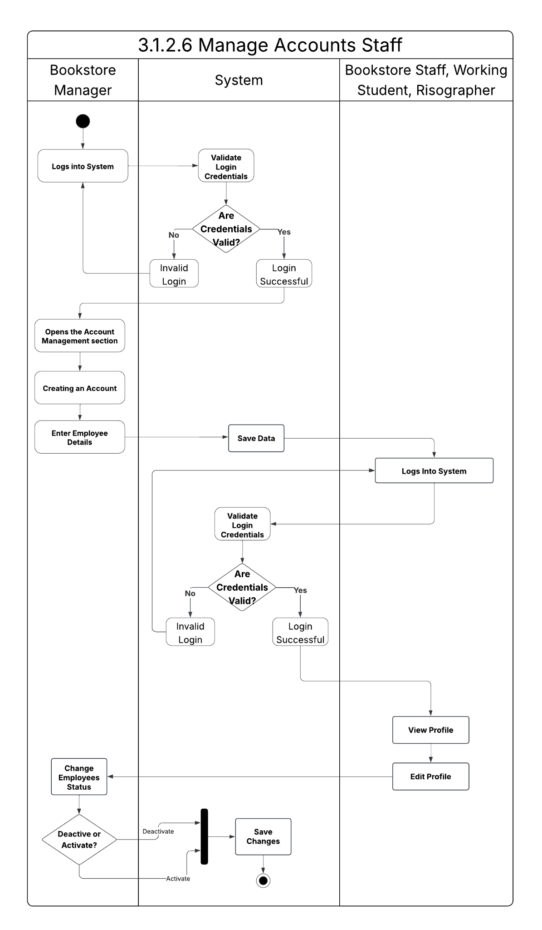
3.1.2.2 Manage Account (Student / Parent / Teacher)
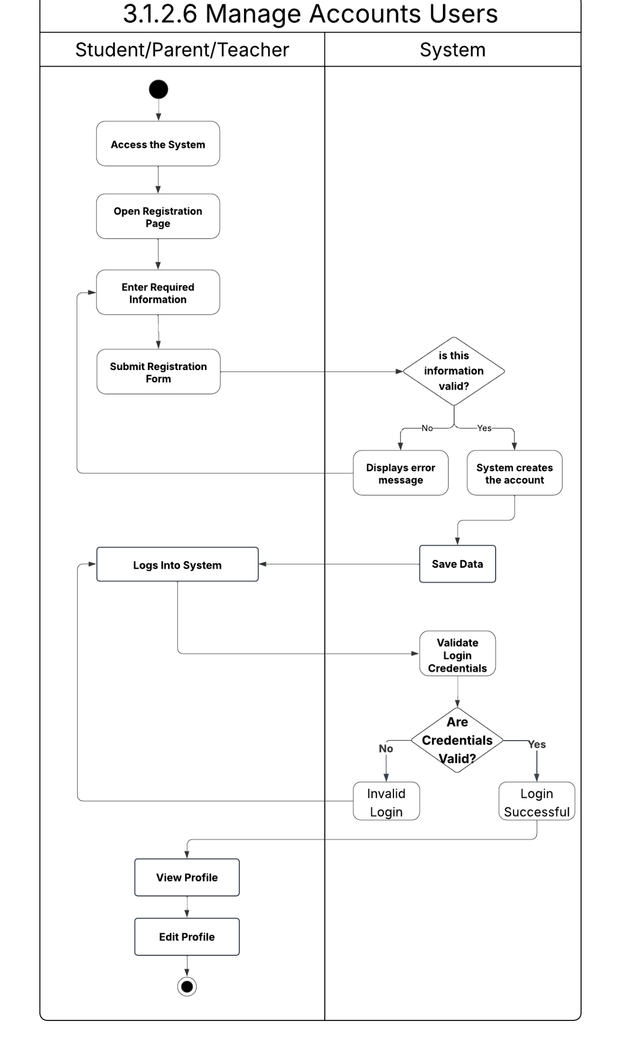
3.1.2.3 Manage Orders (Student, Parent, Teacher)
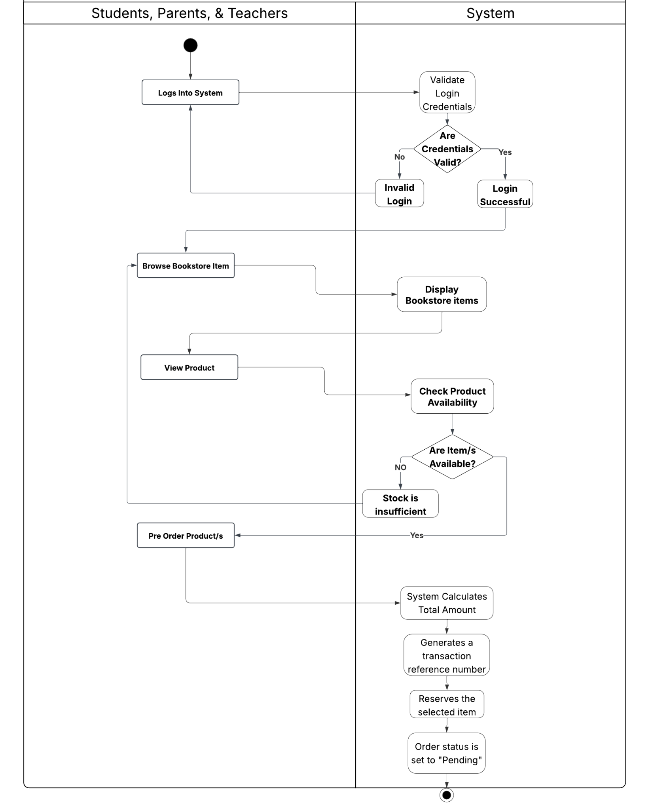

3.1.2.4 Manage Orders (Bookstore Manager / Bookstore Staff)
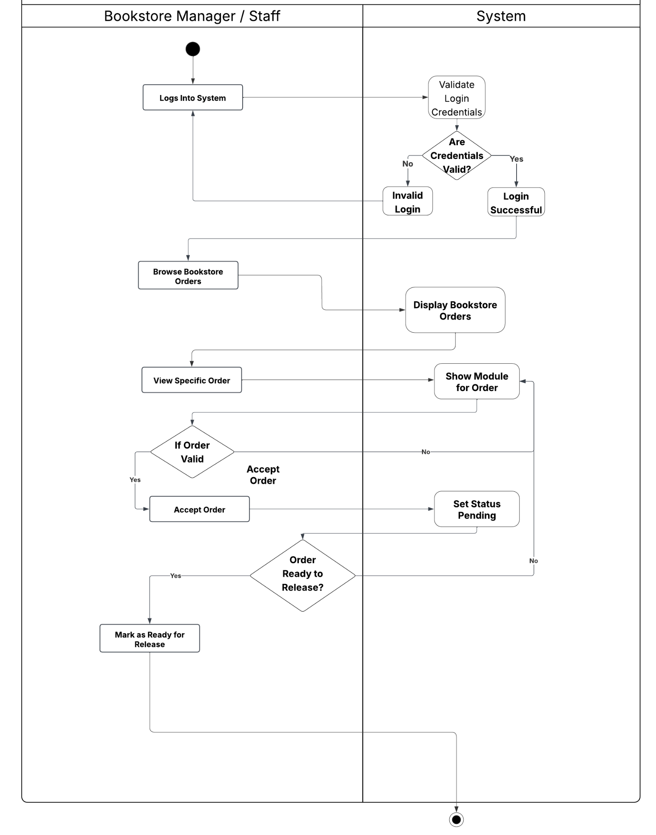

3.1.2.5 Manage Job Orders (Risographer, Teacher)
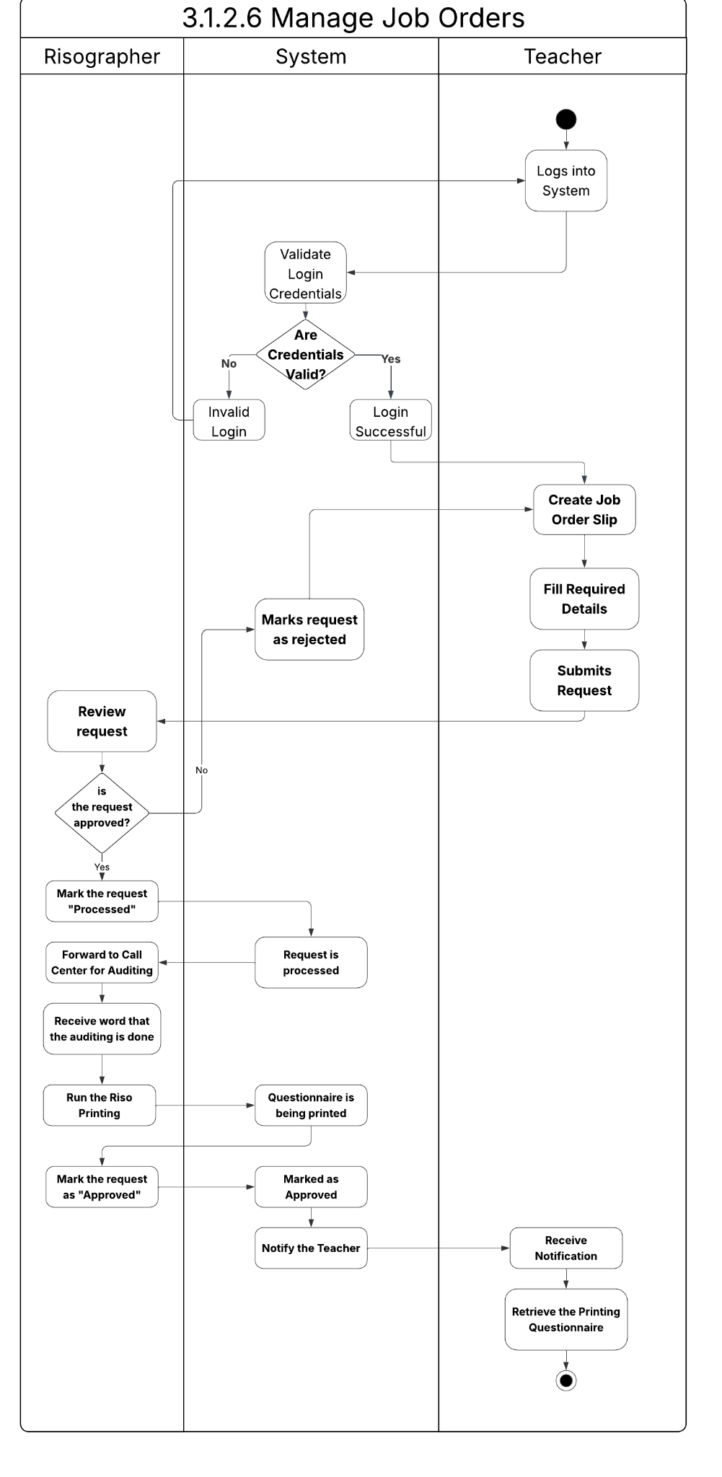
3.1.2.6 Manage Appointment (Student/Parent/Teacher, Bookstore Staff / Working Student)
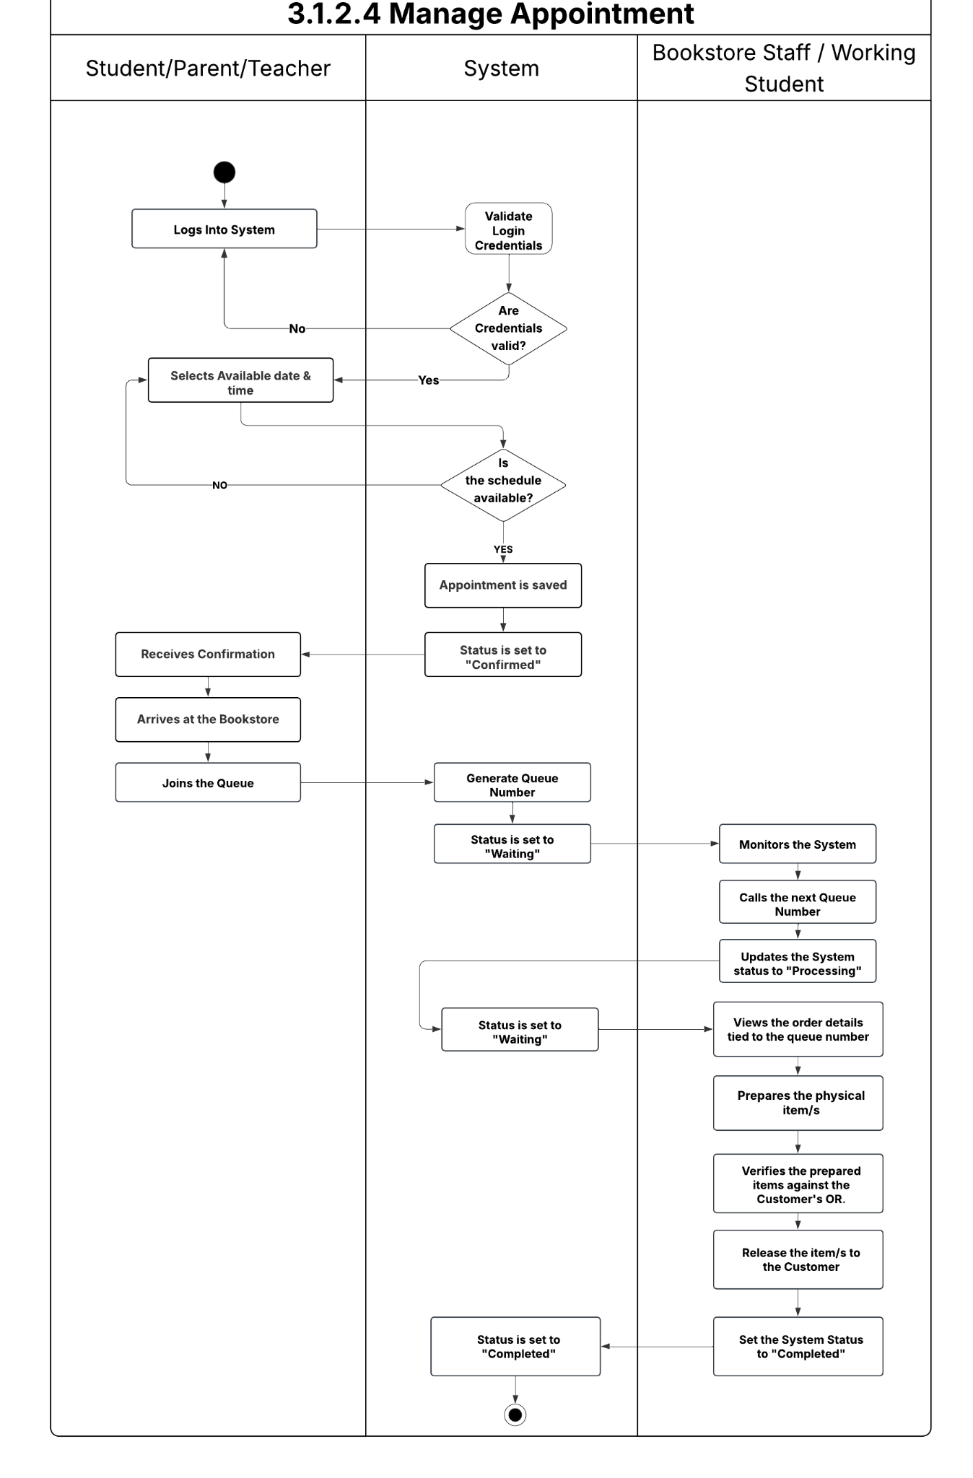
3.1.2.7 Manage Payments (Student, Teacher, and Parent, Bookstore Staff / Working Student, Bookstore Manager)
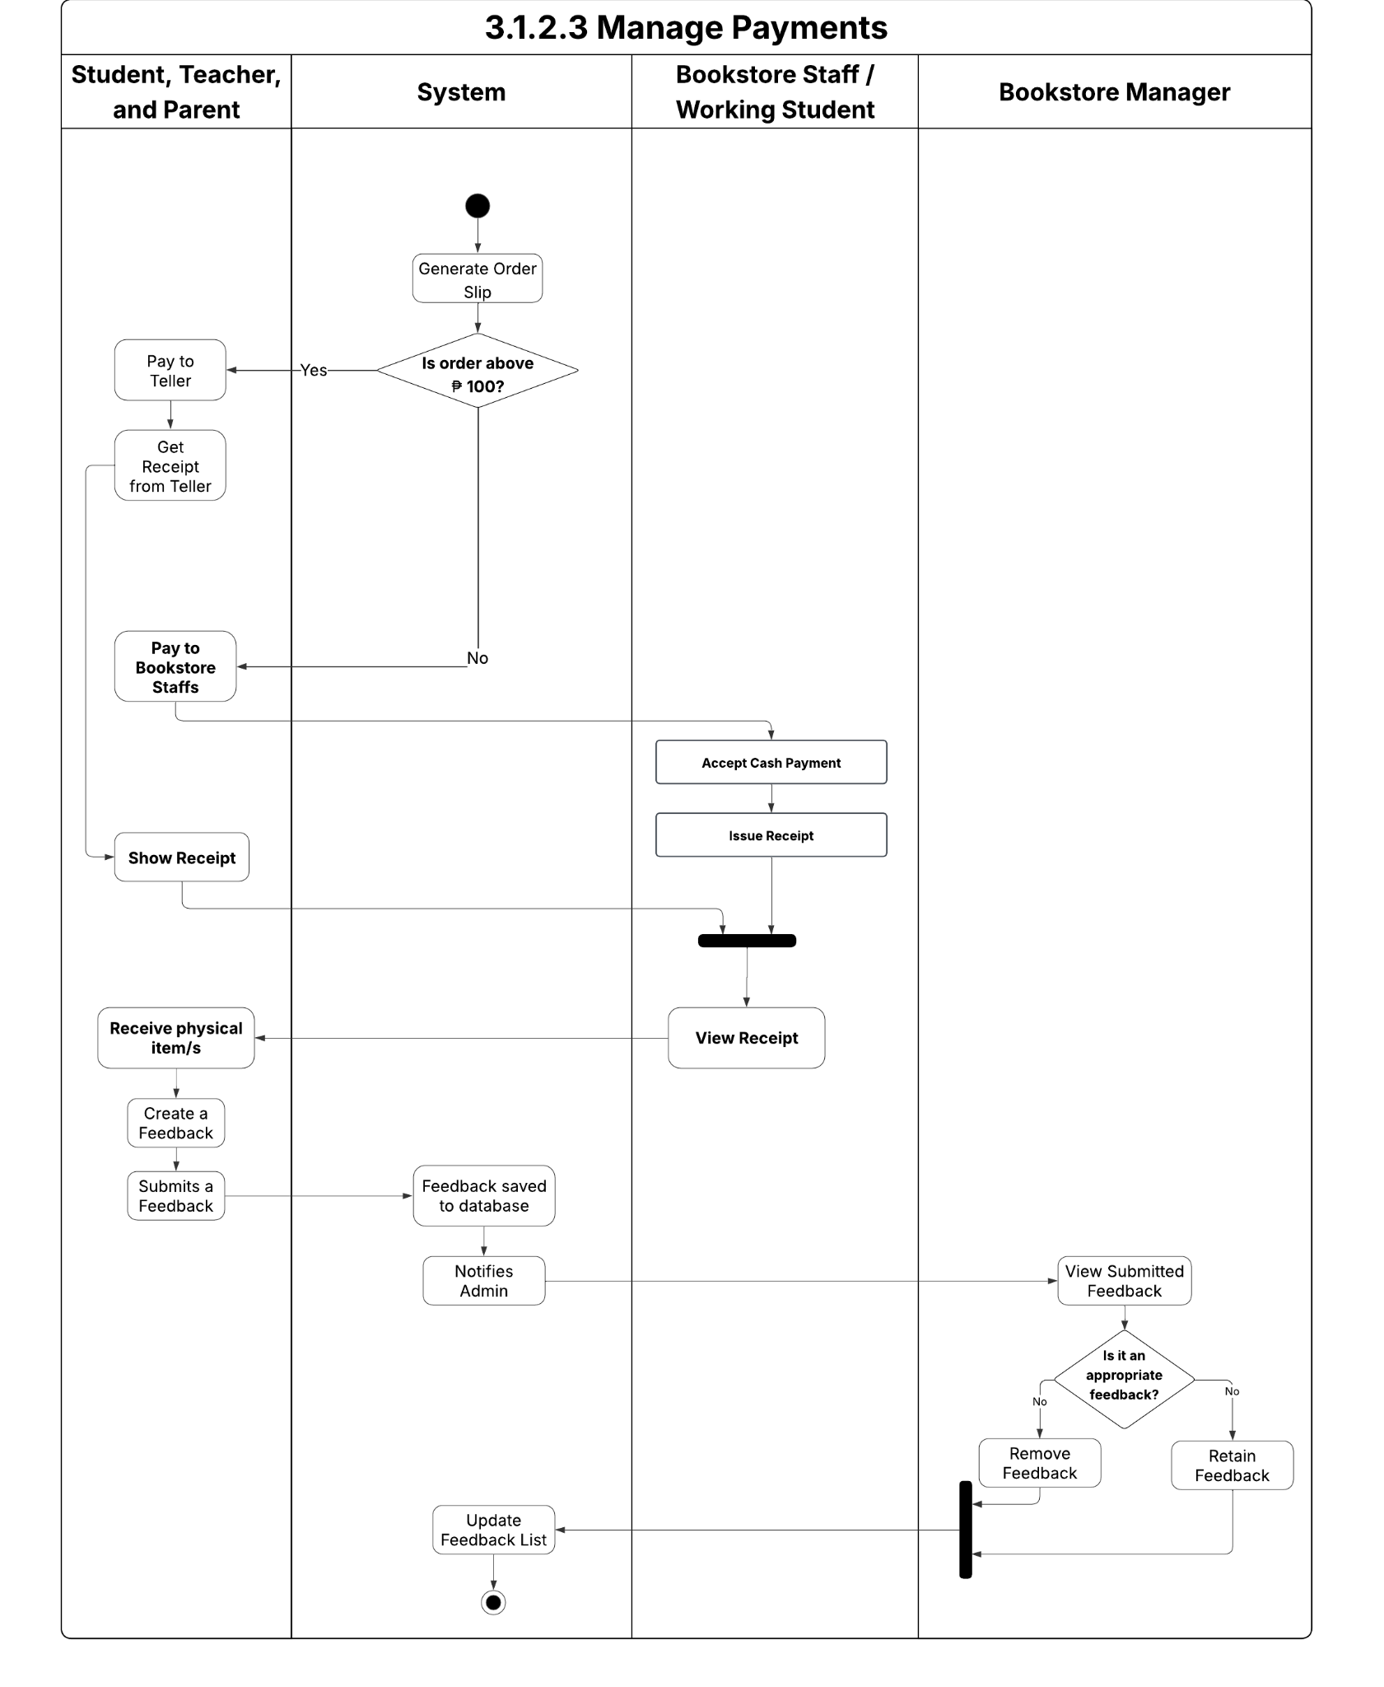

3.1.2.8 Manage Inventory (Bookstore Manager / Bookstore Staff)
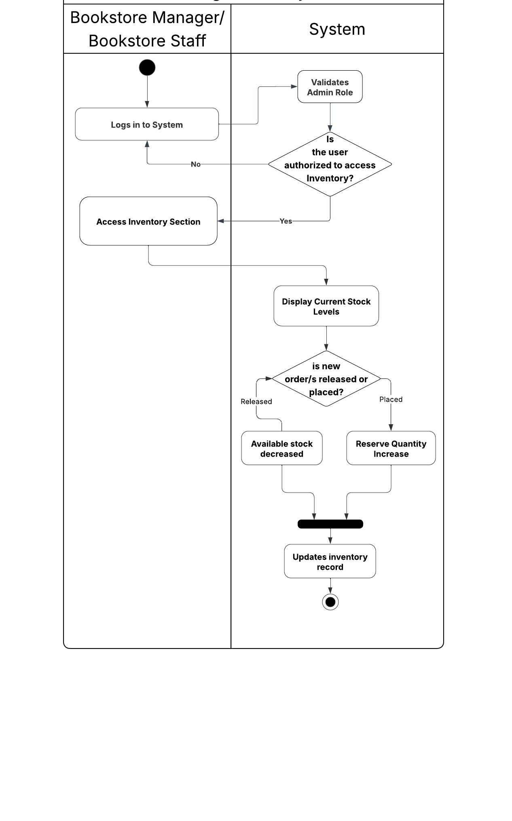

3.1.2.9 Manage Reports
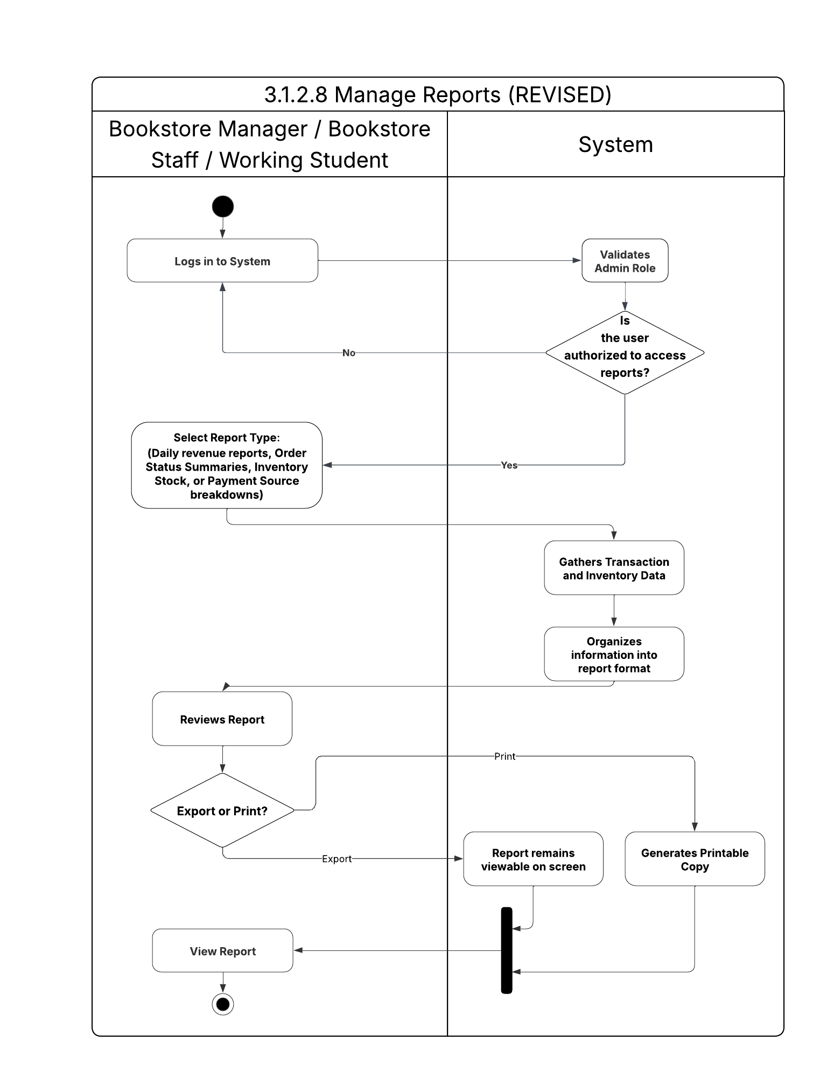

3.2 Design

3.2.1. Relational Database
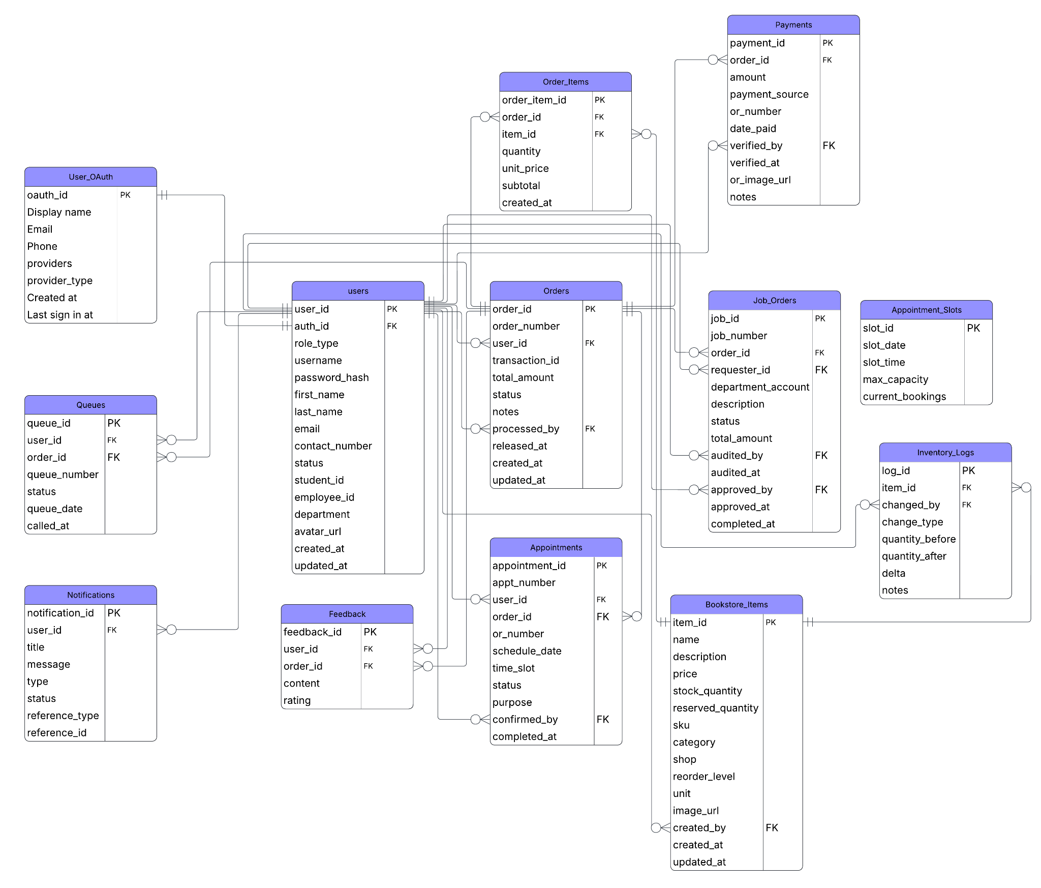
3.2.2. File Structure

Table 1. Users
This table stores the comprehensive profile information for every individual (students, staff, manager) within the system, including contact details, HNU identification, and account status.
Field Name | Data Type | Description
user_id (PK) | UUID | Unique internal identifier for the user profile.
auth_id (FK) | UUID | Reference to auth.users(id) in Supabase.
role_type | user_role (ENUM) | Access levels: manager, staff, working_students, teacher, students, parent.
username | VARCHAR(100) | Unique login name.
password_hash | VARCHAR(255) | Secure hash of user credentials. (handled by Supabase)
first_name | VARCHAR(100) | User’s given name.
last_name | VARCHAR(100) | User’s family name.
email | VARCHAR(255) | Unique university email address.
contact_number | VARCHAR(20) | Personal mobile or telephone number.
status | user_status (ENUM) | Account state: 'Active' or 'Inactive'.
students_id | VARCHAR(50) | Unique HNU Students ID.
employee_id | VARCHAR(50) | Unique HNU Employee ID.
department | VARCHAR(150) | Academic or administrative department.
avatar_url | TEXT | Link to the user's profile picture storage.
created_at | TIMESTAMPTZ | Automatic timestamp of record creation.
updated_at | TIMESTAMPTZ | Automatic timestamp of the most recent update.

Table 2. Bookstore_Items
This table functions as the master product catalog, tracking item specifications, pricing, current stock levels, and store location.
Field Name | Data Type | Description
item_id (PK) | UUID | Unique identifier for the inventory item.
name | VARCHAR(200) | Name of the book or item.
description | TEXT | Detailed information about the item (e.g., size, edition).
price | DECIMAL(10,2) | Current unit price of the item.
stock_quantity | INT(11) | Physical quantity currently available in the store.
reserved_quantity | INT(11) | Quantity currently held for pending digital orders.
sku | VARCHAR(100) | Unique Stock Keeping Unit for barcode tracking.
category | item_category (ENUM) | Grouping: Textbook, Uniform, Supply, Souvenir, Riso.
shop | item_shop (ENUM) | Physical Location: Bookstore, Souvenir Shop, or Riso.
reorder_level | INT(11) | Minimum stock threshold before triggering an alert.
unit | VARCHAR(20) | Measurement unit (e.g., pc, set, ream).
image_url | TEXT | Link to the product image.
is_active | BOOLEAN | Toggle for item visibility in the storefront.
created_by (FK) | UUID | References the staff user who added the item.
created_at | TIMESTAMPTZ | Audit: Date and time added to inventory.
updated_at | TIMESTAMPTZ | Audit: Date and time of last stock change.

Table 3. Orders
This table acts as the primary transaction header, managing the order lifecycle from creation to fulfillment and linking orders to specific user accounts.
Field Name | Data Type | Description
order_id (PK) | UUID | Unique identifier for the order.
order_number | VARCHAR(30) | Formatted ID: ORD-YYYY-00001.
user_id (FK) | UUID | Links the order to the user who placed it.
transaction_id | VARCHAR(100) | Unique tracking ID for physical verification.
total_amount | DECIMAL(10,2) | The total calculated cost of the order items.
status | order_status (ENUM) | Lifecycle: Pending, Ready, Released, Cancelled.
notes | TEXT | Special instructions for fulfillment.
processed_by (FK) | UUID | Staff user who prepared the order.
released_at | TIMESTAMPTZ | Precise time when items were claimed.
created_at | TIMESTAMPTZ | Audit: Timestamp of order placement.
updated_at | TIMESTAMPTZ | Audit: Timestamp of last status change.

Table 4. Order_Items
This table serves as a bridge between products and orders, detailing which specific items were purchased, the quantity, and the price at the time of the transaction.
Field Name | Data Type | Description
order_item_id (PK) | UUID | Unique identifier for the line item.
order_id (FK) | UUID | Parent order reference.
item_id (FK) | UUID | Specific inventory item reference.
quantity | INTEGER | Number of units ordered.
unit_price | DECIMAL(10,2) | Price of the item at the time of purchase.
subtotal | DECIMAL(10,2) | Computed: quantity * unit_price.
created_at | TIMESTAMPTZ | Timestamp of line item entry.

Table 5. Payments
This table records all financial data, including official receipt (OR) mapping and payment verification status, ensuring accurate fiscal reporting.
Field Name | Data Type | Description
payment_id (PK) | UUID | Unique identifier for the scheduled slot.
order_id(FK) | UUID | Associated order reference.
amount | DECIMAL(10,2) | Total amount verified as paid.
payment_source | payment_source (ENUM) | Origin: 'Bookstore' (<₱100) or 'Teller' (≥₱100).
or_number | VARCHAR(50) | Official Receipt number from the HNU Teller.
date_paid | TIMESTAMPTZ | Date the payment was officially rendered.
verified_by (FK) | UUID | Staff member who validated the payment.
verified_at | TIMESTAMPTZ | Timestamp of successful verification.
or_image_url | TEXT | Link to the photo of the Official Receipt.
notes | TEXT | Payment-related comments.

Table 6. Job_Orders
This table manages printing and special project requests originating from academic departments, including audit and approval workflows.
Field Name | Data Type | Description
job_id (PK) | UUID | Unique identifier for the job request.
job_number | VARCHAR(30) | Formatted ID: JO-YYYY-00001.
order_id (FK) | UUID | Links to an inventory record for itemized JOs.
requester_id (FK) | UUID | The teacher/staff member making the request.
department_account | VARCHAR(100) | The specific budget account to be billed.
description | TEXT | Specific details of the requested work.
status | jo_status (ENUM) | Workflow: Draft, Pending Audit, Approved, etc.
total_amount | DECIMAL(10,2) | Final cost of the job order.
audited_by (FK) | UUID | Finance/Audit staff who checked the request.
audited_at | TIMESTAMPTZ | Date/time of audit completion.
approved_by (FK) | UUID | Manager who authorized the job order.
approved_at | TIMESTAMPTZ | Date/time of final approval.
completed_at | TIMESTAMPTZ | Date/time of work completion.

Table 7. Appointment
This table tracks scheduled customer visits for order pickups or OR presentations, ensuring organized shop traffic.
Field Name | Data Type | Description
appointment_id(PK) | UUID | Unique identifier for the appointment.
appt_number | VARCHAR(30) | Formatted ID: APT-YYYYMMDD-0001.
user_id (FK) | UUID | User scheduled for the visit.
order_id (FK) | UUID | The specific order to be picked up.
or_number | VARCHAR(50) | Receipt number for physical verification.
schedule_date | DATE | Selected date for the appointment.
time_slot | TIME | Selected hour for the appointment.
status | appt_status (ENUM) | Confirmed, Completed, or Rescheduled.
purpose | TEXT | Reason for visit (Default: OR Presentation).
confirmed_by(FK) | UUID | Staff who validated the visitor's arrival.
completed_at | TIMESTAMPTZ | Date/time visit was finalized.

Table 8. Appointment_Slots
This table governs daily scheduling capacity, defining specific time slots and maximum booking limits for the bookstore staff.
Field Name | Data Type | Description
slot_id (PK) | UUID | Unique identifier for the availability slot.
slot_date | DATE | Specific day offered for booking.
slot_time | TIME | Specific hour offered for booking.
max_capacity | INTEGER | Max users allowed in this time frame (Default: 5).
current_bookings | INTEGER | Number of users already booked in this slot.

Table 9. Queues
This table organizes the real-time, on-site service flow, assigning daily sequential numbers to customers awaiting assistance.
Field Name | Data Type | Description
queue_id (PK) | UUID | Unique identifier for the queue entry.
user_id (FK) | UUID | User currently in the physical queue.
order_id (FK) | UUID | Order associated with the queue entry.
queue_number | INTEGER | Sequential number for the current day.
status | queue_status (ENUM) | Waiting, Processing, or Completed.
queue_date | DATE | Date the entry was issued.
called_at | TIMESTAMPTZ | Time the staff called the user to the counter.

Table 10. Notifications
This table stores automated system alerts directed at users, such as updates on order readiness or appointment confirmation status.
Field Name | Data Type | Description
notification_id(PK) | UUID | Unique identifier for the message.
user_id (FK) | UUID | Recipient of the alert.
title | VARCHAR(200) | Subject header of the alert.
message | TEXT | Content of the notification.
type | VARCHAR(30) | Category: info, success, warning, alert.
status | notif_status (ENUM) | Read or Unread.
reference_type | VARCHAR(30) | Source module (order, appt, queue, jo).
reference_id | UUID | PK of the related record for navigation.

Table 11. Feedback
This table captures qualitative user evaluations, storing ratings and comments used to measure service quality and identify areas for improvement.
Field Name | Data Type | Description
feedback_id (PK) | UUID | Unique identifier for the review.
user_id (FK) | UUID | Recipient of the alert.
order_id (FK) | UUID | Order associated with the feedback.
content | TEXT | Qualitative user comments.
rating | INTEGER | Quantitative score (1 to 5).

Table 12. Inventory_Logs
This table serves as a permanent audit trail, recording every change to stock levels, including restocks, releases, and reservations, to maintain accurate inventory history.
Field Name | Data Type | Description
log_id (PK) | UUID | Unique identifier for the audit entry.
item_id (FK) | UUID | Item being adjusted.
changed_by (FK) | UUID | Staff responsible for the adjustment.
change_type | log_change_type (ENUM) | Type: Restock, Release, Reservation, etc.
quantity_before | INTEGER | Stock count prior to the change.
quantity_after | INTEGER | Stock count after the change.
delta | INTEGER | The net difference (positive or negative).
notes | TEXT | Reasoning for manual adjustments.

Table 13. User_OAuth
This table manages third-party authentication identities, mapping external provider IDs (such as Google or Facebook) to internal user records for secure single-sign-on access.
Field Name | Data Type | Description
oauth_id (PK) | UUID | Unique identifier for the authentication record.
Display name | VARCHAR(50) | Links the identity back to the Users table.
Email | VARCHAR(50) | Email of the user.
Phone | INT(11) | Phone number of the user.
providers | VARCHAR(50) | The provider used (e.g., 'google', 'facebook').
provider_type | VARCHAR(255) | The unique type returned by the external provider.
Created at | DATE | Date of the account created at.
Last sign in at | TIMESTAMPTZ | Timestamp of the most recent successful login.

3.2.3. Program Hierarchy

3.2.3.1 Top Level
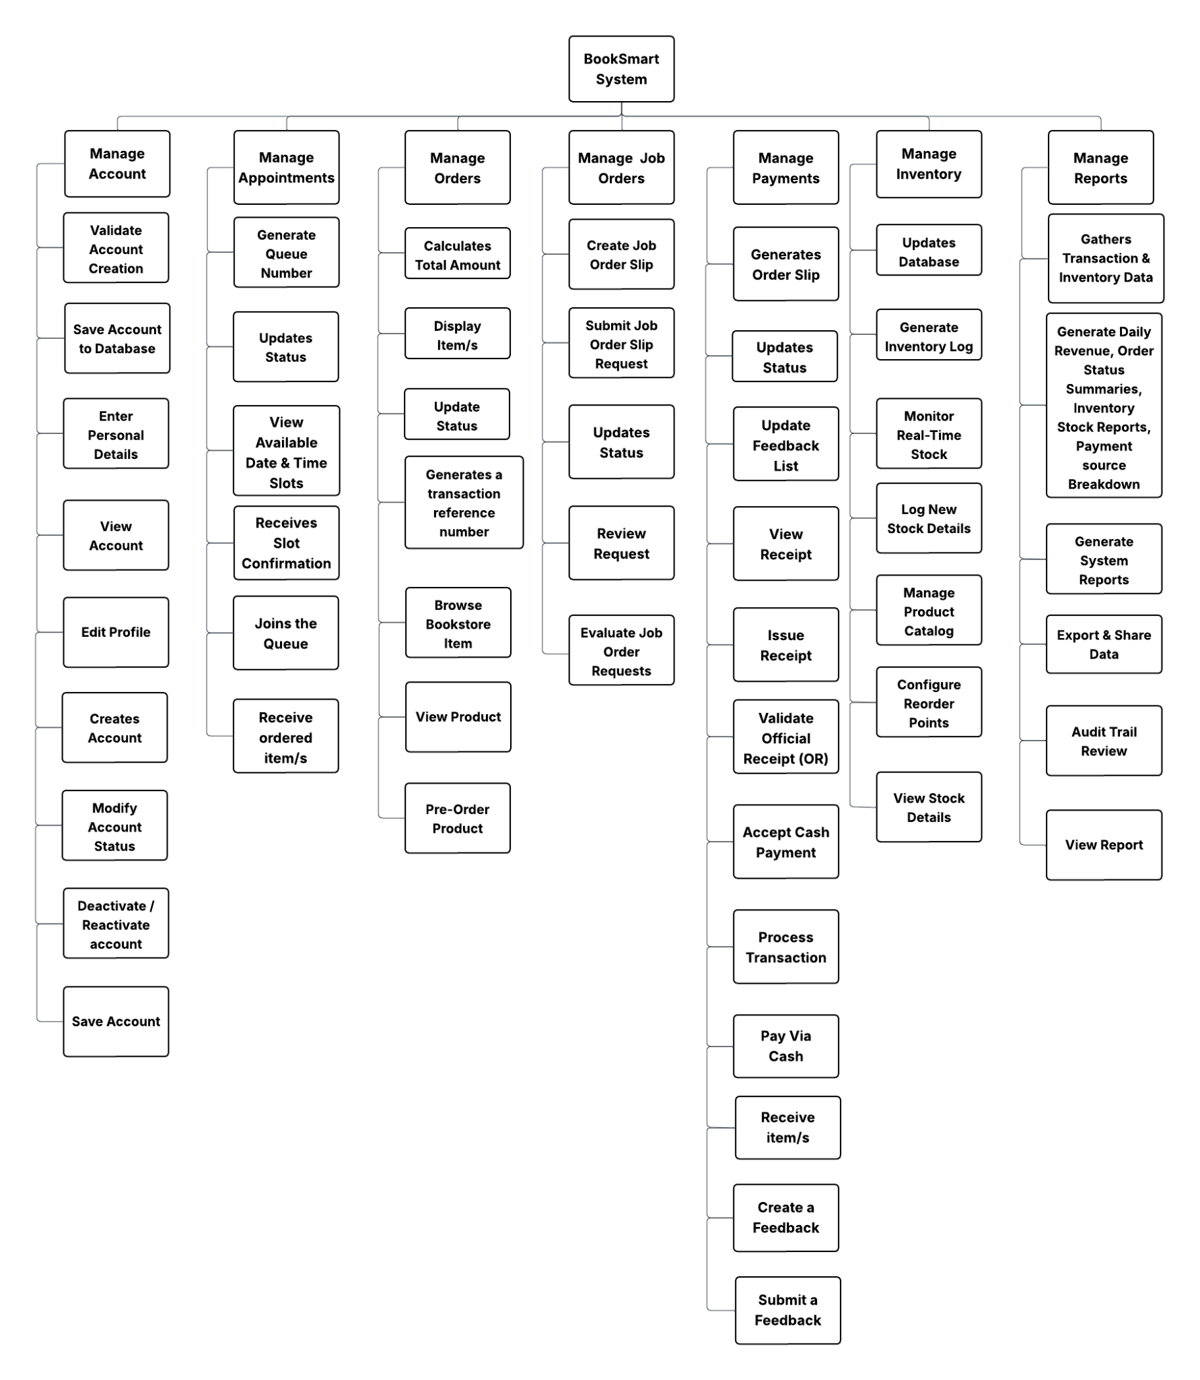

3.2.3.2 Administrator (Bookstore Manager)

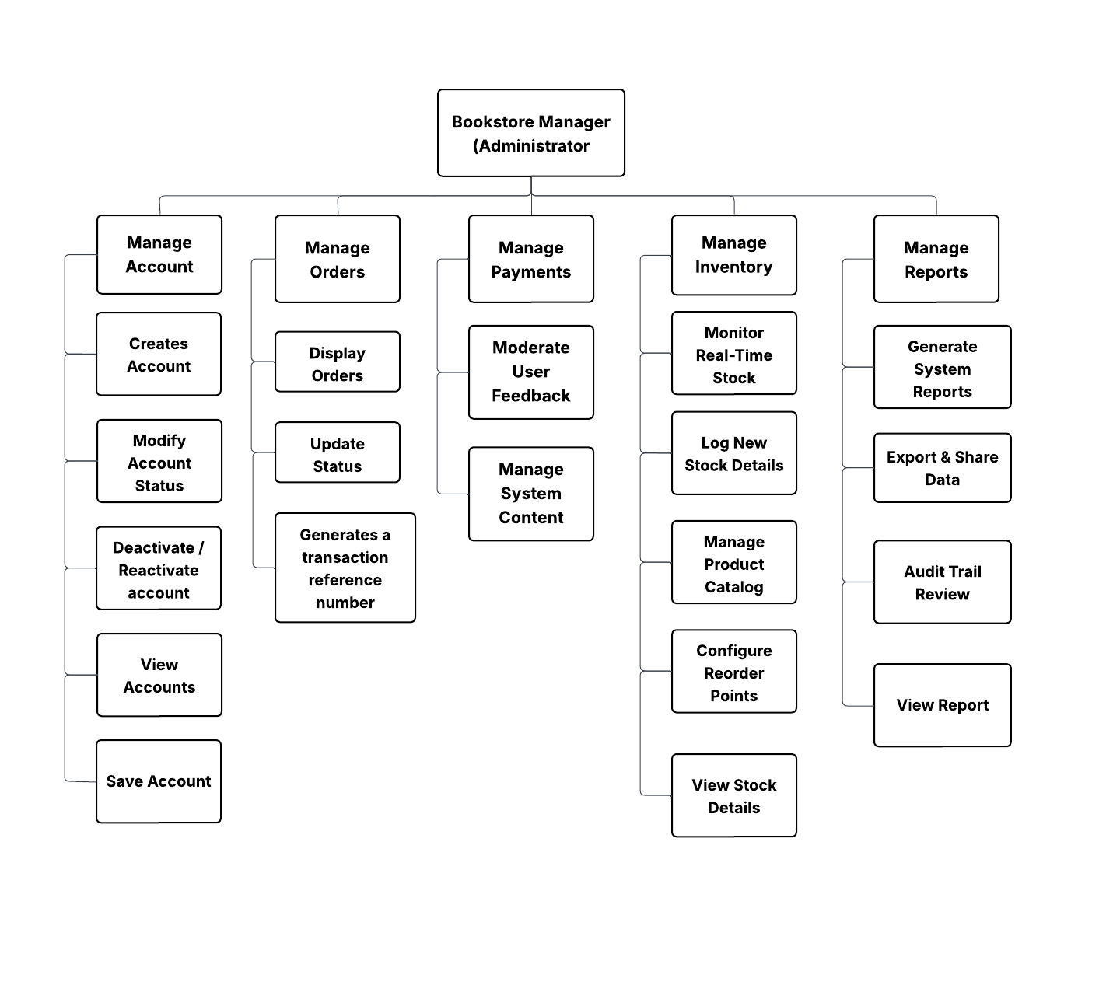

3.2.3.3 Bookstore Staff / Working Students
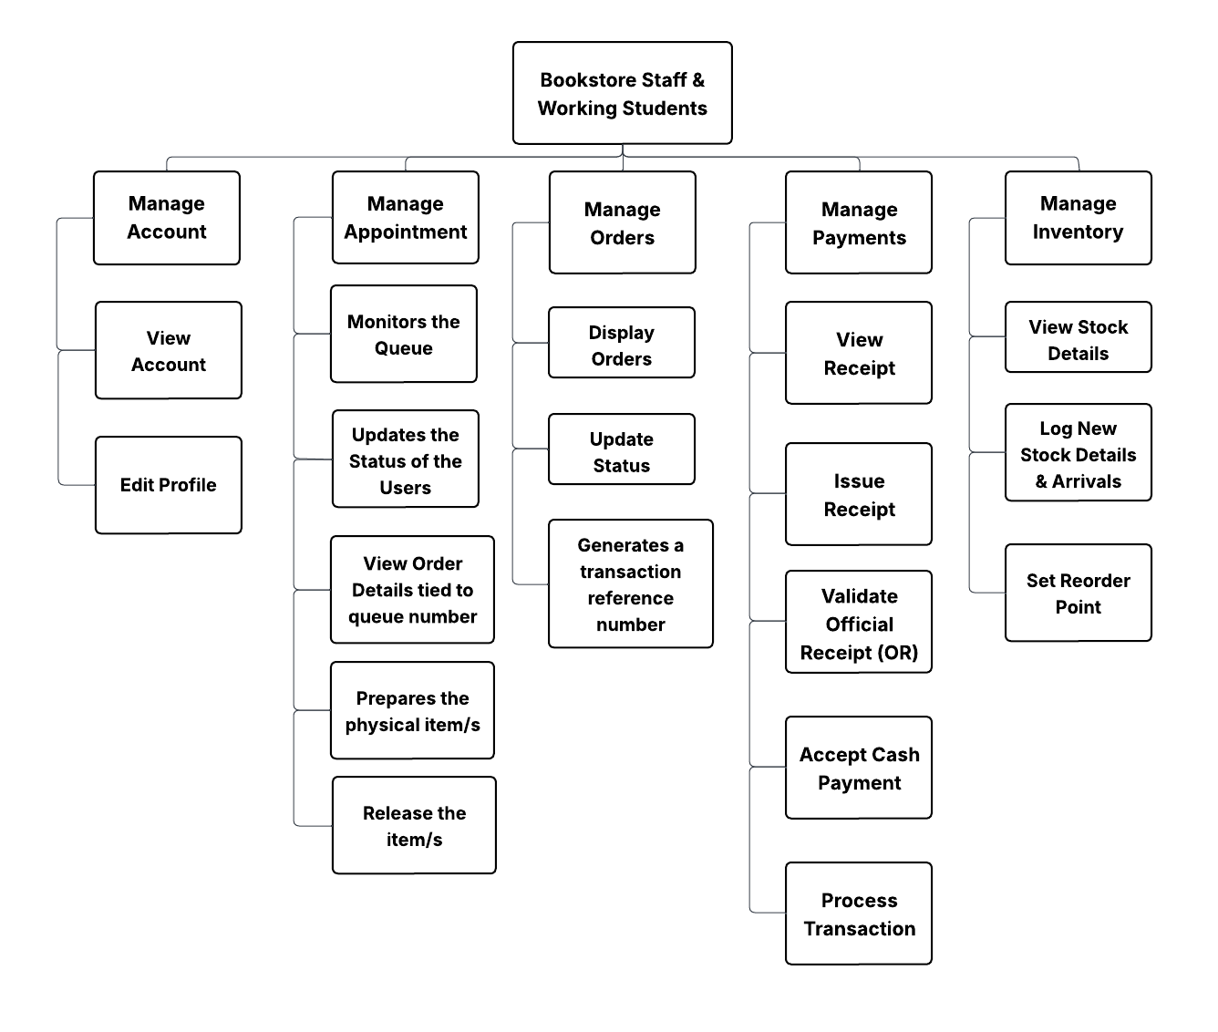

3.2.3.4 Teachers
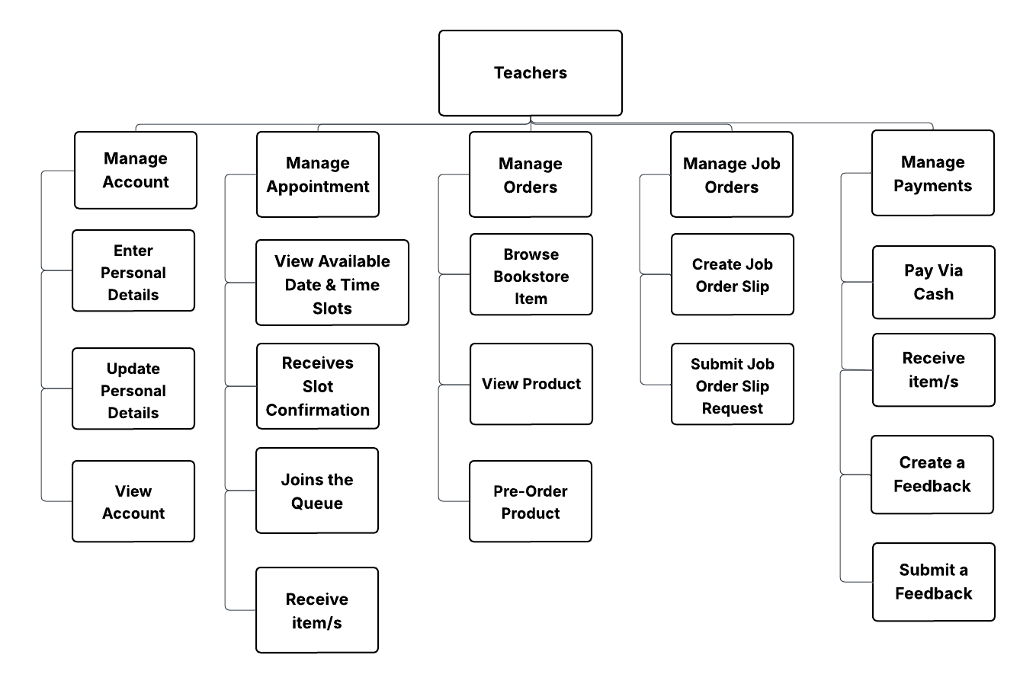

3.2.3.5 Students/Parents

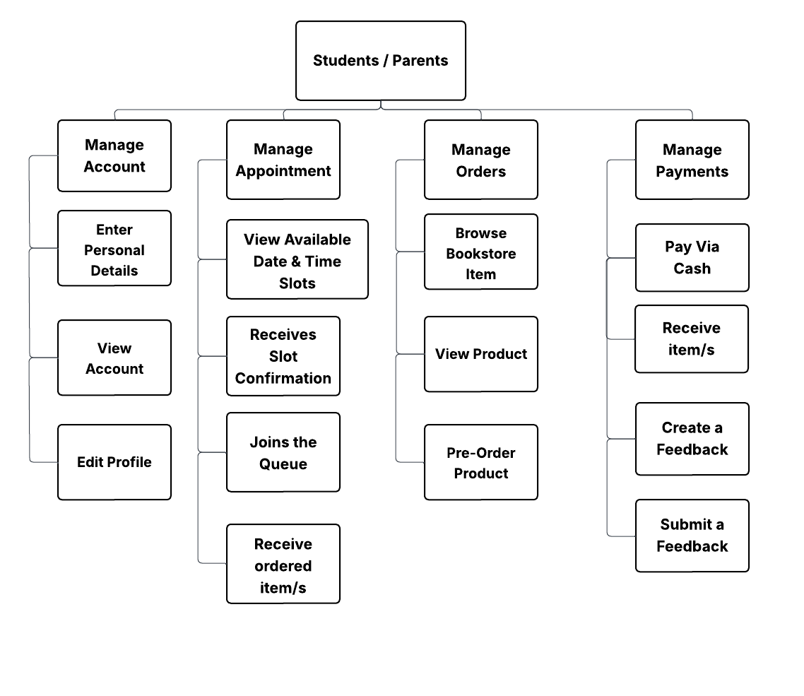

3.2.3.6 Risographer
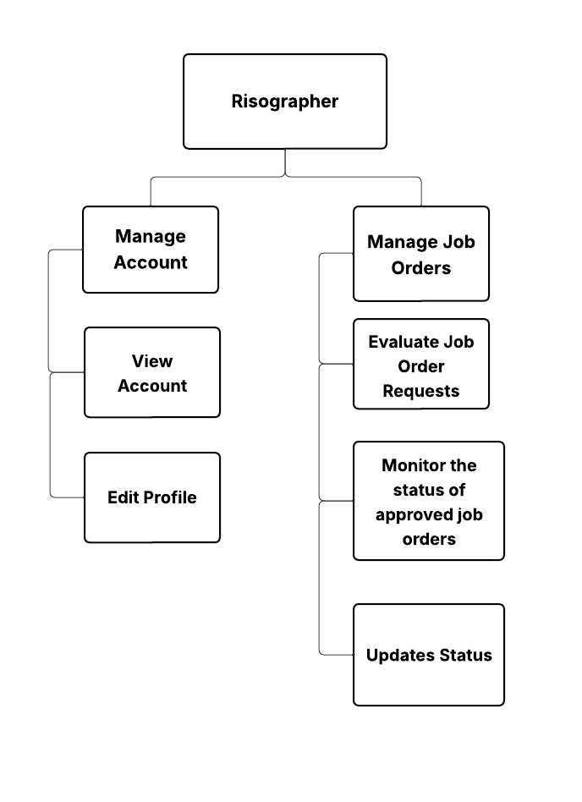



Prof. Jorenz P. Ranes
Technical Adviser

February 28, 2026
Date

