Document No: | [Subject] | Issue: | [Status] | Effective date: | [Publish Date]

Document Title:
[Title]
Summary / Scope:
Reason for Issue / Nature of Change:
Issue | Date | Details – reason for issue / nature of change
01
02
03

AUTHORISATION
 | Name: | Job title: |  | Signed:
Author: |  | Click to enter text
Reviewer: |  | Click to enter text
Approver / Owner: |  | Click to enter text
Authorisation details required irrespective of document approval process applied. |  |  |  | Electronic signatures required only where SharePoint approval workflows are not being used.

Copyright Statement
© 2026 Renishaw plc

This document is the property of Renishaw plc and the information contained herein is confidential. The contents of the document must not be reproduced or disclosed wholly or in part, or used for purposes other than that for which it has been supplied, without the prior written permission of Renishaw plc, or, if it has been furnished under a contract with another party, as expressly authorised under that contract.

Table of Contents
1 Introduction 3
2 Component Calculations 3
2.1 Triangle & PWM Wave Oscillator 3
2.2 Sin Wave Oscillator 5
2.3 Output Circuit 7

Introduction

Component Calculations

Triangle & PWM Wave Oscillator
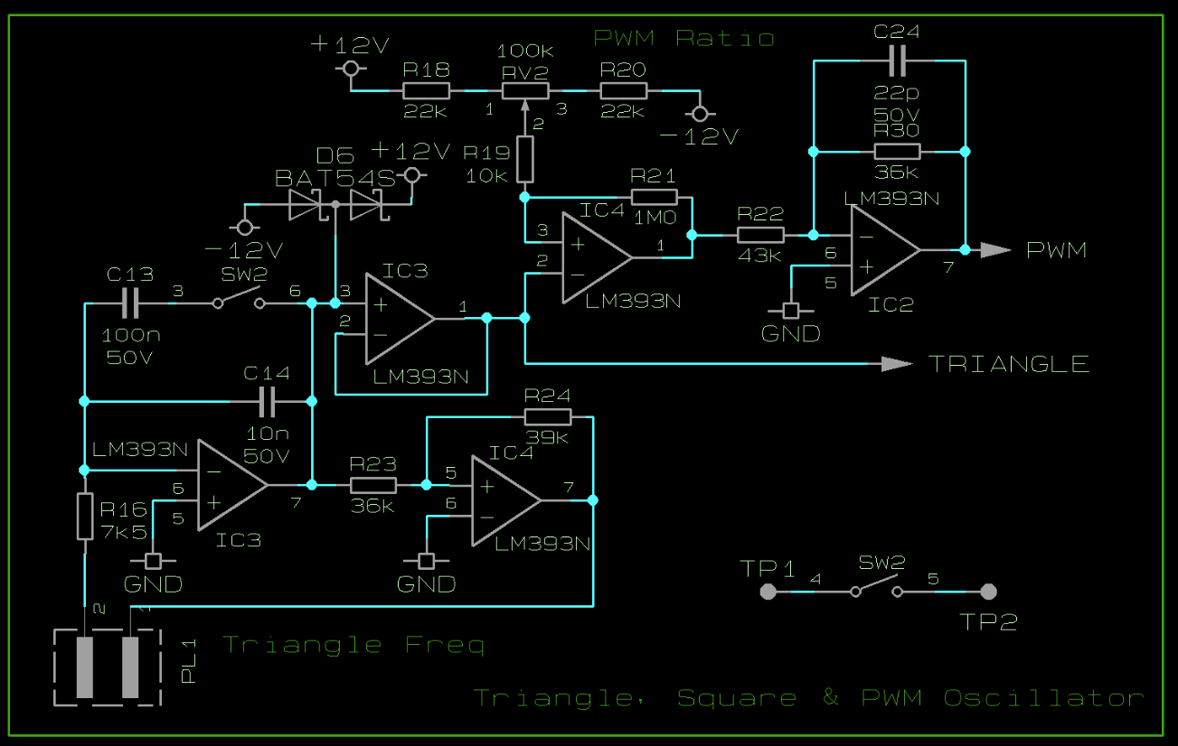

The frequency ($f$) of the triangle & PWM oscillator is found from the sum of charge and discharge times of a capacitance between upper and lower threshold voltages ($V_{U}$ and $V_{L}$) when a constant drive voltage ($V_{d}$) is applied. ${PL}_{1}$ is to be fitted with a 100kΩ variable resistance. The frequency is calculated by
$$f=\frac{V_{d}}{2R_{T}C_{T}V_{T}}$$
Where:
$$C_{T}=\left\{\begin{aligned}{SW}_{1}=0 \\ {SW}_{1}=1 \end{aligned}\right.{C_{14} \atop C_{14}+C_{13}}$$
$$R_{T}={PL}_{1}+R_{16}$$
$$V_{T}=2∙\frac{R_{23}}{R_{24}}V_{d}$$
$R_{23}$ and $R_{24}$ define the amplitude of the triangle and contribute to the frequency of the oscillator. The signal needs to be brought away from the rails to prevent distortion, however larger amplitudes allow lower frequencies – and so a target amplitude of 10V was defined. Values of 36kΩ and 39kΩ were chosen to achieve this value.
$$V=\frac{36}{39}∙11V≈10V$$
$C_{13}$ and $C_{14}$ were chosen to be a factor of 10 apart to allow the oscillator to reach a greater range of frequencies while still allowing some crossover to ensure it can cover the entire range. When using a 100k variable resistor, values of 10nF and 100nF are needed to place the available frequency range correctly as well as a series resistance ($R_{16}$) of 7.5kΩ for an offset shift.

To create the PWM signal, a reference voltage is needed within the bounds of the triangle signal. $R_{18}$ and $R_{20}$ were set at 22kΩ combined with ${RV}_{2}$ of 100kΩ, to limit the voltage threshold range down to a useful level.
$$V_{L}=IR_{L}=\frac{12-(-12)}{10000+2∙2200}∙2200=3.67$$
$$12V-3.67V=8.33V$$
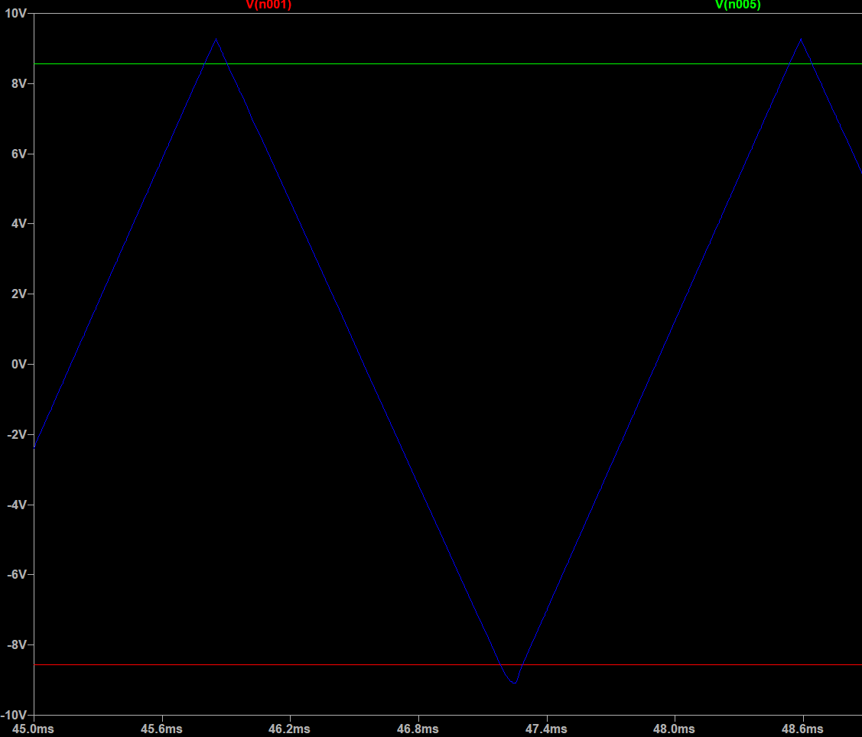
$R_{19}$ was added as a 10kΩ resistance to protect the op amp ${IC}_{4}$ from ESD from the potentiometer. Similarly, $D_{6}$ is in place to protect the inputs of ${IC}_{3}$. A 1MΩ resistance ($R_{21}$) was added across ${IC}_{4}$ to add hysteresis in case the potentiometer is noisy. $R_{22}$ and $R_{30}$ were selected to reduce the output level of the comparator from the rails to the target amplitude. $C_{24}$ was put in place as a small capacitance (22pF) to remove the harsh transient spikes that arose from the PWM gain.
$$V=\frac{36}{43}∙12V≈10V$$

Sin Wave Oscillator
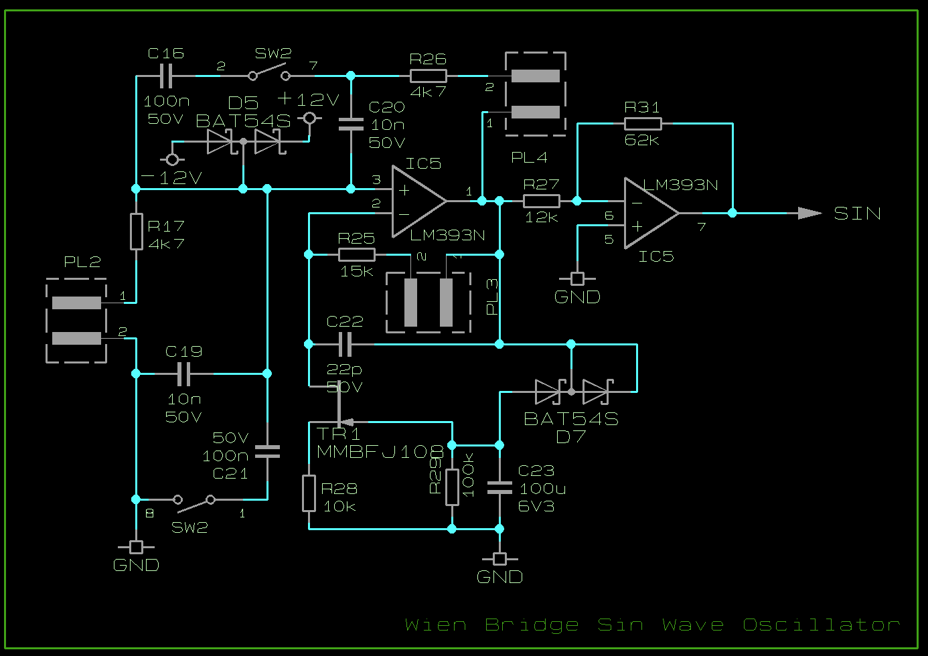
The frequency ($f$) of the sin wave oscillator is determined by the RC network between the output and non-inverting input of the centre op amp (${IC}_{5}$). The series and parallel networks must remain symmetric to amplify a specific frequency at a time.
$$f=\frac{1}{2π∙R_{T}C_{T}}$$
Where:
$$C_{T}=\left\{\begin{aligned}{SW}_{1}=0 \\ {SW}_{1}=1 \end{aligned}\right.{C_{19}== C_{20} \atop {(C}_{19}+C_{21})==(C_{20}+C_{16})}$$
$$R_{T}={PL}_{2}+R_{17}=={PL}_{4}+R_{26}$$
${PL}_{2}$ and ${PL}_{4}$ are to be connected to variable resistances of 100kΩ. $C_{19}$ and $C_{20}$ are 10nF and $C_{16}$ and $C_{21}$ are 100nF to match the triangle oscillator. $R_{17}$ and $R_{26}$ are chosen to be 4.7kΩ to most closely match the frequency curve of the other oscillator, allowing access to the desired range with sufficient crossover between capacitor settings.

The gain feedback control relies on JFET ${TR}_{1}$ and surrounding components to regulate the amplitude across frequencies. The JFET acts as a voltage-controlled resistor which sums with $R_{28}$ to make a gain compared to $R_{25}$ and ${PL}_{3}$. The ratio of (${RV}_{4}+R_{11}):({TR}_{1}+R_{8})$ needs to always be exactly (or just over) 2:1. If $R_{28}$ is set at 10kΩ then $R_{25}$ can be 15kΩ such that when combined with ${PL}_{3}$ ranging over 10kΩ, the total can range from 15k to 25k adjustable.
The time constant created by $R_{29}$ and $C_{23}$ should be at least 100x the period of the lowest frequency available.
$$R_{29}∙C_{23}≫\left(\frac{1}{20Hz}=0.05\right)$$
Choosing $R_{29}$ to be 100kΩ leaves $C_{23}$ needing to be greater than 50µF and so 100µF is chosen for safety. The small capacitor $C_{22}$ is there to filter out high frequency noise and was chosen as 22pF.

Output Circuit
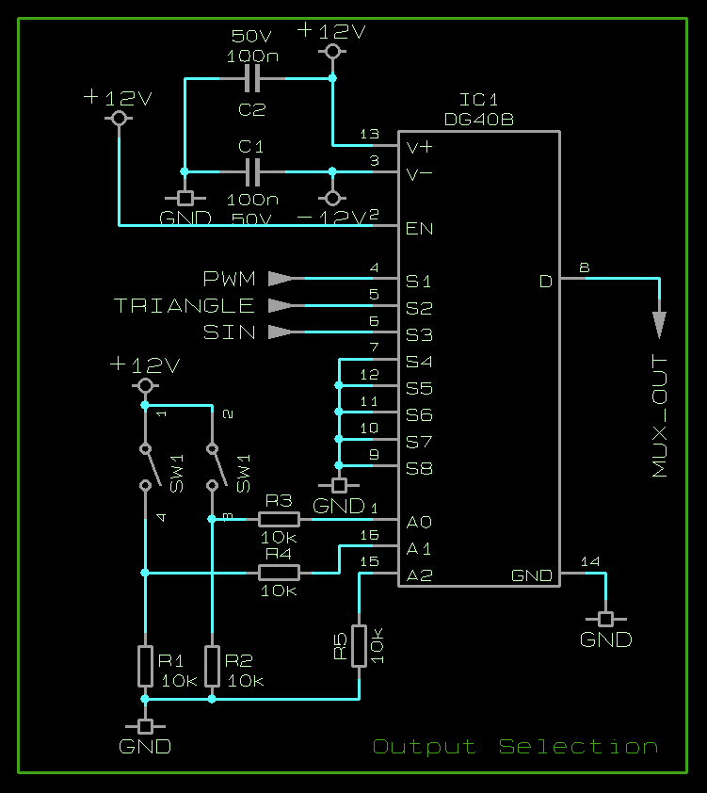
$R_{1}$, $R_{2}$ and $R_{5}$ are pulling the input pins of the mux to ground for a more stable logic input. 10k was selected for this purpose. $R_{3}$ and $R_{4}$ are put in place to protect the ${IC}_{1}$ inputs from ESD from ${SW}_{1}$.
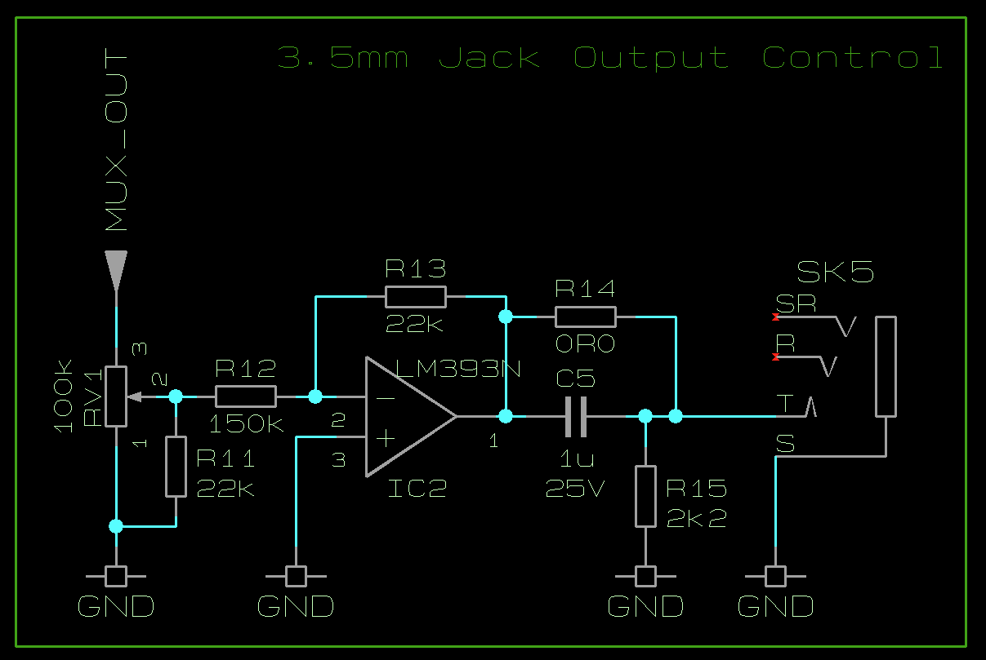

For volume control, the signal needs to be attenuated from +/-10V down to 1V rms. The combination of ${RV}_{1}$ and $R_{11}$ mimics logarithmic control to match the exponential human hearing while the op amp in ${IC}_{2}$ uses $R_{12}$ and $R_{13}$ to attenuate the resultant signal.
$$V=\frac{22}{150}∙10≈1.4V$$
$$V_{rms}=\frac{1.4V}{\sqrt{2}}=1V$$

There is a series capacitance at the output to remove any DC bias from the signal. This creates a filtering effect. Combined with the load of the output and $R_{15}$.

