# 11SDD Term 3 - Tile Based RPG Portfolio

## Defining the Problem

As FuseBlade is a game, the only real problem that this software solves is boredom, as is the case with most the games.

## Planning

### Combat System Flowchart

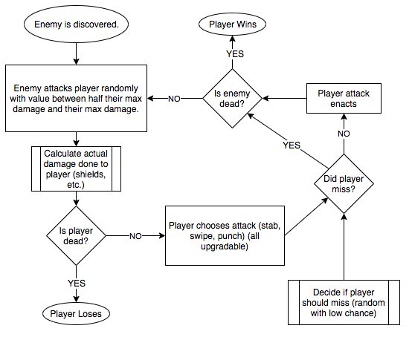

### Gantt Chart

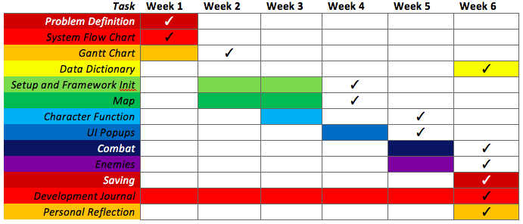

### Data Dictionary

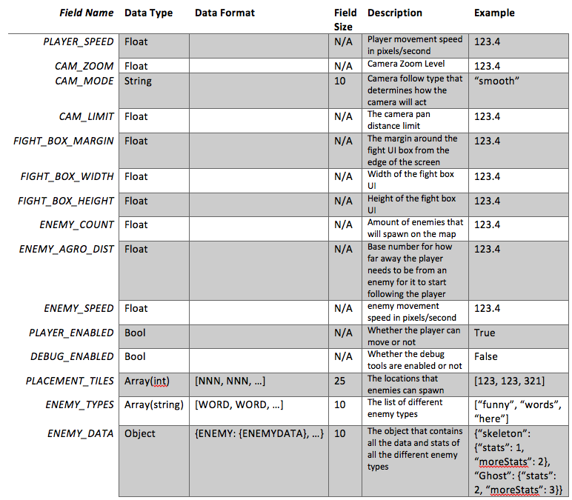

## Personal Reflection

### **Marcus Karozis**

Overall I thought the project went better then expected, we managed to make it look nice and something to be proud of, however we did have ambitious goals at the beginning that were not helped by a large portion of the time allocated to us working on the project was dedicated to trying to get the excalibur.js framework working, which in the end we ended up switching frameworks to phaser.js 3. Because of this setback, towards the end of the project we started to just build the project to the specifications instead of to our original plan. This focused our work efforts but because of the lack of features compared to what we had originally planned and that I have become quite fond of this project, I will most likely continue working on it after it is handed in as I would like to see it completed with the full list of features.

### **Ben Carroll**