28/1/17
IMPLEMENTATION OF GYM MANAGEMENT SYSTEM

1. LOGIN FORM:

PROGRAM:

Imports System.Data

Public Class LOGIN
Dim loginerror As String
Dim ab As Integer
Public Function logins()
Dim DBConn As New ADODB.Connection
Dim user As New ADODB.Recordset
Dim Usernam As String
Dim UserDB As String
Dim passDB As String
Dim typeDB As String
Dim userfound As Boolean
DBConn.Open("Provider = Microsoft.Jet.OLEDB.4.0;Data Source ='" & "C:\Documents and Settings\CSE\My Documents\Visual Studio 2010\Projects\Gym management\Gym management\login.mdb'")
'"C:\Users\Hi\Documents\Visual Studio 2010\Projects\Gym management\Gym management\login.mdb'")
user.Open("logintable", DBConn, ADODB.CursorTypeEnum.adOpenStatic, ADODB.LockTypeEnum.adLockOptimistic)
userfound = False
logins = False
Usernam = "Username ='" & usertxt.Text & "'"
Do
user.Find(Usernam)
If user.BOF = False And user.EOF = False Then
UserDB = user.Fields("Username").Value.ToString
passDB = user.Fields("Password").Value.ToString
typeDB = user.Fields("usertype").Value.ToString
If UserDB <> usertxt.Text Then
user.MoveNext()

Else
userfound = True
If passDB = passtxt.Text Then
If typeDB = typetxt.Text Then
If typeDB = "user" Then
ab = 1
End If
If typeDB = "coach" Then
ab = 0
End If
user.Close()
DBConn.Close()
Return True
Else
loginerror = "mismatch is usertype"
user.Close()
DBConn.Close()
Return False
End If
user.Close()
DBConn.Close()
Return True
Else
loginerror = "invalid password"
user.Close()
DBConn.Close()
Return False
End If
End If

Else
loginerror = "invalid username"
user.Close()
DBConn.Close()
Return False
End If
Loop Until userfound = True
user.Close()
DBConn.Close()
Return False
End Function

Private Sub Button1_Click(ByVal sender As System.Object, ByVal e As System.EventArgs) Handles Submit.Click
If logins() = True Then
MessageBox.Show("loggedin...successfully")
If (ab = 1) Then
Form3.Show()
Else
Form4.Show()
End If
Else
MessageBox.Show(loginerror, "login message")
End If

End Sub

Private Sub Label1_Click(ByVal sender As System.Object, ByVal e As System.EventArgs) Handles Label1.Click

End Sub
End Class

LOGIN FORM:

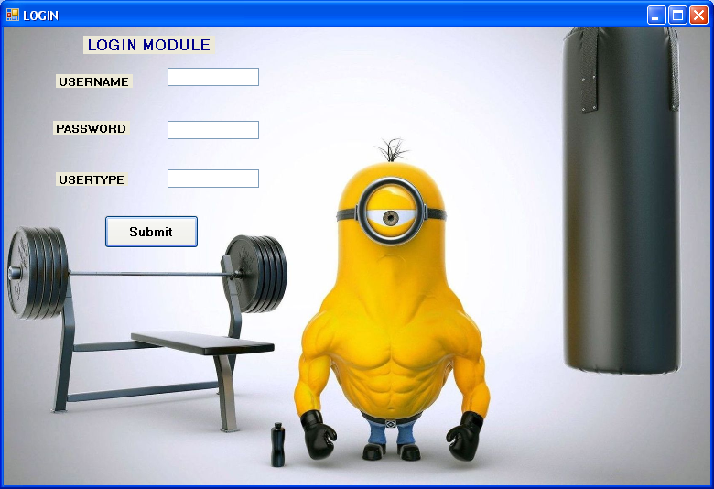

2.REGISTER

PROGRAM:
Imports System.Data

Public Class Form2
Private Property Sql As Object
Private Property Sql2 As Object

Private Sub Form2_Load(ByVal sender As System.Object, ByVal e As System.EventArgs) Handles MyBase.Load

End Sub

Private Sub Button1_Click(ByVal sender As System.Object, ByVal e As System.EventArgs) Handles Button1.Click
Dim con As New OleDb.OleDbConnection
Dim con2 As New OleDb.OleDbConnection

Dim cmd As New OleDb.OleDbCommand
Dim cmd2 As New OleDb.OleDbCommand

con.ConnectionString = "Provider = Microsoft.Jet.OLEDB.4.0;Data Source ='" & "C:\Documents and Settings\CSE\My Documents\Visual Studio 2010\Projects\Gym management\Gym management\register.mdb'"
con2.ConnectionString = "Provider = Microsoft.Jet.OLEDB.4.0;Data Source ='" & "C:\Documents and Settings\CSE\My Documents\Visual Studio 2010\Projects\Gym management\Gym management\login.mdb'"

'"PROVIDER = Microsoft.Jet.OLEDB.4.0; Data Source = .mdb"

con.Open()
con2.Open()

Sql = "INSERT INTO registration ([Name],Age,[Residential Address],[Mailing Address],[User type],[User Name],[Password],Cardno,phone) VALUES ('" & Me.TextBox2.Text & "','" & Me.TextBox3.Text & "','" & Me.TextBox4.Text & "','" & Me.TextBox5.Text & "','" & Me.TextBox6.Text & "','" & Me.TextBox7.Text & "','" & Me.TextBox8.Text & "','" & Me.TextBox9.Text & "','" & Me.TextBox10.Text & "')"

Sql2 = "INSERT INTO logintable([Username],[Password],[Usertype]) VALUES ('" & Me.TextBox7.Text & "','" & Me.TextBox8.Text & "','" & Me.TextBox6.Text & "')"
cmd = New OleDb.OleDbCommand(Sql, con)
cmd2 = New OleDb.OleDbCommand(Sql2, con2)

cmd.ExecuteNonQuery()
cmd2.ExecuteNonQuery()
MessageBox.Show("Inserted", "Sign Up Msg")

Me.TextBox2.Text = ""
Me.TextBox3.Text = ""
Me.TextBox4.Text = ""
Me.TextBox5.Text = ""
Me.TextBox6.Text = ""
Me.TextBox7.Text = ""
Me.TextBox8.Text = ""
Me.TextBox9.Text = ""
Me.TextBox10.Text = ""

con.Close()
con2.Close()
LOGIN.Show()
End Sub

Private Sub Button2_Click(ByVal sender As System.Object, ByVal e As System.EventArgs) Handles Button2.Click
LOGIN.Show()
End Sub

Private Sub Button3_Click(ByVal sender As System.Object, ByVal e As System.EventArgs) Handles Button3.Click
Me.Close()
End Sub
End Class

DESIGN:

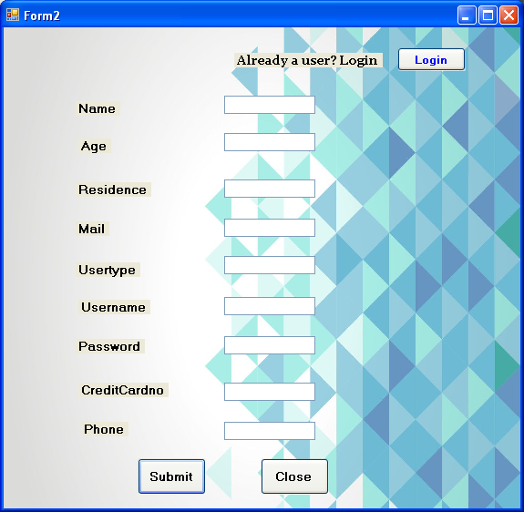

3.USER MODULE:

Public Class Form3

Private Sub Button3_Click(ByVal sender As System.Object, ByVal e As System.EventArgs) Handles Button3.Click
form16.show()
End Sub

Private Sub Button1_Click(ByVal sender As System.Object, ByVal e As System.EventArgs) Handles Button1.Click
Form5.Show()
End Sub

Private Sub Button2_Click(ByVal sender As System.Object, ByVal e As System.EventArgs) Handles Button2.Click
Form6.Show()
End Sub

Private Sub Button4_Click(ByVal sender As System.Object, ByVal e As System.EventArgs) Handles Button4.Click
Form7.Show()
End Sub

Private Sub Button5_Click(ByVal sender As System.Object, ByVal e As System.EventArgs) Handles Button5.Click
Form8.Show()
End Sub

Private Sub Button6_Click(ByVal sender As System.Object, ByVal e As System.EventArgs) Handles Button6.Click
Form10.Show()
End Sub

Private Sub Button7_Click(ByVal sender As System.Object, ByVal e As System.EventArgs) Handles Button7.Click
Form15.Show()
End Sub

Private Sub Button9_Click(ByVal sender As System.Object, ByVal e As System.EventArgs) Handles Button9.Click
Form9.Show()
End Sub

Private Sub Button10_Click(ByVal sender As System.Object, ByVal e As System.EventArgs) Handles Button10.Click
Form12.show()
End Sub

Private Sub Button11_Click(ByVal sender As System.Object, ByVal e As System.EventArgs) Handles Button11.Click
Me.Close()
Form2.Close()
Form10.Close()

End Sub

Private Sub Form3_Load(ByVal sender As System.Object, ByVal e As System.EventArgs) Handles MyBase.Load

End Sub
End Class

DESIGN:

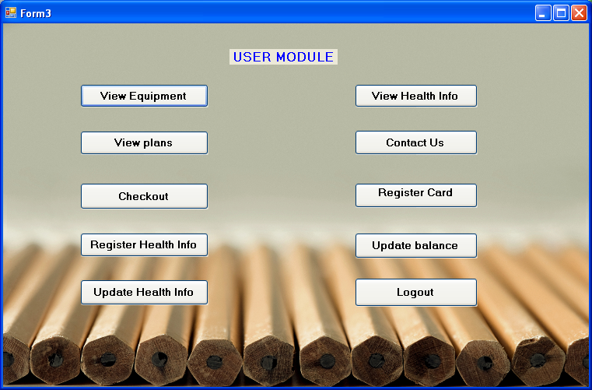

4.COACH MODULE:

PROGRAM:
Public Class Form4

Private Sub Label1_Click(ByVal sender As System.Object, ByVal e As System.EventArgs) Handles Label1.Click

End Sub

Private Sub Button1_Click(ByVal sender As System.Object, ByVal e As System.EventArgs) Handles Button1.Click
Form11.Show()
End Sub

Private Sub Button4_Click(ByVal sender As System.Object, ByVal e As System.EventArgs) Handles Button4.Click
Form9.Show()
End Sub

Private Sub Button2_Click(ByVal sender As System.Object, ByVal e As System.EventArgs) Handles Button2.Click
Form13.Show()
End Sub

Private Sub Button5_Click(ByVal sender As System.Object, ByVal e As System.EventArgs) Handles Button5.Click
Form12.Show()
End Sub

Private Sub Button3_Click(ByVal sender As System.Object, ByVal e As System.EventArgs) Handles Button3.Click
Form13.Show()
End Sub

Private Sub Button6_Click(ByVal sender As System.Object, ByVal e As System.EventArgs) Handles Button6.Click
Me.Close()
End Sub

Private Sub Form4_Load(ByVal sender As System.Object, ByVal e As System.EventArgs) Handles MyBase.Load
End Sub
End Class

DESIGN:

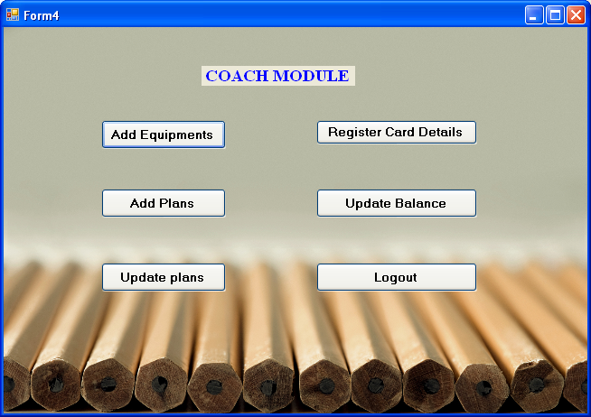

5.VIEW EQUIPMENT:

PROGRAM:
Imports System.Data
Imports System.Data.OleDb

Public Class Form5

Private Sub DataGridView1_CellContentClick(ByVal sender As System.Object, ByVal e As System.Windows.Forms.DataGridViewCellEventArgs) Handles DataGridView1.CellContentClick

End Sub

Private Sub Button1_Click(ByVal sender As System.Object, ByVal e As System.EventArgs) Handles Button1.Click
Dim MyConn As New OleDb.OleDbConnection
MyConn.ConnectionString = "Provider = Microsoft.Jet.OLEDB.4.0;Data Source ='" & "C:\Documents and Settings\CSE\My Documents\Visual Studio 2010\Projects\Gym management\Gym management\equipment.mdb'"
MyConn.Open()

Dim ds As New DataSet
Dim dt As New DataTable
ds.Tables.Add(dt)
Dim da As OleDbDataAdapter
Dim source1 As New BindingSource

da = New OleDbDataAdapter("Select * from equipments", MyConn)
da.Fill(dt)
DataGridView1.DataSource = dt.DefaultView
MyConn.Close()

End Sub

Private Sub Button2_Click(ByVal sender As System.Object, ByVal e As System.EventArgs) Handles Button2.Click
Me.Close()
End Sub
End Class

DESIGN:

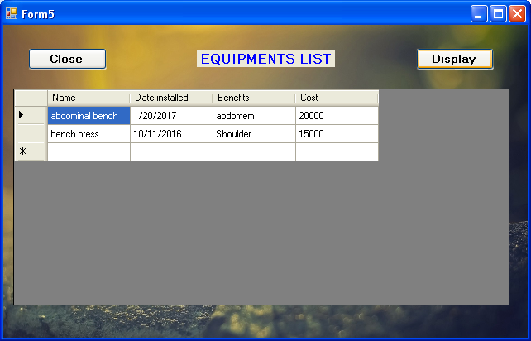

6.VIEW PLANS:

PROGRAM:
Imports System.Data
Imports System.Data.OleDb

Public Class Form6

Private Sub Button1_Click(ByVal sender As System.Object, ByVal e As System.EventArgs) Handles Button1.Click
Dim MyConn As New OleDb.OleDbConnection
MyConn.ConnectionString = "Provider = Microsoft.Jet.OLEDB.4.0;Data Source ='" & "C:\Documents and Settings\CSE\My Documents\Visual Studio 2010\Projects\Gym management\Gym management\plan.mdb'"
MyConn.Open()

Dim ds As New DataSet
Dim dt As New DataTable
ds.Tables.Add(dt)
Dim da As OleDbDataAdapter
Dim source1 As New BindingSource

da = New OleDbDataAdapter("Select * from plans", MyConn)
da.Fill(dt)
DataGridView1.DataSource = dt.DefaultView
MyConn.Close()
End Sub

Private Sub DataGridView1_CellContentClick(ByVal sender As System.Object, ByVal e As System.Windows.Forms.DataGridViewCellEventArgs) Handles DataGridView1.CellContentClick

End Sub

Private Sub Button2_Click(ByVal sender As System.Object, ByVal e As System.EventArgs) Handles Button2.Click
Me.Close()
End Sub
End Class

DESIGN:

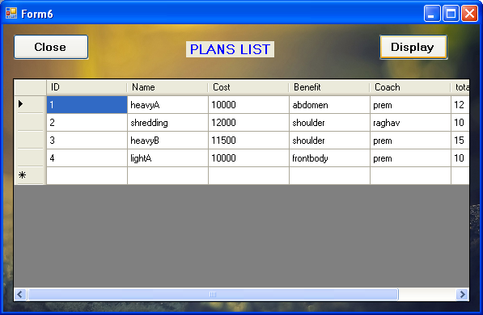

7.REGISTER HEALTH INFO:

PROGRAM:

Imports System.Data.OleDb
Public Class Form7
Private Property Sql As Object
Public myconnection As OleDbConnection = New OleDbConnection

Private Sub Button1_Click(ByVal sender As System.Object, ByVal e As System.EventArgs) Handles Button1.Click
Dim con As New OleDb.OleDbConnection
Dim cmd As New OleDb.OleDbCommand
Dim i, n, m As Single
Dim str1 As String
Dim provider As String
Dim datafile As String
Dim connstring As String

'Dim s1, s2,s3,s4 As String
's1 = Me.TextBox1.Text
's2 = Me.TextBox2.Text
's3 = Me.TextBox3.Text
's4 = Me.TextBox4.Text
provider = "Provider=Microsoft.Jet.OLEDB.4.0;Data Source="
datafile = "C:\Documents and Settings\CSE\My Documents\Visual Studio 2010\Projects\Gym management\Gym management\healthinfo.mdb"
connstring = provider & datafile
myconnection.ConnectionString = connstring
'"PROVIDER = Microsoft.Jet.OLEDB.4.0; Data Source = .mdb"
myconnection.Open()
Try

n = Single.Parse(TextBox3.Text)
m = Single.Parse(TextBox4.Text)
i = m / (n * n)
If i >= 19 And i <= 26 Then
str1 = "fit"
Else
str1 = "unfit"
End If

Sql = "INSERT INTO healthinfos ([username],age,height,weight,BMI,Fitness) VALUES ('" & Me.TextBox1.Text & "','" & Me.TextBox2.Text & "','" & n & "','" & m & "','" & i & "','" & str1 & "')"
cmd = New OleDb.OleDbCommand(Sql, myconnection)
cmd.ExecuteNonQuery()
MessageBox.Show("Inserted", "Sign Up Msg")

Me.TextBox2.Text = ""
Me.TextBox3.Text = ""
Me.TextBox4.Text = ""
Catch ex As Exception
MsgBox(ex.Message)
End Try
myconnection.Close()
End Sub

Private Sub Button2_Click(ByVal sender As System.Object, ByVal e As System.EventArgs) Handles Button2.Click
Me.Close()
End Sub
End Class

DESIGN:

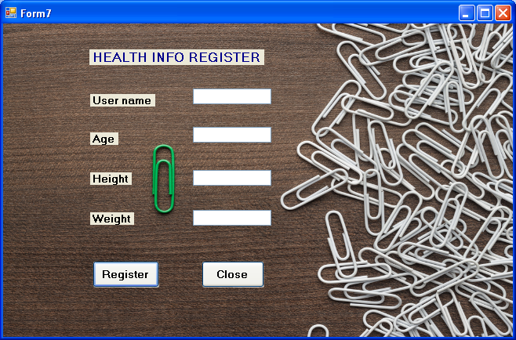

8.UPDATE HEALTH INFO:

PROGRAM:

Imports System.Data.OleDb

Public Class Form8
Dim provider As String
Dim dataFile As String
Dim connString As String
Dim myConnection As OleDbConnection = New OleDbConnection

Private Sub Form1_Load(ByVal sender As System.Object, ByVal e As System.EventArgs) Handles MyBase.Load

'provider = "Provider=Microsoft.ACE.OLEDB.12.0;Data Source="
'dataFile = "C:\Users\Admin\Documents\Visual Studio 2012\Projects\JK\JK\bin\Debug\JK.mdb"
'connString = provider & dataFile
'myConnection.ConnectionString = connString
myConnection.ConnectionString = "Provider = Microsoft.Jet.OLEDB.4.0;Data Source ='" & "C:\Documents and Settings\CSE\My Documents\Visual Studio 2010\Projects\Gym management\Gym management\healthinfo.mdb'"

End Sub

Private Sub Button1_Click(ByVal sender As System.Object, ByVal e As System.EventArgs) Handles Button2.Click
myConnection.Open()
Dim str As String
str = "Update healthinfos Set [username]='" & TextBox1.Text & "',age= '" & TextBox2.Text & "',height='" & TextBox4.Text & "',weight='" & TextBox4.Text & "' where username= '" & TextBox1.Text & "' "
Dim cmd As OleDbCommand = New OleDbCommand(str, myConnection)
Try
cmd.ExecuteNonQuery()
Me.Hide()
MsgBox("stats updated successfully")
myConnection.Close()
'TextBox1.Clear()
'TextBox2.Clear()
'TextBox3.Clear()
'TextBox4.Clear()
'TextBox5.Clear()
'TextBox6.Clear()
TextBox1.Text = " "
TextBox2.Text = " "
TextBox3.Text = " "
TextBox4.Text = " "

Catch ex As Exception
MsgBox(ex.Message)
End Try
End Sub

Private Sub Button2_Click(ByVal sender As System.Object, ByVal e As System.EventArgs) Handles Button1.Click
myConnection.Open()
Dim str As String
str = "Delete [username],age,height,weight,BMI,Fitness from healthinfos where [username]='" & TextBox1.Text & "'"
Dim cmd As OleDbCommand = New OleDbCommand(str, myConnection)
Try
cmd.ExecuteNonQuery()
Me.Hide()
MsgBox("stats deleted successfully")
myConnection.Close()
'TextBox1.Clear()
'TextBox2.Clear()
'TextBox3.Clear()
'TextBox4.Clear()
TextBox1.Text = " "
TextBox2.Text = " "
TextBox3.Text = " "
TextBox4.Text = " "
Catch ex As Exception
MsgBox(ex.Message)
End Try
End Sub

Private Sub TextBox1_TextChanged(ByVal sender As System.Object, ByVal e As System.EventArgs) Handles TextBox1.TextChanged

End Sub

Private Sub TextBox4_TextChanged(ByVal sender As Object, ByVal e As EventArgs) Handles TextBox4.TextChanged

End Sub
End Class

DESIGN:

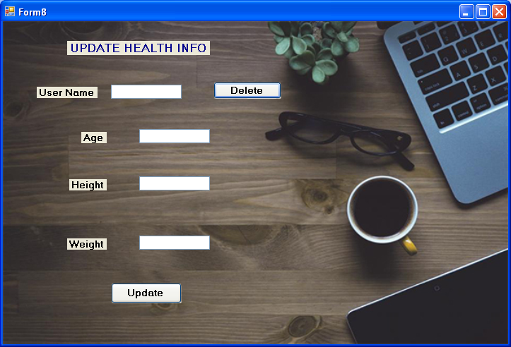

9.REGISTER CARD DETAILS:

PROGRAM:

Public Class Form9
Private Property Sql As Object
Private Sub Form9_Load(ByVal sender As System.Object, ByVal e As System.EventArgs) Handles MyBase.Load

End Sub

Private Sub Button1_Click(ByVal sender As System.Object, ByVal e As System.EventArgs) Handles Button1.Click
Dim con As New OleDb.OleDbConnection
Dim cmd As New OleDb.OleDbCommand
Dim provider As String
Dim datafile As String
Dim connstring As String

provider = "Provider=Microsoft.Jet.OLEDB.4.0;Data Source="
datafile = "C:\Documents and Settings\CSE\My Documents\Visual Studio 2010\Projects\Gym management\Gym management\creditcard.mdb"
connstring = provider & datafile
con.ConnectionString = connstring
'"PROVIDER = Microsoft.Jet.OLEDB.4.0; Data Source = .mdb"

con.Open()
Sql = "INSERT INTO creditcards ([username],cardno,[cardtype],balance,pinno) VALUES ('" & Me.TextBox1.Text & "','" & Me.TextBox2.Text & "','" & Me.TextBox3.Text & "','" & Me.TextBox4.Text & "','" & Me.TextBox5.Text & "')"
cmd = New OleDb.OleDbCommand(Sql, con)

cmd.ExecuteNonQuery()
MessageBox.Show("Inserted", "Sign Up Msg")
Me.TextBox1.Text = ""
Me.TextBox2.Text = ""
Me.TextBox3.Text = ""
Me.TextBox4.Text = ""
Me.TextBox5.Text = ""
con.Close()
End Sub

Private Sub Button2_Click(ByVal sender As System.Object, ByVal e As System.EventArgs) Handles Button2.Click
Me.Close()
End Sub
End Class

DESIGN:
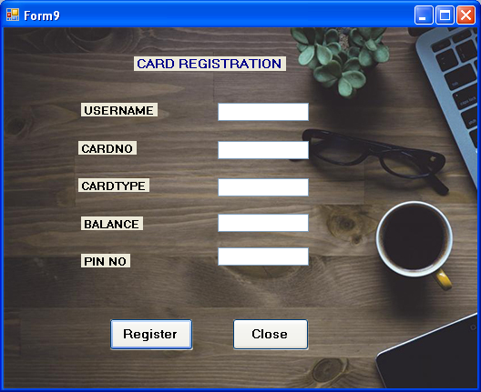

10.VIEW HEALTH INFO:

PROGRAM:

Imports System.Data.OleDb
Public Class Form10
Dim provider As String
Dim datafile As String
Dim connstring As String
Dim c As Integer
Public myconnection As OleDbConnection = New OleDbConnection
Public dr As OleDbDataReader

Private Sub Label1_Click(ByVal sender As System.Object, ByVal e As System.EventArgs) Handles Label1.Click

End Sub

Private Sub Button1_Click(ByVal sender As System.Object, ByVal e As System.EventArgs) Handles Button1.Click
provider = "Provider=Microsoft.Jet.OLEDB.4.0;Data Source="
datafile = "C:\Documents and Settings\CSE\My Documents\Visual Studio 2010\Projects\Gym management\Gym management\healthinfo.mdb"
connstring = provider & datafile
myconnection.ConnectionString = connstring
myconnection.Open()
TextBox2.Clear()
TextBox3.Clear()
TextBox3.Clear()
TextBox4.Clear()
Dim str As String
str = "SELECT * FROM healthinfos WHERE (username = '" & TextBox1.Text & "')"
Dim cmd As OleDbCommand = New OleDbCommand(str, myconnection)
dr = cmd.ExecuteReader
While dr.Read()
TextBox2.Text = dr("height").ToString
TextBox3.Text = dr("weight").ToString
TextBox4.Text = dr("BMI").ToString
TextBox5.Text = dr("Fitness").ToString

End While
End Sub

Private Sub Form10_Load(ByVal sender As System.Object, ByVal e As System.EventArgs) Handles MyBase.Load

End Sub
End Class

DESIGN:

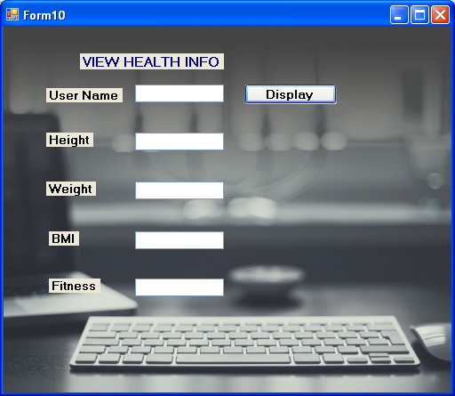

11.CHECKOUT:

PROGRAM:

Imports System.Data.OleDb

Public Class Form16
Dim provider As String
Dim datafile As String
Dim connstring As String
Dim c, c2 As Integer
Dim coa As String
Dim acc1, acc2 As Long
Public myconnection As OleDbConnection = New OleDbConnection
Public myconnection2 As OleDbConnection = New OleDbConnection
Public myconnection3 As OleDbConnection = New OleDbConnection
Public myconnection4 As OleDbConnection = New OleDbConnection
Public myconnection5 As OleDbConnection = New OleDbConnection

Public dr As OleDbDataReader
Public dr2 As OleDbDataReader
Public dr3 As OleDbDataReader
Public dr4 As OleDbDataReader

Private Sub Button2_Click(ByVal sender As System.Object, ByVal e As System.EventArgs) Handles Button2.Click
Me.Close()
End Sub

Private Sub Button3_Click(ByVal sender As System.Object, ByVal e As System.EventArgs) Handles Button3.Click
provider = "Provider=Microsoft.Jet.OLEDB.4.0;Data Source="
datafile = "C:\Documents and Settings\CSE\My Documents\Visual Studio 2010\Projects\Gym management\Gym management\plan.mdb"
connstring = provider & datafile
myconnection.ConnectionString = connstring
myconnection.Open()
Dim str As String
str = "SELECT * FROM plans WHERE ([Name] = '" & TextBox1.Text & "')"
Dim cmd As OleDbCommand = New OleDbCommand(str, myconnection)
dr = cmd.ExecuteReader
While dr.Read()
TextBox4.Text = dr("Cost").ToString
TextBox5.Text = dr("Coach").ToString
End While
c = Long.Parse(TextBox4.Text)
coa = (TextBox5.Text)
dr.Close()
myconnection.Close()

End Sub

Private Sub Button1_Click(ByVal sender As System.Object, ByVal e As System.EventArgs) Handles Button1.Click
provider = "Provider=Microsoft.Jet.OLEDB.4.0;Data Source="
datafile = "C:\Documents and Settings\CSE\My Documents\Visual Studio 2010\Projects\Gym management\Gym management\creditcard.mdb"
connstring = provider & datafile
myconnection3.ConnectionString = connstring
myconnection3.Open()

Dim str As String
Dim str3 As String
str = "SELECT * FROM creditcards WHERE cardno = " & TextBox3.Text
Dim cmd As OleDbCommand = New OleDbCommand(str, myconnection3)

'procedure 1
acc1 = acc1 - c
str3 = "Update creditcards Set balance='" & acc1 & "' where cardno= " & TextBox3.Text
Dim cmd3 As OleDbCommand = New OleDbCommand(str3, myconnection3)
Try
cmd3.ExecuteNonQuery()
MsgBox("amount taken from user")
Catch ex As Exception
MsgBox(ex.Message)
End Try

myconnection3.Close()

'procedure 2
myconnection5.ConnectionString = connstring
myconnection5.Open()
Dim str4 As String
acc2 = acc2 + c
str4 = "Update creditcards Set balance='" & acc2 & "' where ([username]= '" & TextBox5.Text & "')"
Dim cmd4 As OleDbCommand = New OleDbCommand(str4, myconnection5)
Try
cmd4.ExecuteNonQuery()
MsgBox("amount deposited to coach")
Catch ex As Exception
MsgBox(ex.Message)
End Try
myconnection5.Close()

End Sub

Private Sub Button4_Click(ByVal sender As System.Object, ByVal e As System.EventArgs) Handles Button4.Click
provider = "Provider=Microsoft.Jet.OLEDB.4.0;Data Source="
datafile = "C:\Documents and Settings\CSE\My Documents\Visual Studio 2010\Projects\Gym management\Gym management\creditcard.mdb"
connstring = provider & datafile

myconnection2.ConnectionString = connstring
myconnection4.ConnectionString = connstring

Try
myconnection2.Open()
Dim str5 As String
str5 = "SELECT * FROM creditcards WHERE ([username] = '" & TextBox2.Text & "')"
Dim cmd5 As OleDbCommand = New OleDbCommand(str5, myconnection2)
dr4 = cmd5.ExecuteReader
While dr4.Read()
TextBox6.Text = dr4("balance").ToString
End While
acc1 = Long.Parse(TextBox6.Text)
Catch ex As Exception
MsgBox(ex.Message)
End Try
dr4.Close()
myconnection2.Close()

Try
myconnection4.Open()
Dim str2 As String
str2 = "SELECT * FROM creditcards WHERE ([username] = '" & TextBox5.Text & "')"
Dim cmd2 As OleDbCommand = New OleDbCommand(str2, myconnection4)
dr3 = cmd2.ExecuteReader
While dr3.Read()
TextBox7.Text = dr3("balance").ToString
End While
acc2 = Long.Parse(TextBox7.Text)
Catch ex As Exception
MsgBox(ex.Message)
End Try
dr3.Close()
myconnection4.Close()
End Sub
End Class

DESIGN:

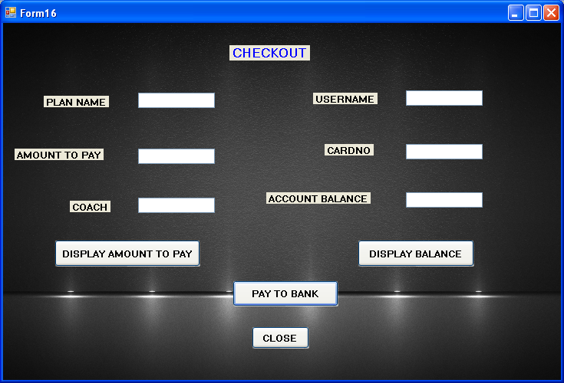

12.UPDATE BALANCE:

PROGRAM:

Imports System.Data.OleDb

Public Class Form12
Dim provider As String
Dim datafile As String
Dim connstring As String
Dim loginerror As String
Dim str2 As String
Dim a1 As Long
Dim a2 As Long
Public myconnection As OleDbConnection = New OleDbConnection
Public dr As OleDbDataReader

Private Sub Button4_Click(ByVal sender As System.Object, ByVal e As System.EventArgs) Handles Button4.Click
provider = "Provider=Microsoft.Jet.OLEDB.4.0;Data Source="
datafile = "C:\Documents and Settings\CSE\My Documents\Visual Studio 2010\Projects\Gym management\Gym management\creditcard.mdb"
connstring = provider & datafile
myconnection.ConnectionString = connstring
myconnection.Open()
Dim str As String
a2 = (TextBox1.Text)
str = "SELECT * FROM creditcards WHERE cardno =" & a2
Dim cmd As OleDbCommand = New OleDbCommand(str, myconnection)
Try
dr = cmd.ExecuteReader
While dr.Read()
TextBox3.Text = dr("balance").ToString
End While

Catch ex As Exception
MsgBox(ex.Message)
End Try
myconnection.Close()
End Sub

Private Sub Button1_Click(ByVal sender As System.Object, ByVal e As System.EventArgs) Handles Button1.Click
provider = "Provider=Microsoft.Jet.OLEDB.4.0;Data Source="
datafile = "C:\Documents and Settings\CSE\My Documents\Visual Studio 2010\Projects\Gym management\Gym management\creditcard.mdb"
connstring = provider & datafile
myconnection.ConnectionString = connstring
myconnection.Open()

a1 = Long.Parse(TextBox3.Text)
a1 = a1 + (Long.Parse(TextBox4.Text))

str2 = "Update creditcards Set balance='" & a1 & "' where cardno= " & TextBox1.Text
Dim cmd2 As OleDbCommand = New OleDbCommand(str2, myconnection)
Try
cmd2.ExecuteNonQuery()
Me.Hide()
MsgBox("stats updated successfully")
myconnection.Close()
'TextBox1.Clear()
'TextBox2.Clear()
'TextBox3.Clear()
'TextBox4.Clear()
TextBox1.Text = " "
TextBox3.Text = " "
TextBox4.Text = " "

Catch ex As Exception
MsgBox(ex.Message)
End Try
myconnection.Close()
End Sub

Private Sub Button2_Click(ByVal sender As System.Object, ByVal e As System.EventArgs) Handles Button2.Click
provider = "Provider=Microsoft.Jet.OLEDB.4.0;Data Source="
datafile = "C:\Documents and Settings\CSE\My Documents\Visual Studio 2010\Projects\Gym management\Gym management\creditcard.mdb"
connstring = provider & datafile
myconnection.ConnectionString = connstring
myconnection.Open()

a1 = Long.Parse(TextBox3.Text)
a1 = a1 - (Long.Parse(TextBox4.Text))

str2 = "Update creditcards Set balance='" & a1 & "' where cardno= " & TextBox1.Text
Dim cmd2 As OleDbCommand = New OleDbCommand(str2, myconnection)
Try
cmd2.ExecuteNonQuery()
Me.Hide()
MsgBox("stats updated successfully")
myconnection.Close()
'TextBox1.Clear()
'TextBox2.Clear()
'TextBox3.Clear()
'TextBox4.Clear()
TextBox1.Text = " "
TextBox3.Text = " "
TextBox4.Text = " "

Catch ex As Exception
MsgBox(ex.Message)
End Try
End Sub

Private Sub Button3_Click(ByVal sender As System.Object, ByVal e As System.EventArgs) Handles Button3.Click
Me.Close()
End Sub

Private Sub Form12_Load(ByVal sender As System.Object, ByVal e As System.EventArgs) Handles MyBase.Load

End Sub

End Class

DESIGN:
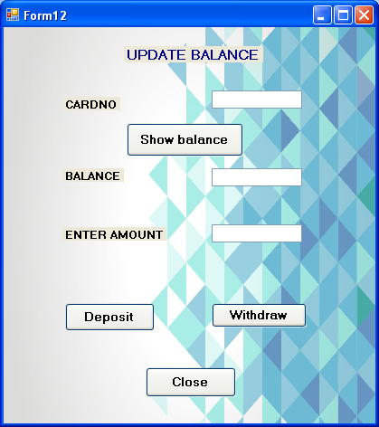

13.ADD EQUIPMENTS:

PROGRAM:

Public Class Form11
Private Property Sql As Object
Private Sub Button1_Click(ByVal sender As System.Object, ByVal e As System.EventArgs) Handles Button1.Click
Dim con As New OleDb.OleDbConnection
Dim cmd As New OleDb.OleDbCommand

'Dim s1, s2,s3,s4 As String
's1 = Me.TextBox1.Text
's2 = Me.TextBox2.Text
's3 = Me.TextBox3.Text
's4 = Me.TextBox4.Text
con.ConnectionString = "Provider = Microsoft.Jet.OLEDB.4.0;Data Source ='" & "C:\Documents and Settings\CSE\My Documents\Visual Studio 2010\Projects\Gym management\Gym management\equipment.mdb'"

'"PROVIDER = Microsoft.Jet.OLEDB.4.0; Data Source = .mdb"

con.Open()
Sql = "INSERT INTO equipments ([Name],[Date installed],[benefits],cost) VALUES ('" & Me.TextBox1.Text & "','" & Me.TextBox2.Text & "','" & Me.TextBox3.Text & "','" & Me.TextBox4.Text & "')"
cmd = New OleDb.OleDbCommand(Sql, con)
cmd.ExecuteNonQuery()
MessageBox.Show("Inserted", "add equipments Msg")

Me.TextBox2.Text = ""
Me.TextBox3.Text = ""
Me.TextBox4.Text = ""
con.Close()
End Sub

Private Sub Button2_Click(ByVal sender As System.Object, ByVal e As System.EventArgs) Handles Button2.Click
Me.Close()
End Sub
End Class

DESIGN:

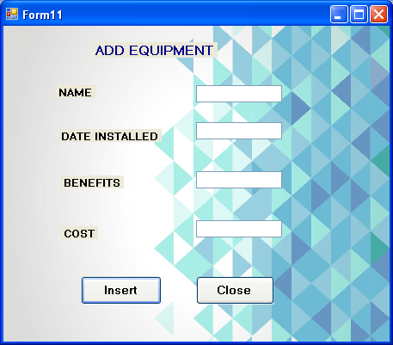

14.ADD AND UPDATE PLANS:

PROGRAM:

Imports System.Data
Imports System.Data.OleDb

Public Class Form13
Private Property Sql As Object
Private Property sql2 As Object
Public myconnection As OleDbConnection = New OleDbConnection

Private Sub Button1_Click(ByVal sender As System.Object, ByVal e As System.EventArgs) Handles Button1.Click
Dim con As New OleDb.OleDbConnection
Dim cmd As New OleDb.OleDbCommand
Dim provider As String
Dim datafile As String
Dim connstring As String
Try
provider = "Provider=Microsoft.Jet.OLEDB.4.0;Data Source="
datafile = "C:\Documents and Settings\CSE\My Documents\Visual Studio 2010\Projects\Gym management\Gym management\plan.mdb"
connstring = provider & datafile
myconnection.ConnectionString = connstring
myconnection.Open()
Sql = "INSERT INTO plans (ID,[Name],Cost,[Benefit],[Coach],totalweeks) VALUES ('" & Me.TextBox1.Text & "','" & Me.TextBox2.Text & "','" & Me.TextBox3.Text & "','" & Me.TextBox4.Text & "','" & Me.TextBox5.Text & "','" & Me.TextBox6.Text & "')"
cmd = New OleDb.OleDbCommand(Sql, myconnection)

cmd.ExecuteNonQuery()
MessageBox.Show("Inserted", "Sign Up Msg")
Me.TextBox1.Text = ""
Me.TextBox2.Text = ""
Me.TextBox3.Text = ""
Me.TextBox4.Text = ""
Me.TextBox5.Text = ""
Me.TextBox6.Text = ""
Catch ex As Exception
MsgBox(ex.Message)
End Try
con.Close()
End Sub

Private Sub Button2_Click(ByVal sender As System.Object, ByVal e As System.EventArgs) Handles Button2.Click
Me.Close()
End Sub

Private Sub Button3_Click(ByVal sender As System.Object, ByVal e As System.EventArgs) Handles Button3.Click
Dim con As New OleDb.OleDbConnection

con.ConnectionString = "Provider = Microsoft.Jet.OLEDB.4.0;Data Source ='" & "C:\Documents and Settings\CSE\My Documents\Visual Studio 2010\Projects\Gym management\Gym management\plan.mdb'"
'"PROVIDER = Microsoft.Jet.OLEDB.4.0; Data Source = .mdb"
con.Open()
Dim str As String
str = "Update plans Set ID='" & TextBox1.Text & "',[Name]= '" & TextBox2.Text & "',Cost='" & TextBox3.Text & "',[Benefit]='" & TextBox4.Text & "',[Coach]='" & TextBox5.Text & "',totalweeks='" & TextBox6.Text & "' where ID= " & TextBox1.Text
Dim cmd As OleDbCommand = New OleDbCommand(str, con)
Try
cmd.ExecuteNonQuery()
Me.Hide()
MsgBox("stats updated successfully")
con.Close()
TextBox1.Text = " "
TextBox2.Text = " "
TextBox3.Text = " "
TextBox4.Text = " "

Catch ex As Exception
MsgBox(ex.Message)
End Try

con.Close()
End Sub

Private Sub Form13_Load(ByVal sender As System.Object, ByVal e As System.EventArgs) Handles MyBase.Load

End Sub
End Class
