1.0 Introduction

Report by The United Nations Children’s Fund (UNICEF) show that the mortality rate is a result of various factors, such as nutrition, availability of safe water, child and maternal services available, the availability of medication and immunization.

## 1.1. Key facts

* Every year nearly 45% of all under 5 child deaths are among newborn infants, babies in their first 28 days of life or the neonatal period.
* Three quarters of all newborn deaths occur in the first week of life.
* In developing countries nearly half of all mothers and newborns do not receive skilled care during and immediately after birth.
* Up to two thirds of newborn deaths can be prevented if known, effective health measures are provided at birth and during the first week of life.

2.0 Proposal

We are proposing to provide and customize a mobile and web application solution called Doc-interact, the application seeks to enable doctors and nurses interact in real-time and share cases of new born babies.

The application will apply especially to doctors and nurses in rural areas who have strange cases and would like to get advice from other expert doctors.

The solution will help doctors to be able to treat such cases whenever they come across them.

The solution will also help doctors to communicate to parents with infants promptly.

The platform will eventually become an information sharing platform among docs and nurses in rural areas and expert doctors.

3.0 Features

* Will have a mobile end for clinicians and doctors and web based application as well
* Will allow doctors to save data offline and send it when there is availability of data
* Will be able to capture the coordinates of the location where the doctor is sending information from
* Allow sharing of text, images and videos
* Web based, and mobile based
* Allow sharing of cases that will be discussed at length

4.0 Requirements

Zalego will need the following;

* Color theme for the web based project
* Logo for the web based system
* Server space

5.0 Project Schedule

The project has taken a period of 6 months

**5.1 Activities:**

1. User interface design and development
2. Database design and development
3. Testing

|  |  |  |  |  |  |  |
| --- | --- | --- | --- | --- | --- | --- |
| *Period in Months* | *MONTH 1* | *MONTH 2* | *MONTH 3* | *MONTH 4* | *MONTH 5* | *MONTH 6* |
| **Activity** |
| **1** |  |  |  |  |  |  |
| **2** |  |  |  |  |  |  |
| **3** |  |  |  |  |  |  |

***6.0 Tele health technical Operation***

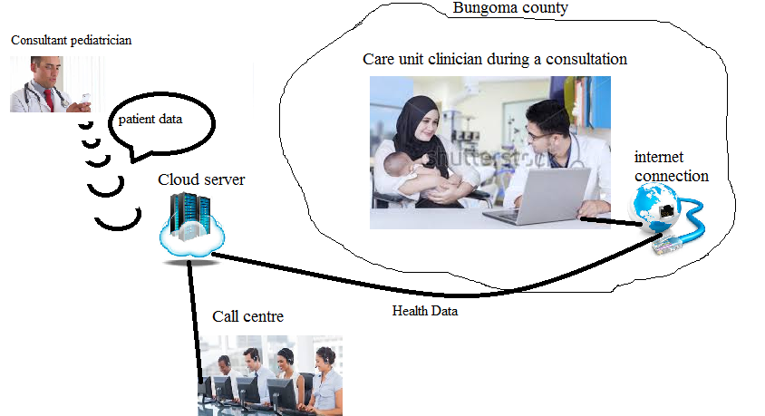

|  |  |  |  |
| --- | --- | --- | --- |
| **Module** | **DESCRIPTION** | Duration | **UNITS PRICE(Kshs)** |
| User interface and framework design | Further design and customization of the interface | 1 week | 20,000 |
| Text, Images and Video sharing | Customizing sending of text, audio and video files | 1 week | 20,000 |
| Database development | This is the storage area where the data will be securely archived | 1 week | 50,000 |
| Web development | Customization of the web application | 2 Weeks | 20,000 |
| Web Hosting and Email set up | Purchase of domain name, webhosting and email set up | 3 days | 20,000 |
| **GRAND** **TOTAL**    **VAT (16%)**    **NET TOTAL** | | | 130,000 |
| 20,800 |
| 150,800 |

7.0 Cost

8.0 Signatures

Client: [………….]

Name:_____________________________________

Designation:_________________________________

Date________________________________________

Signature ____________________________________

Developer: [………….]

Name ____________________________________

Signature_________________________________

Title: ____________________________________

Date: __________________________________