- 503 Students

  - Mean: 0.797654
  - Min: 0.100000
  - Max: 5.00000

- ~69.38% of students

- The correlation coefficient is 0.187061. It is positive, but weak.

- Scatter plot:
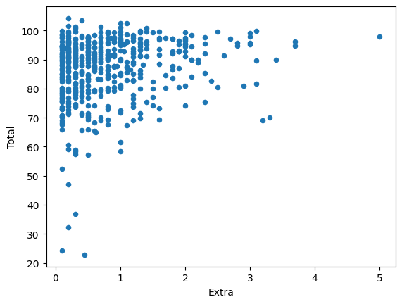
- The linear equation is y = 2.79x + 84.54

- The RMSE is ~10.71

- 2nd Scatter Plot:
