Baseline:

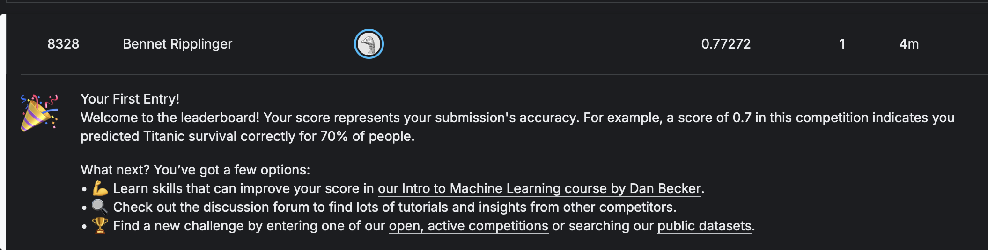

Part 2:
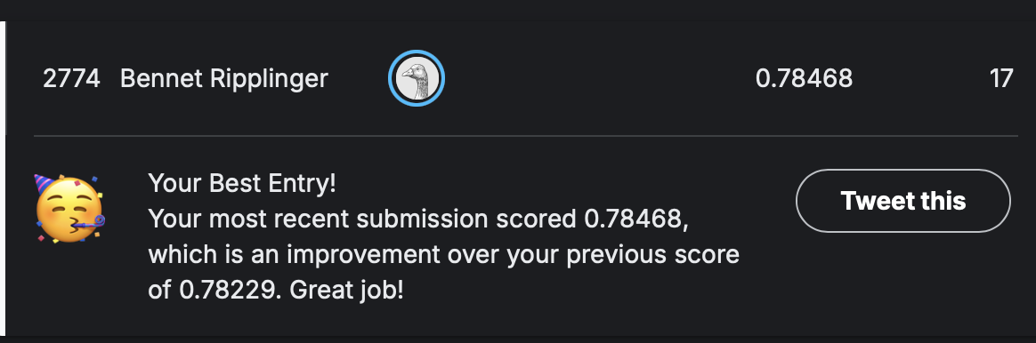
- I filled in missing values for the age and fare columns with their columns medians, used one hot encoding and feature engineering. Adding features for Child, Young_Adult, and Adult, Elder, by assigning a certain age range to each. Family_Size by adding the sibsp (siblings and spouses) and parch (parents and children) columns. Finally Is_Alone by checking if the Family_Size column was 0.
- The model that worked best for me was random forest, though not submitted, I tried a Stacking Classifier with random forest and svc, with RandomForest as the final estimator, but the accuracy was significantly lower than just RandomForest, although I didn’t try to fine tune it too much, so it might have been overfitting.

- Performance Evaluation:
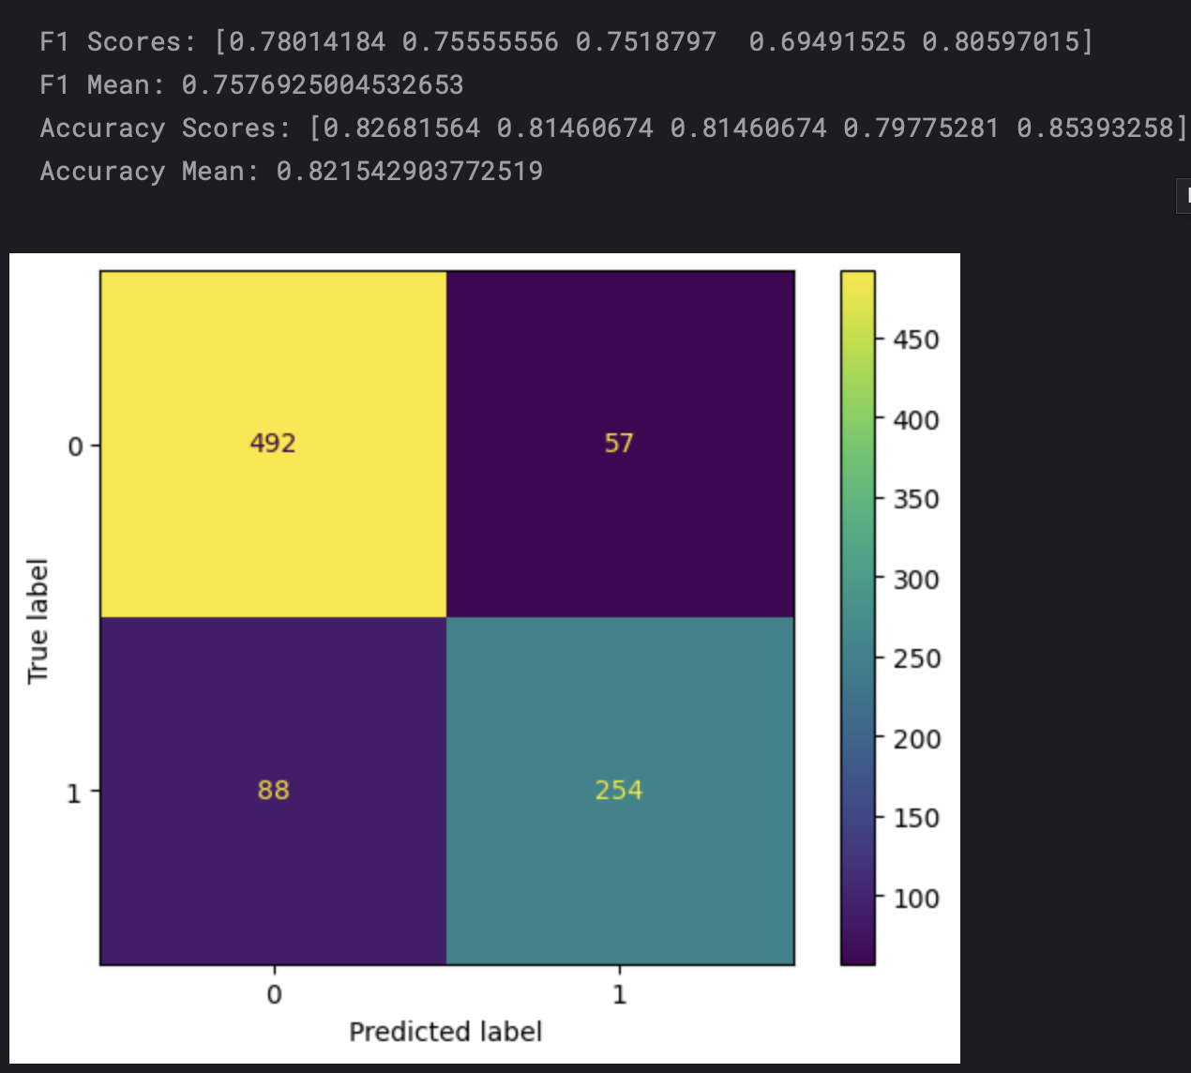
- The best score I got was an accuracy of 0.78468 and a leaderboard position of 2774.

