Dig:
IP Addresses: 104.18.19.143 and 104.18.18.143
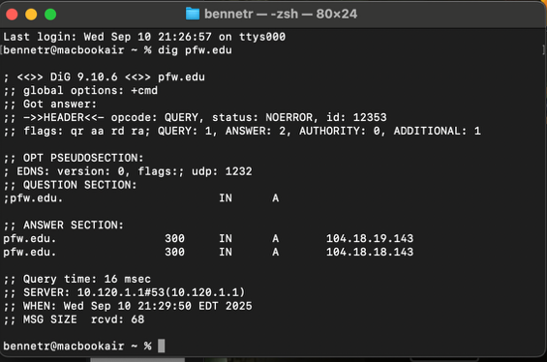
DNS: idnsa.pfw.edu , dns1.pfw.edu
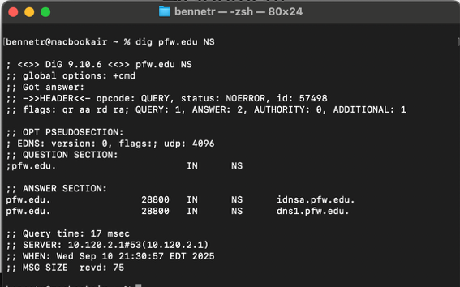
Mail Servers: pfw-edu.mail.protection.outlook.com.
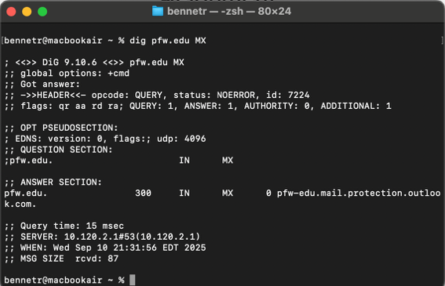

HTTP GET vs POST:
- The main difference between POST and GET is that the information from the user is stored in the URL with GET and with POST it’s stored inside the body.
- You should use GET when wanting something to copy and paste since its in the URL. You should use POST when you’re dealing with sensitive data or big data and big file sizes since GET has a limited size in the URL.
- 200: Approved OK, Successful Request
301: Moved Permanently: A webpage has been moved to a new URL.
404: Not Found: Server couldn’t find webpage at URL given.

Web Service:
Fort Wayne IN: 65.8 F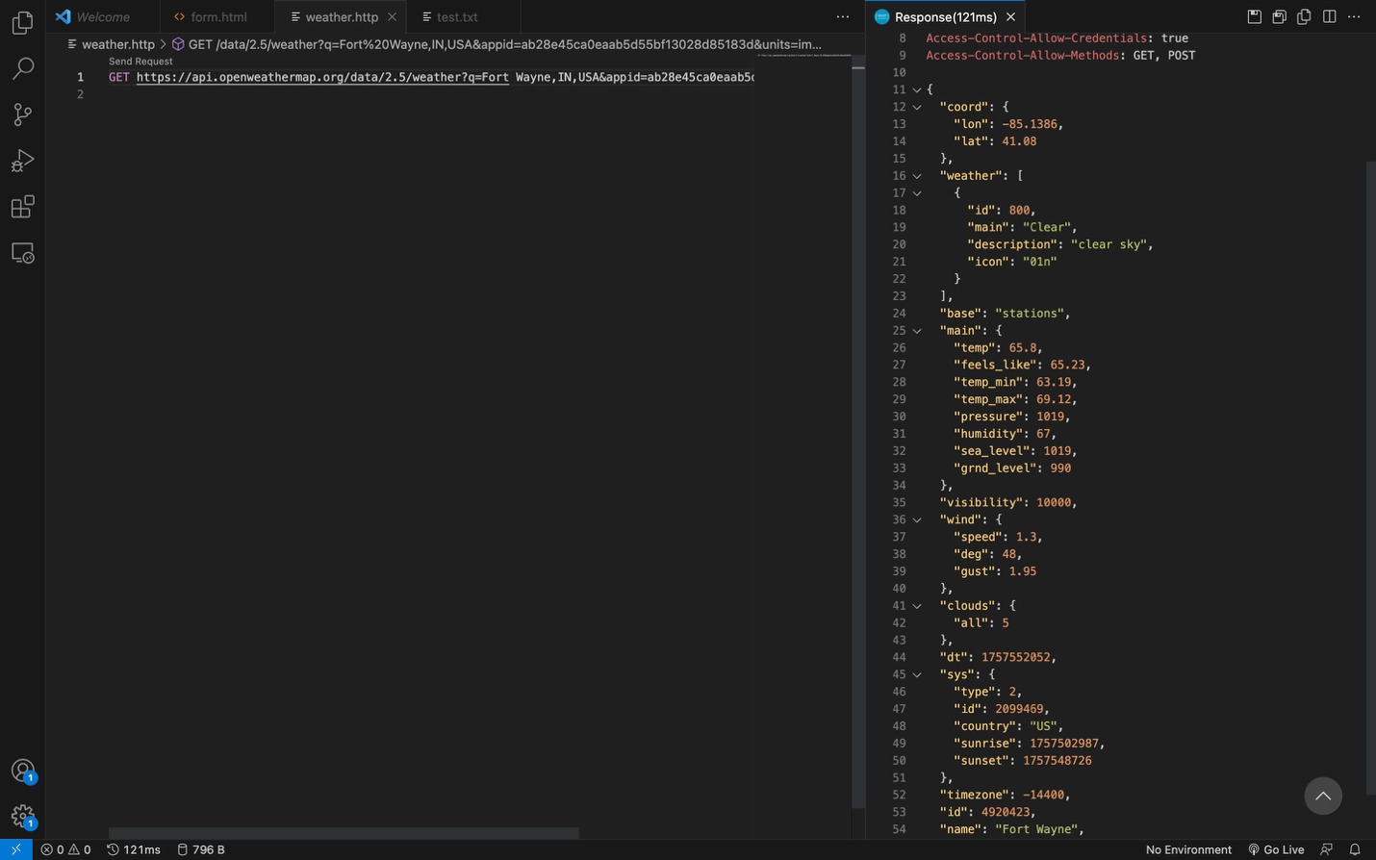
Miami FL: 78.8 F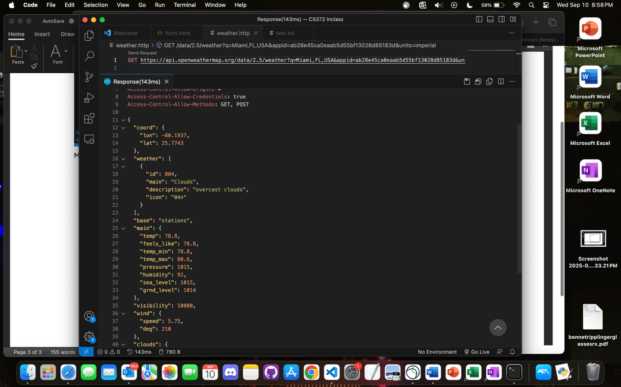
San Francisco CA: 65.23 F