Technician Briefing: Electrical Issue on Leopard 53 Power Catamaran

Owner: Matthew Kahn

Vessel: 2025 Leopard 53 Power Catamaran

Inverter System: Dual Victron Phoenix Inverters 12/3000

Inverter Location: Designated compartment behind the starboard engine room

# Reported Issue: Inverter-Linked Power Cutoff

When running high-power AC appliances (e.g., watermaker, microwave, electric kettle), the following behavior occurs:  
- Appliance operates for 1–3 minutes.  
- Suddenly, all power on the boat shuts off, including other systems.  
- After a brief interval, power comes back on automatically.  
- The cycle repeats consistently when any of these appliances are used.  
- The issue is not isolated to a specific appliance; it appears linked to overall power draw.

# Additional Background: Delivery Trip Charging Issue

During delivery from Fort Lauderdale to East Hampton in April, the captain reported unusual charging behavior while underway:  
- Despite engine operation, the battery bank could not charge above 88%.  
- When plugged into shore power or using the generator, the batteries charged to 100% normally.  
- The crew suspected an alternator issue, but it was not confirmed.  
Although distinct from the current inverter-shutdown issue, this behavior may be related. If alternators were not fully charging the house bank, or if battery health declined due to persistent undercharging, it could explain increased voltage sag under load — a common cause for inverter shutdowns during high appliance use.

# Power System Configuration Summary

Inverter System:  
- Two Victron Phoenix Inverter 12/3000 units (12V, 3000VA, 120V 60Hz).  
- One is labeled as dedicated to the microwave oven.  
- Both are parallel connectable and sine wave output.  
- Supports global voltage/frequency compatibility.  
- Switches between shore power, generator, and battery bank.

Battery Charger:  
- Victron Centaur Battery Charger 12V 100A observed in setup.

Battery Bank:  
- Supplies DC power to inverters; likely 12V lithium or AGM.  
- Voltage sag under high load may contribute to shutdown behavior.

# Preliminary Diagnosis and Observations

1. Inverter Overload or Over-Temperature Shutdown:  
- Appliance load may exceed inverter capacity, triggering auto-shutdown.  
  
2. Voltage Drop Under Load:  
- Batteries may sag under high draw, even if SOC is nominal.  
  
3. Appliance Startup Surges:  
- Initial surge from microwave/kettle may cause brief overdraw.  
  
4. Faulty Transfer Relay or Configuration:  
- Misconfigured transfer relay could result in full power loss and reset behavior.

# Suggested Actions for Technician

1. Review inverter logs via VictronConnect or Cerbo GX.  
2. Measure DC battery voltage under load.  
3. Confirm inverter settings:  
 - Continuous output rating  
 - Input current limits  
 - Voltage shutdown thresholds  
4. Test appliances individually.  
5. Inspect battery cabling and terminals.

# Additional Notes

- Inverters located behind the starboard engine room.  
- Access to Cerbo GX or schematics can be provided.  
- Issue persists with or without shore/generator power.

# System Photos

Victron Phoenix Inverters 12/3000 (2 units, one labeled for microwave)

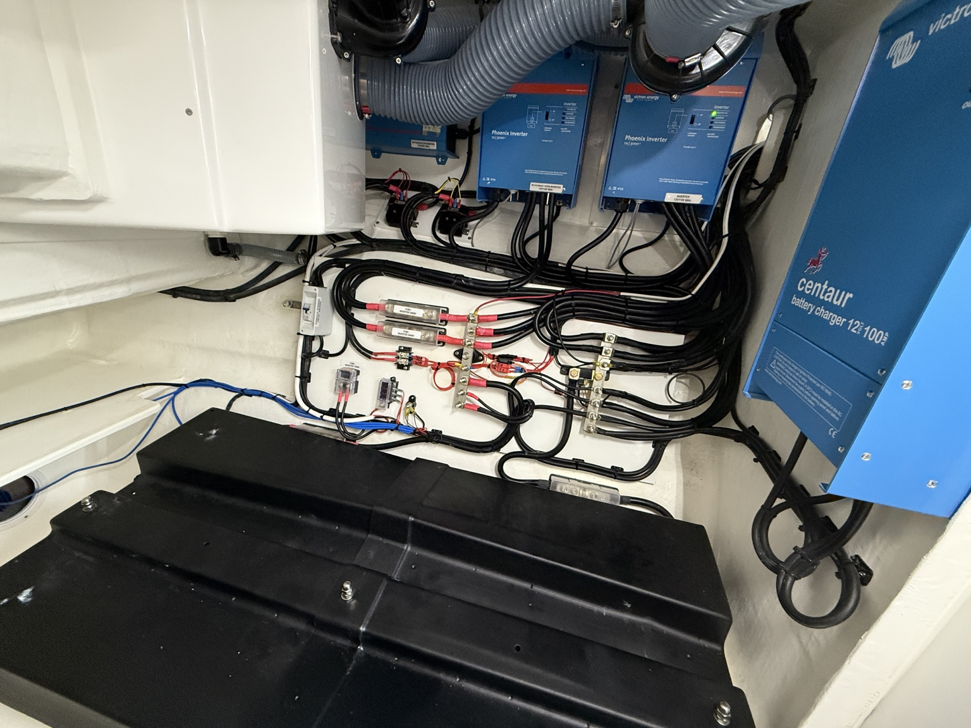

Victron Centaur Battery Charger 12V 100A

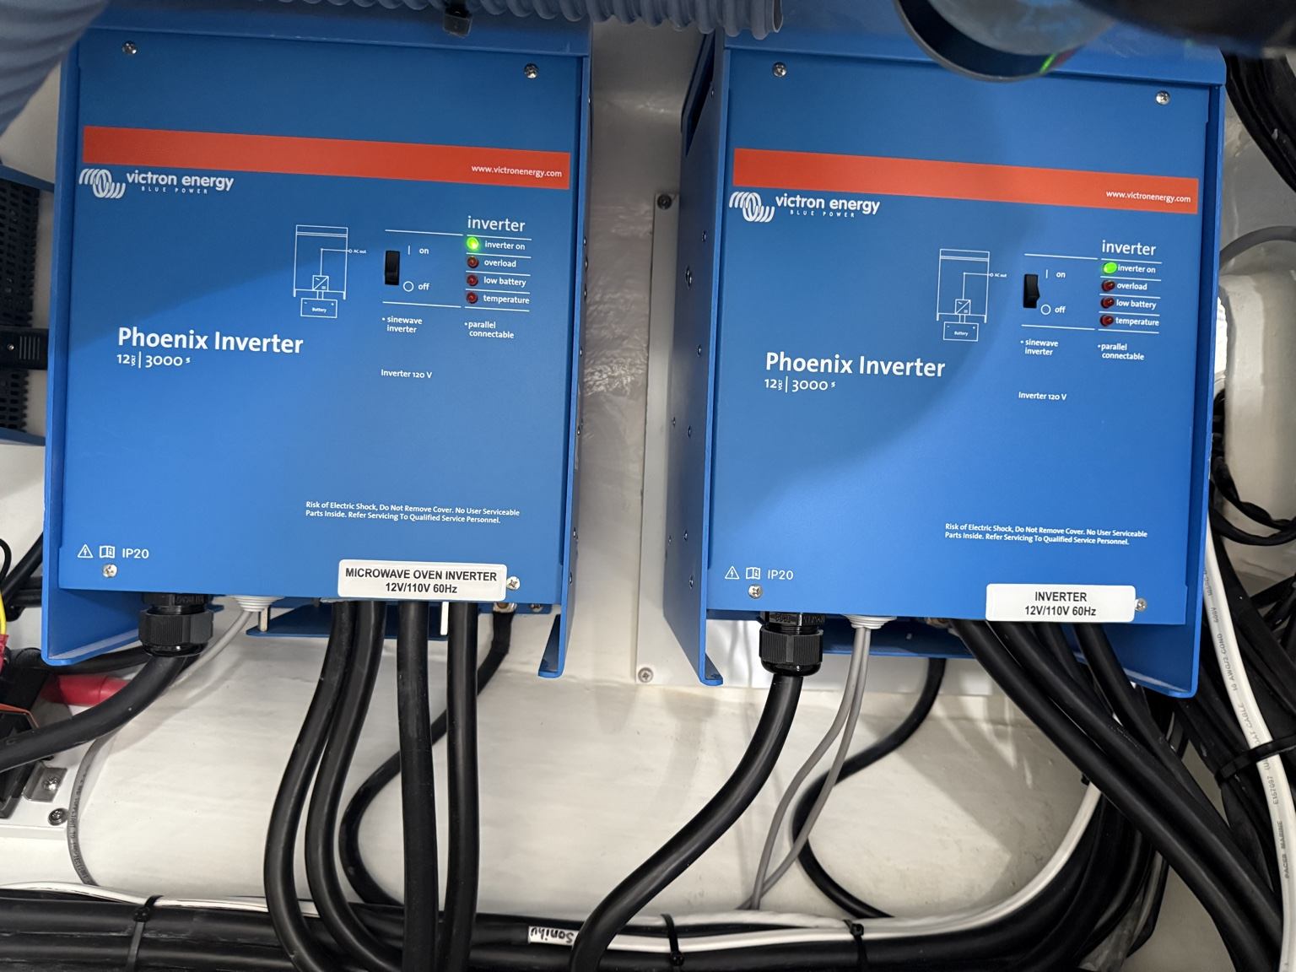

Electrical compartment showing wiring and layout

