Technician Briefing: Electrical Issue on Leopard 53 Power Catamaran

Owner: Matthew Kahn

Vessel: 2025 Leopard 53 Power Catamaran

Inverter System: Dual Victron Phoenix Inverters 12/3000

Inverter Location: Designated compartment behind the starboard engine room

# Reported Issue: Inverter-Linked Power Cutoff

When running high-power AC appliances (e.g., watermaker, microwave, electric kettle), the following behavior occurs:  
- Appliance operates for 1–3 minutes.  
- Suddenly, all power on the boat shuts off, including other systems.  
- After a brief interval, power comes back on automatically.  
- The cycle repeats consistently when any of these appliances are used.  
- The issue is not isolated to a specific appliance; it appears linked to overall power draw.

# Power System Configuration Summary

Inverter System:  
- Two Victron Phoenix Inverter 12/3000 units (12V, 3000VA, 120V 60Hz).  
- One is labeled as dedicated to the microwave oven.  
- Both are parallel connectable and sine wave output.  
- Supports global voltage/frequency compatibility.  
- Switches between shore power, generator, and battery bank.

Battery Charger:  
- Victron Centaur Battery Charger 12V 100A observed in setup.

Battery Bank:  
- Supplies DC power to inverters; likely 12V lithium or AGM.  
- Voltage sag under high load may contribute to shutdown behavior.

# Preliminary Diagnosis and Observations

1. Inverter Overload or Over-Temperature Shutdown:  
- Appliance load may exceed inverter capacity, triggering auto-shutdown.  
  
2. Voltage Drop Under Load:  
- Batteries may sag under high draw, even if SOC is nominal.  
  
3. Appliance Startup Surges:  
- Initial surge from microwave/kettle may cause brief overdraw.  
  
4. Faulty Transfer Relay or Configuration:  
- Misconfigured transfer relay could result in full power loss and reset behavior.

# Suggested Actions for Technician

1. Review inverter logs via VictronConnect or Cerbo GX.  
2. Measure DC battery voltage under load.  
3. Confirm inverter settings:  
 - Continuous output rating  
 - Input current limits  
 - Voltage shutdown thresholds  
4. Test appliances individually.  
5. Inspect battery cabling and terminals.

# Additional Notes

- Inverters located behind the starboard engine room.  
- Access to Cerbo GX or schematics can be provided.  
- Issue persists with or without shore/generator power.

# System Photos

Victron Phoenix Inverters 12/3000 (2 units, one labeled for microwave)

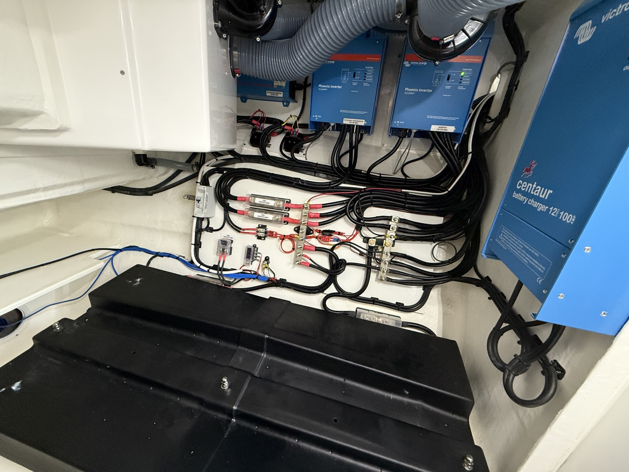

Victron Centaur Battery Charger 12V 100A

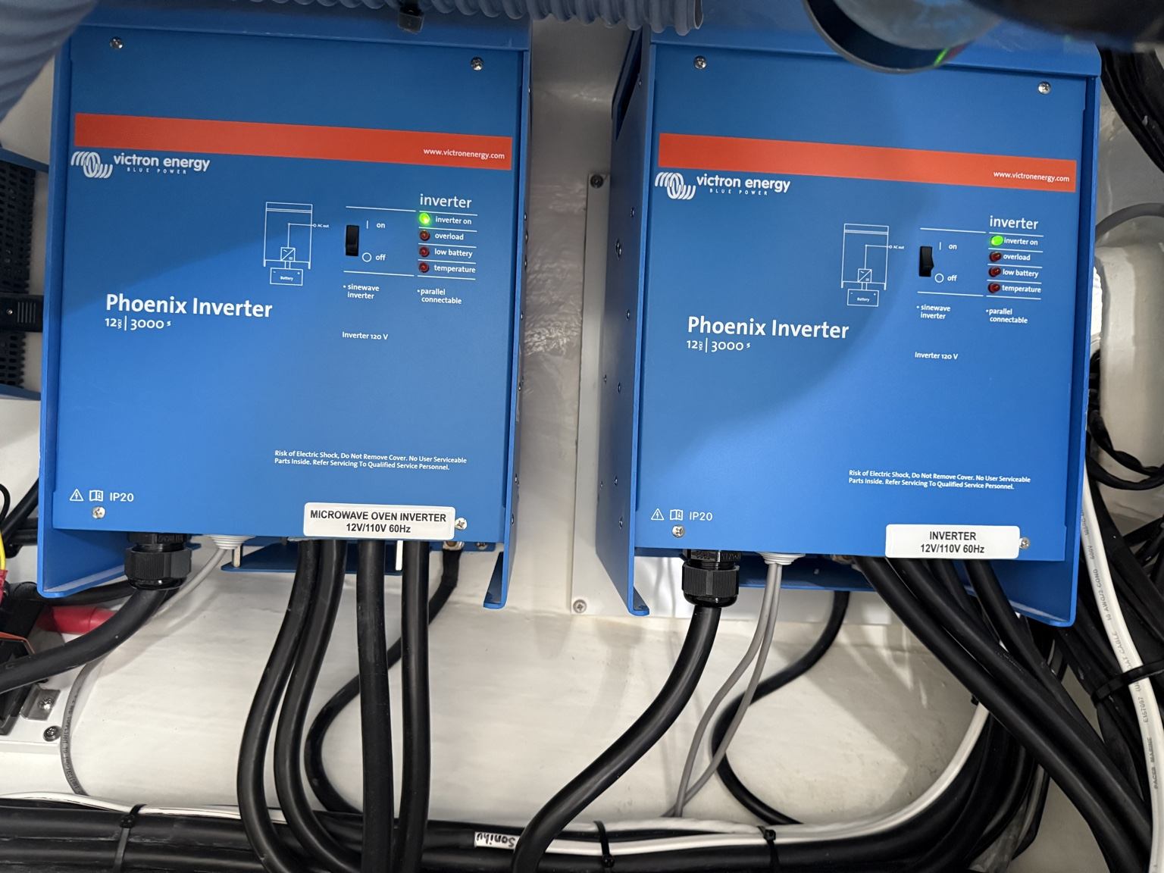

Electrical compartment showing wiring and layout

