 |  | Benjamin Diedrichsen  Polyglot Software Architect
github: https://github.com/bennidi
online: https://bennidi.github.io/resume
stackoverflow: bennidi
*: 06.04.1984
Phone: +49 176 – 57 864 501
Mail: b.diedrichsen@gmail.com

The design and construction of software systems - be it small libraries, frameworks or midsize software landscapes - is my job and one of my greatest passions. This includes many aspects of the software lifecycle:  planning and design, data and domain modeling, prototyping, deployment, production and maintenance.  Polyglot  I write code in various languages using combinations of object oriented and functional paradigm. @home on the JVM [Java, Scala, Groovy], I recently became an enthusiastic user of the JavaScript ecosystem - node.js, coffeescript, livescript, react.js  Everything is a model  I enjoy the creative task of deconstructing reality into appropriate models of objects, functions, data structures and information flows. I take pride in writing beautiful and efficient code - git clone my open source projects and have a look. | I also believe in the values of agile methodologies: open and honest communication, collective learning and team collaboration are as important as choosing the right technology stack.  You can hire me to  - design and prototype core modules or system architecture  - fix performance issues in application code or data models  - plan and implement major refactorings  - help with code reviews, technology decisions, development cycle and team process  I grant discounts if you  - have a an interesting technology stack  - solve social problems instead of consumer problems
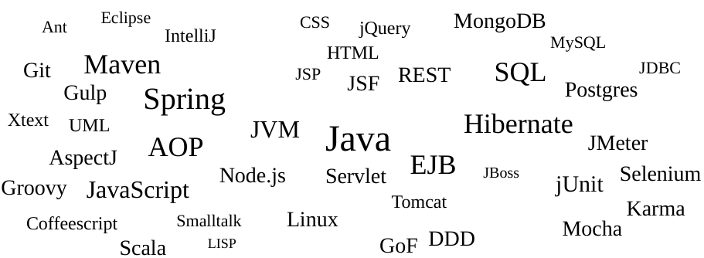

Software projects (selection)
06/2015 – 12/2015  Okotta GmbH  www.okotta.com |  | Implementation of REST-API Stack  Mobile App with REST data backend. Scalable data repositories secured with JSON Web Tokens.
Technologies |  | Scala, Scalatra, MongoDB, reactivemongo, JWT, Swagger, WireMock, reactjs, ES6
Tasks |  | - Requirements engineering and domain modeling  - Design and implementaion of REST-API stack  - Evaluation of persistence technologies  - Implementation of full stack integration testing  - Internal Data Tool based on ES6 and react.js
06/2014-12/2014  Small Improvements  www.small-improvements.com |  | REST API built on Google App Engine and Memcache  Web application running on GAE with BigTable and Memache. Angular frontend connects via Ajax to data backend.
Technologies |  | Java 6, Groovy, GAE, Memcache, Google Guava, Jackson, Jmeter, Spock, Gradle
Tasks |  | - Performance optimization of object serialization  - (Re-)Implementation of REST-API with composable serializers  - Integration of caching layer using Guava Cache  - Refactoring to patterns
03/2013 - 09/2013  ProfitBricks GmbH  www.profitbricks.com |  | Automated provisioning of Virtual Machines in Data Centers  J2EE application handling customer requests for virtualized server infrastructure
Technologies |  | Java 7, EJB 3, JPA 2 (EclipseLink), Postgres, Glassfish, jUnit, cglib, OSGI, H2, Jenkings, Maven, git
Tasks |  | - Rewrite test infrastructure with internal DSL and H2  - Lazy assertions with cglib and dynamic proxies  - Profiling and performance optimizations  - Code reviews and refactorings
02/2012 - 12/2012  Alecto GmbH  www.friendsurance.de |  | Web application with scalable relational social graph  Online platform offering comparison services around insurances and a social graph for customers to form trust networks
Technologies |  | Java 7, EJB 3, JPA 2 (Hibernate), Spring 3, Postgres, Tomcat 7, Glassfish, Selenium, JSF, Maven, git
Tasks |  | - Full migration from EJB 3 (Glassfish) to Spring (Tomcat)  - Redesign of persistence abstraction layer  - Historized social graph based on immutable data (Postgres)  - Caching layer with synchronization across machines  - Selenium test infrastructure on grid server

Co-operative course of studies
15.10.2007 – 30.09.2008  ottogroup  www.ottogroup.com |  | Softwaredevelopment ottogroup retail systems  Supporting the migration of the object-relational persistence layer in a large scale J2EE application landscape
Technologies |  | Java 6, Kodo (JDO 2.0, JPA 1.0), jUnit, Spring, Xtext, Xtend,Xpand, Bea WebLogic, Maven.
Tasks |  | - Extension of existing persistence infrastructure for operating JDO and JPA in parallel (soft migration strategy)  - Automatic transformation of all OR-mapping definitions as part of my diploma thesis

Degree program
01.10.2004 –30.09.2008 |  | Co-operative degree program 'Economics and computer science (Dipl. FH)' in co-operation with ottogroup
Focue areas |  | Model driven software development  Modern software technologies  Datastream Managementsystems
Diploma thesis |  | Implementation of a generic transformation component for XML based models and its application to a model migration problem
Final grades |  | 1.0 (thesis), 1.5 (diploma)

IT-Qualifications
- 8+ years software development experience in J2EE business environment
- Strong experience running J2EE technologies in production: EJB, Spring, JTA, JPA, Servlet, JSP, application servers, servlet containers
- Object relationial persistence: Data and object modeling, query optimization, Postgres, MySql
- Good understanding of architecture and design patterns: SOLID, Messaging, Pipes&Filters, REST, GoF Patterns
- Experience with model driven software development and modeling: Xtext, Xtend, Xpand, EMF, UML, AndroMDA
- Solid experience with XML technologies: XSD, XSLT, XPath
- Understanding of functional programming (Lisp/Scheme)
- Development Tools: Maven, Git, Ant, SVN,CVS,Jenkins
- Experienced Linux user

More
[github:mbassador]  [github:mailody]  [github:kermit] |  | Java Event Bus with larger user base: HighPerformance implementation of publishsubscribe pattern. Low memory footprint, nonblocking iterators, high throughput  Online trash mail service built with Node.js, MongoDB, restify, knockout.js, HTML 5, Java client for Selenium  Kermit is an elegant, stream-based, extensible web scraper system. It is packed with pluggable features and offers a plugin mechanism for easy extension. Written in Node.js and coffeescript with NeDB as datastore.

Languages
Foreign* |  | * Self evaluation according to refernce framework of European Language  Portfolio ( see appendix or www.coe.int/portfolio )
   | oral | writing
  English | C1 | C2
  Spanish | B2 | C1
  French | A1 | A2
Native |  | Deutsch

