|  |  |
| --- | --- |
|  | **MINISTRY OF EDUCATION AND TRAINING** |

|  |
| --- |
| **FPT UNIVERSITY** |
| Capstone Project Document |
| WeTeach |
|  |
| |  |  | | --- | --- | | **WeTeach** | | | **Group Members** | Nguyễn Viết Nam – SE03599 – 0984536543  Trần Nhật Trường – SE03527 – 0978203753  Nguyễn Thịnh Cường – SE03238 – 0969666682  Chu Văn Toàn – SE03675 - 0962464541 | | **Supervisor** | Đào Trọng Duy | | **Ext Supervisor** |  | | **Capstone Project code** | TE | |
|  |

Table of Contents

**Chapter 1: Introduction3**

1. Introduction and Motivation3
2. Project Information3

2.1 Supervisor3

2.2 Team Members3

1. Existing/Similar Product4

**Chapter 2: Software Project Management6**

1. Introduction5

1.1 Purpose6

1.2 Definition and Acronyms6

2. Project Overview5

2.1 Project Description6

2.2 Standard Objectives6

2.3 Milestones and Deliverables6

3. Project Organization5

3.1 Software 6

3.2 Project Lifecycle6

3.3 Role and Responsibilities6

4. Tool and Infrastructures5

4.1 Hardware6

4.2 Software6

5. Schedule5

6. Communication Management5

2.3 Milestones and Deliverables6

2.3 Milestones and Deliverables6

7. Risk Management5

2.3 Milestones and Deliverables6

2.3 Milestones and Deliverables6

8. Configuration Management5

2.3 Milestones and Deliverables6

2.3 Milestones and Deliverables6

9. Coding Convention5

2.3 Milestones and Deliverables6

2.3 Milestones and Deliverables6

**CHAPTER 1: INTRODUCTION**

1. **Introduction and Motivation**

Nowadays the Internet has become part and parcel of our life in today’s modern world. People use the internet to search for specific information, to connect with each other and for many other reasons. We can see very clear that education websites have grown along with the development of the internet.

Even though there are thousands of those website all over the internet (most of them are in English), we can’t really find that much website that can serve Vietnamese people. Because the majority of Vietnamese people are not good at English, they find it difficult to fully understand when they study in English.

Also, Vietnamese people have very high needs for extra classes but the only problem is they sometime don’t know where to look for not only good, trusted… classes but also convenient for them.

For the above-mentioned reason, we come up with the idea to create an education website that can resolve these problem.

1. **Project Information**
   1. **Supervisor**

|  |  |  |  |  |
| --- | --- | --- | --- | --- |
|  | **Full Name** | **Phone Number** | **Email** | **Title** |
| **Supervisor** | Đào Trọng Duy |  | [duydt@fe.edu.vn](mailto:duydt@fe.edu.vn) | Lecturer |

* 1. **Team Members**

|  |  |  |  |  |  |
| --- | --- | --- | --- | --- | --- |
| **No** | **Full Name** | **Student ID** | **Phone Number** | **Email** | **Role in Group** |
| 1 | Nguyễn Viết Nam | SE03599 | 0984536543 | [namnvse03599@fpt.edu.vn](mailto:namnvse03599@fpt.edu.vn) | Leader |
| 2 | Trần Nhật Trường | SE03527 | 0978203753 | [truongtnse03527@fpt.edu.vn](mailto:truongtnse03527@fpt.edu.vn) | Member |
| 3 | Chu Văn Toàn | SE03675 | 0962464541 | [toancvse03675@fpt.edu.vn](mailto:toancvse03675@fpt.edu.vn) | Member |
| 4 | Nguyễn Thịnh Cường | SE03238 | 0969666682 | [cuongntse03238@fpt.edu.vn](mailto:cuongntse03238@fpt.edu.vn) | Member |

1. **Existing/Similar Product**
   1. ***Udemy***

**

Udemy is a global marketplace for learning and teaching online where more than 15 million students learn from an extensive library of 45,000 courses. Whether learning for professional development or personal enrichment, students can master new skills through self-paced, on-demand courses, while instructors have a way to share their knowledge with the world. For companies, Udemy for Business offers subscription access to a collection of business-relevant courses as well as a simple platform to host and distribute their own content in one central place.

* Advantages:
* Most courses are self-paced (Start when you’re ready, set your own schedule).
* Udemy have a wide range of 45,000 course portfolio.
* On any given subject, there are courses from multiple authors so you can choose the best one.
* Udemy provides lifetime access to all its courses.
* Many courses are offered free of cost.
* Disadvatages:
* There are a lot of “low quality” courses.
* Pay through creadit card or paypal which is not many Vietnamese use that.
* Does not have many “good” courses in Vietnamese.

***3.2 Edumall***

**

Edumall is a website for learning and teaching online. Edumall provides thousands of different courses for Vietnamese.

* Advantages:
* Most courses are self-paced.
* 100% course’s content is Vietnamese.
* Easy to pay (COD, ATM…)
* Edumall provides lifetime access to all its courses.
* Many courses are offered free of cost.
* Disadvantages:
* Lack of communicate between trainer and leaner.
* Edumall does not have preview course.

**Chapter 2: Software Project Plan**

1. **INTRODUCTION**
   1. **Purpose**

This document includes information about WeTeach team, work schedule from start to the end of project; project risk management plan and communication plan. This will be used by project manager to manage and control work of all team. The supervisor can use this to track progress of the project team.

* 1. **Definition and Acronyms**

|  |  |  |
| --- | --- | --- |
| **Acronyms & Abbreviation** | **Definition** | **Note** |
| PM | Project Manager |  |
| PMP | Project Management Plan |  |
| SRS | Software Requirement Specification |  |
| SDD | Software Detail Design |  |
| SUM | Software User Manual |  |

Table 2.1: Definitions and Acronyms

1. **PROJECT OVERVIEW**
   1. **Project Description**

|  |  |  |  |
| --- | --- | --- | --- |
| **Project Code** | TE | **Project Level** | Group |
| **Application Type** | Website | **Project Manager** | Nguyen Viet Nam |
| **Project Category** | Development | **Business Domain** | Service |

Table 2.2: Project Description

This website has 2 mains users: *Leaner* and *Trainer*. WeTeach’s goal is become a bridge between *Leaner* and *Trainer. Leaner* can use this website to look for different course in different category. *Trainer* can use this website to provide, promote…their course. We have review system that will make sure every course has the best content.

* 1. **Standard Objectives**
* This project must be finished no later than 18 Aug, 2017
* The 4 of team members give best effort to complete the project
* The final site covers 100% of requirements
  1. **Milestones and Deliverables**
* **Milestones**

|  |  |  |
| --- | --- | --- |
| **No** | **Milestones** | **Completion Date** |
| 1 | Kick off Project | 05/10/2017 |
| 2 | End of Phase 1 | 07/07/2017 |
| 3 | End of Phase 2 | 08/18/2017 |
| 4 | Project defense | Expected: 08/23/2017 – 08/25/2017 |

*Table 2.3: Milestones*

* **Deliverables**

|  |  |  |  |  |  |
| --- | --- | --- | --- | --- | --- |
| **No** | **Deliverables** | **Format** | **Delivery Date** | **Verified by** | **Delivery Medium** |
| 1 | Project Introduction | .pdf | 05/15/2017 | Instructor | Email |
| 2 | Project Management Plan | .pdf | 05/22/2017 | Instructor | Email |
| 3 | Project Software Requirement Specification | .pdf | 06/01/2017 | Instructor | Email |
| 4 | Project Software Design Description | .pdf | 06/15/2017 | Instructor | Email |
| 5 | Project Software Test Documentation | .pdf | 07/21/2017 | Instructor | Email |
| 6 | Project Software User’s Manual | .pdf | 08/14/2017 | Instructor | Email |
| 7 | Project Source Code | Hard Copy on CD | 08/18/2017 | Instructor | Meet Directly |
| 8 | Project Document | Hard Copy on Paper | 08/18/2017 | Instructor | Meet Directly |

*Table 2.4: Deliverables*

1. **PROJECT ORGANIZATION**
   1. **Software Process Model**

In this project, we apply Incremental and Iterative model as development process model.

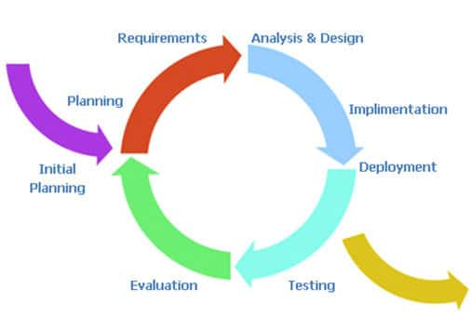

*Figure 2.1: Incremental and Iterative Model*

Incremental and Iterative software development is a method of software development that is modeled around a gradual increase in feature additions and a cyclical release and upgrade pattern. This method begins with planning and continues through iterative development cycles involving continuous user feedback and the incremental addition of features concluding with the deployment of completed software at the end of each cycle. It is one of the methodologies of Agile software development, rational unified process and extreme programming.

* 1. **Project Lifecycle**

This project is divided into 2 phase: Phase 1 and Phase 2. Each Phase goes through planning, requirement specification, analysis and design, development, testing and evaluation. In each Phase we base on result of the previous Phase to plan and specify requirement and develop additional function for the system.

* 1. **Role and Responsibilities**

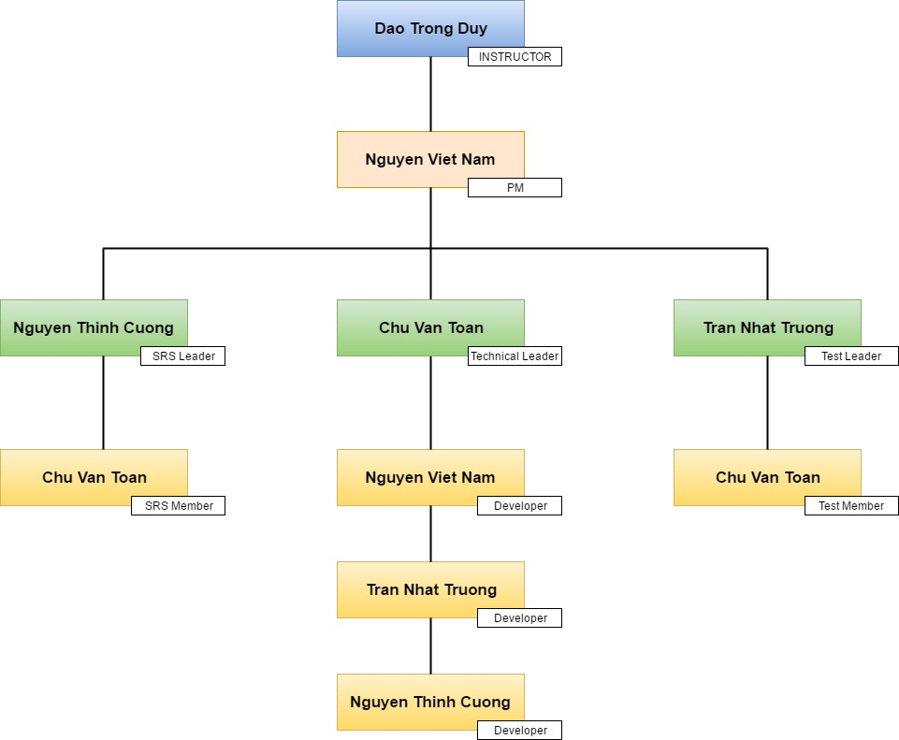

*Figure 2.2: Organization Structure*

|  |  |  |
| --- | --- | --- |
| **Role** | **Full Name** | **Responsibility** |
| Instructor | Dao Trong Duy | * Give instruction for project team. * Verify Deliverables. * Supervise project team’s status |
| PM | Nguyen Viet Nam | Have overall responsibility of the project:   * Create project plan. * Assign task to team members. * Tracking team member’s work. * Report work status to the instructor |
|  ***Requirement analysis team*** | | |
| SRS Leader | Nguyen Thinh Cuong | Complete SRS document and submit to PM. |
| SRS Member | Chu Van Toan | Create user case diagram  Specify non-functional requirement |
|  ***Technical team*** | | |
| Technical Leader | Chu Van Toan | * Create coding convention * Decide technique and tools to be used * Develop website |
| Developer #1 | Nguyen Viet Nam | Together with team leader develop website |
| Developer #2 | Nguyen Thinh Cuong | Together with team leader develop website |
| Developer #3 | Tran Nhat Truong | Together with team leader develop website |
|  ***Test team*** | | |
| Test Leader | Tran Nhat Truong | * Create test plan * Create test case * Report test result |
| Test Member | Chu Van Toan | * Implement test case |

1. **TOOL AND INFRASTRUCTURES**
   1. **Hardware**

* Personal computer for coding and testing with minimum configuration of 4GB RAM, 320GB of hard disk, Intel core i5
* Internet network connection
  1. **Software**

|  |  |  |
| --- | --- | --- |
| **Category** | **Software Name** | **Version** |
| Operating System | Microsoft Windows 10 | Professional |
| Office Tools | Microsoft Word | 2016 |
| Microsoft Excel | 2016 |
| Microsoft Power Point | 2016 |
| Management Tools | Microsoft Project | 2016 |
| Google Driver |  |
| Design Tools | [www.draw.io](http://www.draw.io) |  |
| Balsamiq Mockups | 3.5.9 |
| Development Tools | Eclipse |  |
| Database Tools | SQL Server Management Studio |  |
| Source Code Management Tool | Riouxsvn |  |

1. **SCHEDULE**

* **Detailed Schedule**

Below is the image of work schedule for this project.

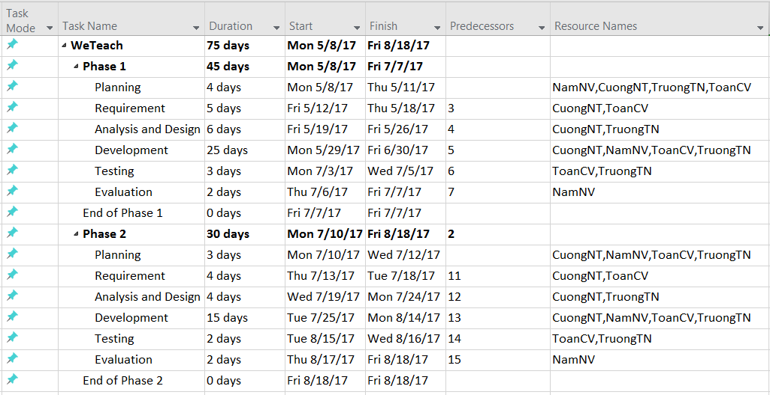

*Figure 2.3: Task List*

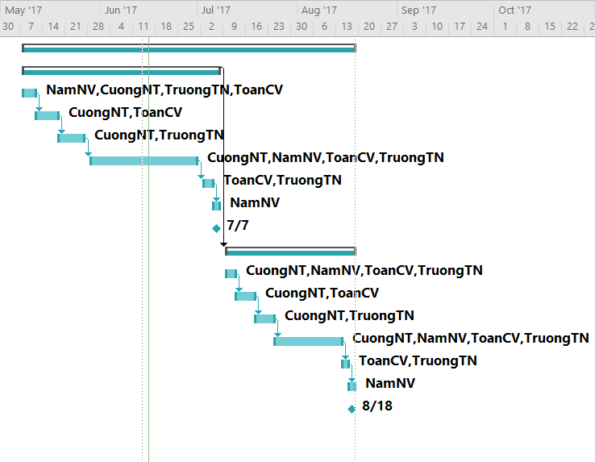

*Figure 2.4: Grant Chart*

1. **COMMUNICATION MANAGEMENT**
   1. **Meeting Schedule**

We scheduled to meet the instructor once a week and have our own meeting which is also once a week to assign work and resolve all the problems that we have to face during working time.

* 1. **Communication Channels**

Our main communication channels are physical meeting, email, Facebook Messager…

1. **RISK MANAGEMENT**
   1. **Risk Analysis**
   2. **Evaluate Risk**

|  |  |  |  |  |
| --- | --- | --- | --- | --- |
| **Risk Code** | **Risk** | **Avoidance Plan** | **Contingency Plan** | **Impact** |
| R01 | Team member is not pulling their weight. | Create friendly but professional environment.  Listen and give everybody the chance to speak out their ideas. | Talk to them directly.  Talk about this issues with the team to work it out. | High |
| R02 | Team member lack of knowledge and skill. | Provide training classes for team members. | Project Manager have responsibility to monitor and support team members whenever they need. | Medium |
| R03 | Team member have conflict. | Organize team building to create a cohesive group. | Bring up the issue with the team and together find the solution. | High |
| R04 | The product does not receive a good feedback from the customer. | Meet customer at least 1 time per 2 weeks to discuss and review website’s requirement. | Specify customer’s required again and work overtime if necessary. | High |
| R05 | Deliver the website later than expected. | Project Manager have responsibility to make sure everything is on track. | Work overtime if necessary. | High |
| R06 | Data lost | Always backup data using SVN or Google Docs. Each team member also should keep data file in their own computer. | Try to restore as much data as possible. | High |
| R07 | Requirement changing too much. | The team and customer together agree on the requirement. The team have responsibility to give customer advise. | Carefully review the requirement to decide if it’s necessary to be change. Work overtime if necessary. | Medium |

1. **CONFIGURATION MANAGEMENT**
   1. **Version Numbering Rules**

* **For Documents:**

Each file has a version number as part of its identity. This version number is physically represented as a 2-part string with the following format: <version>.<revision>

For example, version 1.0 indicates 1 as the version, and 0 as the revision number.

The original version will be numbered 0.1. Subsequent revisions will be numbered 0.2, 0.3 and so on. The approved version will be 1.0.

* **Version number:** appears to the left of the decimal. It is changed only when the core content of the item is significance changed. For example: when a item is completely overhauled, with substantial internal changes, the version 1.0 would become version 2.0.
* **Revision number:** appears to the right of the decimal. It is changed when the existing content is changed, but the main (or core) content is remained. The normal sequence of revision is 1.1, 1.2, and so on.
* **For Software Source Files:**

Software executables and support files are generally identified by name and version number.

The version number is physically represented as a 3-part string with the following format: <version>.<revision><update>.

For example, version 1.1a indicates 1 as the version, 0 as the revision number, and a as the update level.

* **Version number:** appears to the left of the decimal. It is changed only when the core content of the item is significance changed, as when moving from one are of the development tool to another, when an application is completely overhauled, or the user interface changes fundamentally. In this case, version 1.1a would become version 2.0.
* **Revision number:** appears to the right of the decimal. It is changed when new features, functionality or other content are added or significantly changed. In normal case, the core architecture or user interface have been extended or limited in some manner. The most common reason for changing the revision number is adding a new module or other functionality to the software. The normal sequence of revision is 1.0, 1.1 and 1.2 and so on.
* **Update level:** is appended or incremented when the only change to the software item is to correct on or more defects, without the addition of any new function. Version 1.1 would become v1.1a, 1.1b and so on. This updating is overridden when a combination revision, involving bug fixes and new feature additions, is performed. In such a case, the software revision number is incremented and any update indicator is dropped, as in v1.1b to 1.2.
  1. **Directory Structure**

A folder for storing all project documents is created on Github. This folder includes of some main folders as viewed following table:

|  |  |  |
| --- | --- | --- |
| **Main Folder** | **Sub-folder** | **Purpose** |
| **Templates** |  | Store templates of documents |
| **Meeting Minutes** |  | Store project meeting minutes |
| **Project Report** | TE_Report1_ProjectIntroduction | Store Introduction Document |
| TE_Report2_ProjectManagementPlan | Store PMP and related files |
| TE_Report3_SoftwareRequirementSpecification | Store SRS and related files |
| TE_Report4_SoftwareProjectDesignDescription | Store SDD and related files |
| TE_Report5_SoftwareProjectTestDocumentation | Store STD and related files |
| TE_Report6_SoftwareUserManual | Store SUM and related files |
| **Source Code** | Phase 1 | Store source code completed in Phase 1 |
| Phase 2 | Store source code completed in Phase 2 |
| **Training** |  | Store training documents of team members |

1. **CODING CONVENTION**
   1. **Coding Convention**

* Using prefix “TE” for each classes or constants – For example: TE_ImangeProcessor.
* Naming class: Use the uppercase letter for the first character
* Naming variables:
* Start the name with a lowercase letter and capitalize the first letter of embedded words.
* Start the name with a verb.
* Don’t use prefixes.
* Use keywords before all arguments.
* Make the word before the argument describe the argument.
  1. **Comment Convention**
* Write comment for all functions and important logic.

**Chapter 3: Software Requirement Specification**

1. **Introduction**
   1. **Purpose**

This document is created as the introduction for project WeTeach – our Capstone Project at FPT University.

* 1. **Scope**

WeTeach is an education website for all ages. Our goal is *leaners* (The one who look for courses) find a best course that have high quality content, reasonable price and the most inportant is suitable for them; and through our website, *trainer* and *leaner* can introduce their course to everyone who need it.

Our website will provide *trainer* analytics about number of course view from leaners, geography... to help them increase their courses’ quality.

The interface of the website must be simple and easy to use. The website must have the interface as well as logical layout, attractive design. Moreover, the website must also have an interesting and diversity content to attract more user.

WeTeach use interface language is English because we want to attract not only Vietnamese learners and trainers but also expats especially those who looking for teaching opportunity.

1. **Overview**
   1. **Overview Description**
      1. **System Overview**

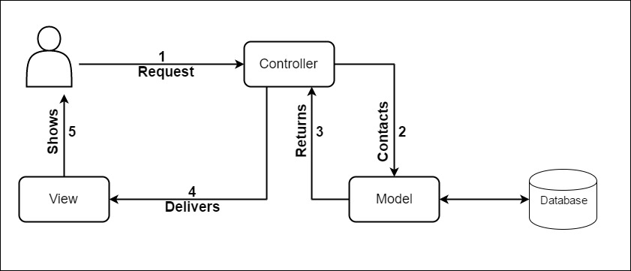

*Figure 3.1: System Overview*

* + 1. **Entity-Relationship Model**
       1. **Entity-Relationship Model**
       2. **Entity Details**
    2. **Product Feature**

|  |  |  |  |
| --- | --- | --- | --- |
| **Use Case No.** | **Function Name** | **Actor** | **Description** |
| UC01 | Sign Up as Trainer | Gs | Create new trainer account. |
| UC02 | Sign Up as Learner | Gs | Create new learner account. |
| UC03 | Sign In | Ad, Tr, Lr | Login in to WeTeach’s system. |
| UC04 | Log Out | Ad, Tr, Lr | Log out of WeTeach’s system. |
| UC05 | Change Password | Ad, Tr, Lr | This allows users to change their password. |
| UC06 | Forget Password | Ad, Tr, Lr | This allows users to reset password every time they forget. |
| UC07 | Update Profile Picture | Ad, Tr, Lr | This allows users to change their profile picture. |
| UC08 | View Personal Profile | Ad, Tr, Lr | This allows users to see their personal detail. |
| UC09 | Send Messages | Ad, Tr, Lr | This allows users to send messages to others. |
| UC10 | View Messages | Ad, Tr, Lr | This allows users to view their messages. |
| UC11 | Delete Message | Ad, Tr, Lr | This allows users to delete messages. |
| UC12 | Comment Course | Ad, Tr, Lr | Users can comment under each course. |
| UC13 | Edit Comment | Ad, Tr, Lr | Users can edit their comment. |
| UC14 | Delete Comment | Ad, Tr, Lr | Users can delete their comment. |
| UC15 | Rate Course | Ad, Tr, Lr | This allows users to rate courses. |
| UC16 | Rate Trainer | Ad, Tr, Lr | Users can rate trainers. |
| UC17 | View Course Statistic | Ad, Tr | Trainers can view their course statistic. |
| UC18 | Create New Course | Ad, Tr | This allows trainers to create new course. |
| UC19 | Edit Course Detail | Ad, Tr | This allows trainers to edit course detail. |
| UC20 | Delete Courses | Ad, Tr | Trainers can delete their course. |
| UC21 | Upload Documents | Ad, Tr | Trainers can upload document such as certification… |
| UC22 | Delete Documents | Ad, Tr | Trainers can delete their document. |
| UC23 | View Documents Dashboard | Ad, Tr | This allows trainers to access their document dashboard. |
| UC24 | Edit Profile Trainer | Ad, Tr | This allows trainers to edit their profile. |
| UC25 | View Course Detail | Ad, Tr, Lr, Gs | This allows users to view course detail. |
| UC26 | Search Course | Ad, Tr, Lr, Gs | This allows users to search for course. |
| UC27 | View Trainer List | Ad, Tr, Lr, Gs | This allows users to view trainers list. |
| UC28 | View Other Public Profile | Ad, Tr, Lr, Gs | This allows users to view other profile. |
| UC29 | View Course Comment | Ad, Tr, Lr, Gs | This allows users to view comment under each course detail. |
| UC30 | View Course’s Rate | Ad, Tr, Lr, Gs | Users can view course’s rate. |
| UC31 | View Trainer’s Rate | Ad, Tr, Lr, Gs | Users can view trainer’s rate. |
| UC32 | View Document Picture | Ad, Tr, Lr, Gs | This allows users to view trainer’s document. |
| UC33 | View Website Statistic | Ad | This allows admin to view website’s statistic. |
| UC34 | Review Trainer’s Document | Ad | Admin can review trainer’s document before publishing. |
| UC35 | Review New Course | Ad | Admin can review course before publishing. |
| UC36 | Review Trainer’s Account | Ad | This allows admin to review trainer’s account before providing trainer permission. |
| UC37 | Block Learners | Ad | Admin can block learners. |
| UC38 | Block Trainers | Ad | Admin can block trainers. |
| UC39 | Unblock Learners | Ad | Admin can unblock learners. |
| UC40 | Unblock Trainers | Ad | Admin can unblock trainers. |
| UC41 | Add New Trainer Account | Ad | This allows admin to add new trainer account. |
| UC42 | Add New Learner Account | Ad | This allows admin to add new learner account. |
| UC43 | Edit Trainer’s Information | Ad | This allows admin to edit trainer’s information. |
| UC44 | Edit Learner’s Information | Ad | This allows admin to edit learner’s information. |
| UC45 | Delete Trainer’s Account | Ad | Admin can delete trainer’s account. |
| UC46 | Delete Learner’s Account | Ad | Admin can delete learner’s account. |
| UC47 | Change Trainer’s Role | Ad | Admin can change trainer’s role. |
| UC48 | Change Learner’s Role | Ad | Admin can change learner’s role. |
| UC49 | Edit Profile (Learner) | Ad, Lr | This allows learners to edit their profile. |
| UC50 | Save Course | Ad, Lr | This allows learner to save course. |
| UC51 | View Course Saved List | Ad, Lr | This allows learner to view course saved list. |
| UC52 | View Course View History | Ad, Lr | This allow learner to view course view history. |

*Table 3.: Product Feature*

* 1. **Use Case Diagram**
     1. **Administrator, Trainer and Learner Use Case Diagram**

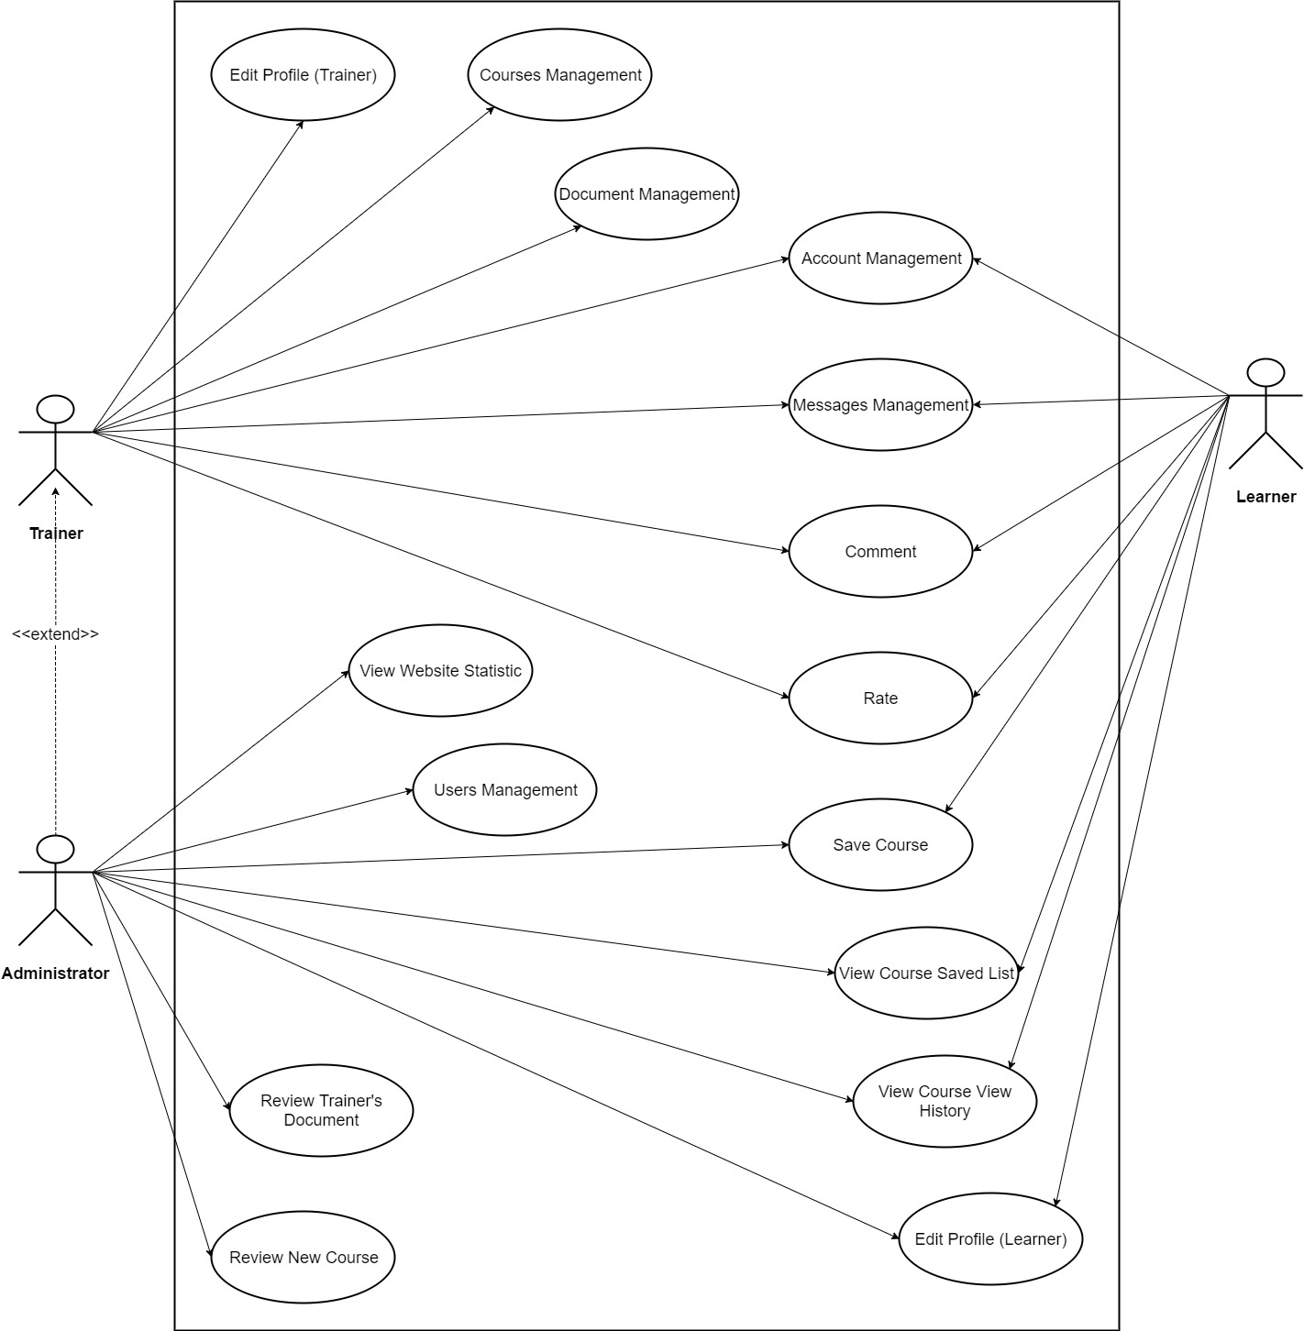

*Figure 3.3: Administrator, Trainer and Learner Use Case Diagram*

* + 1. **Guest Use Case Diagram**

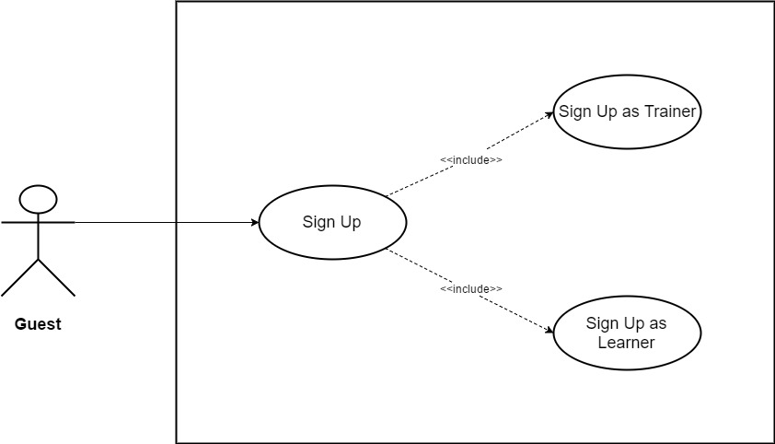

*Figure 3.4: Guest Use Case Diagram*

* + 1. **Administrator, Trainer, Learner, Guest Use Case Diagram**

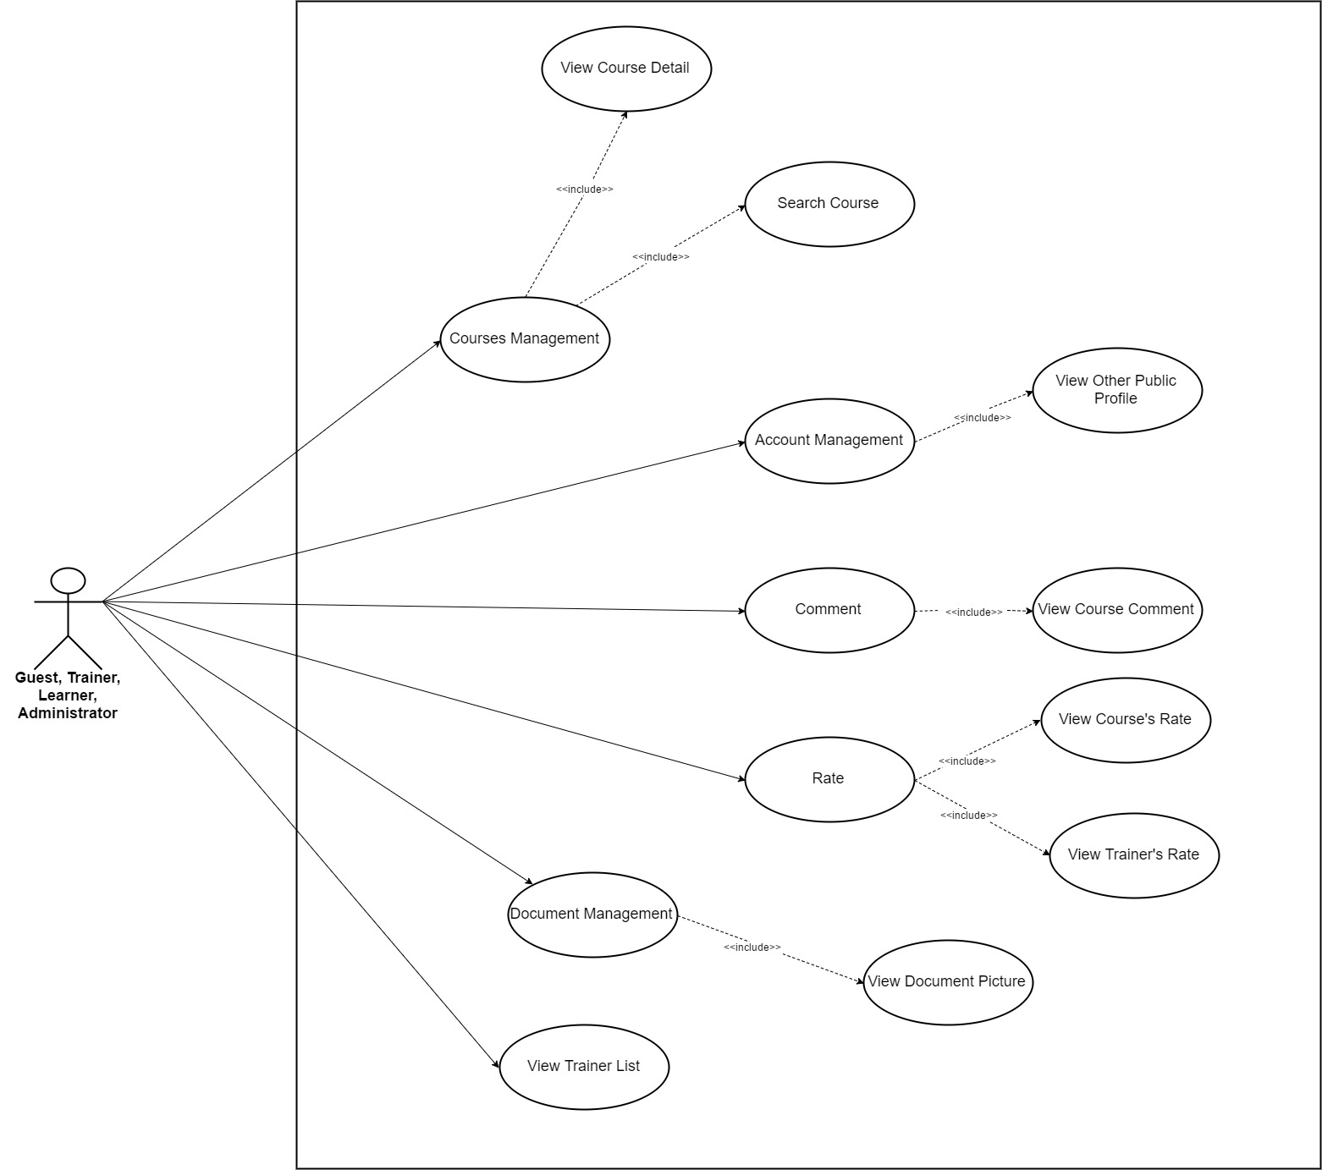

*Figure 3.5: Administrator, Trainer, Learner and Guest Use Case Diagram*

* + 1. **Use Case Diagram about Course Management**

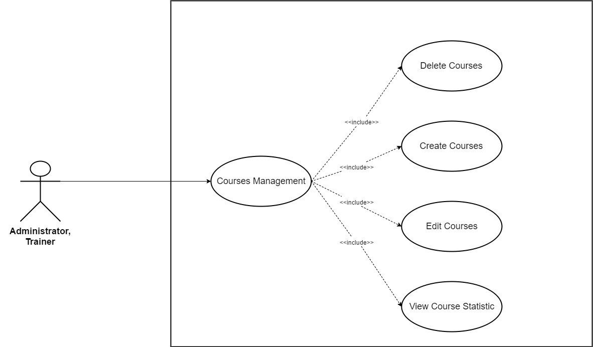

*Figure 3.6: Use Case Diagram about Course Management*

* + 1. **Use Case Diagram about Document Management**

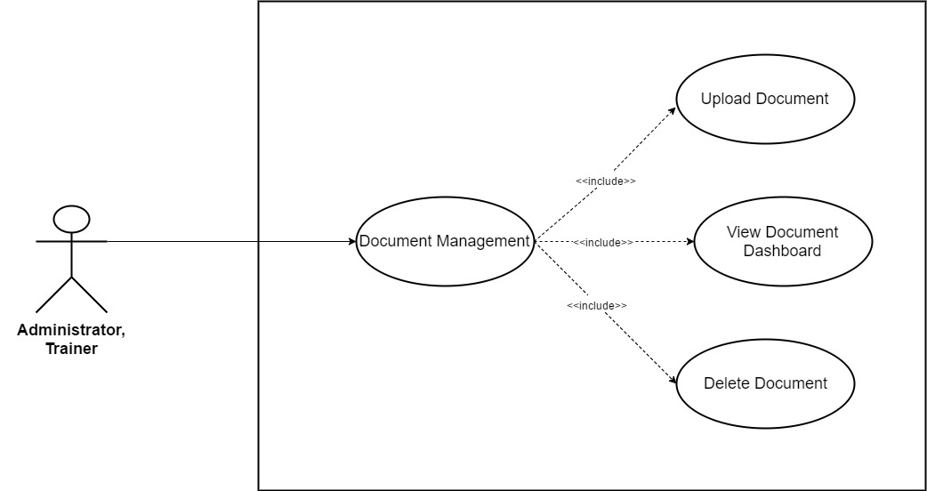

*Figure 3.7: Use Case Diagram about Document Management*

* + 1. **Use Case Diagram about Account Management**

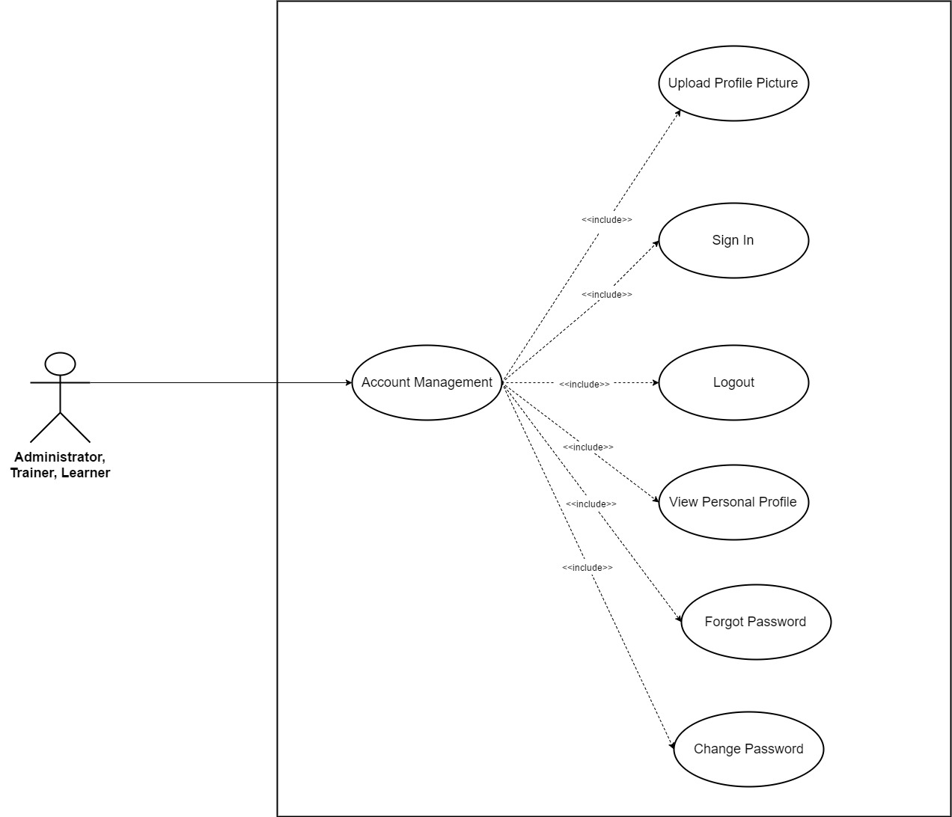

*Figure 3.8: Use Case Diagram about Account Management*

* + 1. **Use Case Diagram about Message Management**

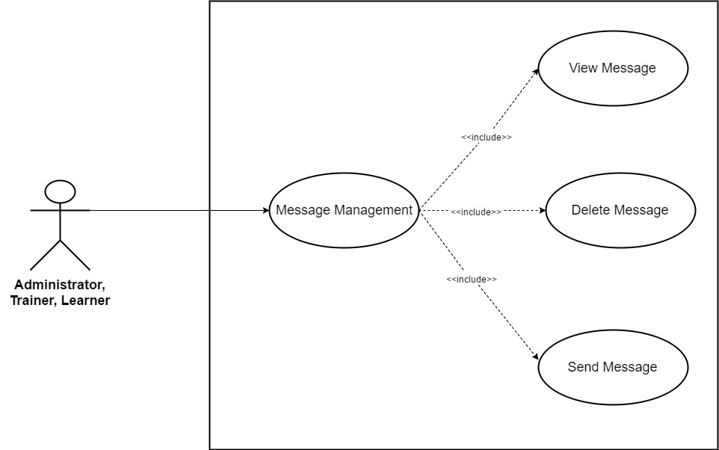

*Figure 3.9: Use Case Diagram about Message Management*

* + 1. **Use Case Diagram about Comment**

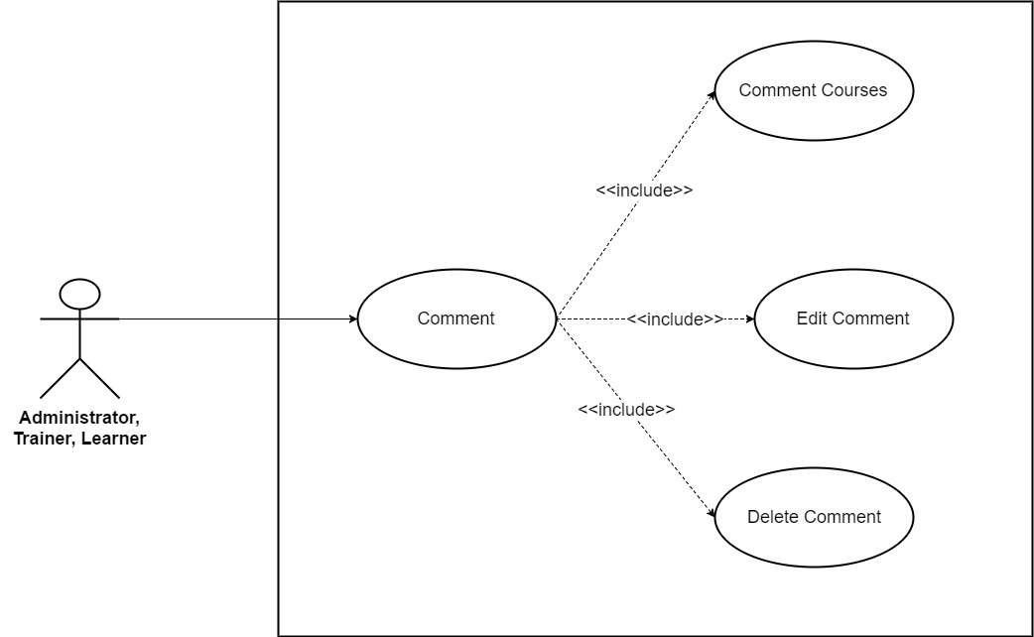

*Figure 3.10: Use Case Diagram about Comment*

* + 1. **Use Case Diagram about Rate**

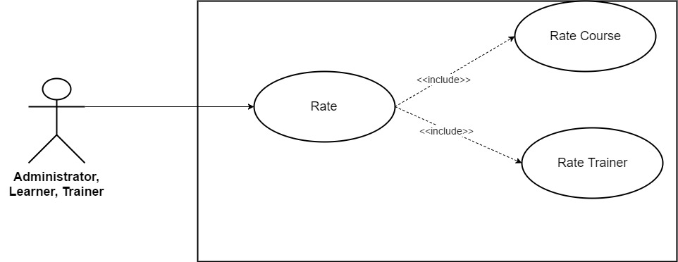

*Figure 3.11: Use Case Diagram about Rate*

* + 1. **Use Case Diagram about Users Management**

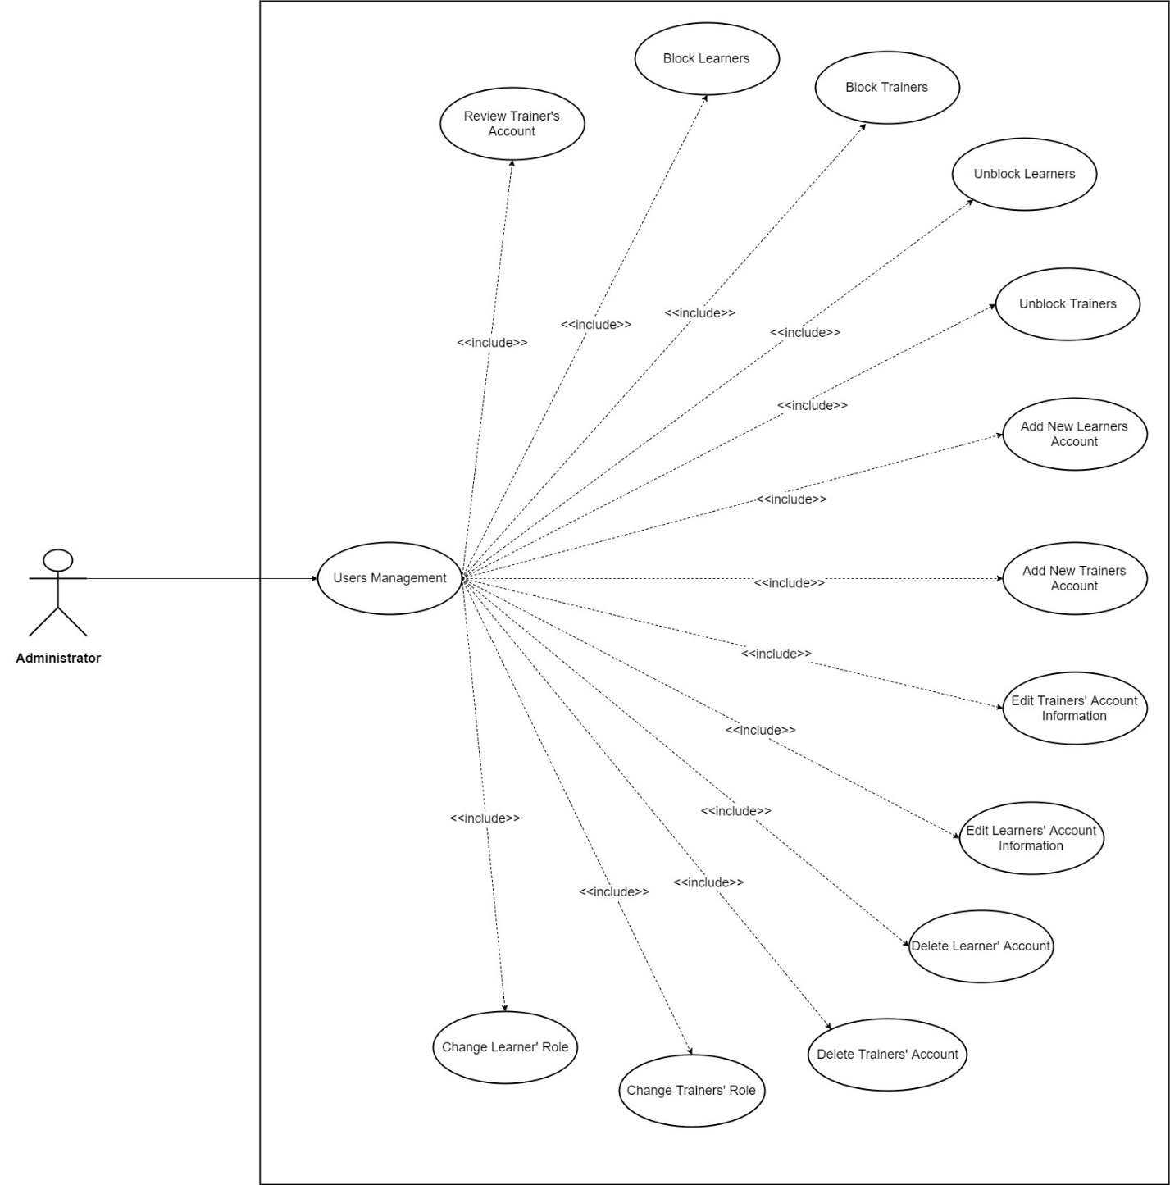

*Figure 3.12: Use Case Diagram about Users Management*

1. **Functional Requirements**
   1. **Business Rules**

|  |  |  |
| --- | --- | --- |
| **ID** | **Business Rules Name** | **Business Rules Description** |
| BR1 | User details | The following details are required when create a new user:   * Email * Password * Confirm Password * Account Type * First Name * Last Name * Gender * DOB * Phone Number * Job * Profile Picture * Biography   For Trainer:   * Fields * Document (include Certification…) |
| BR2 | Email | Email’s format must be abc@xyz |
| BR3 | Password | Password must contains at least one upper case, one number, one special character and length must be >8 |
| BR4 | Introduction | Length must be < 200 |
| BR5 | Fields | Fields must belong to one of the following categories:   * Development * Business * IT & Software * Personal Development * Design * Marketing * Office Productivity * Music * Health & Fitness * Teacher Training * Music * Language * Academic |
| BR6 | Rate Course | Users can rate each course as many times as they want but the system will only record the latest one. |
| BR7 | Rate Trainer | Users can rate each Trainer as many times as they want but the system will only record the latest one. |
| BR8 | Course Statistic | The system will only record data from logged in users not guest. |
| BR9 | Create New Course – Course Goals | Each text input’s length must be < 150 |
| BR10 | Create New Course – Curriculum | Required format: .xlxs |
| BR11 | Create New Course – Course Title | Length must be < 100 |
| BR12 | Create New Course – Course Subtitle | Length must be < 150 |
| BR13 | Create New Course – Course Description | Length must be < 1000 |
| BR14 | Create New Course – Course Image | Upload one image only. Required dimensions: 2048x1152 pixels. Required format: .jpg, .jpeg, .gif, .bmp or .png |
| BR15 | Create New Course – Promotional Video | Upload one video only. Required quality: at least 360p. Required format: .mp4 |
| BR16 | Create New Course – Auto Reply | Length must be < 200 |
| BR17 | Create New Course | Course Title, Course Subtitle, Course Description, Language, Level, Category, Course Image, Fee are required. |
| BR18 | Document | Required format: .pdf, .png, .jpg.. |
| BR19 | Login | Username and Password can’t be blank. |

*Table 3. : Business Rules*

* 1. **Functionality**
     1. **Guest**

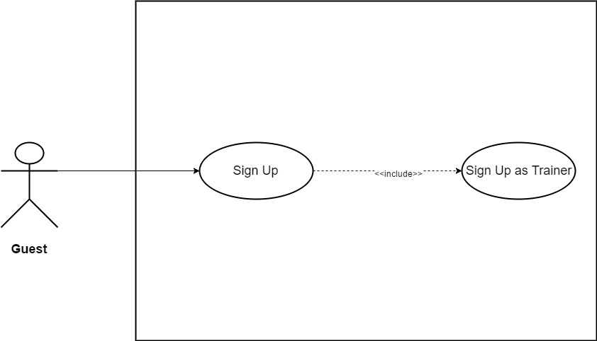

*Figure 3.13: Sign Up as Trainer*

|  |  |  |  |  |
| --- | --- | --- | --- | --- |
| **Use Case ID** | UC01 | | **Version** | 1.0 |
| **Use Case Name** | Sign Up as Trainer | | | |
| **Create By** | TruongTN | | **Last Updated** |  |
| **Primary Actor** | Guest | | **Secondary Actor** |  |
| **Description** | Create new account for *Trainer* | | | |
| **Pre-Conditions** | * User must have valid account. * Internet connection is required. | | | |
| **Post-Conditions** | * User account information is added into Database. * User can sign in as *Trainer* | | | |
| **Normal Flows** | | | | |
| **Step** | **Actor** | **Action** | | |
| 1 | Guest | Click on "Sign up" menu, the menu stays on the right side of search bar. | | |
| 2 | System | Display role choosing page. There are two roles that user can sign up for: *Trainer* and *Learner.* | | |
| 3 | Guest | Click “*Trainer”.* | | |
| 4 | System | Display “Sign Up” page which contain the following information:   * Sign Up via Google * Sign Up via Facebook * Email (Text Input) * Password (Text Input) * Confirm Password (Text Input) * Trainer Name (Text Input) * Fields (Combo Box) * Contact (Text Input) * Address (Text Input) * Introduction (Text Area) * Document. | | |
| 5 | Guest | Enter all required information. | | |
| 6 | Guest | Click “Sign Up” button. | | |
| 7 | System | Add account information into system Database. | | |
| 8 | System | Display Homepage. User appears as Trainer. | | |
|  | | | | |
| **Exception** | | | | |
| **EC1** | At step 5, all or more than one required fields are blank. | | | |
| **Step** | **Actor** | **Action** | | |
| 5.1 | Guest | Leave all required field blank. | | |
| 5.2 | Guest | Click “Sign Up” button. | | |
| 5.3 | System | Display message: “Please Fill In All Required Field!” | | |
| **EC2** | At step 5, *Email* is left blank. | | | |
| **Step** | **Actor** | **Action** | | |
| 5.1 | Guest | Leave *Email* field blank. | | |
| 5.2 | Guest | Click “Sign Up” button. | | |
| 5.3 | System | Display message: “Please Enter Email!” | | |
| **EC3** | At step 5, only *Password* is left blank. | | | |
| **Step** | **Actor** | **Action** | | |
| 5.1 | Guest | Leave *Password* field blank. | | |
| 5.2 | Guest | Click “Sign Up” button. | | |
| 5.3 | System | Display message: “Please Enter Password!” | | |
| **EC4** | At step 5, only *Trainer Name* is left blank. | | | |
| **Step** | **Actor** | **Action** | | |
| 5.1 | Guest | Leave *Trainer Name* field blank. | | |
| 5.2 | Guest | Click “Sign Up” button. | | |
| 5.3 | System | Display message: “Please Enter Trainer Name!” | | |
| **EC5** | At step 5, only *Fields* is not selected. | | | |
| **Step** | **Actor** | **Action** | | |
| 5.1 | Guest | Do not select *Fields.* | | |
| 5.2 | Guest | Click “Sign Up” button. | | |
| 5.3 | System | Display message: “Please Select Fields!” | | |
| **EC6** | At step 5, only *Contact* is left blank. | | | |
| **Step** | **Actor** | **Action** | | |
| 5.1 | Guest | Leave *Contact* field blank. | | |
| 5.2 | Guest | Click “Sign Up” button. | | |
| 5.3 | System | Display message: “Please Enter Password!” | | |
| **EC7** | At step 5, only *Address* is left blank. | | | |
| **Step** | **Actor** | **Action** | | |
| 5.1 | Guest | Leave *Address* field blank. | | |
| 5.2 | Guest | Click “Sign Up” button. | | |
| 5.3 | System | Display message: “Please Enter Address!” | | |
| **EC8** | At step 5, *Email* is invalid. (Incorrect *Email* format: abc@xyz) | | | |
| **Step** | **Actor** | **Action** | | |
| 5.1 | Guest | Enter invalid *Email*. | | |
| 5.2 | Guest | Click “Sign Up” button. | | |
| 5.3 | System | Display message: “Invalid Email!” | | |
| **EC9** | At step 5, *Password*’s length < 8. | | | |
| **Step** | **Actor** | **Action** | | |
| 5.1 | Guest | Enter *Password* less than 8 characters. | | |
| 5.2 | Guest | Click “Sign Up” button. | | |
| 5.3 | System | Display message: “Password must contains at least one upper case, one number, one special character and length must be >8!” | | |
| **EC10** | At step 5, *Password* does not contain any upper case. | | | |
| **Step** | **Actor** | **Action** | | |
| 5.1 | Guest | Enter *Password* that does not contain any upper case. | | |
| 5.2 | Guest | Click “Sign Up” button. | | |
| 5.3 | System | Display message: “Password must contains at least one upper case, one number, one special character and length must be >8!” | | |
| **EC11** | At step 5, *Password* does not contain any number. | | | |
| **Step** | **Actor** | **Action** | | |
| 5.1 | Guest | Enter *Password* that does not contain any number. | | |
| 5.2 | Guest | Click “Sign Up” button. | | |
| 5.3 | System | Display message: “Password must contains at least one upper case, one number, one special character and length must be >8!” | | |
| **EC12** | At step 5, *Password* does not contain at least one special character. | | | |
| **Step** | **Actor** | **Action** | | |
| 5.1 | Guest | Enter *Password* does not contain at least one special character. | | |
| 5.2 | Guest | Click “Sign Up” button. | | |
| 5.3 | System | Display message: “Password must contains at least one upper case, one number, one special character and length must be >8!” | | |
| **EC13** | At step 5, *Password* and *Confirm Password* do not match. | | | |
| **Step** | **Actor** | **Action** | | |
| 5.1 | Guest | Enter *Confirm Password* that does not match *Password.* | | |
| 5.2 | Guest | Click “Sign Up” button. | | |
| 5.3 | System | Display message: “Password does not match!” | | |
| **EC14** | At step 5, *Introduction*’s length > 200 character. | | | |
| **Step** | **Actor** | **Action** | | |
| 5.1 | Guest | Enter more than 200 character in *Introduction* field. | | |
| 5.2 | Guest | Click “Sign Up” button. | | |
| 5.3 | System | Display message: “Length must be < 200” | | |
| **EC15** | At step 5, User does not upload document. | | | |
| **Step** | **Actor** | **Action** | | |
| 5.1 | Guest | User does not upload document. | | |
| 5.2 | Guest | Click “Sign Up” button. | | |
| 5.3 | System | Display message: “Please upload at least one validate document such as University/College Graduation Certificate…” | | |
| **EC16** | At step 5, *Document* does not meet the format requirement. | | | |
| **Step** | **Actor** | **Action** | | |
| 5.1 | Guest | User upload wrong document’s format. | | |
| 5.2 | Guest | Click “Sign Up” button. | | |
| 5.3 | System | Display message: “Document’s format must be one of these following type: .pdf, .png, .jpeg!” | | |
| **EC17** | At step 5, Email address is already registered. | | | |
| **Step** | **Actor** | **Action** | | |
| 5.1 | Guest | Enter email address is already registered. | | |
| 5.2 | Guest | Click “Sign Up” button. | | |
| 5.3 | System | Display message: “The email address you have entered is already registered.” | | |
|  |  |  | | |
| **Priority** | High | | | |
| **Frequency of Use** | High | | | |
| **Business Rules** | BR1, BR2, BR3, BR4, BR5, BR6, BR17 | | | |

*Table 3.2: Sign Up as Trainer*

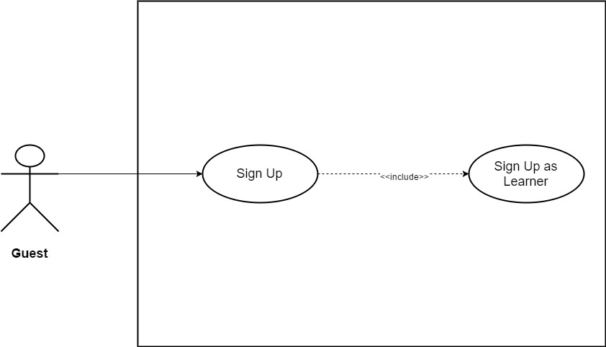

*Figure 3.14: Sign Up as Learner*

|  |  |  |  |  |
| --- | --- | --- | --- | --- |
| **Use Case ID** | UC02 | | **Version** | 1.0 |
| **Use Case Name** | Sign Up as Learner | | | |
| **Create By** | TruongTN | | **Last Updated** |  |
| **Primary Actor** | Guest | | **Secondary Actor** |  |
| **Description** | Create new account for *Learner* | | | |
| **Pre-Conditions** | * User must have valid account. * Internet connection is required. | | | |
| **Post-Conditions** | * User account information is added into Database. * User can sign in as *Learner* | | | |
| **Normal Flows** | | | | |
| **Step** | **Actor** | **Action** | | |
| 1 | Guest | Click on "Sign up" menu, the menu stays on the right side of search bar. | | |
| 2 | System | Display role choosing page. There are two roles that user can sign up for: *Trainer* and *Leraner.* | | |
| 3 | Guest | Click “*Learner”.* | | |
| 4 | System | Display “Sign Up” page which contain the following information:   * Sign Up via Google * Sign Up via Facebook * Email (Text Input) * Password (Text Input) * Confirm Password (Text Input) * First Name (Text Input) * Last Name (Text Input) * Gender (Radio Button) * Date of Birth (Date Picker) * Contact (Text Input) * Job (Text Input) * Introduction (Text Area) | | |
| 5 | Guest | Enter all required information. Gender default is “*Male*” | | |
| 6 | Guest | Click “Sign Up” button. | | |
| 7 | System | Add account information into system Database. | | |
| 8 | System | Display Homepage. User appears as *Learner*. | | |
|  | | | | |
| **Exception** | | | | |
| **EC1** | At step 5, all or more than one required fields are blank. | | | |
| **Step** | **Actor** | **Action** | | |
| 5.1 | Guest | Leave all required field blank. | | |
| 5.2 | Guest | Click “Sign Up” button. | | |
| 5.3 | System | Display message: “Please Fill In All Required Field!” | | |
| **EC2** | At step 5, *Email* is left blank. | | | |
| **Step** | **Actor** | **Action** | | |
| 5.1 | Guest | Leave *Email* field blank. | | |
| 5.2 | Guest | Click “Sign Up” button. | | |
| 5.3 | System | Display message: “Please Enter Email!” | | |
| **EC3** | At step 5, only *Password* is left blank. | | | |
| **Step** | **Actor** | **Action** | | |
| 5.1 | Guest | Leave *Password* field blank. | | |
| 5.2 | Guest | Click “Sign Up” button. | | |
| 5.3 | System | Display message: “Please Enter Password!” | | |
| **EC4** | At step 5, only *First Name* is left blank. | | | |
| **Step** | **Actor** | **Action** | | |
| 5.1 | Guest | Leave *First Name* field blank. | | |
| 5.2 | Guest | Click “Sign Up” button. | | |
| 5.3 | System | Display message: “Please Enter Your First Name!” | | |
| **EC5** | At step 5, only *Last Name* is left blank. | | | |
| **Step** | **Actor** | **Action** | | |
| 5.1 | Guest | Leave *Last Name* field blank. | | |
| 5.2 | Guest | Click “Sign Up” button. | | |
| 5.3 | System | Display message: “Please Enter Your Last Name!” | | |
| **EC6** | At step 5, only *Date of Birth* is not selected. | | | |
| **Step** | **Actor** | **Action** | | |
| 5.1 | Guest | Do not select *Date of Birth.* | | |
| 5.2 | Guest | Click “Sign Up” button. | | |
| 5.3 | System | Display message: “Please Select Date of Birth!” | | |
| **EC7** | At step 5, only *Contact* is left blank. | | | |
| **Step** | **Actor** | **Action** | | |
| 5.1 | Guest | Leave *Contact* field blank. | | |
| 5.2 | Guest | Click “Sign Up” button. | | |
| 5.3 | System | Display message: “Please Enter Password!” | | |
| **EC8** | At step 5, only *Job* is left blank. | | | |
| **Step** | **Actor** | **Action** | | |
| 5.1 | Guest | Leave *Job* field blank. | | |
| 5.2 | Guest | Click “Sign Up” button. | | |
| 5.3 | System | Display message: “Please Enter Job!” | | |
| **EC9** | At step 5, *Email* is invalid. (Incorrect *Email* format: abc@xyz) | | | |
| **Step** | **Actor** | **Action** | | |
| 5.1 | Guest | Enter invalid *Email*. | | |
| 5.2 | Guest | Click “Sign Up” button. | | |
| 5.3 | System | Display message: “Invalid Email!” | | |
| **EC10** | At step 5, *Password*’s length < 8. | | | |
| **Step** | **Actor** | **Action** | | |
| 5.1 | Guest | Enter *Password* less than 8 characters. | | |
| 5.2 | Guest | Click “Sign Up” button. | | |
| 5.3 | System | Display message: “Password must contains at least one upper case, one number, one special character and length must be >8!” | | |
| **EC11** | At step 5, *Password* does not contain any upper case. | | | |
| **Step** | **Actor** | **Action** | | |
| 5.1 | Guest | Enter *Password* that does not contain any upper case. | | |
| 5.2 | Guest | Click “Sign Up” button. | | |
| 5.3 | System | Display message: “Password must contains at least one upper case, one number, one special character and length must be >8!” | | |
| **EC12** | At step 5, *Password* does not contain any number. | | | |
| **Step** | **Actor** | **Action** | | |
| 5.1 | Guest | Enter *Password* that does not contain any number. | | |
| 5.2 | Guest | Click “Sign Up” button. | | |
| 5.3 | System | Display message: “Password must contains at least one upper case, one number, one special character and length must be >8!” | | |
| **EC13** | At step 5, *Password* does not contain at least one special character. | | | |
| **Step** | **Actor** | **Action** | | |
| 5.1 | Guest | Enter *Password* does not contain at least one special character. | | |
| 5.2 | Guest | Click “Sign Up” button. | | |
| 5.3 | System | Display message: “Password must contains at least one upper case, one number, one special character and length must be >8!” | | |
| **EC14** | At step 5, *Password* and *Confirm Password* do not match. | | | |
| **Step** | **Actor** | **Action** | | |
| 5.1 | Guest | Enter *Confirm Password* that does not match *Password.* | | |
| 5.2 | Guest | Click “Sign Up” button. | | |
| 5.3 | System | Display message: “Password does not match!” | | |
| **EC15** | At step 5, *Introduction*’s length > 200 character. | | | |
| **Step** | **Actor** | **Action** | | |
| 5.1 | Guest | Enter more than 200 character in *Introduction* field. | | |
| 5.2 | Guest | Click “Sign Up” button. | | |
| 5.3 | System | Display message: “Length must be < 200” | | |
| **EC16** | At step 5, Email address is already registered. | | | |
| **Step** | **Actor** | **Action** | | |
| 5.1 | Guest | Enter email address is already registered. | | |
| 5.2 | Guest | Click “Sign Up” button. | | |
| 5.3 | System | Display message: “The email address you have entered is already registered.” | | |
|  |  |  | | |
| **Priority** | High | | | |
| **Frequency of Use** | High | | | |
| **Business Rules** | BR1, BR2, BR3, BR4, BR5, BR6, BR17 | | | |

*Table 3.3: Sign Up as Learner*

* + 1. **Administrator/Trainer/Learner**

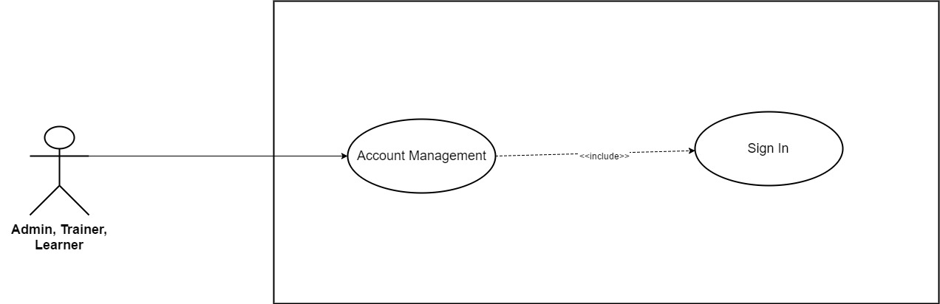 *Figure 3.15: Sign In*

|  |  |  |  |  |
| --- | --- | --- | --- | --- |
| **Use Case ID** | UC03 | | **Version** | 1.0 |
| **Use Case Name** | Sign In | | | |
| **Create By** | TruongTN | | **Last Updated** |  |
| **Primary Actor** | Trainer/Learner | | **Secondary Actor** | Administrator |
| **Description** | Sign in into System system | | | |
| **Pre-Conditions** | * User must have System’s account. * Internet connection is required. | | | |
| **Post-Conditions** | * User’s account is logged into system * Send user to Homepage after sign in. | | | |
| **Normal Flows** | | | | |
| **Step** | **Actor** | **Action** | | |
| 1 | Trainer/Learner | Click “Sign In” in the header to the right of Sign Up button. | | |
| 2 | System | Show “Sign In” window. | | |
| 3 | Trainer/Learner | Enter Email and Password. | | |
| 4 | Trainer/Learner | Click “Sign In”. | | |
| 5 | System | Log account into System’s system. | | |
| 6 | System | Send Trainer/Learner to Homepage. | | |
|  | | | | |
| **Exception** | | | | |
| **EC1** | At step 3, Email and Password are left blank.. | | | |
| **Step** | **Actor** | **Action** | | |
| 3.1 | Trainer/Learner | Leave Email and Password blank. | | |
| 3.2 | Trainer/Learner | Click “Sign In” button. | | |
| 3.3 | System | Display message: “Please Enter Email and Password!” | | |
| **EC2** | At step 3, Email is left blank. | | | |
| **Step** | **Actor** | **Action** | | |
| 3.1 | Trainer/Learner | Leave Email blank. | | |
| 3.2 | Trainer/Learner | Click “Sign In” button | | |
| 3.3 | System | Display message: “Please Enter Your Email!” | | |
| **EC3** | At step 3, Password is left blank. | | | |
| **Step** | **Actor** | **Action** | | |
| 3.1 | Trainer/Learner | Leave Password blank. | | |
| 3.2 | Trainer/Learner | Click “Sign In” button | | |
| 3.3 | System | Display message: “Please Enter Your Password!” | | |
| **EC4** | At step 3, Trainer/Learner enter wrong or un-register Email. | | | |
| **Step** | **Actor** | **Action** | | |
| 3.1 | Trainer/Learner | Enter wrong or un-register Email. | | |
| 3.2 | Trainer/Learner | Click “Sign In” button. | | |
| 3.3 | System | Display message: “The email address that you’re entered doesn’t match any account. Sign up for an account!”. | | |
| **EC5** | At step 4, Trainer/Learner enter wrong Password. | | | |
| **Step** | **Actor** | **Action** | | |
| 3.1 | Trainer/Learner | Enter wrong password. | | |
| 3.2 | Trainer/Learner | Click “Sign In” button | | |
| 3.3 | System | Display message: “The password that you’re entered is incorrect!”. | | |
|  |  |  | | |
| **Priority** | High | | | |
| **Frequency of Use** | High | | | |
| **Business Rules** | BR18 | | | |

*Table 3. : Sign In*

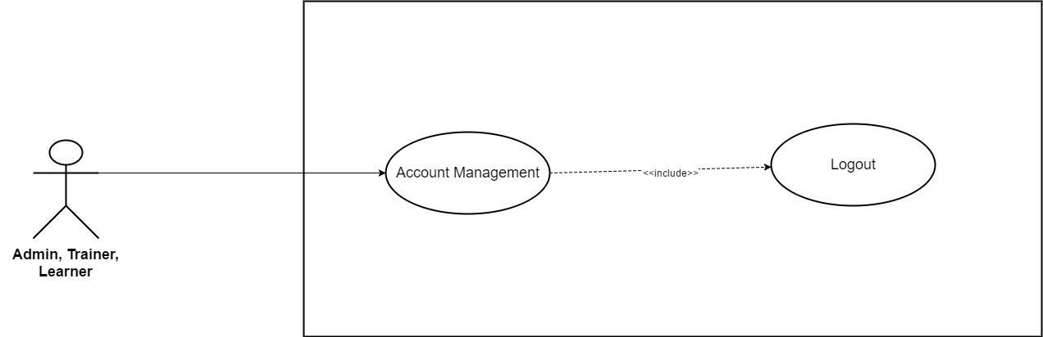

*Figure 3.16: Logout*

|  |  |  |  |  |
| --- | --- | --- | --- | --- |
| **Use Case ID** | UC04 | | **Version** | 1.0 |
| **Use Case Name** | Logout | | | |
| **Create By** | TruongTN | | **Last Updated** |  |
| **Primary Actor** | Trainer/Learner | | **Secondary Actor** | Administrator |
| **Description** | Logout of the system | | | |
| **Pre-Conditions** | * User must login first. * Internet connection is required. | | | |
| **Post-Conditions** | * User’s account is logged out of system. * Send user to homepage as Guest. | | | |
| **Normal Flows** | | | | |
| **Step** | **Actor** | **Action** | | |
| 1 | Trainer/Learner | Move mouse to Trainer/Learner’s name to the right of search bar. | | |
| 2 | System | Display drop-down list. | | |
| 3 | Trainer/Learner | Click “Logout” | | |
| 4 | System | Log user out of system. | | |
| 5 | System | Send user to Homepage as Guest. | | |
|  | | | | |
|  |  |  | | |
| **Priority** | High | | | |
| **Frequency of Use** | High | | | |
| **Business Rules** |  | | | |

*Table 3. : Logout*

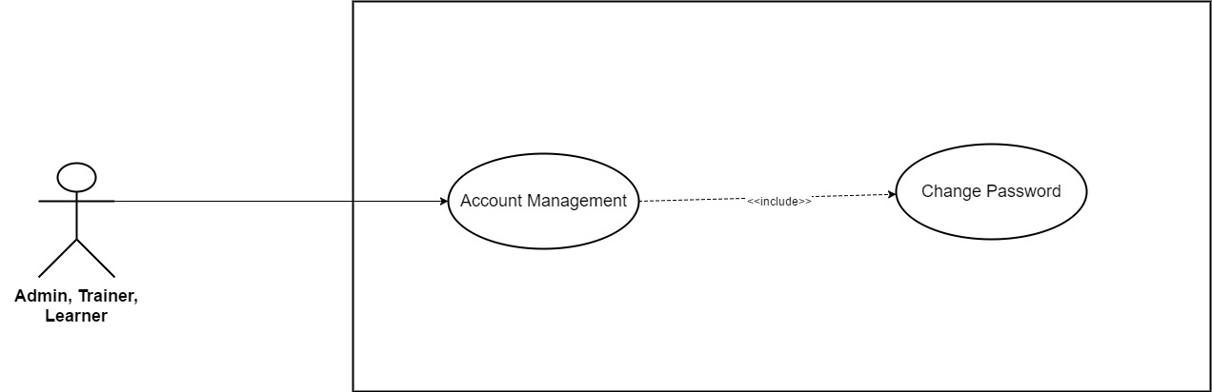

*Figure 3.17: Change Password*

|  |  |  |  |  |  |
| --- | --- | --- | --- | --- | --- |
| **Use Case ID** | UC05 | | | **Version** | 1.0 |
| **Use Case Name** | Change Password | | | | |
| **Create By** | TruongTN | | | **Last Updated** |  |
| **Primary Actor** | Trainer/Learner | | | **Secondary Actor** | Administrator |
| **Description** | Change password. | | | | |
| **Pre-Conditions** | * User must login first. * Internet connection is required. | | | | |
| **Post-Conditions** | * New password is saved and updated into system. | | | | |
| **Normal Flows** | | | | | |
| **Step** | **Actor** | | **Action** | | |
| 1 | Trainer/Learner | | Move mouse to Trainer/Learner’s name to the right of search bar. | | |
| 2 | System | | Display drop-down list. | | |
| 3 | Trainer/Learner | | Click “Change Password” | | |
| 4 | System | | Send Trainer to “Change Password” page | | |
| 5 | System | | Display “Change Password” page which contain the following information:   * Email * Current Password * New Password * Confirm New Password | | |
| 6 | Trainer/Learner | | Enter current password, new password and confirm new password. Email can’t be edit. | | |
| 7 | Trainer/Learner | | Click “Save” button. | | |
| 8 | System | | Update password into system’s Database. | | |
| 9 | System | | Display “Change Password” page with message: “Change Password Successfully!” | | |
|  | | | | | |
| **Exception** | | | | | |
| **EC1** | At step 6, only Current Password is left blank | | | | |
| **Step** | **Actor** | | **Action** | | |
| 6.1 | Trainer/Learner | | Leave only Current Password blank. | | |
| 6.2 | Trainer/Learner | | Click “Save” button. | | |
| 6.3 | System | | Display message: “Please Enter Your Current Password!” | | |
| **EC2** | At step 5, only New Password is left blank. | | | | |
| **Step** | **Actor** | | **Action** | | |
| 6.1 | Trainer/Learner | | Leave New Password blank. | | |
| 6.2 | Trainer/Learner | | Click “Save” button. | | |
| 6.3 | System | | Display message: “Please Enter New Password!” | | |
| **EC3** | At step 6, only Confirm New Password is blank. | | | | |
| **Step** | **Actor** | | **Action** | | |
| 6.1 | Trainer/Learner | | Leave Confirm New Password blank. | | |
| 6.2 | Trainer/Learner | | Click “Save” button. | | |
| 6.3 | System | | Display message: “Please Confirm New Password!” | | |
| **EC4** | At step 6, New Password and Confirm New Password does not match. | | | | |
| **Step** | **Actor** | | **Action** | | |
| 6.1 | Trainer/Learner | | New Password and Confirm New Password does not match. | | |
| 6.2 | Trainer/Learner | | Click “Save” button. | | |
| 6.3 | System | | Display message: “New Password and Confirm does not match!” | | |
| **EC5** | At step 6, Trainer/Learner enter wrong current password. | | | | |
| **Step** | **Actor** | | **Action** | | |
| 6.1 | Trainer/Learner | | Enter wrong current password. | | |
| 6.2 | Trainer/Learner | | Click “Save” button. | | |
| 6.3 | System | | Display message: “The Current Password that you’re entered is incorrect. Please enter again!” | | |
| **EC6** | At step 6, New Password’s length < 8. | | | | |
| **Step** | **Actor** | **Action** | | | |
| 6.1 | Guest | Enter New Password less than 8 characters. | | | |
| 6.2 | Guest | Click “Sign Up” button. | | | |
| 6.3 | System | Display message: “Password must contains at least one upper case, one number, one special character and length must be >8!” | | | |
| **EC7** | At step 6, New Password does not contain any upper case. | | | | |
| **Step** | **Actor** | **Action** | | | |
| 6.1 | Guest | Enter New Password that does not contain any upper case. | | | |
| 6.2 | Guest | Click “Sign Up” button. | | | |
| 6.3 | System | Display message: “Password must contains at least one upper case, one number, one special character and length must be >8!” | | | |
| **EC8** | At step 6, New Password does not contain any number. | | | | |
| **Step** | **Actor** | **Action** | | | |
| 6.1 | Guest | Enter New Password that does not contain any number. | | | |
| 6.2 | Guest | Click “Sign Up” button. | | | |
| 6.3 | System | Display message: “Password must contains at least one upper case, one number, one special character and length must be >8!” | | | |
| **EC9** | At step 6, New Password does not contain at least one special character. | | | | |
| **Step** | **Actor** | **Action** | | | |
| 6.1 | Guest | Enter New Password does not contain at least one special character. | | | |
| 6.2 | Guest | Click “Sign Up” button. | | | |
| 6.3 | System | Display message: “Password must contains at least one upper case, one number, one special character and length must be >8!” | | | |
|  |  |  | | | |
| **Priority** | High | | | | |
| **Frequency of Use** | High | | | | |
| **Business Rules** |  | | | | |

*Table 3. : Change Password*

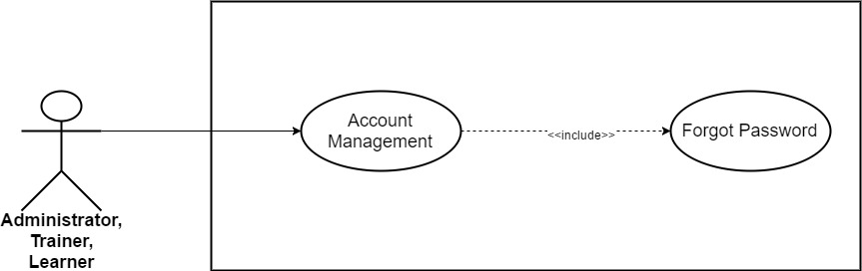

*Figure 3.17: Forget Password*

|  |  |  |  |  |  |
| --- | --- | --- | --- | --- | --- |
| **Use Case ID** | UC06 | | | **Version** | 1.0 |
| **Use Case Name** | Forget Password | | | | |
| **Create By** | TruongTN | | | **Last Updated** |  |
| **Primary Actor** | Trainer/Learner | | | **Secondary Actor** | Administrator |
| **Description** | Users use in case they forget their password. | | | | |
| **Pre-Conditions** | * Must have WeTeach’s account * Internet connection is required. | | | | |
| **Post-Conditions** | * Password reset and send new password to user’s email. | | | | |
| **Normal Flows** | | | | | |
| **Step** | **Actor** | | **Action** | | |
| 1 | Trainer/Learner | | Click “Sign In”. | | |
| 2 | System | | Display drop-down list. | | |
| 3 | Trainer/Learner | | Click “Forget Password!” | | |
| 4 | System | | Send Trainer to reset password page | | |
| 5 | Trainer/Learner | | Input email address that used to sign up into WeTeach. | | |
| 6 | System | | Send new password to their email. | | |
|  | | | | | |
|  |  |  | | | |
| **Priority** | High | | | | |
| **Frequency of Use** | High | | | | |
| **Business Rules** |  | | | | |

*Table 3. : Forget Password*

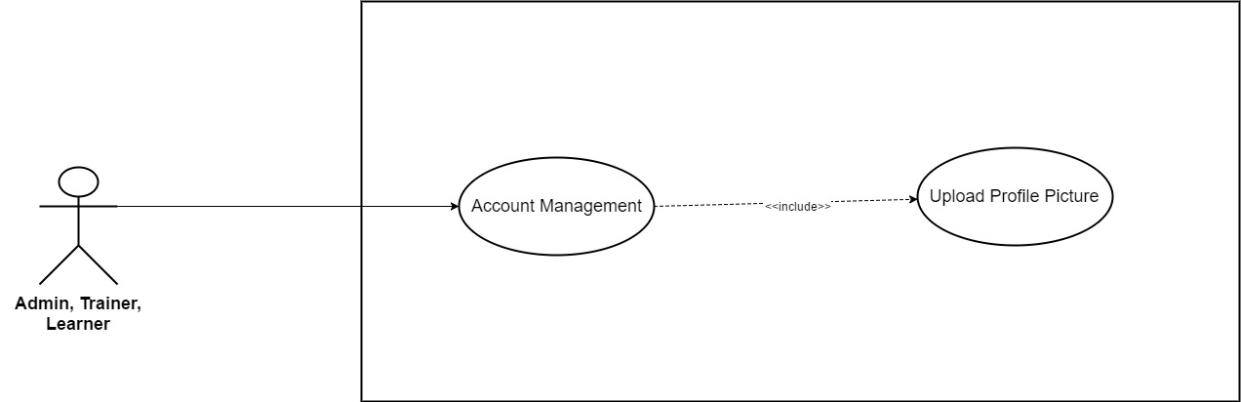

*Figure 3.18: Upload Profile Picture*

|  |  |  |  |  |
| --- | --- | --- | --- | --- |
| **Use Case ID** | UC07 | | **Version** | 1.0 |
| **Use Case Name** | Upload Profile Picture | | | |
| **Create By** | TruongTN | | **Last Updated** |  |
| **Primary Actor** | Trainer/Learner | | **Secondary Actor** | Administrator |
| **Description** | Upload profile picture. | | | |
| **Pre-Conditions** | * User must login first. * Internet connection is required. | | | |
| **Post-Conditions** | * Profile picture is saved into system. | | | |
| **Normal Flows** | | | | |
| **Step** | **Actor** | **Action** | | |
| 1 | Trainer/Learner | Move mouse to Trainer/Learner’s name to the right of search bar. | | |
| 2 | System | Display drop-down list. | | |
| 3 | Trainer/Learner | Click “My Profile” | | |
| 4 | System | Send Trainer to “My Profile” page | | |
| 5 | Trainer/Learner | Click on profile picture. | | |
| 6 | Trainer/Learner | Choose picture on device. | | |
| 7 | Trainer/Learner | Double click on the picture or click “Open” | | |
| 8 | System | Display message: “Your picture has been uploaded!” | | |
|  | | | | |
| **Exception** | | | | |
| **UC1** | At step 7, Trainer/Learner upload picture with different dimensions. | | | |
| **Step** | **Actor** | **Action** | | |
| 7.1 | Trainer/Learner | Upload picture with different dimensions. | | |
| 7.2 | System | Crop to fit a square. | | |
|  |  |  | | |
| **Priority** | High | | | |
| **Frequency of Use** | High | | | |
| **Business Rules** |  | | | |

*Table 3. : Upload Profile Picture*

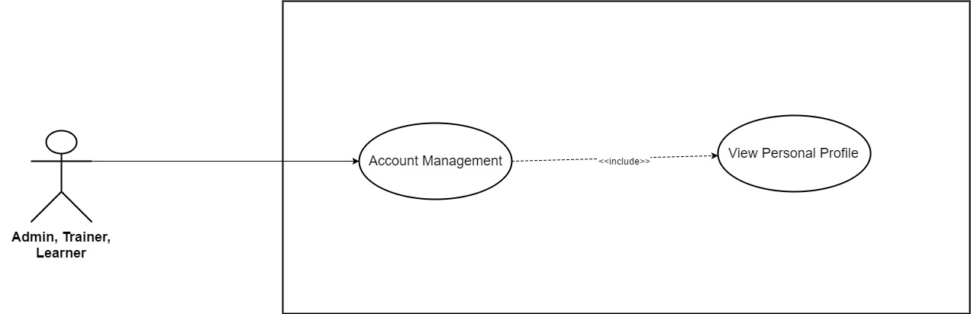

*Figure 3.19: View Personal Profile*

|  |  |  |  |  |
| --- | --- | --- | --- | --- |
| **Use Case ID** | UC08 | | **Version** | 1.0 |
| **Use Case Name** | View Personal Profile | | | |
| **Create By** | TruongTN | | **Last Updated** |  |
| **Primary Actor** | Trainer/Learner | | **Secondary Actor** | Administrator |
| **Description** | View Personal Profile | | | |
| **Pre-Conditions** | * User must login first. * Internet connection is required. | | | |
| **Post-Conditions** | * Display user personal profile. | | | |
| **Normal Flows** | | | | |
| **Step** | **Actor** | **Action** | | |
| 1 | Trainer/Learner | Move mouse to Trainer/Learner’s name to the right of search bar. | | |
| 2 | System | Display drop-down list. | | |
| 3 | Trainer/Learner | Click “My Profile” | | |
| 4 | System | Send Trainer/Learner to My Profile page | | |
| 5 | System | Display “My Profile” page which contain the following information:   * Email * Trainer Name * Fields * Contact * Address * Introduction | | |
|  |  |  | | |
| **Priority** | High | | | |
| **Frequency of Use** | High | | | |
| **Business Rules** |  | | | |

*Table 3. : View Personal Profile*

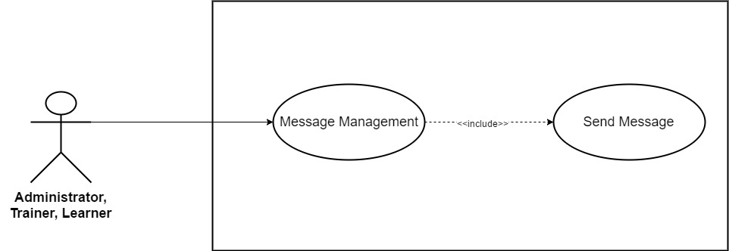

*Figure 3.20: Send Message*

|  |  |  |  |  |
| --- | --- | --- | --- | --- |
| **Use Case ID** | UC09 | | **Version** | 1.0 |
| **Use Case Name** | Send Message | | | |
| **Create By** | TruongTN | | **Last Updated** |  |
| **Primary Actor** | Trainer/Learner | | **Secondary Actor** | Administrator |
| **Description** | Send Message | | | |
| **Pre-Conditions** | * User must login first. * Internet connection is required. | | | |
| **Post-Conditions** | * Display messages page. | | | |
| **Normal Flows** | | | | |
| **Step** | **Actor** | **Action** | | |
| 1 | Trainer/Learner | Click the name of user that want to send message to. | | |
| 2 | System | Display public profile. | | |
| 3 | Trainer/Learner | Click “Send Message” | | |
| 4 | System | Pop up send message window. | | |
| 5 | Trainer/Learner | Input message. | | |
| 6 | Trainer/Learner | Click “Send” or enter. | | |
| 7 | System | Send message to receiver. | | |
|  | | | | |
| **Priority** | High | | | |
| **Frequency of Use** | High | | | |
| **Business Rules** |  | | | |

*Table 3. : Send Message*

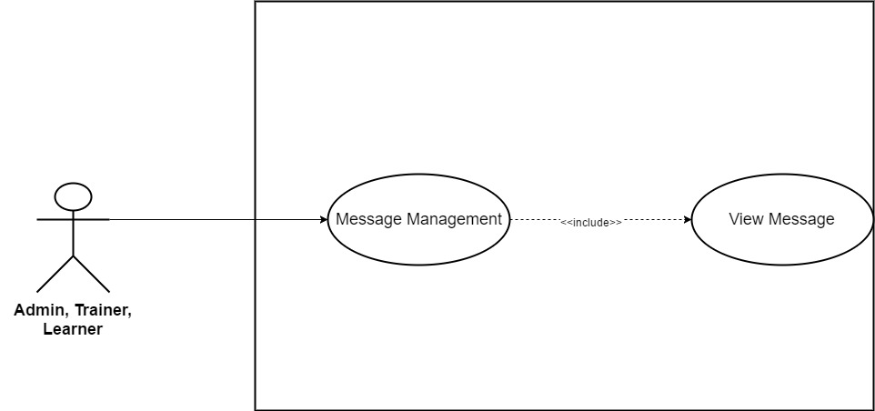

*Figure 3.21: View Message*

|  |  |  |  |  |
| --- | --- | --- | --- | --- |
| **Use Case ID** | UC10 | | **Version** | 1.0 |
| **Use Case Name** | View Message | | | |
| **Create By** | TruongTN | | **Last Updated** |  |
| **Primary Actor** | Trainer/Learner | | **Secondary Actor** | Administrator |
| **Description** | View Messages | | | |
| **Pre-Conditions** | * User must login first. * Internet connection is required. | | | |
| **Post-Conditions** | * Display messages page. | | | |
| **Normal Flows** | | | | |
| **Step** | **Actor** | **Action** | | |
| 1 | Trainer/Learner | Move mouse to Trainer/Learner’s name to the right of search bar. | | |
| 2 | System | Display drop-down list. | | |
| 3 | Trainer/Learner | Click “My Messages” | | |
| 4 | System | Send Trainer to “My Messages” page | | |
| 5 | Trainer/Learner | Click on messages to read. | | |
|  | | | | |
| **Priority** | High | | | |
| **Frequency of Use** | High | | | |
| **Business Rules** |  | | | |

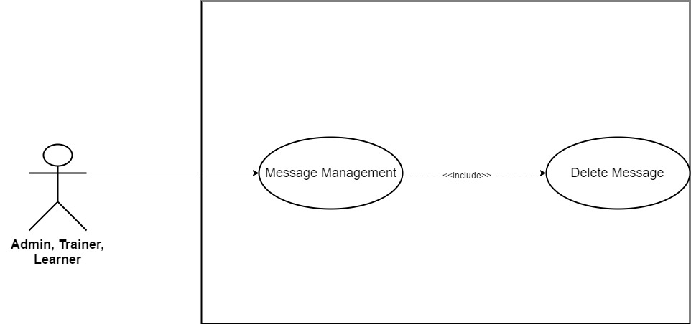

*Figure 3.22: Delete Message*

|  |  |  |  |  |
| --- | --- | --- | --- | --- |
| **Use Case ID** | UC11 | | **Version** | 1.0 |
| **Use Case Name** | Delete Message | | | |
| **Create By** | TruongTN | | **Last Updated** |  |
| **Primary Actor** | Trainer, Learner | | **Secondary Actor** | Administrator |
| **Description** | Delete Message | | | |
| **Pre-Conditions** |  | | | |
| **Post-Conditions** |  | | | |
| **Normal Flows** | | | | |
| **Step** | **Actor** | **Action** | | |
| 1 | Trainer, Learner | Move mouse to Trainer/Learner’s name to the right of search bar. | | |
| 2 | System | Display drop-down list. | | |
| 3 | Trainer, Learner, | Click “My Message” | | |
| 4 | System | Send to “My Profile” page | | |
| 5 | Trainer, Learner | Select message that needed to be delete. | | |
| 6 | Trainer, Learner | Click trash icon to delete. | | |
| 7 | System | Delete message out of database. | | |
|  | | | | |
|  | | | | |
| **Priority** | High | | | |
| **Frequency of Use** | High | | | |
| **Business Rules** |  | | | |

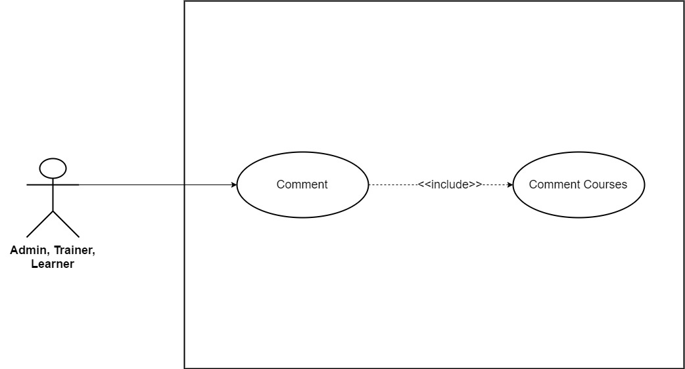

*Figure 3.23: Comment Courses*

|  |  |  |  |  |
| --- | --- | --- | --- | --- |
| **Use Case ID** | UC12 | | **Version** | 1.0 |
| **Use Case Name** | Comment Courses | | | |
| **Create By** | TruongTN | | **Last Updated** |  |
| **Primary Actor** | Trainer, Learner | | **Secondary Actor** | Administrator |
| **Description** | Comment Courses | | | |
| **Pre-Conditions** |  | | | |
| **Post-Conditions** |  | | | |
| **Normal Flows** | | | | |
| **Step** | **Actor** | **Action** | | |
| 1 | Trainer, Learner, Administrator | Scroll down course detail page. | | |
| 2 | System | Display comment section. | | |
| 3 | Trainer, Learner, Administrator | Input comment. | | |
| 4 | System | Update new comment into database. | | |
|  | | | | |
|  | | | | |
| **Priority** | High | | | |
| **Frequency of Use** | High | | | |
| **Business Rules** |  | | | |

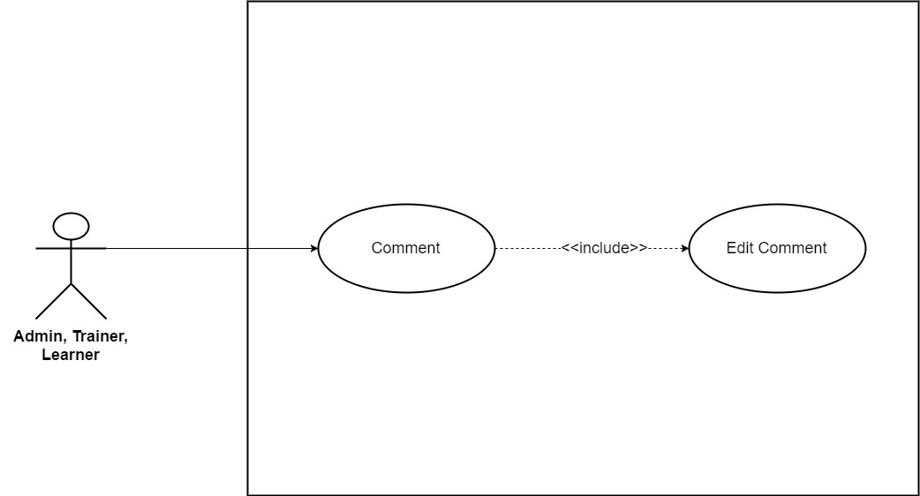

*Figure 3.24: Edit Comment*

|  |  |  |  |  |
| --- | --- | --- | --- | --- |
| **Use Case ID** | UC13 | | **Version** | 1.0 |
| **Use Case Name** | Edit Comment | | | |
| **Create By** | TruongTN | | **Last Updated** |  |
| **Primary Actor** | Trainer, Learner | | **Secondary Actor** | Administrator |
| **Description** | Edit Comment | | | |
| **Pre-Conditions** |  | | | |
| **Post-Conditions** |  | | | |
| **Normal Flows** | | | | |
| **Step** | **Actor** | **Action** | | |
| 1 | Trainer, Learner, Administrator | Choose comment that want to edit. | | |
| 2 | Trainer, Learner, Administrator | Click “Edit”. | | |
| 3 | System | Display input field. | | |
| 4 | Trainer, Learner, Administrator | Edit comment. | | |
| 5 | Trainer, Learner, Administrator | Click “Save”. | | |
| 6 | System | Save new comment into database | | |
|  | | | | |
|  | | | | |
| **Priority** | High | | | |
| **Frequency of Use** | High | | | |
| **Business Rules** |  | | | |

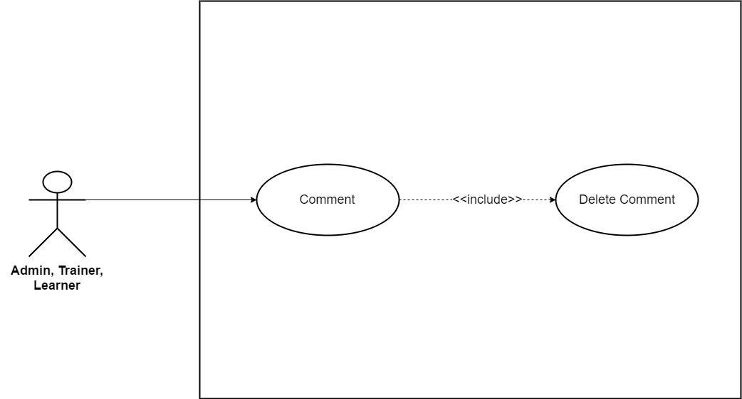

*Figure 3.25: Delete Comment*

|  |  |  |  |  |
| --- | --- | --- | --- | --- |
| **Use Case ID** | UC14 | | **Version** | 1.0 |
| **Use Case Name** | Delete Comment | | | |
| **Create By** | TruongTN | | **Last Updated** |  |
| **Primary Actor** | Trainer, Learner | | **Secondary Actor** | Administrator |
| **Description** | Edit Comment | | | |
| **Pre-Conditions** |  | | | |
| **Post-Conditions** |  | | | |
| **Normal Flows** | | | | |
| **Step** | **Actor** | **Action** | | |
| 1 | Trainer, Learner, Administrator | Choose comment that want to delete. | | |
| 2 | Trainer, Learner, Administrator | Click “Delete”. | | |
| 3 | System | Delete comment from database. | | |
|  | | | | |
|  | | | | |
| **Priority** | High | | | |
| **Frequency of Use** | High | | | |
| **Business Rules** |  | | | |

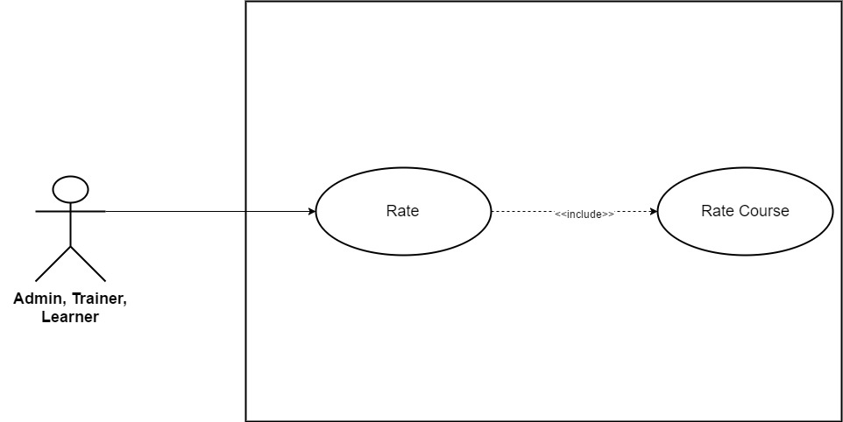

*Figure 3.26: Rate Course*

|  |  |  |  |  |
| --- | --- | --- | --- | --- |
| **Use Case ID** | UC15 | | **Version** | 1.0 |
| **Use Case Name** | Rate Course | | | |
| **Create By** | TruongTN | | **Last Updated** |  |
| **Primary Actor** | Trainer, Learner | | **Secondary Actor** | Administrator |
| **Description** | Rate Course | | | |
| **Pre-Conditions** |  | | | |
| **Post-Conditions** |  | | | |
| **Normal Flows** | | | | |
| **Step** | **Actor** | **Action** | | |
| 1 | Trainer, Learner, Administrator | Scroll down course detail page. | | |
| 2 | System | Display rate section. | | |
| 3 | Trainer, Learner, Administrator | Rate course. | | |
| 4 | System | Update new rate into database. | | |
|  | | | | |
|  | | | | |
| **Priority** | High | | | |
| **Frequency of Use** | High | | | |
| **Business Rules** |  | | | |

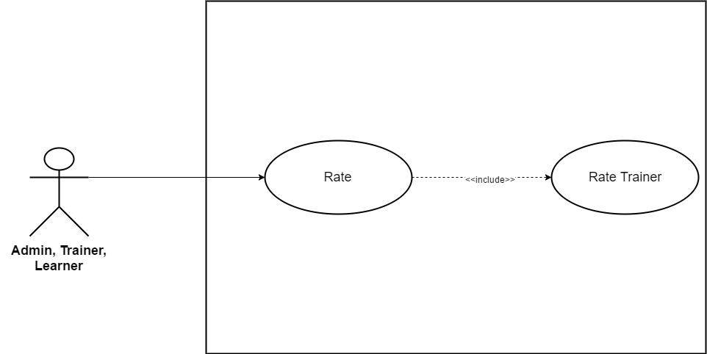

*Figure 3.27: Rate Trainer*

|  |  |  |  |  |
| --- | --- | --- | --- | --- |
| **Use Case ID** | UC16 | | **Version** | 1.0 |
| **Use Case Name** | Rate Trainer | | | |
| **Create By** | TruongTN | | **Last Updated** |  |
| **Primary Actor** | Trainer, Learner | | **Secondary Actor** | Administrator |
| **Description** | Rate Trainer | | | |
| **Pre-Conditions** |  | | | |
| **Post-Conditions** |  | | | |
| **Normal Flows** | | | | |
| **Step** | **Actor** | **Action** | | |
| 1 | Trainer, Learner, Administrator | Click “Trainers” on the menu, the menu stays on the right side of search bar. | | |
| 2 | System | Display trainer list | | |
| 3 | Trainer, Learner, Administrator | Rate trainer. | | |
| 4 | System | Update new rate into database. | | |
|  | | | | |
|  | | | | |
| **Priority** | High | | | |
| **Frequency of Use** | High | | | |
| **Business Rules** |  | | | |

* + 1. **Administrator/Trainer**

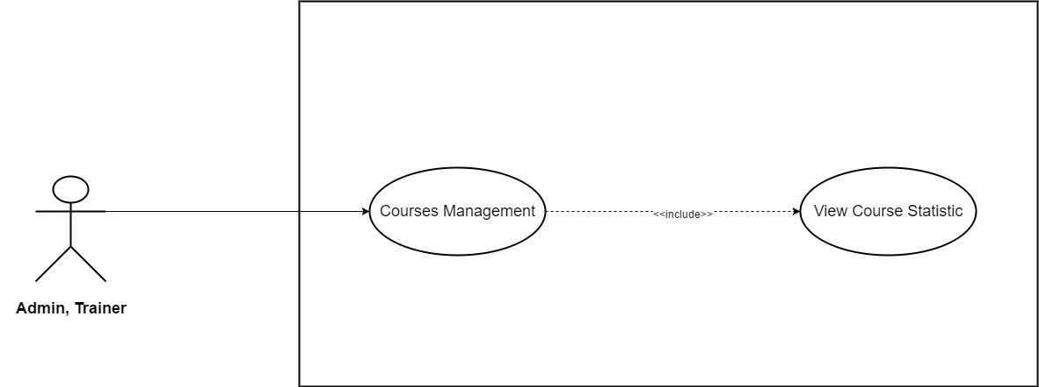

*Figure 3.28: View Course Statistic*

|  |  |  |  |  |
| --- | --- | --- | --- | --- |
| **Use Case ID** | UC17 | | **Version** | 1.0 |
| **Use Case Name** | View Course Statistic | | | |
| **Create By** | TruongTN | | **Last Updated** |  |
| **Primary Actor** | Trainer | | **Secondary Actor** | Administrator |
| **Description** | View Course Statistic | | | |
| **Pre-Conditions** | * User must login first. * Internet connection is required. * User have to be Trainer or Administrator. | | | |
| **Post-Conditions** | * Display view course statistic page. | | | |
| **Normal Flows** | | | | |
| **Step** | **Actor** | **Action** | | |
| 1 | Trainer | Move mouse to Trainer’s name to the right of search bar. | | |
| 2 | System | Display drop-down list. | | |
| 3 | Trainer | Click “Course Management” | | |
| 4 | System | Send Trainer to “Course Management” page | | |
| 5 | Trainer | Click “View Statistic” | | |
| 6 | System | Display “View Statistic” page | | |
| 7 | Trainer | Choose course. | | |
| 8 | System | Display course’s statistic page. | | |
|  | | | | |
| **Priority** | High | | | |
| **Frequency of Use** | High | | | |
| **Business Rules** |  | | | |

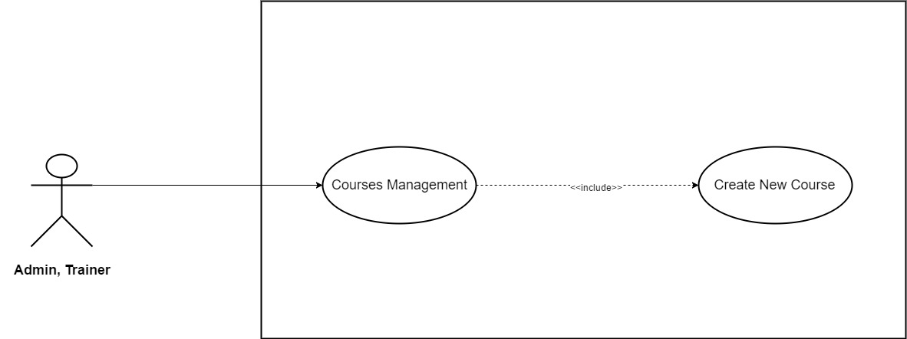

*Figure 3.29: Create New Course*

|  |  |  |  |  |
| --- | --- | --- | --- | --- |
| **Use Case ID** | UC18 | | **Version** | 1.0 |
| **Use Case Name** | Create New Course | | | |
| **Create By** | TruongTN | | **Last Updated** |  |
| **Primary Actor** | Trainer | | **Secondary Actor** | Administrator |
| **Description** | Create new course | | | |
| **Pre-Conditions** | * User must login first. * Internet connection is required. * User have to be Trainer | | | |
| **Post-Conditions** | * New course is saved into system and waited to be approved by administrator. | | | |
| **Normal Flows** | | | | |
| **Step** | **Actor** | **Action** | | |
| 1 | Trainer | Move mouse to Trainer’s name to the right of search bar. | | |
| 2 | System | Display drop-down list. | | |
| 3 | Trainer | Click “Create New Course” | | |
| 4 | System | Send Trainer to “Create New Course” page | | |
| 5 | System | Display “Create New Course” page which contains 5 categories:   * Course Goals * Curriculum * Course Landing Page * Fee * Auto Reply | | |
| 6 | Trainer | Enter course goals information. | | |
| 7 | Trainer | Click “Save” button to save entered information. | | |
| 8 | Trainer | Click “Curriculum”. | | |
| 9 | System | Display “Curriculum” page. | | |
| 10 | Trainer | Click “Upload Lectures and Sections (.xlxs)” to upload. | | |
| 11 | Trainer | Click “Save” button to save. | | |
| 12 | Trainer | Click “Course Landing Page” . | | |
| 13 | System | Display “Course Landing Page” page which contains the following field:   * Course Title * Course Subtitle * Course Description * Language * Level * Category * Primary Taught * Tags * Course Image * Promotional Video | | |
| 14 | Trainer | Enter all the information needed in Course Landing Page. | | |
| 15 | Trainer | Click “Save” button to save. | | |
| 16 | Trainer | Click “Fee” to enter course’s fee. | | |
| 17 | System | Display “Fee” page. | | |
| 18 | Trainer | Choose currency unit. Default: VND | | |
| 19 | Trainer | Enter course’s fee. | | |
| 20 | Trainer | Click “Save” button to save. | | |
| 21 | Trainer | Click “Auto Reply”. | | |
| 22 | System | Display “Auto Reply” page. | | |
| 23 | Trainer | Enter message. | | |
| 24 | Trainer | Click “Save” button to save. | | |
| 25 | Trainer | Click “Submit for review”. | | |
| 26 | System | Submit to the system. | | |
| 27 | Administrator | Approve course. | | |
|  | | | | |
| **Exception** | | | | |
| **EC1** | At step 6, Trainer enter more than 150 character in each text input. | | | |
| **Step** | **Actor** | **Action** | | |
| 6.1 | Trainer | Enter more than 150 character in each text input. | | |
| 6.2 | Trainer | Click “Save” button. | | |
| 6.3 | System | Display message: “Length must be less than 150 character” | | |
| **EC2** | At step 10, Trainer upload wrong file format. | | | |
| **Step** | **Actor** | **Action** | | |
| 10.1 | Trainer | Upload wrong file format. | | |
| 10.2 | Trainer | Click “Save” button. | | |
| 10.3 | System | Display message: “Wrong file format. Required format is .xlxs!” | | |
| **EC3** | At step 14, Course Title is left blank. | | | |
| **Step** | **Actor** | **Action** | | |
| 14.1 | Trainer | Course Title is left blank. | | |
| 14.2 | Trainer | Click “Save” button. | | |
| 14.3 | System | Display message: “Please Enter Course Title!” | | |
| **EC4** | At step 14, Course Subtitle is left blank. | | | |
| **Step** | **Actor** | **Action** | | |
| 14.1 | Trainer | Course Subtitle is left blank. | | |
| 14.2 | Trainer | Click “Save” button. | | |
| 14.3 | System | Display message: “Please Enter Course Subtitle!” | | |
| **EC5** | At step 14, Course Description is left blank. | | | |
| **Step** | **Actor** | **Action** | | |
| 14.1 | Trainer | Course Description is left blank. | | |
| 14.2 | Trainer | Click “Save” button. | | |
| 14.3 | System | Display message: “Please Enter Course Description!” | | |
| **EC6** | At step 14, Trainer doesn’t choose language. | | | |
| **Step** | **Actor** | **Action** | | |
| 14.1 | Trainer | Doesn’t choose language | | |
| 14.2 | Trainer | Click “Save” button. | | |
| 14.3 | System | Display message: “Please Choose Course Language!” | | |
| **EC7** | At step 14, Trainer doesn’t choose category. | | | |
| **Step** | **Actor** | **Action** | | |
| 14.1 | Trainer | Doesn’t choose category | | |
| 14.2 | Trainer | Click “Save” button. | | |
| 14.3 | System | Display message: “Please Choose Course Category!” | | |
| **EC6** | At step 14, Trainer doesn’t upload course image. | | | |
| **Step** | **Actor** | **Action** | | |
| 14.1 | Trainer | Doesn’t upload course image. | | |
| 14.2 | Trainer | Click “Save” button. | | |
| 14.3 | System | Display message: “Please Upload Course Image!” | | |
| **EC7** | At step 14, Trainer enter more than 100 character in course title. | | | |
| **Step** | **Actor** | **Action** | | |
| 14.1 | Trainer | Enter more than 100 characters in course title. | | |
| 14.2 | Trainer | Click “Save” button. | | |
| 14.3 | System | Display message: “Course title length’s must be less than 100 characters” | | |
| **EC8** | At step 14, Trainer enter more than 150 character in course subtitle. | | | |
| **Step** | **Actor** | **Action** | | |
| 14.1 | Trainer | Enter more than 150 characters in course subtitle. | | |
| 14.2 | Trainer | Click “Save” button. | | |
| 14.3 | System | Display message: “Course subtitle’s length must be less than 150 characters” | | |
| **EC9** | At step 14, Trainer enter more than 1000 character in course description. | | | |
| **Step** | **Actor** | **Action** | | |
| 14.1 | Trainer | Enter more than 1000 characters in course description. | | |
| 14.2 | Trainer | Click “Save” button. | | |
| 14.3 | System | Display message: “Course description’s length must be less than 1000 characters” | | |
| **EC8** | At step 14, Trainer upload wrong course image’s dimensions. | | | |
| **Step** | **Actor** | **Action** | | |
| 14.1 | Trainer | Upload wrong course image’s dimensions. | | |
| 14.2 | Trainer | Click “Save” button. | | |
| 14.3 | System | Display message: “Image’s dimensions must be 2048x1152 pixels” | | |
| **EC9** | At step 14, Trainer upload wrong course image’s format. | | | |
| **Step** | **Actor** | **Action** | | |
| 14.1 | Trainer | Upload wrong course image’s format. | | |
| 14.2 | Trainer | Click “Save” button. | | |
| 14.3 | System | Display message: “Image’s format must be one of the following: .jpg, .jpeg, .gif, .bmp or .png!” | | |
| **EC10** | At step 14, Trainer upload video with low quality (less than 360p). | | | |
| **Step** | **Actor** | **Action** | | |
| 14.1 | Trainer | Upload video with low quality (less than 360p) | | |
| 14.2 | Trainer | Click “Save” button. | | |
| 14.3 | System | Display message: “The video’s quality must be at least 360p !” | | |
| **EC11** | At step 14, Trainer upload video with the wrong format. | | | |
| **Step** | **Actor** | **Action** | | |
| 14.1 | Trainer | Upload video with the wrong format. | | |
| 14.2 | Trainer | Click “Save” button. | | |
| 14.3 | System | Display message: “The video’s format must be .mp4!” | | |
| **EC12** | At step 19, Fee is left blank. | | | |
| **Step** | **Actor** | **Action** | | |
| 19.1 | Trainer | Leave fee blank. | | |
| 19.2 | Trainer | Click “Save” button. | | |
| 19.3 | System | Display message: “Please enter course’s fee!” | | |
| **EC13** | At step 23, Trainer enter more than 200 characters in auto reply. | | | |
| **Step** | **Actor** | **Action** | | |
| 23.1 | Trainer | Enter more than 200 characters in auto reply. | | |
| 23.2 | Trainer | Click “Save” button. | | |
| 23.3 | System | Display message: “Auto reply must be less than 200 characters!” | | |
|  |  |  | | |
| **Priority** | High | | | |
| **Frequency of Use** | High | | | |
| **Business Rules** | BR9, BR10, BR11, BR12, BR13, BR14, BR15, BR16, BR17 | | | |

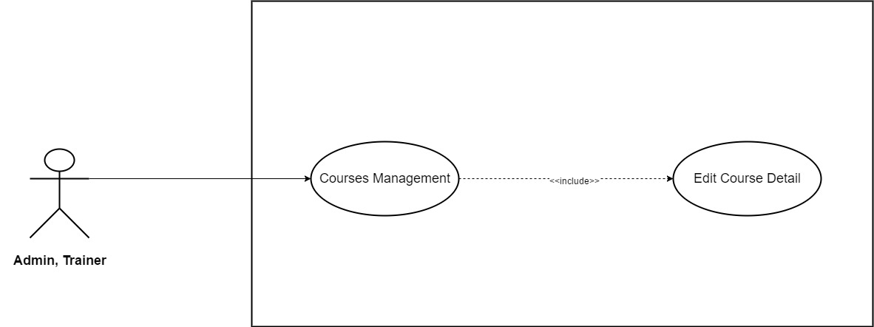

*Figure 3.30: Edit Course Detail*

|  |  |  |  |  |
| --- | --- | --- | --- | --- |
| **Use Case ID** | UC19 | | **Version** | 1.0 |
| **Use Case Name** | Edit Course Detail | | | |
| **Create By** | TruongTN | | **Last Updated** |  |
| **Primary Actor** | Trainer | | **Secondary Actor** | Administrator |
| **Description** | Edit course detail. | | | |
| **Pre-Conditions** | * User must login first. * Internet connection is required. * User have to be Trainer or Administrator. | | | |
| **Post-Conditions** | * New course detail is saved and updated into system. | | | |
| **Normal Flows** | | | | |
| **Step** | **Actor** | **Action** | | |
| 1 | Trainer | Move mouse to Trainer’s name to the right of search bar. | | |
| 2 | System | Display drop-down list. | | |
| 3 | Trainer | Click “Course Management” | | |
| 4 | System | Send Trainer to “Course Management” page | | |
| 5 | Trainer | Click “Edit” button. | | |
| 6 | System | Display edit course page (same as “Create New Course” page” | | |
| 7 | Trainer | Edit course goals information. | | |
| 8 | Trainer | Click “Save” button to save entered information. | | |
| 9 | Trainer | Click “Curriculum”. | | |
| 10 | System | Display “Curriculum” page. | | |
| 11 | Trainer | Click “Upload Lectures and Sections (.xlxs)” to upload. | | |
| 12 | Trainer | Click “Save” button to save. | | |
| 13 | Trainer | Click “Course Landing Page” . | | |
| 14 | System | Display “Course Landing Page” page which contains the following field:   * Course Title * Course Subtitle * Course Description * Language * Level * Category * Primary Taught * Tags * Course Image * Promotional Video | | |
| 15 | Trainer | Edit all the information that they need to change in Course Landing Page. | | |
| 16 | Trainer | Click “Save” button to save. | | |
| 17 | Trainer | Click “Fee” to enter course’s fee. | | |
| 18 | System | Display “Fee” page. | | |
| 19 | Trainer | Choose currency unit. Default: VND | | |
| 20 | Trainer | Edit course’s fee. | | |
| 21 | Trainer | Click “Save” button to save. | | |
| 22 | Trainer | Click “Auto Reply”. | | |
| 23 | System | Display “Auto Reply” page. | | |
| 24 | Trainer | Edit message. | | |
| 25 | Trainer | Click “Save” button to save. | | |
| 26 | Trainer | Click “Submit for review”. | | |
| 27 | System | Submit to the system. | | |
| 28 | Administrator | Approve update. | | |
|  | | | | |
| **Exception** | | | | |
| **EC1** | At step 7, Trainer enter more than 150 character in each text input. | | | |
| **Step** | **Actor** | **Action** | | |
| 7.1 | Trainer | Enter more than 150 character in each text input. | | |
| 7.2 | Trainer | Click “Save” button. | | |
| 7.3 | System | Display message: “Length must be less than 150 character” | | |
| **EC2** | At step 11, Trainer upload wrong file format. | | | |
| **Step** | **Actor** | **Action** | | |
| 11.1 | Trainer | Upload wrong file format. | | |
| 11.2 | Trainer | Click “Save” button. | | |
| 11.3 | System | Display message: “Wrong file format. Required format is .xlxs!” | | |
| **EC3** | At step 15, Course Title is left blank. | | | |
| **Step** | **Actor** | **Action** | | |
| 15.1 | Trainer | Course Title is left blank. | | |
| 15.2 | Trainer | Click “Save” button. | | |
| 15.3 | System | Display message: “Please Enter Course Title!” | | |
| **EC4** | At step 15, Course Subtitle is left blank. | | | |
| **Step** | **Actor** | **Action** | | |
| 15.1 | Trainer | Course Subtitle is left blank. | | |
| 15.2 | Trainer | Click “Save” button. | | |
| 15.3 | System | Display message: “Please Enter Course Subtitle!” | | |
| **EC5** | At step 15, Course Description is left blank. | | | |
| **Step** | **Actor** | **Action** | | |
| 15.1 | Trainer | Course Description is left blank. | | |
| 15.2 | Trainer | Click “Save” button. | | |
| 15.3 | System | Display message: “Please Enter Course Description!” | | |
| **EC6** | At step 13, Trainer doesn’t choose language. | | | |
| **Step** | **Actor** | **Action** | | |
| 15.1 | Trainer | Doesn’t choose language | | |
| 15.2 | Trainer | Click “Save” button. | | |
| 15.3 | System | Display message: “Please Choose Course Language!” | | |
| **EC7** | At step 15, Trainer doesn’t choose category. | | | |
| **Step** | **Actor** | **Action** | | |
| 15.1 | Trainer | Doesn’t choose category | | |
| 15.2 | Trainer | Click “Save” button. | | |
| 15.3 | System | Display message: “Please Choose Course Category!” | | |
| **EC6** | At step 15, Trainer doesn’t upload course image. | | | |
| **Step** | **Actor** | **Action** | | |
| 15.1 | Trainer | Doesn’t upload course image. | | |
| 15.2 | Trainer | Click “Save” button. | | |
| 15.3 | System | Display message: “Please Upload Course Image!” | | |
| **EC7** | At step 15, Trainer enter more than 100 character in course title. | | | |
| **Step** | **Actor** | **Action** | | |
| 15.1 | Trainer | Enter more than 100 characters in course title. | | |
| 15.2 | Trainer | Click “Save” button. | | |
| 15.3 | System | Display message: “Course title length’s must be less than 100 characters” | | |
| **EC8** | At step 15, Trainer enter more than 150 character in course subtitle. | | | |
| **Step** | **Actor** | **Action** | | |
| 15.1 | Trainer | Enter more than 150 characters in course subtitle. | | |
| 15.2 | Trainer | Click “Save” button. | | |
| 15.3 | System | Display message: “Course subtitle’s length must be less than 150 characters” | | |
| **EC9** | At step 15, Trainer enter more than 1000 character in course description. | | | |
| **Step** | **Actor** | **Action** | | |
| 15.1 | Trainer | Enter more than 1000 characters in course description. | | |
| 15.2 | Trainer | Click “Save” button. | | |
| 15.3 | System | Display message: “Course description’s length must be less than 1000 characters” | | |
| **EC8** | At step 15, Trainer upload wrong course image’s dimensions. | | | |
| **Step** | **Actor** | **Action** | | |
| 15.1 | Trainer | Upload wrong course image’s dimensions. | | |
| 15.2 | Trainer | Click “Save” button. | | |
| 15.3 | System | Display message: “Image’s dimensions must be 2048x1152 pixels” | | |
| **EC9** | At step 15, Trainer upload wrong course image’s format. | | | |
| **Step** | **Actor** | **Action** | | |
| 15.1 | Trainer | Upload wrong course image’s format. | | |
| 15.2 | Trainer | Click “Save” button. | | |
| 15.3 | System | Display message: “Image’s format must be one of the following: .jpg, .jpeg, .gif, .bmp or .png!” | | |
| **EC10** | At step 15, Trainer upload video with low quality (less than 360p). | | | |
| **Step** | **Actor** | **Action** | | |
| 15.1 | Trainer | Upload video with low quality (less than 360p) | | |
| 15.2 | Trainer | Click “Save” button. | | |
| 15.3 | System | Display message: “The video’s quality must be at least 360p !” | | |
| **EC11** | At step 15, Trainer upload video with the wrong format. | | | |
| **Step** | **Actor** | **Action** | | |
| 15.1 | Trainer | Upload video with the wrong format. | | |
| 15.2 | Trainer | Click “Save” button. | | |
| 15.3 | System | Display message: “The video’s format must be .mp4!” | | |
| **EC12** | At step 20, Fee is left blank. | | | |
| **Step** | **Actor** | **Action** | | |
| 20.1 | Trainer | Leave fee blank. | | |
| 20.2 | Trainer | Click “Save” button. | | |
| 20.3 | System | Display message: “Please enter course’s fee!” | | |
| **EC13** | At step 24, Trainer enter more than 200 characters in auto reply. | | | |
| **Step** | **Actor** | **Action** | | |
| 24.1 | Trainer | Enter more than 200 characters in auto reply. | | |
| 24.2 | Trainer | Click “Save” button. | | |
| 24.3 | System | Display message: “Auto reply must be less than 200 characters!” | | |
|  |  |  | | |
| **Priority** | High | | | |
| **Frequency of Use** | High | | | |
| **Business Rules** | BR9, BR10, BR11, BR12, BR13, BR14, BR15, BR16, BR17 | | | |

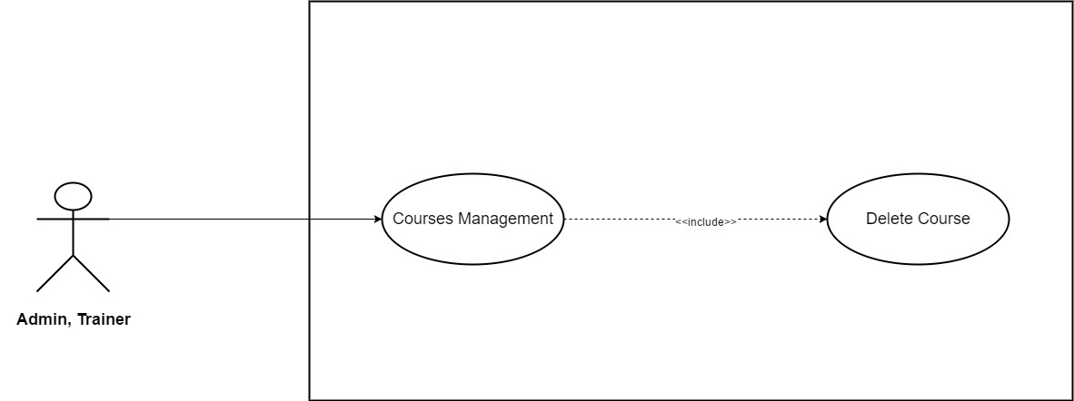

*Figure 3.31: Delete Course*

|  |  |  |  |  |
| --- | --- | --- | --- | --- |
| **Use Case ID** | UC20 | | **Version** | 1.0 |
| **Use Case Name** | Delete Courses | | | |
| **Create By** | TruongTN | | **Last Updated** |  |
| **Primary Actor** | Trainer | | **Secondary Actor** | Administrator |
| **Description** | Delete courses | | | |
| **Pre-Conditions** | * User must login first. * Internet connection is required. * User must be Trainer or Administrator. | | | |
| **Post-Conditions** | * Selected course is removed out of system. | | | |
| **Normal Flows** | | | | |
| **Step** | **Actor** | **Action** | | |
| 1 | Trainer | Move mouse to Trainer’s name to the right of search bar. | | |
| 2 | System | Display drop-down list. | | |
| 3 | Trainer | Click “Course Management” | | |
| 4 | System | Display “Course Management” page . | | |
| 5 | Trainer | Click “Select” button. | | |
| 6 | Trainer | Choose all course that want to delete. | | |
| 7 | Trainer | Click “Delete”. | | |
| 8 | System | Delete all the chosen course out of the system. | | |
| 9 | System | Update and reload “Course Management” page. | | |
|  | | | | |
| **Priority** | High | | | |
| **Frequency of Use** | High | | | |
| **Business Rules** |  | | | |

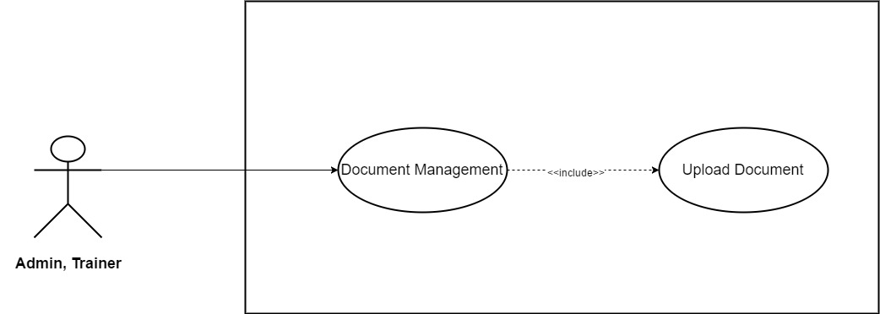

*Figure 3.32: Upload Document*

|  |  |  |  |  |
| --- | --- | --- | --- | --- |
| **Use Case ID** | UC21 | | **Version** | 1.0 |
| **Use Case Name** | Upload Document | | | |
| **Create By** | TruongTN | | **Last Updated** |  |
| **Primary Actor** | Trainer | | **Secondary Actor** | Administrator |
| **Description** | Upload Trainer’s documents | | | |
| **Pre-Conditions** | * User must login first. * Internet connection is required. * User must be Trainer. | | | |
| **Post-Conditions** | * New Document is saved into system and waited to be approved by administrator. | | | |
| **Normal Flows** | | | | |
| **Step** | **Actor** | **Action** | | |
| 1 | Trainer | Move mouse to Trainer’s name to the right of search bar. | | |
| 2 | System | Display drop-down list. | | |
| 3 | Trainer | Click “Documents” | | |
| 4 | System | Send Trainer to Documents’ page | | |
| 5 | System | Display “Documents” page which contain all document that Trainer has uploaded. | | |
| 6 | Trainer | Click “Upload” button. | | |
| 7 | System | Display upload window. | | |
| 8 | Trainer | Choose document file to upload. | | |
| 9 | Trainer | Click “Save” to save documents. “Cancel” to back to Documents’ page. | | |
|  |  |  | | |
| **Exception** | | | | |
| **EC1** | At step 8, *Document* does not meet the format requirement. | | | |
| **Step** | **Actor** | **Action** | | |
| 8.1 | Trainer | User upload wrong document’s format. | | |
| 8.2 | Trainer | Click “Save” button. | | |
| 8.3 | System | Display message: “Document’s format must be .pdf!” | | |
|  |  |  | | |
| **Priority** | High | | | |
| **Frequency of Use** | High | | | |
| **Business Rules** |  | | | |

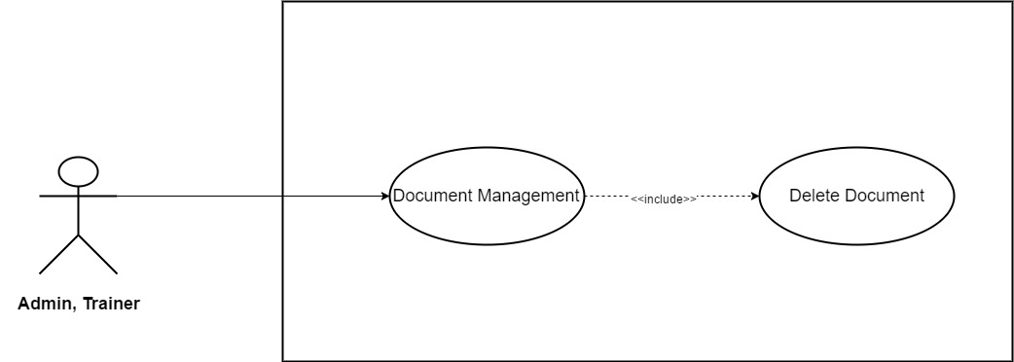

*Figure 3.33: Delete Document*

|  |  |  |  |  |
| --- | --- | --- | --- | --- |
| **Use Case ID** | UC22 | | **Version** | 1.0 |
| **Use Case Name** | Delete Documents | | | |
| **Create By** | TruongTN | | **Last Updated** |  |
| **Primary Actor** | Trainer | | **Secondary Actor** | Administrator |
| **Description** | Delete Document | | | |
| **Pre-Conditions** | * User must login as Trainer first. * Internet connection is required. | | | |
| **Post-Conditions** | * Selected document is removed from the system. | | | |
| **Normal Flows** | | | | |
| **Step** | **Actor** | **Action** | | |
| 1 | Trainer | Move mouse to Trainer’s name to the right of search bar. | | |
| 2 | System | Display drop-down list. | | |
| 3 | Trainer | Click “Documents” | | |
| 4 | System | Send Trainer to Documents’ page | | |
| 5 | System | Display “Documents” page which contain all document that Trainer has uploaded. | | |
| 6 | Trainer | Click “Select”. | | |
| 7 | Trainer | Select all the document that need to be delete. | | |
| 8 | Trainer | Click “Delete”. | | |
| 9 | System | Delete selected document out of the system. | | |
| 10 | System | Update and reload “Documents” page. | | |
|  |  |  | | |
| **Priority** | High | | | |
| **Frequency of Use** | High | | | |
| **Business Rules** |  | | | |

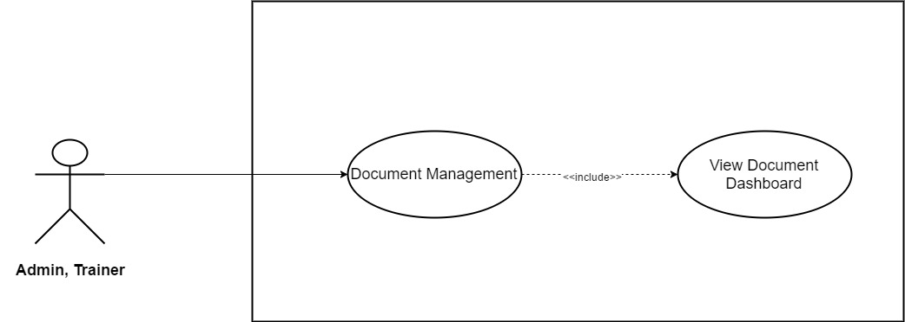

*Figure 3.34: View Document Dashboard*

|  |  |  |  |  |
| --- | --- | --- | --- | --- |
| **Use Case ID** | UC23 | | **Version** | 1.0 |
| **Use Case Name** | View Documents Dashboard | | | |
| **Create By** | TruongTN | | **Last Updated** |  |
| **Primary Actor** | Trainer | | **Secondary Actor** | Administrator |
| **Description** | Access documents dashboard. | | | |
| **Pre-Conditions** | * User must login as Trainer first. * Internet connection is required. | | | |
| **Post-Conditions** | * Display Document page. | | | |
| **Normal Flows** | | | | |
| **Step** | **Actor** | **Action** | | |
| 1 | Trainer | Move mouse to Trainer’s name to the right of search bar. | | |
| 2 | System | Display drop-down list. | | |
| 3 | Trainer | Click “Documents” | | |
| 4 | System | Send Trainer to Documents’ page | | |
| 5 | System | Display “Documents” page which contain all document that Trainer has uploaded. | | |
|  |  |  | | |
| **Priority** | High | | | |
| **Frequency of Use** | High | | | |
| **Business Rules** |  | | | |

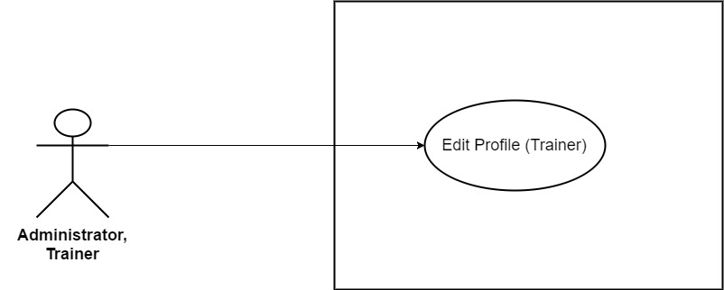

*Figure 3.35: Edit Profile (Trainer)*

|  |  |  |  |  |
| --- | --- | --- | --- | --- |
| **Use Case ID** | UC24 | | **Version** | 1.0 |
| **Use Case Name** | Edit Profile (*Trainer*) | | | |
| **Create By** | TruongTN | | **Last Updated** |  |
| **Primary Actor** | Trainer | | **Secondary Actor** | Administrator |
| **Description** | Edit account’s information for *Trainer* | | | |
| **Pre-Conditions** | * User must login first. * Internet connection is required. | | | |
| **Post-Conditions** | * New account information is saved and updated into system. | | | |
| **Normal Flows** | | | | |
| **Step** | **Actor** | **Action** | | |
| 1 | Trainer | Move mouse to Trainer’s name to the right of search bar. | | |
| 2 | System |  | | |
| 3 | Trainer |  | | |
| 4 | System |  | | |
| 5 | System | Display drop-down list. | | |
| 6 | Trainer | Click “My Profile” | | |
| 7 | Trainer | Send Trainer to “My Profile” page | | |
| 8 | System | Update information into system’s Database. | | |
| 9 | System | Display “My Profile” page with updated information. | | |
|  | | | | |
| **Exception** | | | | |
| **EC1** | At step 6, Trainer remove all required field and leave it blank. | | | |
| **Step** | **Actor** | **Action** | | |
| 6.1 | Trainer | Remove and leave all required field blank. | | |
| 6.2 | Trainer | Click “Save” button. | | |
| 6.3 | System | Display message: “Please Fill In All Required Field!” | | |
| **EC2** | At step 6, Trainer only remove Trainer Name and leave it blank. | | | |
| **Step** | **Actor** | **Action** | | |
| 6.1 | Trainer | Remove and leave Trainer Name blank. | | |
| 6.2 | Trainer | Click “Save” button. | | |
| 6.3 | System | Display message: “Please Enter Trainer Name!” | | |
| **EC3** | At step 6, only *Fields* is not selected. | | | |
| **Step** | **Actor** | **Action** | | |
| 6.1 | Trainer | Do not select *Fields.* | | |
| 6.2 | Trainer | Click “Save” button. | | |
| 6.3 | System | Display message: “Please Select Fields!” | | |
| **EC4** | At step 6, Trainer remove and leave *Contact* blank. | | | |
| **Step** | **Actor** | **Action** | | |
| 6.1 | Trainer | Remove and leave *Contact* field blank. | | |
| 6.2 | Trainer | Click “Save” button. | | |
| 6.3 | System | Display message: “Please Enter Password!” | | |
| **EC5** | At step 6, Trainer only remove and leave *Address* blank. | | | |
| **Step** | **Actor** | **Action** | | |
| 6.1 | Trainer | Remove and leave *Address* blank. | | |
| 6.2 | Trainer | Click “Save” button. | | |
| 6.3 | System | Display message: “Please Enter Address!” | | |
| **EC6** | At step 6, *Introduction*’s length > 200 character. | | | |
| **Step** | **Actor** | **Action** | | |
| 6.1 | Trainer | Enter more than 200 character in *Introduction* field. | | |
| 6.2 | Trainer | Click “Save” button. | | |
| 6.3 | System | Display message: “Length must be < 200” | | |
|  |  |  | | |
| **Priority** | High | | | |
| **Frequency of Use** | High | | | |
| **Business Rules** | BR1 | | | |

* + 1. **Administrator/Learner/Trainer/Guest**

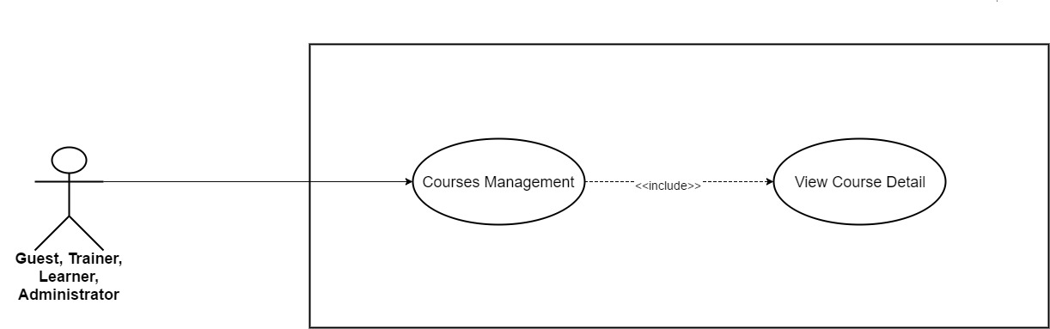

*Figure 3.36: View Course Detail*

|  |  |  |  |  |
| --- | --- | --- | --- | --- |
| **Use Case ID** | UC25 | | **Version** | 1.0 |
| **Use Case Name** | View Course Detail | | | |
| **Create By** | TruongTN | | **Last Updated** |  |
| **Primary Actor** | Guest, Trainer, Learner | | **Secondary Actor** | Administrator |
| **Description** | View Course Detail | | | |
| **Pre-Conditions** |  | | | |
| **Post-Conditions** |  | | | |
| **Normal Flows** | | | | |
| **Step** | **Actor** | **Action** | | |
| 1 | Guest, Trainer, Learner, Administrator | Go to course list that display in homepage or select course list by category. | | |
| 2 | Guest, Trainer, Learner, Administrator | Choose the course that they want to see detail. | | |
| 3 | System | Display course detail page. | | |
|  | | | | |
|  | | | | |
| **Priority** | High | | | |
| **Frequency of Use** | High | | | |
| **Business Rules** |  | | | |

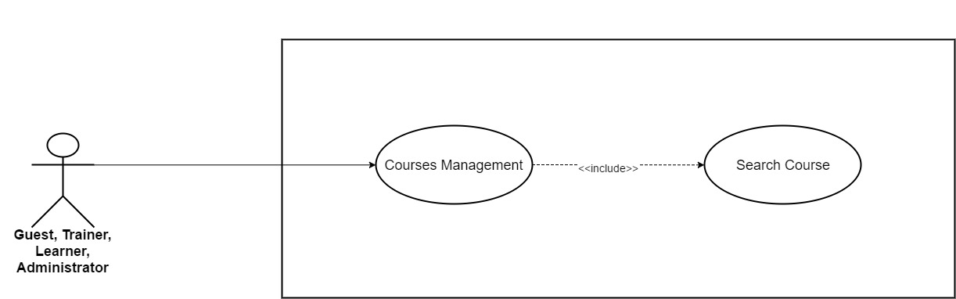

*Figure 3.37: Search Course*

|  |  |  |  |  |
| --- | --- | --- | --- | --- |
| **Use Case ID** | UC26 | | **Version** | 1.0 |
| **Use Case Name** | Search Course | | | |
| **Create By** | TruongTN | | **Last Updated** |  |
| **Primary Actor** | Guest, Trainer, Learner | | **Secondary Actor** | Administrator |
| **Description** | Search Course | | | |
| **Pre-Conditions** |  | | | |
| **Post-Conditions** |  | | | |
| **Normal Flows** | | | | |
| **Step** | **Actor** | **Action** | | |
| 1 | Guest, Trainer, Learner, Administrator | Fill in course name that needed to be search in search bar. | | |
| 2 | System | Display all match result. | | |
|  | | | | |
|  | | | | |
| **Priority** | High | | | |
| **Frequency of Use** | High | | | |
| **Business Rules** |  | | | |

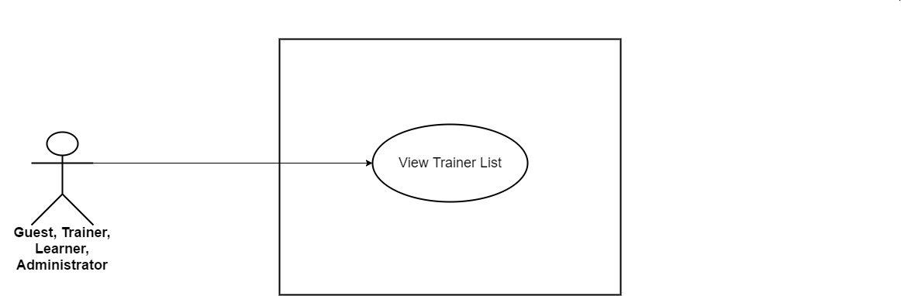

*Figure 3.38: View Trainer List*

|  |  |  |  |  |
| --- | --- | --- | --- | --- |
| **Use Case ID** | UC27 | | **Version** | 1.0 |
| **Use Case Name** | View Trainer List | | | |
| **Create By** | TruongTN | | **Last Updated** |  |
| **Primary Actor** | Trainer,Learner,Guest | | **Secondary Actor** | Administrator |
| **Description** | View all trainer in the system. | | | |
| **Pre-Conditions** | * User must login first. * Internet connection is required. | | | |
| **Post-Conditions** | * Display trainer list. | | | |
| **Normal Flows** | | | | |
| **Step** | **Actor** | **Action** | | |
| 1 | Trainer/Learner | Click “Trainer” in the header to the left of search bar. | | |
| 2 | System | Display trainer list. | | |
|  |  |  | | |
| **Priority** | High | | | |
| **Frequency of Use** | High | | | |
| **Business Rules** |  | | | |

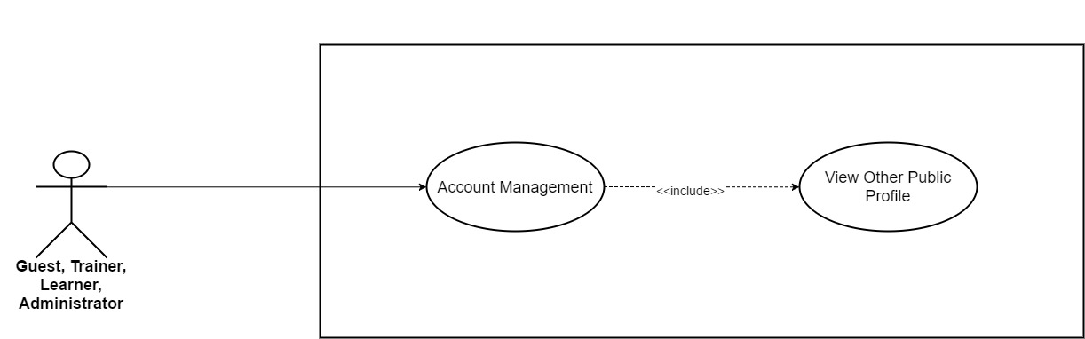

*Figure 3.39: View Other Public Profile*

|  |  |  |  |  |
| --- | --- | --- | --- | --- |
| **Use Case ID** | UC28 | | **Version** | 1.0 |
| **Use Case Name** | View Other Public Profile | | | |
| **Create By** | TruongTN | | **Last Updated** |  |
| **Primary Actor** | Guest, Trainer, Learner | | **Secondary Actor** | Administrator |
| **Description** | View Other Public Profile | | | |
| **Pre-Conditions** |  | | | |
| **Post-Conditions** |  | | | |
| **Normal Flows** | | | | |
| **Step** | **Actor** | **Action** | | |
| 1 | Guest, Trainer, Learner, Administrator | Click username that they want to see public profile. | | |
| 2 | System | Display public profile page. | | |
|  | | | | |
|  | | | | |
| **Priority** | High | | | |
| **Frequency of Use** | High | | | |
| **Business Rules** |  | | | |

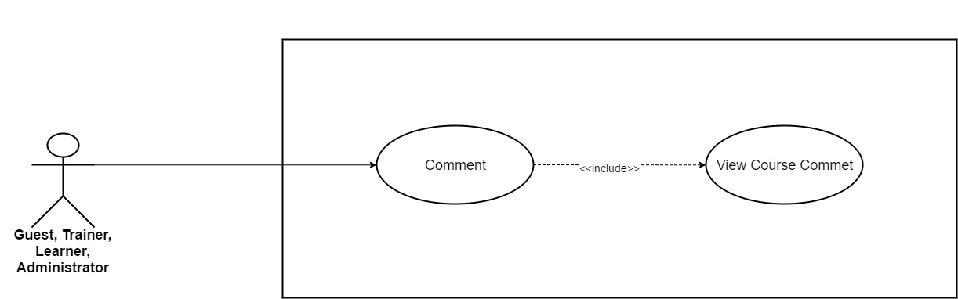

*Figure 3.40: View Course Comment*

|  |  |  |  |  |
| --- | --- | --- | --- | --- |
| **Use Case ID** | UC29 | | **Version** | 1.0 |
| **Use Case Name** | View Course Comment | | | |
| **Create By** | TruongTN | | **Last Updated** |  |
| **Primary Actor** | Guest, Trainer, Learner | | **Secondary Actor** | Administrator |
| **Description** | View Course Comment | | | |
| **Pre-Conditions** |  | | | |
| **Post-Conditions** |  | | | |
| **Normal Flows** | | | | |
| **Step** | **Actor** | **Action** | | |
| 1 | Guest, Trainer, Learner, Administrator | In course detail, scroll down till the end of the page. | | |
| 2 | System | Display comment section page. | | |
|  | | | | |
|  | | | | |
| **Priority** | High | | | |
| **Frequency of Use** | High | | | |
| **Business Rules** |  | | | |

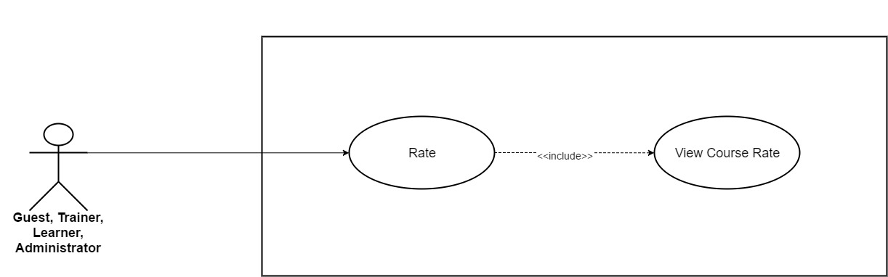

*Figure 3.41: View Course Rate*

|  |  |  |  |  |
| --- | --- | --- | --- | --- |
| **Use Case ID** | UC30 | | **Version** | 1.0 |
| **Use Case Name** | View course rate | | | |
| **Create By** | TruongTN | | **Last Updated** |  |
| **Primary Actor** | Guest, Trainer, Learner | | **Secondary Actor** | Administrator |
| **Description** | View Course rate. | | | |
| **Pre-Conditions** |  | | | |
| **Post-Conditions** |  | | | |
| **Normal Flows** | | | | |
| **Step** | **Actor** | **Action** | | |
| 1 | Guest, Trainer, Learner, Administrator | Open course. | | |
| 2 | System | Display course detail page. Rate course is under course’s name. | | |
|  | | | | |
|  | | | | |
| **Priority** | High | | | |
| **Frequency of Use** | High | | | |
| **Business Rules** |  | | | |

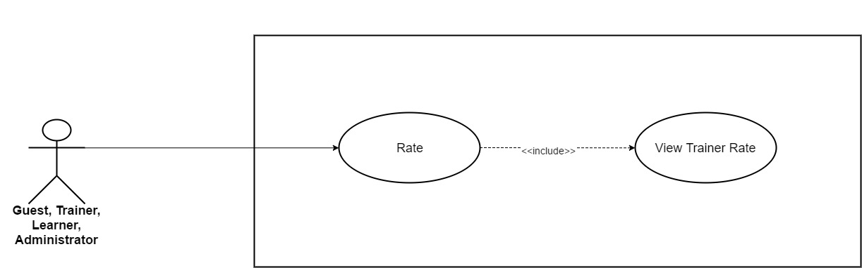

*Figure 3.42: View Trainer Rate*

|  |  |  |  |  |
| --- | --- | --- | --- | --- |
| **Use Case ID** | UC31 | | **Version** | 1.0 |
| **Use Case Name** | View Trainer Rate | | | |
| **Create By** | TruongTN | | **Last Updated** |  |
| **Primary Actor** | Trainer, Learner, Guest | | **Secondary Actor** | Administrator |
| **Description** | View trainer’s rate. | | | |
| **Pre-Conditions** |  | | | |
| **Post-Conditions** |  | | | |
| **Normal Flows** | | | | |
| **Step** | **Actor** | **Action** | | |
| 1 | Trainer, Learner, Administrator | Click “Trainers” on the menu, the menu stays on the right side of search bar. | | |
| 2 | System | Display trainer list. Rate is under trainer’s picture. | | |
|  | | | | |
|  | | | | |
| **Priority** | High | | | |
| **Frequency of Use** | High | | | |
| **Business Rules** |  | | | |

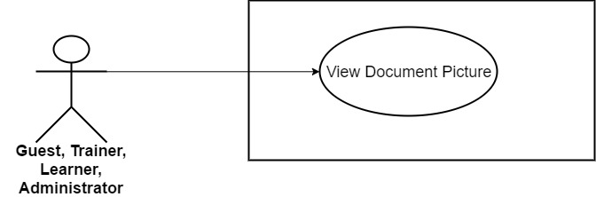

*Figure 3.43: View Document Picture*

|  |  |  |  |  |
| --- | --- | --- | --- | --- |
| **Use Case ID** | UC32 | | **Version** | 1.0 |
| **Use Case Name** | View Document Picture | | | |
| **Create By** | TruongTN | | **Last Updated** |  |
| **Primary Actor** | Trainer, Learner | | **Secondary Actor** | Administrator |
| **Description** | View Document Picture | | | |
| **Pre-Conditions** |  | | | |
| **Post-Conditions** |  | | | |
| **Normal Flows** | | | | |
| **Step** | **Actor** | **Action** | | |
| 1 | Trainer, Learner | On public profile page or document page, click document. | | |
| 2 | System | Display document picture. | | |
|  | | | | |
|  | | | | |
| **Priority** | High | | | |
| **Frequency of Use** | High | | | |
| **Business Rules** |  | | | |

* + 1. **Administrator**

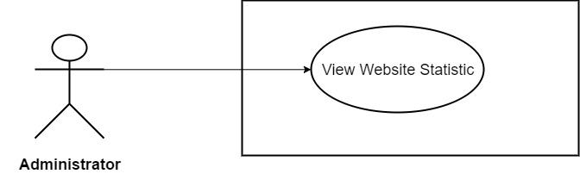

*Figure 3.44: View Website Statistic*

|  |  |  |  |  |
| --- | --- | --- | --- | --- |
| **Use Case ID** | UC33 | | **Version** | 1.0 |
| **Use Case Name** | View Website Statistic | | | |
| **Create By** | TruongTN | | **Last Updated** |  |
| **Primary Actor** | Administrator | | **Secondary Actor** |  |
| **Description** | View website statistic | | | |
| **Pre-Conditions** |  | | | |
| **Post-Conditions** |  | | | |
| **Normal Flows** | | | | |
| **Step** | **Actor** | **Action** | | |
| 1 | Administrator | Click “Go to Dashboard” in the menu. | | |
| 2 | System | Send Admin to Admin’s Dashboard. | | |
| 3 | System | Display “Home” page which contain website’s statistic. | | |
|  | | | | |
| **Priority** | High | | | |
| **Frequency of Use** | High | | | |
| **Business Rules** |  | | | |

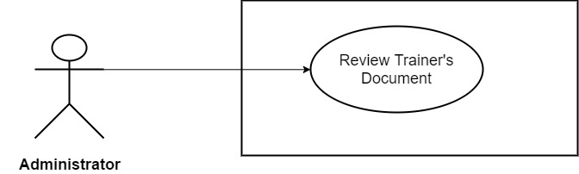

*Figure 3.45: Review Trainer’s Document*

|  |  |  |  |  |
| --- | --- | --- | --- | --- |
| **Use Case ID** | UC34 | | **Version** | 1.0 |
| **Use Case Name** | Review Trainer’s Document | | | |
| **Create By** | TruongTN | | **Last Updated** |  |
| **Primary Actor** | Administrator | | **Secondary Actor** |  |
| **Description** | Review Trainer’s Document | | | |
| **Pre-Conditions** |  | | | |
| **Post-Conditions** |  | | | |
| **Normal Flows** | | | | |
| **Step** | **Actor** | **Action** | | |
| 1 | Administrator | Click “Go to Dashboard” in the menu. | | |
| 2 | System | Send Admin to Admin’s Dashboard. | | |
| 3 | Administrator | Click “Document”. | | |
| 4 | System | Display trainers management page. | | |
| 5 | Administrator | Click “Accept” to accept trainer’s document or Click “Reject” to reject trainer’s document. | | |
| 6 | System | Save new change into database. | | |
|  | | | | |
| **Priority** | High | | | |
| **Frequency of Use** | High | | | |
| **Business Rules** |  | | | |

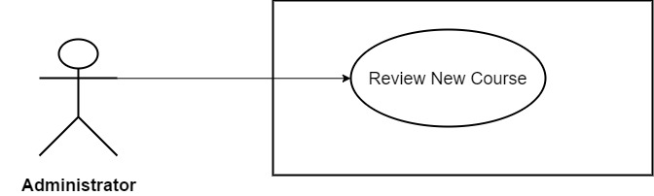

*Figure 3.46: Review New Course*

|  |  |  |  |  |
| --- | --- | --- | --- | --- |
| **Use Case ID** | UC35 | | **Version** | 1.0 |
| **Use Case Name** | Review New Course | | | |
| **Create By** | TruongTN | | **Last Updated** |  |
| **Primary Actor** | Administrator | | **Secondary Actor** |  |
| **Description** | Review New Course | | | |
| **Pre-Conditions** |  | | | |
| **Post-Conditions** |  | | | |
| **Normal Flows** | | | | |
| **Step** | **Actor** | **Action** | | |
| 1 | Administrator | Click “Go to Dashboard” in the menu. | | |
| 2 | System | Send Admin to Admin’s Dashboard. | | |
| 3 | Administrator | Click “Courses”. | | |
| 4 | System | Display courses management page. | | |
| 5 | Administrator | Click “Accept” to accept course or Click “Reject” to reject course. | | |
| 6 | System | Save new change into database. | | |
|  | | | | |
| **Priority** | High | | | |
| **Frequency of Use** | High | | | |
| **Business Rules** |  | | | |

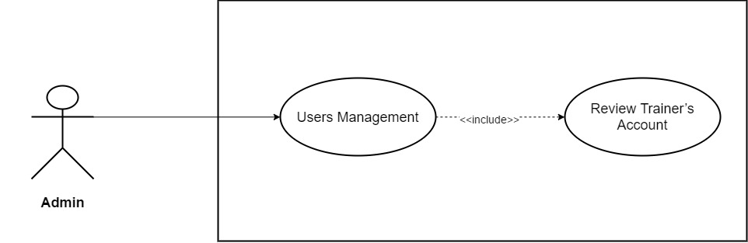

*Figure 3.47: Review Trainer’s Account*

|  |  |  |  |  |
| --- | --- | --- | --- | --- |
| **Use Case ID** | UC36 | | **Version** | 1.0 |
| **Use Case Name** | Review Trainer’s Account | | | |
| **Create By** | TruongTN | | **Last Updated** |  |
| **Primary Actor** | Administrator | | **Secondary Actor** |  |
| **Description** | Review Trainer’s Account | | | |
| **Pre-Conditions** |  | | | |
| **Post-Conditions** |  | | | |
| **Normal Flows** | | | | |
| **Step** | **Actor** | **Action** | | |
| 1 | Administrator | Click “Go to Dashboard” in the menu. | | |
| 2 | System | Send Admin to Admin’s Dashboard. | | |
| 3 | Administrator | Click “Users”. | | |
| 4 | System | Drop down list include “Learners” and “Trainers” | | |
| 5 | Administrator | Click “Trainers” | | |
| 6 | System | Display trainers management page. | | |
| 7 | Administrator | Click “Accept” to accept new trainer sign up or Click “Reject” to reject new trainer sign up. | | |
| 8 | System | Save new change into database. | | |
|  | | | | |
| **Priority** | High | | | |
| **Frequency of Use** | High | | | |
| **Business Rules** |  | | | |

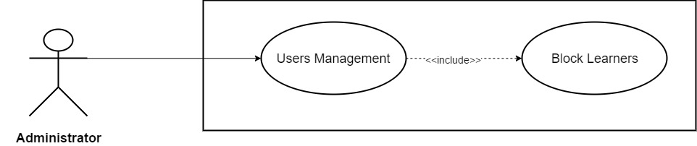

*Figure 3.48: Block Learners*

|  |  |  |  |  |
| --- | --- | --- | --- | --- |
| **Use Case ID** | UC37 | | **Version** | 1.0 |
| **Use Case Name** | Block Learners | | | |
| **Create By** | TruongTN | | **Last Updated** |  |
| **Primary Actor** | Administrator | | **Secondary Actor** |  |
| **Description** | Block Learners | | | |
| **Pre-Conditions** |  | | | |
| **Post-Conditions** |  | | | |
| **Normal Flows** | | | | |
| **Step** | **Actor** | **Action** | | |
| 1 | Administrator | Click “Go to Dashboard” in the menu. | | |
| 2 | System | Send Admin to Admin’s Dashboard. | | |
| 3 | Administrator | Click “Users”. | | |
| 4 | System | Drop down list include “Learners” and “Trainers” | | |
| 5 | Administrator | Click “Learners” | | |
| 6 | System | Display Learners management page. | | |
| 7 | Administrator | Click “Block” next to learner’s name that needed to be edit. | | |
| 8 | System | Display dialog box “Do you want to block this user?” “Yes” “No” | | |
| 9 | Administrator | Click “Yes” to block or “No” to cancel. | | |
| 10 | System | Block account from system. | | |
|  |  |  | | |
|  | | | | |
|  | | | | |
| **Priority** | High | | | |
| **Frequency of Use** | High | | | |
| **Business Rules** |  | | | |

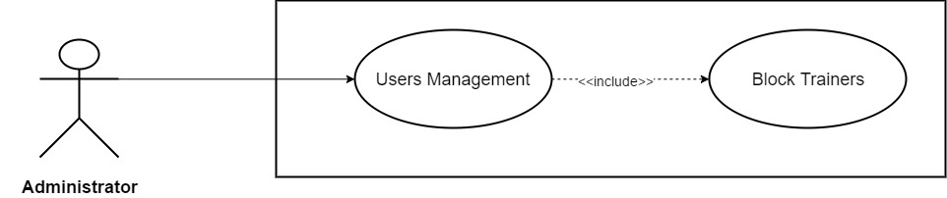

*Figure 3.49: Block Trainers*

|  |  |  |  |  |
| --- | --- | --- | --- | --- |
| **Use Case ID** | UC38 | | **Version** | 1.0 |
| **Use Case Name** | Block Trainers | | | |
| **Create By** | TruongTN | | **Last Updated** |  |
| **Primary Actor** | Administrator | | **Secondary Actor** |  |
| **Description** | Block Trainers | | | |
| **Pre-Conditions** |  | | | |
| **Post-Conditions** |  | | | |
| **Normal Flows** | | | | |
| **Step** | **Actor** | **Action** | | |
| 1 | Administrator | Click “Go to Dashboard” in the menu. | | |
| 2 | System | Send Admin to Admin’s Dashboard. | | |
| 3 | Administrator | Click “Users”. | | |
| 4 | System | Drop down list include “Learners” and “Trainers” | | |
| 5 | Administrator | Click “Trainers” | | |
| 6 | System | Display trainers management page. | | |
| 7 | Administrator | Click “Block” next to trainer’s name that needed to be edit. | | |
| 8 | System | Display dialog box “Do you want to block this user?” “Yes” “No” | | |
| 9 | Administrator | Click “Yes” to block or “No” to cancel. | | |
| 10 | System | Block account from system. | | |
|  |  |  | | |
|  | | | | |
|  | | | | |
| **Priority** | High | | | |
| **Frequency of Use** | High | | | |
| **Business Rules** |  | | | |

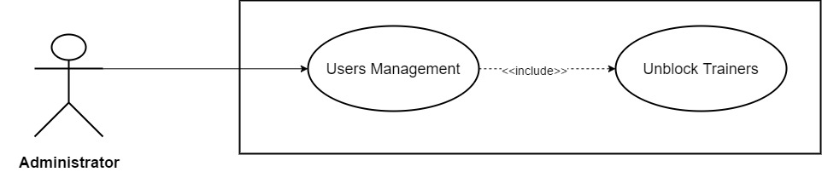

*Figure 3.50: Unblock Trainers*

|  |  |  |  |  |
| --- | --- | --- | --- | --- |
| **Use Case ID** | UC39 | | **Version** | 1.0 |
| **Use Case Name** | Unblock Trainers | | | |
| **Create By** | TruongTN | | **Last Updated** |  |
| **Primary Actor** | Administrator | | **Secondary Actor** |  |
| **Description** | Unblock Trainers | | | |
| **Pre-Conditions** |  | | | |
| **Post-Conditions** |  | | | |
| **Normal Flows** | | | | |
| **Step** | **Actor** | **Action** | | |
| 1 | Administrator | Click “Go to Dashboard” in the menu. | | |
| 2 | System | Send Admin to Admin’s Dashboard. | | |
| 3 | Administrator | Click “Users”. | | |
| 4 | System | Drop down list include “Learners” and “Trainers” | | |
| 5 | Administrator | Click “Trainers” | | |
| 6 | System | Display trainers management page. | | |
| 7 | Administrator | In “Blocked Trainer” table, click “Unblock” next to trainer’s name that needed to be edit. | | |
| 8 | System | Display dialog box “Do you want to unblock this user?” “Yes” “No” | | |
| 9 | Administrator | Click “Yes” to unblock or “No” to cancel. | | |
| 10 | System | Unblock account from system. | | |
|  |  |  | | |
|  | | | | |
|  | | | | |
| **Priority** | High | | | |
| **Frequency of Use** | High | | | |
| **Business Rules** |  | | | |

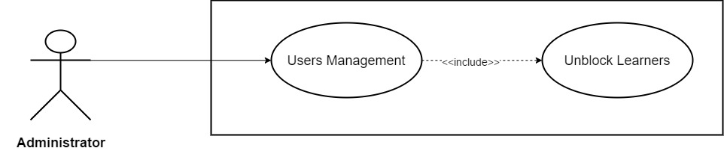

*Figure 3.51: Unblock Learners*

|  |  |  |  |  |
| --- | --- | --- | --- | --- |
| **Use Case ID** | UC40 | | **Version** | 1.0 |
| **Use Case Name** | Unblock Learner | | | |
| **Create By** | TruongTN | | **Last Updated** |  |
| **Primary Actor** | Administrator | | **Secondary Actor** |  |
| **Description** | Unblock Learner | | | |
| **Pre-Conditions** |  | | | |
| **Post-Conditions** |  | | | |
| **Normal Flows** | | | | |
| **Step** | **Actor** | **Action** | | |
| 1 | Administrator | Click “Go to Dashboard” in the menu. | | |
| 2 | System | Send Admin to Admin’s Dashboard. | | |
| 3 | Administrator | Click “Users”. | | |
| 4 | System | Drop down list include “Learners” and “Trainers” | | |
| 5 | Administrator | Click “Learners” | | |
| 6 | System | Display learner management page. | | |
| 7 | Administrator | In “Blocked Learners” table, click “Unblock” next to learner’s name that needed to be edit. | | |
| 8 | System | Display dialog box “Do you want to unblock this user?” “Yes” “No” | | |
| 9 | Administrator | Click “Yes” to unblock or “No” to cancel. | | |
| 10 | System | Unblock account from system. | | |
|  |  |  | | |
|  | | | | |
|  | | | | |
| **Priority** | High | | | |
| **Frequency of Use** | High | | | |
| **Business Rules** |  | | | |

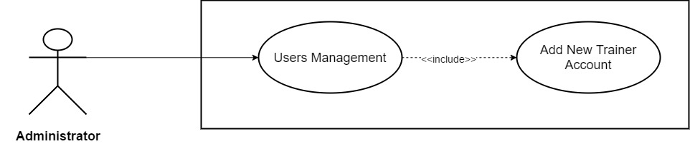

*Figure 3.52: Add New Trainer Account*

|  |  |  |  |  |  |  |
| --- | --- | --- | --- | --- | --- | --- |
| **Use Case ID** | UC41 | | | | **Version** | 1.0 |
| **Use Case Name** | Add New Trainer Account | | | | | |
| **Create By** | TruongTN | | | | **Last Updated** |  |
| **Primary Actor** | Administrator | | | | **Secondary Actor** |  |
| **Description** | Add New Trainer Account | | | | | |
| **Pre-Conditions** |  | | | | | |
| **Post-Conditions** |  | | | | | |
| **Normal Flows** | | | | | | |
| **Step** | **Actor** | | | **Action** | | |
| 1 | Administrator | | | Click “Go to Dashboard” in the menu. | | |
| 2 | System | | | Send Admin to Admin’s Dashboard. | | |
| 3 | Administrator | | | Click “Users”. | | |
| 4 | System | | | Drop down list include “Learners” and “Trainers” | | |
| 5 | Administrator | | | Click “Trainers” | | |
| 6 | System | | | Display trainers management page. | | |
| 7 | Administrator | | | Enter “Email” and “Password” | | |
| 8 | Administrator | | | Click “Create” to save or “Cancel” to cancel. | | |
| 9 | System | | | Save new account into system | | |
|  |  | | |  | | |
| **Exception** | | | | | | |
| **EC1** | | At step 7, all fields are blank. | | | | |
| **Step** | | **Actor** | **Action** | | | |
| 7.1 | | Administrator | Leave all required field blank. | | | |
| 7.2 | | Administrator | Click “Create” button. | | | |
| 7.3 | | System | Display message: “Please Enter Email and Password!” | | | |
| **EC2** | | At step 7, *Email* is left blank. | | | | |
| **Step** | | **Actor** | **Action** | | | |
| 7.1 | | Administrator | Leave *Email* field blank. | | | |
| 7.2 | | Administrator | Click “Create” button. | | | |
| 7.3 | | System | Display message: “Please Enter Email!” | | | |
| **EC3** | | At step 7, only *Password* is left blank. | | | | |
| **Step** | | **Actor** | **Action** | | | |
| 7.1 | | Administrator | Leave *Password* field blank. | | | |
| 7.2 | | Administrator | Click “Create” button. | | | |
| 7.3 | | System | Display message: “Create!” | | | |
| **EC4** | | At step 7, *Email* is invalid. (Incorrect *Email* format: abc@xyz) | | | | |
| **Step** | | **Actor** | **Action** | | | |
| 7.1 | | Administrator | Enter invalid *Email*. | | | |
| 7.2 | | Administrator | Click “Create” button. | | | |
| 7.3 | | System | Display message: “Invalid Email!” | | | |
| **EC5** | | At step 7, *Password*’s length < 8. | | | | |
| **Step** | | **Actor** | **Action** | | | |
| 7.1 | | Administrator | Enter *Password* less than 8 characters. | | | |
| 7.2 | | Administrator | Click “Create” button. | | | |
| 7.3 | | System | Display message: “Password must contains at least one upper case, one number, one special character and length must be >8!” | | | |
| **EC6** | | At step 7, *Password* does not contain any upper case. | | | | |
| **Step** | | **Actor** | **Action** | | | |
| 7.1 | | Administrator | Enter *Password* that does not contain any upper case. | | | |
| 7.2 | | Administrator | Click “Create” button. | | | |
| 7.3 | | System | Display message: “Password must contains at least one upper case, one number, one special character and length must be >8!” | | | |
| **EC7** | | At step 7, *Password* does not contain any number. | | | | |
| **Step** | | **Actor** | **Action** | | | |
| 7.1 | | Administrator | Enter *Password* that does not contain any number. | | | |
| 7.2 | | Administrator | Click “Create” button. | | | |
| 7.3 | | System | Display message: “Password must contains at least one upper case, one number, one special character and length must be >8!” | | | |
| **EC8** | | At step 7, *Password* does not contain at least one special character. | | | | |
| **Step** | | **Actor** | **Action** | | | |
| 7.1 | | Administrator | Enter *Password* does not contain at least one special character. | | | |
| 7.2 | | Administrator | Click “Create” button. | | | |
| 7.3 | | System | Display message: “Password must contains at least one upper case, one number, one special character and length must be >8!” | | | |
| **EC9** | | At step 7, Email address is already registered. | | | | |
| **Step** | | **Actor** | **Action** | | | |
| 7.1 | | Administrator | Enter email address is already registered. | | | |
| 7.2 | | Administrator | Click “Create” button. | | | |
| 7.3 | | System | Display message: “The email address you have entered is already registered.” | | | |
|  | | | | | | |
|  | | | | | | |
| **Priority** | High | | | | | |
| **Frequency of Use** | High | | | | | |
| **Business Rules** |  | | | | | |

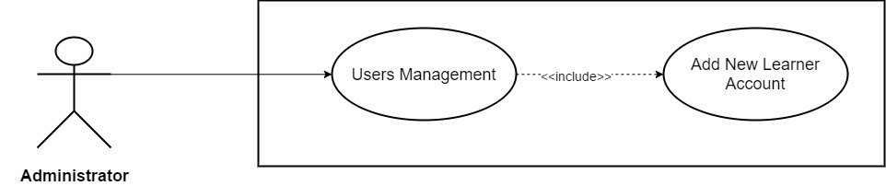

*Figure 3.53: Add New Learner Account*

|  |  |  |  |  |  |  |
| --- | --- | --- | --- | --- | --- | --- |
| **Use Case ID** | UC42 | | | | **Version** | 1.0 |
| **Use Case Name** | Add New Learner Account | | | | | |
| **Create By** | TruongTN | | | | **Last Updated** |  |
| **Primary Actor** | Administrator | | | | **Secondary Actor** |  |
| **Description** | Add New Learner Account | | | | | |
| **Pre-Conditions** |  | | | | | |
| **Post-Conditions** |  | | | | | |
| **Normal Flows** | | | | | | |
| **Step** | **Actor** | | | **Action** | | |
| 1 | Administrator | | | Click “Go to Dashboard” in the menu. | | |
| 2 | System | | | Send Admin to Admin’s Dashboard. | | |
| 3 | Administrator | | | Click “Users”. | | |
| 4 | System | | | Drop down list include “Learners” and “Trainers” | | |
| 5 | Administrator | | | Click “Learners” | | |
| 6 | System | | | Display learners management page. | | |
| 7 | Administrator | | | Enter “Email” and “Password” | | |
| 8 | Administrator | | | Click “Create” to save or “Cancel” to cancel. | | |
| 9 | System | | | Save new account into system | | |
|  |  | | |  | | |
| **Exception** | | | | | | |
| **EC1** | | At step 7, all fields are blank. | | | | |
| **Step** | | **Actor** | **Action** | | | |
| 7.1 | | Administrator | Leave all required field blank. | | | |
| 7.2 | | Administrator | Click “Create” button. | | | |
| 7.3 | | System | Display message: “Please Enter Email and Password!” | | | |
| **EC2** | | At step 7, *Email* is left blank. | | | | |
| **Step** | | **Actor** | **Action** | | | |
| 7.1 | | Administrator | Leave *Email* field blank. | | | |
| 7.2 | | Administrator | Click “Create” button. | | | |
| 7.3 | | System | Display message: “Please Enter Email!” | | | |
| **EC3** | | At step 7, only *Password* is left blank. | | | | |
| **Step** | | **Actor** | **Action** | | | |
| 7.1 | | Administrator | Leave *Password* field blank. | | | |
| 7.2 | | Administrator | Click “Create” button. | | | |
| 7.3 | | System | Display message: “Create!” | | | |
| **EC4** | | At step 7, *Email* is invalid. (Incorrect *Email* format: abc@xyz) | | | | |
| **Step** | | **Actor** | **Action** | | | |
| 7.1 | | Administrator | Enter invalid *Email*. | | | |
| 7.2 | | Administrator | Click “Create” button. | | | |
| 7.3 | | System | Display message: “Invalid Email!” | | | |
| **EC5** | | At step 7, *Password*’s length < 8. | | | | |
| **Step** | | **Actor** | **Action** | | | |
| 7.1 | | Administrator | Enter *Password* less than 8 characters. | | | |
| 7.2 | | Administrator | Click “Create” button. | | | |
| 7.3 | | System | Display message: “Password must contains at least one upper case, one number, one special character and length must be >8!” | | | |
| **EC6** | | At step 7, *Password* does not contain any upper case. | | | | |
| **Step** | | **Actor** | **Action** | | | |
| 7.1 | | Administrator | Enter *Password* that does not contain any upper case. | | | |
| 7.2 | | Administrator | Click “Create” button. | | | |
| 7.3 | | System | Display message: “Password must contains at least one upper case, one number, one special character and length must be >8!” | | | |
| **EC7** | | At step 7, *Password* does not contain any number. | | | | |
| **Step** | | **Actor** | **Action** | | | |
| 7.1 | | Administrator | Enter *Password* that does not contain any number. | | | |
| 7.2 | | Administrator | Click “Create” button. | | | |
| 7.3 | | System | Display message: “Password must contains at least one upper case, one number, one special character and length must be >8!” | | | |
| **EC8** | | At step 7, *Password* does not contain at least one special character. | | | | |
| **Step** | | **Actor** | **Action** | | | |
| 7.1 | | Administrator | Enter *Password* does not contain at least one special character. | | | |
| 7.2 | | Administrator | Click “Create” button. | | | |
| 7.3 | | System | Display message: “Password must contains at least one upper case, one number, one special character and length must be >8!” | | | |
| **EC9** | | At step 7, Email address is already registered. | | | | |
| **Step** | | **Actor** | **Action** | | | |
| 7.1 | | Administrator | Enter email address is already registered. | | | |
| 7.2 | | Administrator | Click “Create” button. | | | |
| 7.3 | | System | Display message: “The email address you have entered is already registered.” | | | |
|  | | | | | | |
|  | | | | | | |
| **Priority** | High | | | | | |
| **Frequency of Use** | High | | | | | |
| **Business Rules** |  | | | | | |

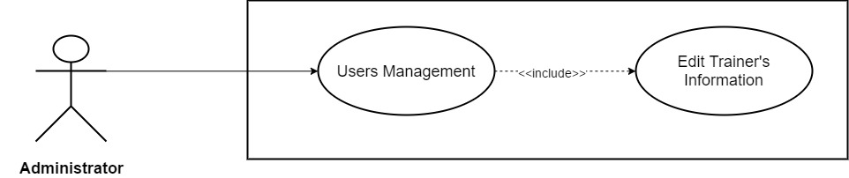

*Figure 3.54: Edit Trainer’s Information*

|  |  |  |  |  |  |  |
| --- | --- | --- | --- | --- | --- | --- |
| **Use Case ID** | UC43 | | | | **Version** | 1.0 |
| **Use Case Name** | Edit Trainer’s Information | | | | | |
| **Create By** | TruongTN | | | | **Last Updated** |  |
| **Primary Actor** | Administrator | | | | **Secondary Actor** |  |
| **Description** | Edit Trainer’s Information | | | | | |
| **Pre-Conditions** |  | | | | | |
| **Post-Conditions** |  | | | | | |
| **Normal Flows** | | | | | | |
| **Step** | **Actor** | | | **Action** | | |
| 1 | Administrator | | | Click “Go to Dashboard” in the menu. | | |
| 2 | System | | | Send Admin to Admin’s Dashboard. | | |
| 3 | Administrator | | | Click “Users”. | | |
| 4 | System | | | Drop down list include “Learners” and “Trainers” | | |
| 5 | Administrator | | | Click “Trainers” | | |
| 6 | System | | | Display trainers management page. | | |
| 7 | Administrator | | | Click “Edit” next to trainer’s name that needed to be edit. | | |
| 8 | Administrator | | | Fill in all information that Administrator want to edit. | | |
| 9 | Administrator | | | Click “Save” to save new information and “Cancel” to cancel. | | |
| 10 | System | | | Save new information account into system | | |
|  |  | | |  | | |
| **Exception** | | | | | | |
| **EC1** | | At step 8, Administrator remove all required field and leave it blank. | | | | |
| **Step** | | **Actor** | **Action** | | | |
| 8.1 | | Administrator | Remove and leave all required field blank. | | | |
| 8.2 | | Administrator | Click “Save” button. | | | |
| 8.3 | | System | Display message: “Please Fill In All Required Field!” | | | |
| **EC2** | | At step 8, Administrator only remove Trainer Name and leave it blank. | | | | |
| **Step** | | **Actor** | **Action** | | | |
| 8.1 | | Administrator | Remove and leave Trainer Name blank. | | | |
| 8.2 | | Administrator | Click “Save” button. | | | |
| 8.3 | | System | Display message: “Please Enter Trainer Name!” | | | |
| **EC3** | | At step 8, only *Fields* is not selected. | | | | |
| **Step** | | **Actor** | **Action** | | | |
| 8.1 | | Administrator | Do not select *Fields.* | | | |
| 8.2 | | Administrator | Click “Save” button. | | | |
| 8.3 | | System | Display message: “Please Select Fields!” | | | |
| **EC4** | | At step 8, Administrator remove and leave *Contact* blank. | | | | |
| **Step** | | **Actor** | **Action** | | | |
| 8.1 | | Administrator | Remove and leave *Contact* field blank. | | | |
| 8.2 | | Administrator | Click “Save” button. | | | |
| 8.3 | | System | Display message: “Please Enter Password!” | | | |
| **EC5** | | At step 8, Administrator only remove and leave *Address* blank. | | | | |
| **Step** | | **Actor** | **Action** | | | |
| 8.1 | | Administrator | Remove and leave *Address* blank. | | | |
| 8.2 | | Administrator | Click “Save” button. | | | |
| 8.3 | | System | Display message: “Please Enter Address!” | | | |
| **EC6** | | At step 8, *Introduction*’s length > 200 character. | | | | |
| **Step** | | **Actor** | **Action** | | | |
| 8.1 | | Administrator | Enter more than 200 character in *Introduction* field. | | | |
| 8.2 | | Administrator | Click “Save” button. | | | |
| 8.3 | | System | Display message: “Length must be < 200” | | | |
|  | | | | | | |
|  | | | | | | |
| **Priority** | High | | | | | |
| **Frequency of Use** | High | | | | | |
| **Business Rules** |  | | | | | |

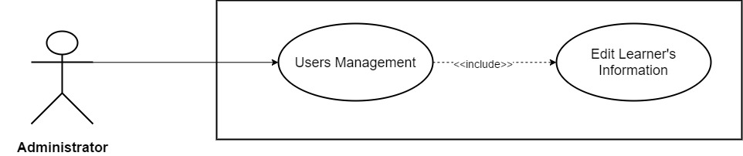

*Figure 3.55: Edit Learner’s Information*

|  |  |  |  |  |  |  |
| --- | --- | --- | --- | --- | --- | --- |
| **Use Case ID** | UC44 | | | | **Version** | 1.0 |
| **Use Case Name** | Edit Learner’s Information | | | | | |
| **Create By** | TruongTN | | | | **Last Updated** |  |
| **Primary Actor** | Administrator | | | | **Secondary Actor** |  |
| **Description** | Edit Learner’s Information | | | | | |
| **Pre-Conditions** |  | | | | | |
| **Post-Conditions** |  | | | | | |
| **Normal Flows** | | | | | | |
| **Step** | **Actor** | | | **Action** | | |
| 1 | Administrator | | | Click “Go to Dashboard” in the menu. | | |
| 2 | System | | | Send Admin to Admin’s Dashboard. | | |
| 3 | Administrator | | | Click “Users”. | | |
| 4 | System | | | Drop down list include “Learners” and “Trainers” | | |
| 5 | Administrator | | | Click “Learners” | | |
| 6 | System | | | Display learners management page. | | |
| 7 | Administrator | | | Click “Edit” next to learner’s name that needed to be edit. | | |
| 8 | Administrator | | | Fill in all information that Administrator want to edit. | | |
| 9 | Administrator | | | Click “Save” to save new information and “Cancel” to cancel. | | |
| 10 | System | | | Save new information account into system | | |
|  |  | | |  | | |
| **Exception** | | | | | | |
| **EC1** | | At step 8, Administrator remove all required field and leave it blank. | | | | |
| **Step** | | **Actor** | **Action** | | | |
| 8.1 | | Administrator | Remove and leave all required field blank. | | | |
| 8.2 | | Administrator | Click “Save” button. | | | |
| 8.3 | | System | Display message: “Please Fill In All Required Field!” | | | |
| **EC2** | | At step 8, Administrator only remove First Name and leave it blank. | | | | |
| **Step** | | **Actor** | **Action** | | | |
| 8.1 | | Administrator | Remove and leave First Name blank. | | | |
| 8.2 | | Administrator | Click “Save” button. | | | |
| 8.3 | | System | Display message: “Please Enter First Name!” | | | |
| **EC3** | | At step 8, Administrator only remove Last Name and leave it blank. | | | | |
| **Step** | | **Actor** | **Action** | | | |
| 8.1 | | Administrator | Remove and leave Last Name blank. | | | |
| 8.2 | | Administrator | Click “Save” button. | | | |
| 8.3 | | System | Display message: “Please Enter Last Name!” | | | |
| **EC4** | | At step 8, Administrator leave Date of Birth blank. | | | | |
| **Step** | | **Actor** | **Action** | | | |
| 8.1 | | Administrator | Leave Date of Birth blank. | | | |
| 8.2 | | Administrator | Click “Save” button. | | | |
| 8.3 | | System | Display message: “Please Enter Date of Birth!” | | | |
| **EC5** | | At step 8, Administrator remove and leave *Contact* blank. | | | | |
| **Step** | | **Actor** | **Action** | | | |
| 8.1 | | Administrator | Remove and leave *Contact* field blank. | | | |
| 8.2 | | Administrator | Click “Save” button. | | | |
| 8.3 | | System | Display message: “Please Enter Password!” | | | |
| **EC6** | | At step 8, Administrator only remove and leave *Job* blank. | | | | |
| **Step** | | **Actor** | **Action** | | | |
| 8.1 | | Administrator | Remove and leave *Job* blank. | | | |
| 8.2 | | Administrator | Click “Save” button. | | | |
| 8.3 | | System | Display message: “Please Enter Job!” | | | |
| **EC7** | | At step 8, *Introduction*’s length > 200 character. | | | | |
| **Step** | | **Actor** | **Action** | | | |
| 8.1 | | Administrator | Enter more than 200 character in *Introduction* field. | | | |
| 8.2 | | Administrator | Click “Save” button. | | | |
| 8.3 | | System | Display message: “Length must be < 200” | | | |
|  | | | | | | |
|  | | | | | | |
| **Priority** | High | | | | | |
| **Frequency of Use** | High | | | | | |
| **Business Rules** |  | | | | | |

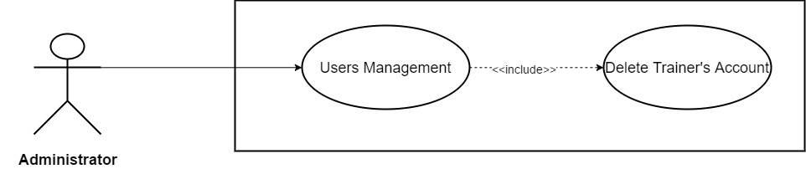

*Figure 3.56: Delete Trainer’s Account*

|  |  |  |  |  |
| --- | --- | --- | --- | --- |
| **Use Case ID** | UC45 | | **Version** | 1.0 |
| **Use Case Name** | Delete Trainer’s Account | | | |
| **Create By** | TruongTN | | **Last Updated** |  |
| **Primary Actor** | Administrator | | **Secondary Actor** |  |
| **Description** | Delete Trainer’s Account | | | |
| **Pre-Conditions** |  | | | |
| **Post-Conditions** |  | | | |
| **Normal Flows** | | | | |
| **Step** | **Actor** | **Action** | | |
| 1 | Administrator | Click “Go to Dashboard” in the menu. | | |
| 2 | System | Send Admin to Admin’s Dashboard. | | |
| 3 | Administrator | Click “Users”. | | |
| 4 | System | Drop down list include “Learners” and “Trainers” | | |
| 5 | Administrator | Click “Trainers” | | |
| 6 | System | Display trainers management page. | | |
| 7 | Administrator | Click “Delete” next to trainer’s name that needed to be edit. | | |
| 8 | System | Display dialog box “Do you want to delete this user?” “Yes” “No” | | |
| 9 | Administrator | Click “Yes” to delete or “No” to cancel. | | |
| 10 | System | Delete account from system. | | |
|  |  |  | | |
|  | | | | |
|  | | | | |
| **Priority** | High | | | |
| **Frequency of Use** | High | | | |
| **Business Rules** |  | | | |

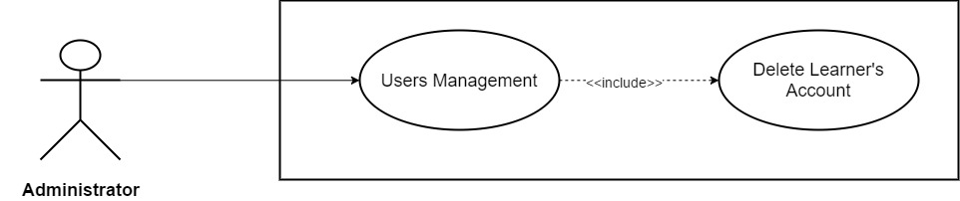

*Figure 3.57: Delete Learner’s Account*

|  |  |  |  |  |
| --- | --- | --- | --- | --- |
| **Use Case ID** | UC46 | | **Version** | 1.0 |
| **Use Case Name** | Delete Learner’s Account | | | |
| **Create By** | TruongTN | | **Last Updated** |  |
| **Primary Actor** | Administrator | | **Secondary Actor** |  |
| **Description** | Delete Learner’s Account | | | |
| **Pre-Conditions** |  | | | |
| **Post-Conditions** |  | | | |
| **Normal Flows** | | | | |
| **Step** | **Actor** | **Action** | | |
| 1 | Administrator | Click “Go to Dashboard” in the menu. | | |
| 2 | System | Send Admin to Admin’s Dashboard. | | |
| 3 | Administrator | Click “Users”. | | |
| 4 | System | Drop down list include “Learners” and “Trainers” | | |
| 5 | Administrator | Click “Learners” | | |
| 6 | System | Display learner management page. | | |
| 7 | Administrator | Click “Delete” next to learner’s name that needed to be edit. | | |
| 8 | System | Display dialog box “Do you want to delete this user?” “Yes” “No” | | |
| 9 | Administrator | Click “Yes” to delete or “No” to cancel. | | |
| 10 | System | Delete account from system. | | |
|  |  |  | | |
|  | | | | |
|  | | | | |
| **Priority** | High | | | |
| **Frequency of Use** | High | | | |
| **Business Rules** |  | | | |

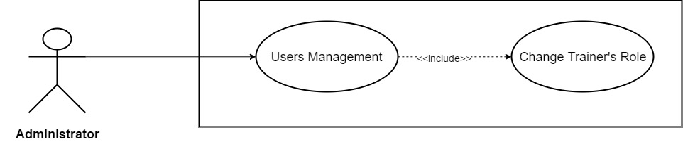

*Figure 3.58: Change Trainer’s Role*

|  |  |  |  |  |
| --- | --- | --- | --- | --- |
| **Use Case ID** | UC47 | | **Version** | 1.0 |
| **Use Case Name** | Change Trainer’s Role | | | |
| **Create By** | TruongTN | | **Last Updated** |  |
| **Primary Actor** | Administrator | | **Secondary Actor** |  |
| **Description** | Change Trainer’s Role | | | |
| **Pre-Conditions** |  | | | |
| **Post-Conditions** |  | | | |
| **Normal Flows** | | | | |
| **Step** | **Actor** | **Action** | | |
| 1 | Administrator | Click “Go to Dashboard” in the menu. | | |
| 2 | System | Send Admin to Admin’s Dashboard. | | |
| 3 | Administrator | Click “Users”. | | |
| 4 | System | Drop down list include “Learners” and “Trainers” | | |
| 5 | Administrator | Click “Trainers” | | |
| 6 | System | Display trainers management page. | | |
| 7 | Administrator | In “Trainers List” table – “Role” column, click “Admin” to change trainer role to admin or click “Learner” to change their role to learner. | | |
| 8 | System | Display dialog box “Do you want to change this user role?” “Yes” “No” | | |
| 9 | Administrator | Click “Yes” to change or “No” to cancel. | | |
| 10 | System | Change trainer role, update new role into system. | | |
|  |  |  | | |
|  | | | | |
|  | | | | |
| **Priority** | High | | | |
| **Frequency of Use** | High | | | |
| **Business Rules** |  | | | |

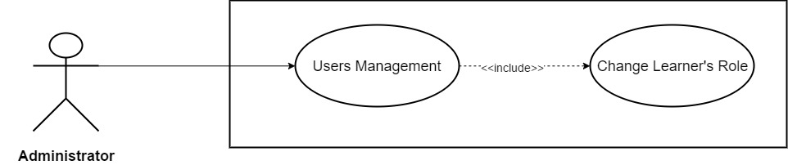

*Figure 3.59: Change Learner’s Role*

|  |  |  |  |  |
| --- | --- | --- | --- | --- |
| **Use Case ID** | UC48 | | **Version** | 1.0 |
| **Use Case Name** | Change Learner’s Role | | | |
| **Create By** | TruongTN | | **Last Updated** |  |
| **Primary Actor** | Administrator | | **Secondary Actor** |  |
| **Description** | Change Learner’s Role | | | |
| **Pre-Conditions** |  | | | |
| **Post-Conditions** |  | | | |
| **Normal Flows** | | | | |
| **Step** | **Actor** | **Action** | | |
| 1 | Administrator | Click “Go to Dashboard” in the menu. | | |
| 2 | System | Send Admin to Admin’s Dashboard. | | |
| 3 | Administrator | Click “Users”. | | |
| 4 | System | Drop down list include “Learners” and “Trainers” | | |
| 5 | Administrator | Click “Learners” | | |
| 6 | System | Display learners management page. | | |
| 7 | Administrator | In “Learners List” table – “Role” column, click “Admin” to change trainer role to admin or click “Trainer” to change their role to trainer. | | |
| 8 | System | Display dialog box “Do you want to change this user role?” “Yes” “No” | | |
| 9 | Administrator | Click “Yes” to change or “No” to cancel. | | |
| 10 | System | Change trainer role, update new role into system. | | |
|  |  |  | | |
|  | | | | |
|  | | | | |
| **Priority** | High | | | |
| **Frequency of Use** | High | | | |
| **Business Rules** |  | | | |

* + 1. **Administrator/Learner**

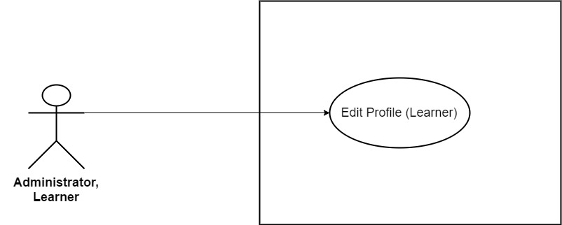

*Figure 3.60: Edit Profile (Learner)*

|  |  |  |  |  |
| --- | --- | --- | --- | --- |
| **Use Case ID** | UC49 | | **Version** | 1.0 |
| **Use Case Name** | Edit Profile (*Learner*) | | | |
| **Create By** | TruongTN | | **Last Updated** |  |
| **Primary Actor** | Learner | | **Secondary Actor** | Administrator |
| **Description** | Edit account’s information for *Learner.* | | | |
| **Pre-Conditions** | * User must login first. * Internet connection is required. | | | |
| **Post-Conditions** | * New account information is saved and updated into system. | | | |
| **Normal Flows** | | | | |
| **Step** | **Actor** | **Action** | | |
| 1 | Learner | Move mouse to Learner’s name to the right of search bar. | | |
| 2 | System | Display drop-down list. | | |
| 3 | Learner | Click “My Profile” | | |
| 4 | System | Send Trainer to “My Profile” page | | |
| 5 | System | Display “My Profile” page which contain the following information:   * Email * First Name * Last Name * Gender * Date of Birth * Contact * Job * Introduction | | |
| 6 | Learner | Enter all the information that they wish to edit. Email can’t be edit. Gender can’t be blank. | | |
| 7 | Learner | Click “Save” button. | | |
| 8 | System | Update information into system’s Database. | | |
| 9 | System | Display “My Profile” page with updated information. | | |
|  | | | | |
| **Exception** | | | | |
| **EC1** | At step 6, Learner remove all required field and leave it blank. | | | |
| **Step** | **Actor** | **Action** | | |
| 6.1 | Learner | Remove and leave all required field blank. | | |
| 6.2 | Learner | Click “Save” button. | | |
| 6.3 | System | Display message: “Please Fill In All Required Field!” | | |
| **EC2** | At step 6, Learner only remove First Name and leave it blank. | | | |
| **Step** | **Actor** | **Action** | | |
| 6.1 | Learner | Remove and leave First Name blank. | | |
| 6.2 | Learner | Click “Save” button. | | |
| 6.3 | System | Display message: “Please Enter First Name!” | | |
| **EC3** | At step 6, Learner only remove Last Name and leave it blank. | | | |
| **Step** | **Actor** | **Action** | | |
| 6.1 | Learner | Remove and leave Last Name blank. | | |
| 6.2 | Learner | Click “Save” button. | | |
| 6.3 | System | Display message: “Please Enter Last Name!” | | |
| **EC4** | At step 6, Learner leave Date of Birth blank. | | | |
| **Step** | **Actor** | **Action** | | |
| 6.1 | Learner | Leave Date of Birth blank. | | |
| 6.2 | Learner | Click “Save” button. | | |
| 6.3 | System | Display message: “Please Enter Date of Birth!” | | |
| **EC5** | At step 6, Learner remove and leave *Contact* blank. | | | |
| **Step** | **Actor** | **Action** | | |
| 6.1 | Learner | Remove and leave *Contact* field blank. | | |
| 6.2 | Learner | Click “Save” button. | | |
| 6.3 | System | Display message: “Please Enter Password!” | | |
| **EC6** | At step 6, Learner only remove and leave *Job* blank. | | | |
| **Step** | **Actor** | **Action** | | |
| 6.1 | Learner | Remove and leave *Job* blank. | | |
| 6.2 | Learner | Click “Save” button. | | |
| 6.3 | System | Display message: “Please Enter Job!” | | |
| **EC7** | At step 6, *Introduction*’s length > 200 character. | | | |
| **Step** | **Actor** | **Action** | | |
| 6.1 | Learner | Enter more than 200 character in *Introduction* field. | | |
| 6.2 | Learner | Click “Save” button. | | |
| 6.3 | System | Display message: “Length must be < 200” | | |
|  |  |  | | |
| **Priority** | High | | | |
| **Frequency of Use** | High | | | |
| **Business Rules** | BR1 | | | |

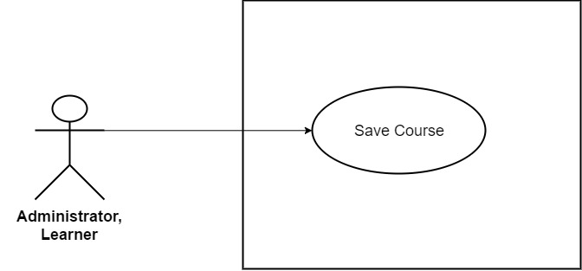

*Figure 3.61: Save Course*

|  |  |  |  |  |
| --- | --- | --- | --- | --- |
| **Use Case ID** | UC50 | | **Version** | 1.0 |
| **Use Case Name** | Save Course | | | |
| **Create By** | TruongTN | | **Last Updated** |  |
| **Primary Actor** | Learner | | **Secondary Actor** | Administrator |
| **Description** | Save course. | | | |
| **Pre-Conditions** | * User must login first. * Internet connection is required. * User must be Learner or Administrator. | | | |
| **Post-Conditions** | * Selected course is saved. | | | |
| **Normal Flows** | | | | |
| **Step** | **Actor** | **Action** | | |
| 1 | Learner | Click the flag in the top-left corner of course image. | | |
| 2 | System | Display message: “Course Saved!” | | |
| **Exception** | | | | |
| **EC1** | At step 1, Learner click save course that has already been saved. | | | |
| 1.1 | Learner | Click save course that has already been saved. | | |
| 1.2 | System | Display message: “Course Unsaved!” | | |
|  |  |  | | |
|  | | | | |
| **Priority** | High | | | |
| **Frequency of Use** | High | | | |
| **Business Rules** |  | | | |

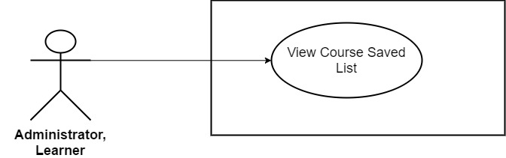

*Figure 3.62: View Course Saved List*

|  |  |  |  |  |
| --- | --- | --- | --- | --- |
| **Use Case ID** | UC51 | | **Version** | 1.0 |
| **Use Case Name** | View Course Saved List | | | |
| **Create By** | TruongTN | | **Last Updated** |  |
| **Primary Actor** | Learner | | **Secondary Actor** | Administrator |
| **Description** | View Course Save List | | | |
| **Pre-Conditions** | * User must login first. * Internet connection is required. * User must be Learner or Administrator. | | | |
| **Post-Conditions** | * Display course saved list. | | | |
| **Normal Flows** | | | | |
| **Step** | **Actor** | **Action** | | |
| 1 | Learner | Move mouse to Learner’s name to the right of search bar. | | |
| 2 | System | Display drop-down list. | | |
| 3 | Learner | Click “Course Saved” | | |
| 4 | System | Display “Course Saved” page . | | |
|  | | | | |
| **Priority** | High | | | |
| **Frequency of Use** | High | | | |
| **Business Rules** |  | | | |

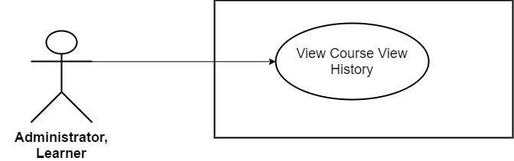

*Figure 3.63: View Course View History*

|  |  |  |  |  |
| --- | --- | --- | --- | --- |
| **Use Case ID** | UC52 | | **Version** | 1.0 |
| **Use Case Name** | View Course View History | | | |
| **Create By** | TruongTN | | **Last Updated** |  |
| **Primary Actor** | Learner | | **Secondary Actor** | Administrator |
| **Description** | View Course View History | | | |
| **Pre-Conditions** | * User must login first. * Internet connection is required. * User must be Learner or Administrator. | | | |
| **Post-Conditions** | * Display course view history. | | | |
| **Normal Flows** | | | | |
| **Step** | **Actor** | **Action** | | |
| 1 | Trainer | Move mouse to Learner’s name to the right of search bar. | | |
| 2 | System | Display drop-down list. | | |
| 3 | Trainer | Click “View’s History” | | |
| 4 | System | Display “View’s History” page . | | |
|  | | | | |
| **Priority** | High | | | |
| **Frequency of Use** | High | | | |
| **Business Rules** |  | | | |

1. **Non-Functional Requirement**
   1. **Usability**

* The website’s UI must be simple, elegant, logical and easy to use.
* Follow Bootstrap framework make design stripped down to the basics, removes any stylistic choices that give it the illusion of three-dimensionality.
* Responsive design, user can easily access by mobile, table and other devices.
  1. **Security**

The security matrix is as follow:

|  |  |  |  |  |
| --- | --- | --- | --- | --- |
| **Functional** | **Guest** | **Learner** | **Trainer** | **Administrator** |
| **Sign Up as Trainer** |  |  |  |  |
| **Sign Up as Learner** |  |  |  |  |
| **Sign In** |  |  |  |  |
| **Log Out** |  |  |  |  |
| **Change Password** |  |  |  |  |
| **Forget Password** |  |  |  |  |
| **Update Profile Picture** |  |  |  |  |
| **View Personal Profile** |  |  |  |  |
| **Send Messages** |  |  |  |  |
| **View Messages** |  |  |  |  |
| **Delete Message** |  |  |  |  |
| **Comment Course** |  |  |  |  |
| **Edit Comment** |  |  |  |  |
| **Delete Comment** |  |  |  |  |
| **Rate Course** |  |  |  |  |
| **Rate Trainer** |  |  |  |  |
| **View Course Statistic** |  |  |  |  |
| **Create New Course** |  |  |  |  |
| **Edit Course Detail** |  |  |  |  |
| **Delete Courses** |  |  |  |  |
| **Upload Documents** |  |  |  |  |
| **Delete Documents** |  |  |  |  |
| **View Documents Dashboard** |  |  |  |  |
| **Edit Profile Trainer** |  |  |  |  |
| **View Course Detail** |  |  |  |  |
| **Search Course** |  |  |  |  |
| **View Trainer List** |  |  |  |  |
| **View Other Public Profile** |  |  |  |  |
| **View Course Comment** |  |  |  |  |
| **View Course’s Rate** |  |  |  |  |
| **View Trainer’s Rate** |  |  |  |  |
| **View Document Picture** |  |  |  |  |
| **View Website Statistic** |  |  |  |  |
| **Review Trainer’s Document** |  |  |  |  |
| **Review New Course** |  |  |  |  |
| **Review Trainer’s Account** |  |  |  |  |
| **Block Learners** |  |  |  |  |
| **Block Trainers** |  |  |  |  |
| **Unblock Learners** |  |  |  |  |
| **Unblock Trainers** |  |  |  |  |
| **Add New Trainer Account** |  |  |  |  |
| **Add New Learner Account** |  |  |  |  |
| **Edit Trainer’s Information** |  |  |  |  |
| **Edit Learner’s Information** |  |  |  |  |
| **Delete Trainer’s Account** |  |  |  |  |
| **Delete Learner’s Account** |  |  |  |  |
| **Change Trainer’s Role** |  |  |  |  |
| **Change Learner’s Role** |  |  |  |  |
| **Edit Profile (Learner)** |  |  |  |  |
| **Save Course** |  |  |  |  |
| **View Course Saved List** |  |  |  |  |
| **View Course View History** |  |  |  |  |

**Chapter 4: Software Project Design Description**

1. **Purpose**

The purpose of this chapter is to give the developer team a guidance of what the system’s architecture is, and how they should be implemented. This chapter consists of:

* Architecture overview
* Database design
* Detailed design
* Detailed description of components

1. **Architecture Overview**
   1. **System Architecture**
   2. **System Architecture Explanation**
2. **Design of WeTeach’s System**
   1. **Architecture Layers Design**
   2. **Database Design**
      1. **Database Diagram**
      2. **Database Detail**
3. **Detailed Design**
   1. **Sign Up as Trainer**

**Description**

User sign up for new account to become a Trainer

**Design**

**Class Diagram**

**Sequence Diagram**

* 1. **Sign Up as Learner**

**Description**

User sign up for new account to become a Trainer

**Design**

**Class Diagram**

**Sequence Diagram**

* 1. **Sign In**

**Description**

User sign up for new account to become a Trainer

**Design**

**Class Diagram**

**Sequence Diagram**

* 1. **Log Out**

**Description**

User sign up for new account to become a Trainer

**Design**

**Class Diagram**

**Sequence Diagram**

* 1. **Change Password**

**Description**

User sign up for new account to become a Trainer

**Design**

**Class Diagram**

**Sequence Diagram**

* 1. **Forget Password**

**Description**

User sign up for new account to become a Trainer

**Design**

**Class Diagram**

**Sequence Diagram**

* 1. **Update Profile Picture**

**Description**

User sign up for new account to become a Trainer

**Design**

**Class Diagram**

**Sequence Diagram**

* 1. **View Personal Profile**

**Description**

User sign up for new account to become a Trainer

**Design**

**Class Diagram**

**Sequence Diagram**

* 1. **Send Message**

**Description**

User sign up for new account to become a Trainer

**Design**

**Class Diagram**

**Sequence Diagram**

* 1. **View Message**

**Description**

User sign up for new account to become a Trainer

**Design**

**Class Diagram**

**Sequence Diagram**

* 1. **Delete Message**

**Description**

User sign up for new account to become a Trainer

**Design**

**Class Diagram**

**Sequence Diagram**

* 1. **Comment Course**

**Description**

User sign up for new account to become a Trainer

**Design**

**Class Diagram**

**Sequence Diagram**

* 1. **Edit Comment**

**Description**

User sign up for new account to become a Trainer

**Design**

**Class Diagram**

**Sequence Diagram**

* 1. **Delete Comment**

**Description**

User sign up for new account to become a Trainer

**Design**

**Class Diagram**

**Sequence Diagram**

* 1. **Rate Course**

**Description**

User sign up for new account to become a Trainer

**Design**

**Class Diagram**

**Sequence Diagram**

* 1. **Rate Trainer**

**Description**

User sign up for new account to become a Trainer

**Design**

**Class Diagram**

**Sequence Diagram**

* 1. **View Course Statistic**

**Description**

User sign up for new account to become a Trainer

**Design**

**Class Diagram**

**Sequence Diagram**

* 1. **Create New Course**

**Description**

User sign up for new account to become a Trainer

**Design**

**Class Diagram**

**Sequence Diagram**

* 1. **Edit Course Detail**

**Description**

User sign up for new account to become a Trainer

**Design**

**Class Diagram**

**Sequence Diagram**

* 1. **Delete Courses**

**Description**

User sign up for new account to become a Trainer

**Design**

**Class Diagram**

**Sequence Diagram**

* 1. **Upload Documents**

**Description**

User sign up for new account to become a Trainer

**Design**

**Class Diagram**

**Sequence Diagram**

* 1. **Delete Documents**

**Description**

User sign up for new account to become a Trainer

**Design**

**Class Diagram**

**Sequence Diagram**

* 1. **View Documents Dashboard**

**Description**

User sign up for new account to become a Trainer

**Design**

**Class Diagram**

**Sequence Diagram**

* 1. **Edit Profile (Trainer)**

**Description**

User sign up for new account to become a Trainer

**Design**

**Class Diagram**

**Sequence Diagram**

* 1. **View Course Detail**

**Description**

User sign up for new account to become a Trainer

**Design**

**Class Diagram**

**Sequence Diagram**

* 1. **Search Course**

**Description**

User sign up for new account to become a Trainer

**Design**

**Class Diagram**

**Sequence Diagram**

* 1. **View Trainer List**

**Description**

User sign up for new account to become a Trainer

**Design**

**Class Diagram**

**Sequence Diagram**

* 1. **View Other Public Profile**

**Description**

User sign up for new account to become a Trainer

**Design**

**Class Diagram**

**Sequence Diagram**

* 1. **View Course Comment**

**Description**

User sign up for new account to become a Trainer

**Design**

**Class Diagram**

**Sequence Diagram**

* 1. **View Course’s Rate**

**Description**

User sign up for new account to become a Trainer

**Design**

**Class Diagram**

**Sequence Diagram**

* 1. **View Trainer’s Rate**

**Description**

User sign up for new account to become a Trainer

**Design**

**Class Diagram**

**Sequence Diagram**

* 1. **View Document Picture**

**Description**

User sign up for new account to become a Trainer

**Design**

**Class Diagram**

**Sequence Diagram**

* 1. **View Website Statistic**

**Description**

User sign up for new account to become a Trainer

**Design**

**Class Diagram**

**Sequence Diagram**

* 1. **Review Trainer’s Document**

**Description**

User sign up for new account to become a Trainer

**Design**

**Class Diagram**

**Sequence Diagram**

* 1. **Review New Course**

**Description**

User sign up for new account to become a Trainer

**Design**

**Class Diagram**

**Sequence Diagram**

* 1. **Review Trainer’s Account**

**Description**

User sign up for new account to become a Trainer

**Design**

**Class Diagram**

**Sequence Diagram**

* 1. **Block Learners**

**Description**

User sign up for new account to become a Trainer

**Design**

**Class Diagram**

**Sequence Diagram**

* 1. **Block Trainers**

**Description**

User sign up for new account to become a Trainer

**Design**

**Class Diagram**

**Sequence Diagram**

* 1. **Unblock Learners**

**Description**

User sign up for new account to become a Trainer

**Design**

**Class Diagram**

**Sequence Diagram**

* 1. **Unblock Trainers**

**Description**

User sign up for new account to become a Trainer

**Design**

**Class Diagram**

**Sequence Diagram**

* 1. **Add New Trainer Account**

**Description**

User sign up for new account to become a Trainer

**Design**

**Class Diagram**

**Sequence Diagram**

* 1. **Add New Learner Account**

**Description**

User sign up for new account to become a Trainer

**Design**

**Class Diagram**

**Sequence Diagram**

* 1. **Edit Trainer’s Information**

**Description**

User sign up for new account to become a Trainer

**Design**

**Class Diagram**

**Sequence Diagram**

* 1. **Edit Learner’s Information**

**Description**

User sign up for new account to become a Trainer

**Design**

**Class Diagram**

**Sequence Diagram**

* 1. **Delete Trainer’s Account**

**Description**

User sign up for new account to become a Trainer

**Design**

**Class Diagram**

**Sequence Diagram**

* 1. **Delete Learner’s Account**

**Description**

User sign up for new account to become a Trainer

**Design**

**Class Diagram**

**Sequence Diagram**

* 1. **Change Trainer’s Role**

**Description**

User sign up for new account to become a Trainer

**Design**

**Class Diagram**

**Sequence Diagram**

* 1. **Change Learner’s Role**

**Description**

User sign up for new account to become a Trainer

**Design**

**Class Diagram**

**Sequence Diagram**

* 1. **Edit Profile (Learner)**

**Description**

User sign up for new account to become a Trainer

**Design**

**Class Diagram**

**Sequence Diagram**

* 1. **Save Course**

**Description**

User sign up for new account to become a Trainer

**Design**

**Class Diagram**

**Sequence Diagram**

* 1. **View Course Saved List**

**Description**

User sign up for new account to become a Trainer

**Design**

**Class Diagram**

**Sequence Diagram**

* 1. **View Course View History**

**Description**

User sign up for new account to become a Trainer

**Design**

**Class Diagram**

**Sequence Diagram**