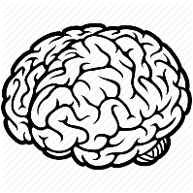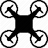Br ne  
 *brain controlled drone*

System Configuration

**Which tools do we use?**

We are going to use the school intern GitLab server. Considering the fact that we are working together with the company g.tec we have some important data (libraries etc.) which are not intended for public consumption. The school GitLab with the possibility to set Repositories to private access is a good place for the Brone Project files.

**Which documents are under version control?**

All Brone project files, including Documents, Prototypes and the project itself will be under version control. We were not able to find any reason why we should exclude files from the version control.

**Organization of artifacts**

**Variant management**

The following diagram displays our guidelines for branching. It is elaborated further down below.

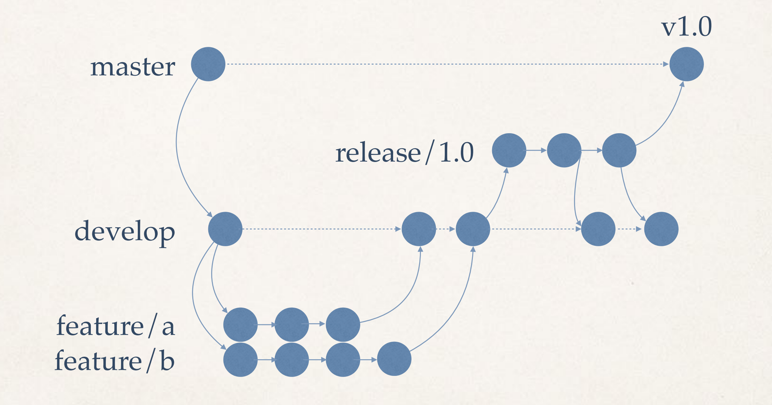

At the beginning of our project, the “master”-Branch as well as a “develop”-Branch are created.

Let us roll up the concept from back to forth and therefore begin with the branches created when developing features. Each time a new feature starts being worked on, a new branch for it is created. When it is ready for the project-group to work with it is pushed to the develop branch. When the project is once again ready for a release, a branch where the version gets checked for various bugs is created. When done doing so, it is pushed to the develop branch (for further development) as well as the master branch.