# Instruction Manuals of Software

Contents

Instruction Manuals of Software 1

Prerequisite environment setup 1

MatConvNet configuration 1

Install and Use OpenCV Interface 2

Build trajectory segments 2

Data configuration 2

Labeling trajectory segments for learning 3

The GUI of labelling software 3

The process of labelling segment 5

Training CNN and apply CNN to trajectories generation 6

## Prerequisite environment setup

### MatConvNet configuration

First go to directory named ‘matconvnet\matlab’contained in this software. The system already contained Win-64 and Mac based binary mex files with CUDA supported, so you will bother building mex files for these two systems and run vl_setupnn.m directly to set path of the MatConvNet. If you want to build mex files on your own, please refer to <http://www.vlfeat.org/matconvnet/install/> for more information. Once the path has been set, please save it in the set path dialogue box.

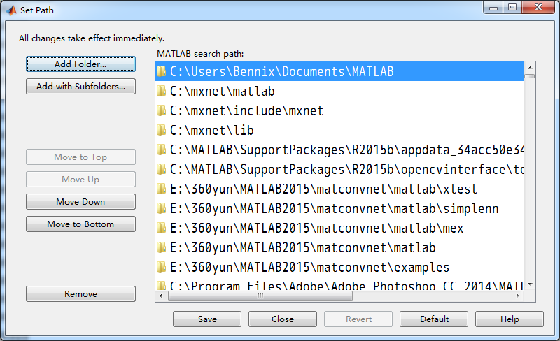

Figure Set Path dialogue box

### Install and Use OpenCV Interface

Please refer Matlab 2015b own help system on how to Install and Use Computer Vision System Toolbox OpenCV Interface. Or just type visionSupportPackages and follow the install wizard.

## Build trajectory segments

### Data configuration

In the file run_first.m there are four variables should be set manually, they are:

filenamebase='E:\\fish3\\CoreView_256\\Master Camera\\CoreView_256_Master_Camera_%05d.bmp';

database='E:\\fish3\\CoreView_256\\data';

total_frame=2000;

total_fish=14;

filenamebase is the format string to locate the filename of the input images, please see <http://www.mathworks.com/help/matlab/matlab_prog/formatting-strings.html?s_tid=srchtitle> for more details of writing your own format string for your own input image data.

database is used to tell system where to store the data.

total_frame is used to tell system how many frames included in data.

total_fish is used tell system how many fishes in the whole image sequence.

When these four variable are set, you can run run_first.m to generate the trajectory segments for human labeling. You will see this dialogue box (as illustrated in Fig. 2) when system is detecting fish head points. After all fish head points have been generated, the progress dialogue box (as illustrated in Fig. 3) will show, and in the database directory will show up new file named all_segments.mat for further human labelling.

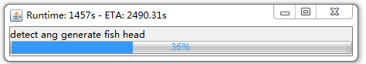

Figure The progress dialogue box of detecting fish head points.

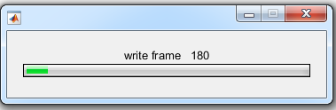

Figure The progress dialogue box of writing results of head detection.

## Labeling trajectory segments for learning

### The GUI of labelling software

User can type gui_mark_learning in Matlab to run the labelling software. The GUI will show like Fig. 4.



Figure The GUI of labelling software

1. Load all data configuration by one click. If data configuration is loaded correctly, 2, 3,4, and 5 will turn green, and there is no more action to do on 2,3,4, and 5.
2. Load all trajectory segments from the location specified in left edit box.
3. Set filenamebase (see Data Configuration part) which contained input image sequence.
4. Set total fish contained in the whole image sequence.
5. Set total frame number of the whole image sequence.
6. Indicator of the current marking fish ID
7. Load previous mark result by filename specified by user
8. Save current mark result and close GUI.
9. Zoom current image for further marking process.
10. Delete selected segment ID in left list box.
11. Edit box for user to specify segment ID manually.
12. Append the segment ID in above edit box to the left list box.
13. The segment ID list box contained segment belong to same current fish ID ordered in time order.
14. Play the image sequence of the selected segment in the left list box.
15. Play the image sequence of the last segment in the left list box.
16. Go to the last frame of the image sequence.
17. Play the image sequence of whole segment in the left list box in time order
18. Go to the first frame of the image sequence.
19. Go to previous frame according to current frame.
20. The indicator of current frame number.
21. Go to frame specified in the left edit box.
22. Go to next frame according to current frame.

### The process of labelling segment

When user played image sequence of the last segment, this is the screen show as illustrated in Fig.5 when the end of the segment is encountered. The red line indicates the trajectory segment of current fish and the blue text indicated the candidate segment for current fish ID, shows at the beginning of the segment. The number before ‘@’ is the segment ID and the number after ‘@’ is the time difference to current frame, negative number means the frame number of beginning point of the segment is past the current frame number.

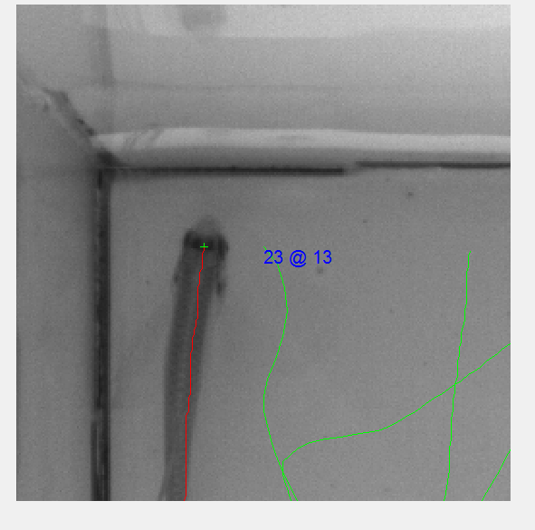

Figure Screen shot one of software

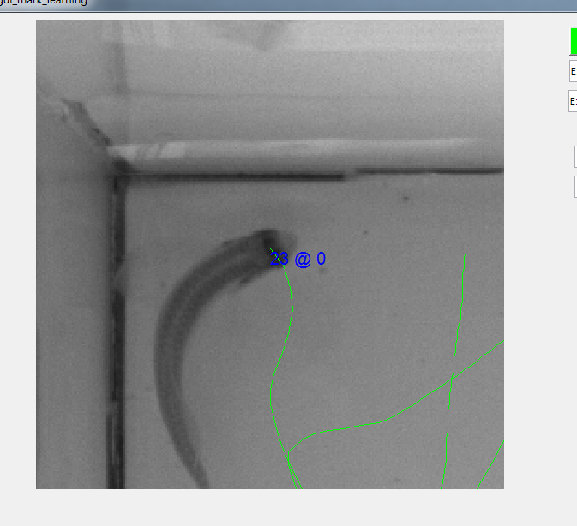

Figure Screen shot two of software

Then the user cloud press button 9 in Fig. 4 to zoom the image for clearly view the image to label the next link segment which belong to the same fish ID. Then user can press button 22 in Fig. 4 to go to next frame according to current frame until situation happened as illustrated in Fig. 6. Then user could use right button of mouse to mark the segment close to the mouse position with the current fish ID, and this ID will show in the segment ID list box as illustrated in Fig.8. User can repeat above mentioned process until all fish had been labeled with segment ID and the current frame number is about 1/3 of the whole sequence.

Finally, user can press save and close button to finish mark the segment data.

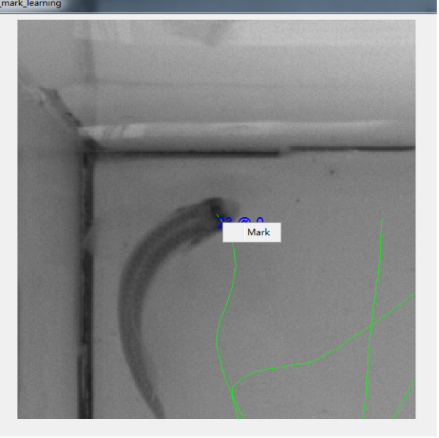

Figure Screen shot three of software

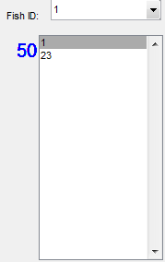

Figure The new appended segment ID 23 to fish 1

## Training CNN and apply CNN to trajectories generation

After the segments been labeled, user can simply type command cnn_tracking.m to training CNN with labeled data and apply best selected CNN to generate final trajectories of all the fish, the final trajectories of all the fish are stored in file named final_trajectorys in data directory user specified.