Software Engineer Technical Assessment:
Prepared for: Dominion Dynamics
Case Study: Aerial Object Detection & Model Adaptation
Author: Benjamin Simms
Date Submitted: 2026-09-01

BACKGROUND
I approached this challenge as if I was in my current role as a Senior Data Scientist. If I am approached by a client about a potential AI project, my first goal is to define their problem, analyse their program data, and create a framework to train and test models on that data. Once this framework is complete, I then aim to create a front-end application, that displays model predictions back to the client.
I find from personal experience that this is the best strategy to retain a client’s interest on a potential solution. It is often difficult to explain machine learning concepts to a client, but the sooner they can see the model visually, they can provide feedback based on their program knowledge.
I am also operating on the basis that this program data is limited and would be costly to annotate or engineer. This has been the case with many of my projects, where I am asked to provide a proof of concept, that is, prove a model can improve from a limited sample of data. Even if the model is not perfect, this proof of concept is meant to justify further data collection.

DATA CONSIDERATIONS:
I defined the task as finetuning a pretrained object detection model on the VisDrone dataset: a collection of aerial drone photographs of urban China with corresponding labels of people and vehicles. For the pretrained model, I chose a small YOLO26 architecture pretrained on the COCO dataset. It is important to note that while the COCO dataset contains people and vehicles, they are large, few and are often the focus of the image. Conversely, the detections in the VisDrone dataset are small, numerous and can exist at the periphery of the image. As a result, I contrived custom metrics to evaluate the finetuned model performance, mainly, the number of model predictions, and the model’s precision on small objects. After analyzing the detections, I determined a small object to be less than 50 x 50 pixels.
It is also important to note that while the VisDrone dataset contains ten classes of data, I chose to constrain the task to single-class detection, treating people and vehicles as a single object class. I chose this for multiple reasons. First, the VisDrone has a very-high class imbalance, where some classes had very few examples compared to say people or cars. With the small amount of training data I selected, I determined that the model would not be able to generalize to these small classes of objects.
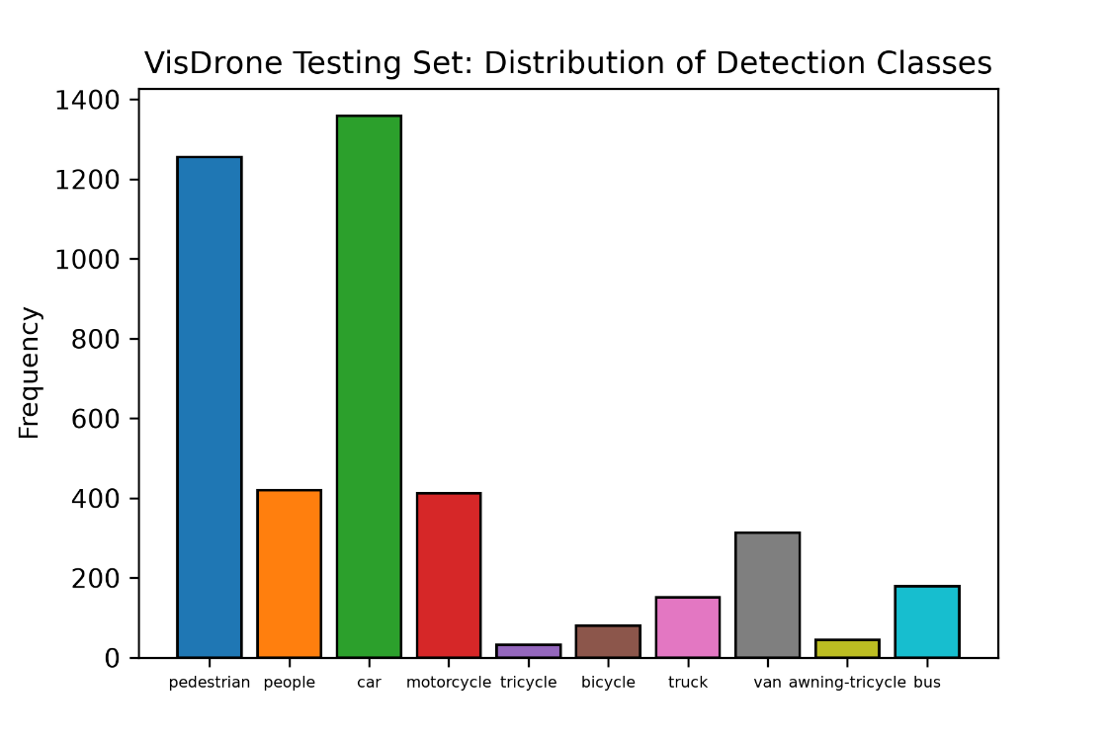
Distribution of detected classes for the entire VisDrone test image folder.
Second, the pre-trained model I chose was trained on the COCO dataset and is trained to identify 75 classes of objects. Unfortunately, there is no one-to-one mapping between the COCO dataset and the VisDrone dataset, which means that it would be impossible to truly compare the pretrained model with the finetuned model on a class-by-class basis. As a result, I made the decision to collapse the predictions into a single object class (people and vehicles). When evaluating the pre-trained model, I created a mapping from the COCO dataset to the VisDrone and filtered the predictions by classes pertaining to people and vehicles, while excluding other objects.
The model architecture I chose requires square images of uniform size for model training. To accommodate this, I converted the images to a 800 by 800-pixel format for training and validation. Ideally, I would truncate the images further, but the detections in the VisDrone dataset are very small and are often overlapping compared to the COCO dataset. Most detections are less than 50 x 50 pixels given a 1690 x 1080 input image, which I consider “small” detections.
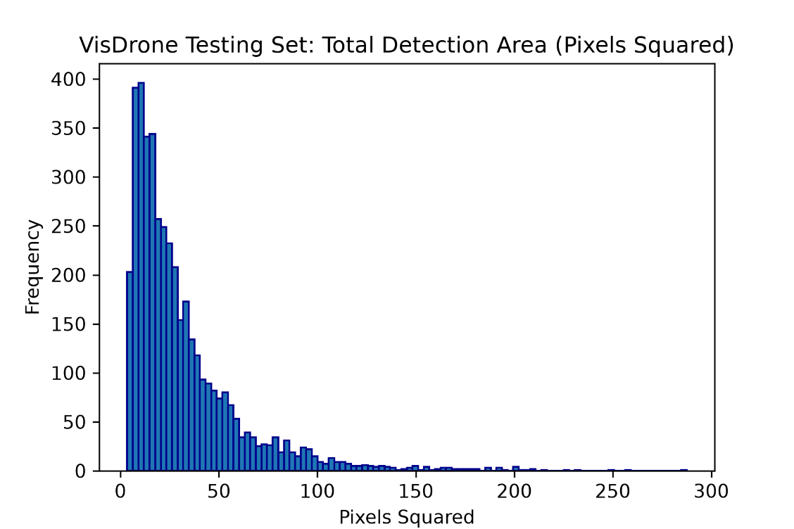
Ideally, I would have done the same operation during model inference, but I found that the finetuned detection model performed significantly worse on resized images. This is likely caused by compressing the aspect ratio of the VisDrone images, which are wide drone photographs. If I were to repeat this experiment, I would have cut the images into square patches and padded them for training and inference.
Finally, I chose a standard 80/10/10 split for my training/validation and testing sets with 800/100/100 images respectively. I acknowledge that this is an extremely small dataset, but it was necessary given the limited resources I had to train models. To mitigate the possibility of data pollution, I sampled my training, validation and testing data from the data splits provided by the data holders. Also, choosing a smaller sample of images allowed me to iterate over the images before training and determine if the same locations are appearing in multiple data sources, which is an issue present in the VisDrone database. While this process was not exact, it allowed me to recognize near-similar views that would interfere with the model evaluation.

Model Training:
For this exercise, I chose to adapt a very small pretrained YOLO26 architecture. I chose this architecture as it performs well on limited hardware, and I have previously used it for a similar task. I chose the latest architecture as compared to previous iterations; it does not suppress overlapping detections. Considering that the VisDrone dataset contains tight overlapping detections, I implemented a custom Non-Maximal-Suppression (NMS) algorithm that I was able to tune manually. I also chose the smallest pretrained YOLO26 model for two reasons. First, in this exercise I was working with both limited hardware and time and was constrained in my number of training runs. Second, I was finetuning on a very small subset of images, and typically smaller models generalize better on small datasets, since they have less parameters, and therefore have less capacity to overfit the training data.
During finetuning, I employed several regularization techniques to avoid overfitting the training data. I opted for a smaller learning rate and used both momentum and weight decay to regularize learning. I also used a larger batch size, to avoid overfitting on single examples.
As a result, the model was able to learn from the training data, and all metrics evaluated on the training and validation set were convergent.
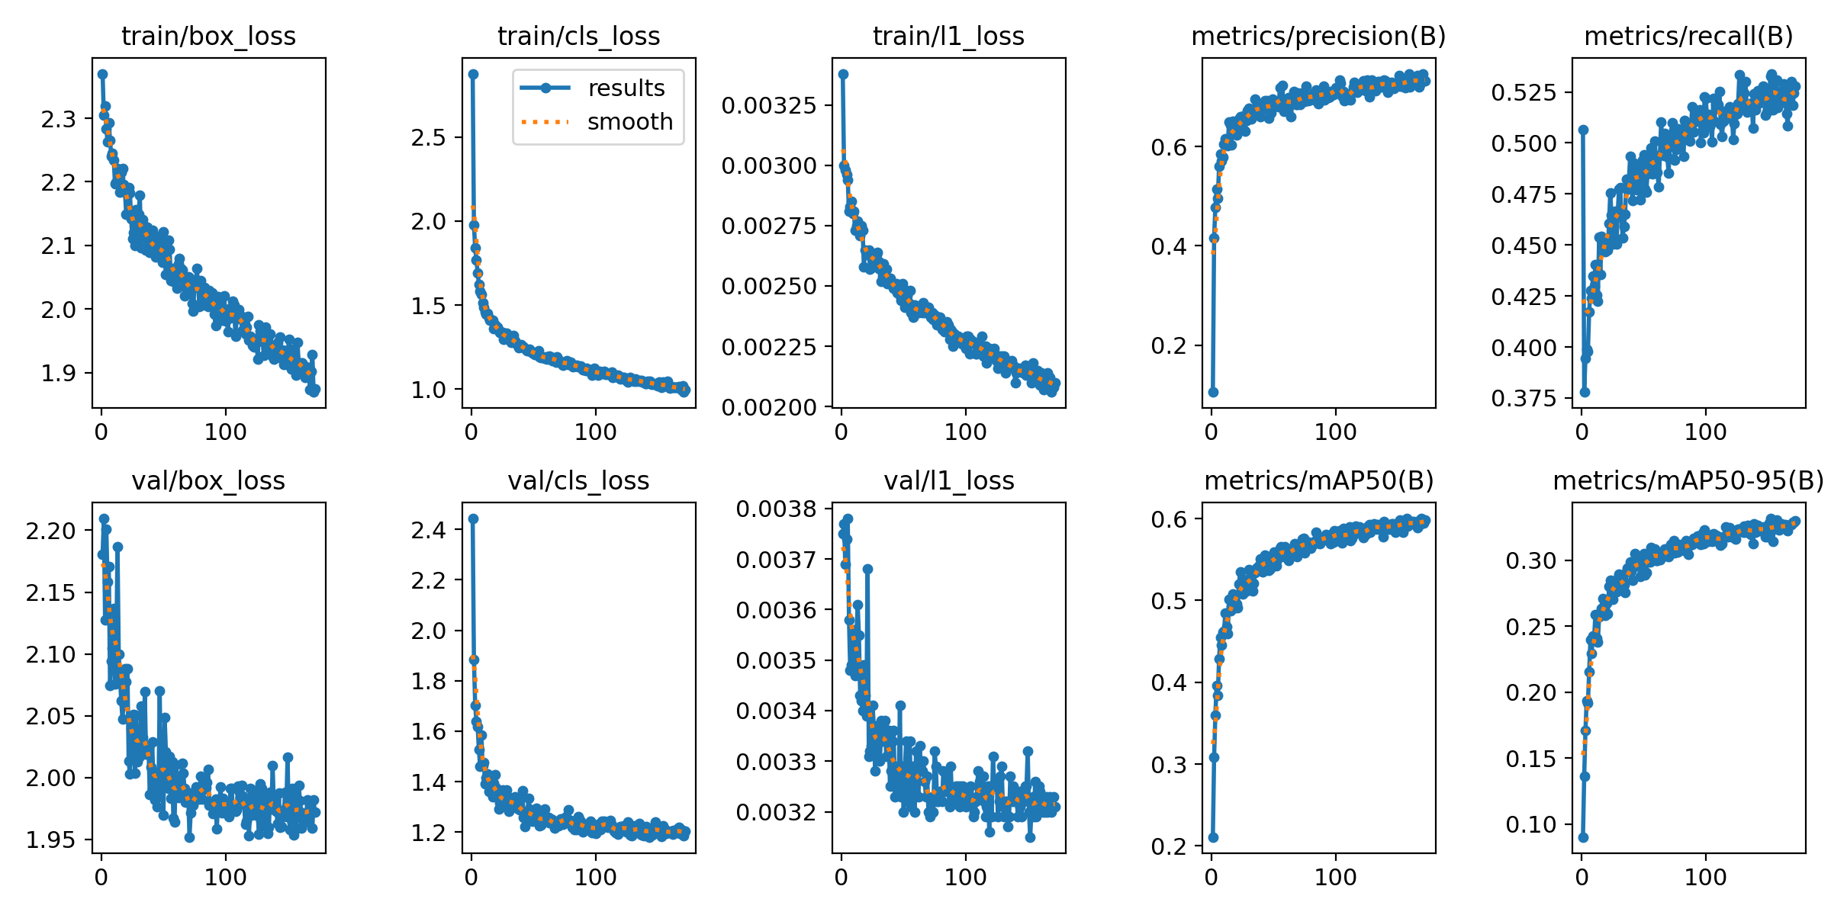

Model Evaluation
I evaluated both the pretrained and finetuned model on the same set of 100 images and compared performance. In addition to mean average precision (mAP), I created a custom function that attempts to match predictions with ground truth labels. This allowed me to determine the number of true positives, false positives, false negatives and the precision and recall of a given model. Precision in this case is the proportion of model predictions that are true positives. Recall is the proportion of ground truth detections that were correctly identified. It is important to identify both precision and recall, as well as the confidences for each prediction, as this allows a client in production to accept model predictions or delegate them for manual review based on their own risk tolerance.
While the finetuned, model outperformed the pretrained model in terms of mean average precision and recall, it was far less precise overall. This is especially true for smaller objects, where the finetuned model identified far more smaller objects, at the expense of its accuracy. It is important to note that while some of the model predictions appear correct, I chose to only accept a prediction as a true positive if it overlapped with the ground truth by at least 75%.

A metric I chose to incorporate was the number of predictions above a given confidence threshold. In this case I chose 0.95 or 95%. This gives us an idea of how many detections would require a manual review in production. In this case, while the finetuned model improved in several ways over the pretrained model, I would not deploy either model, as every model prediction would require human intervention.
For specific images in the testing set, the pretrained model was completely unable to identify any detections, as they were too small for the model to identify. In these cases, the finetuned model was able to identify more than half of the entities.
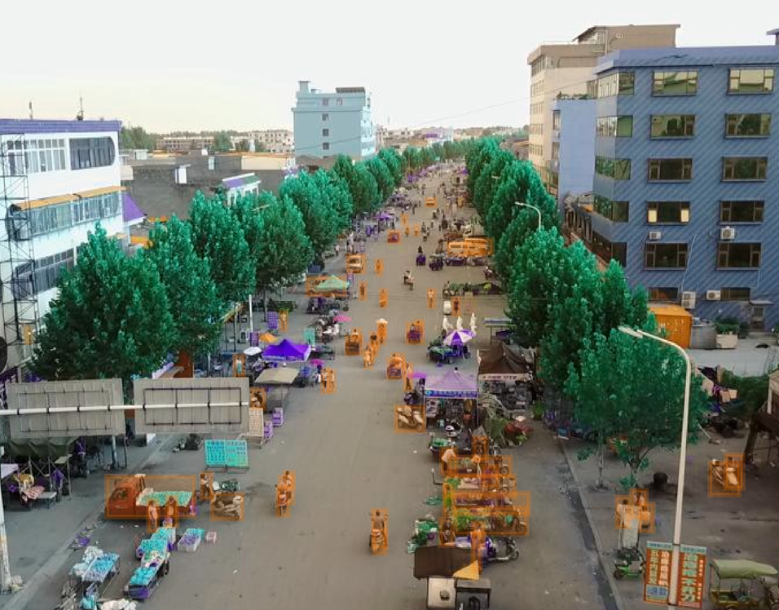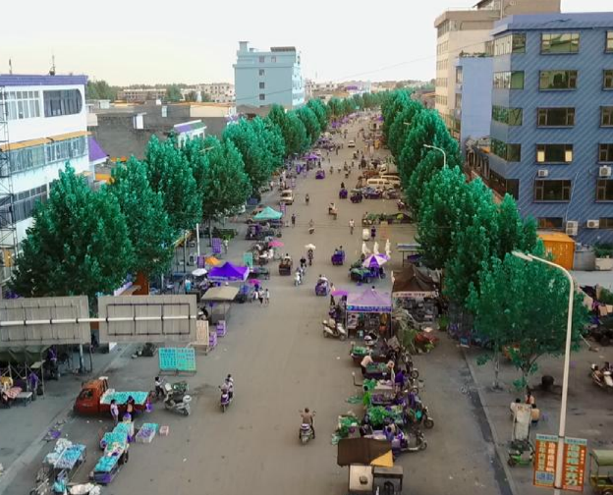
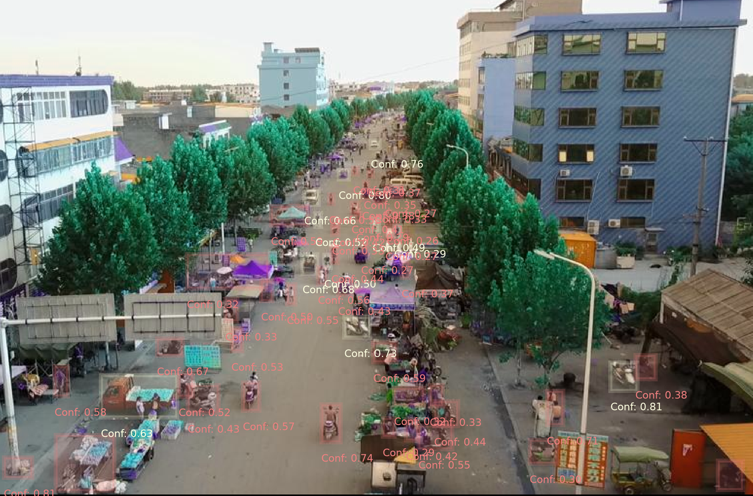
The ground truth image (top-left) with ground truth detections in orange, the pretrained model output (top-right) and the finetuned model output (bottom). Note that correct predictions are light yellow and incorrect/ambiguous predictions are given in red.
In another example, the finetuned model was able to correctly identify eight of nineteen vehicles in the following image, compared to the pretrained model that identified one.
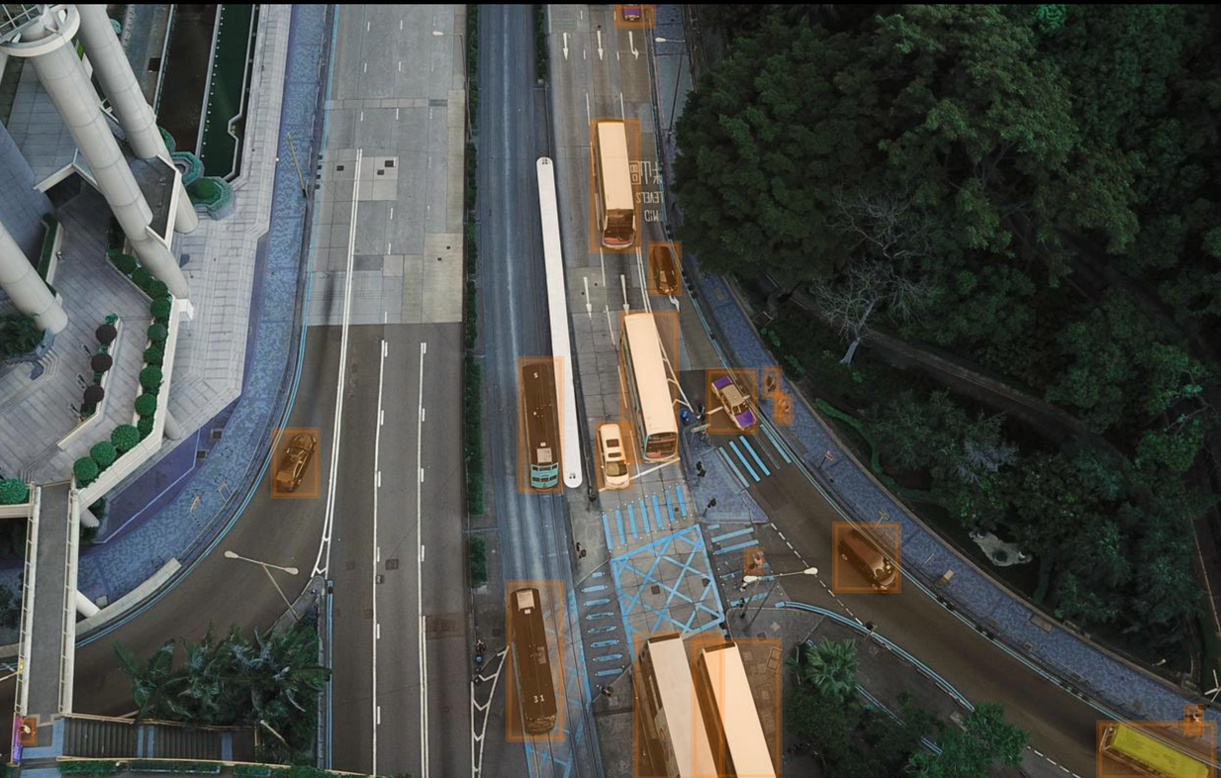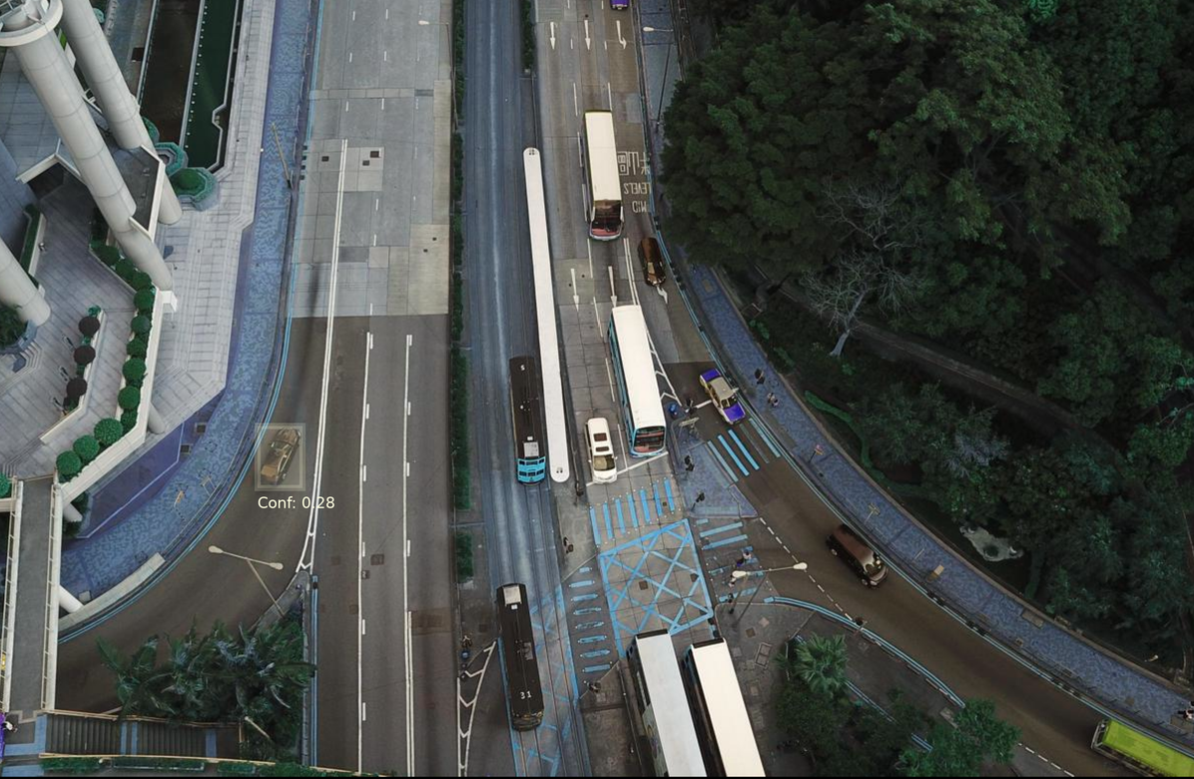
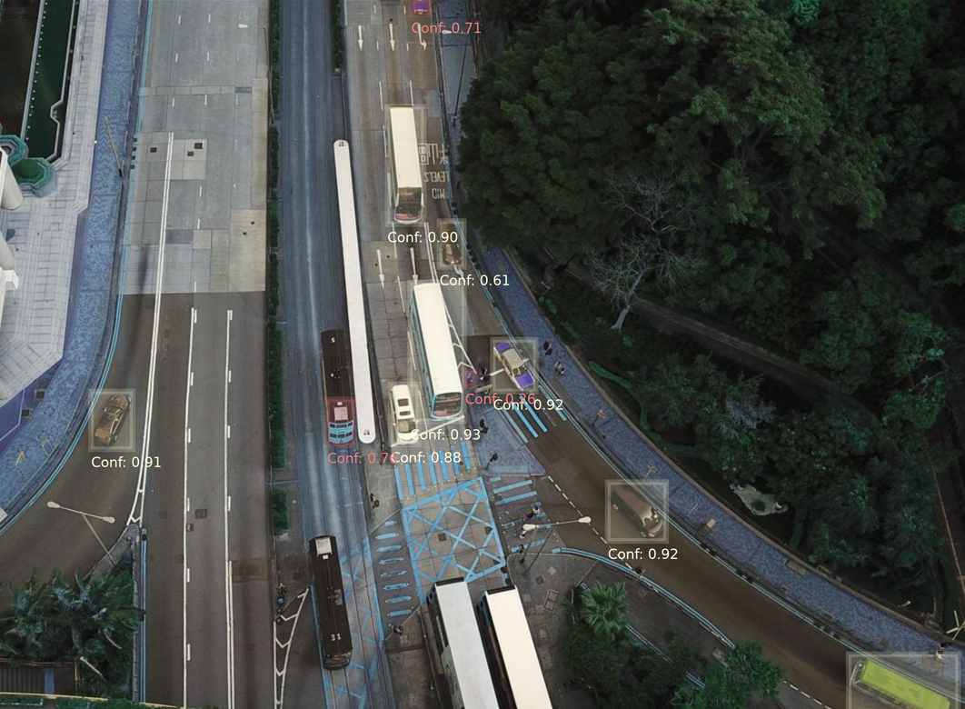
As mentioned earlier, the finetuned model is much less precise when detecting objects and this behavior is worse, the smaller the detection. In this case, the model is identifying the sides of a building as a crowd of people.
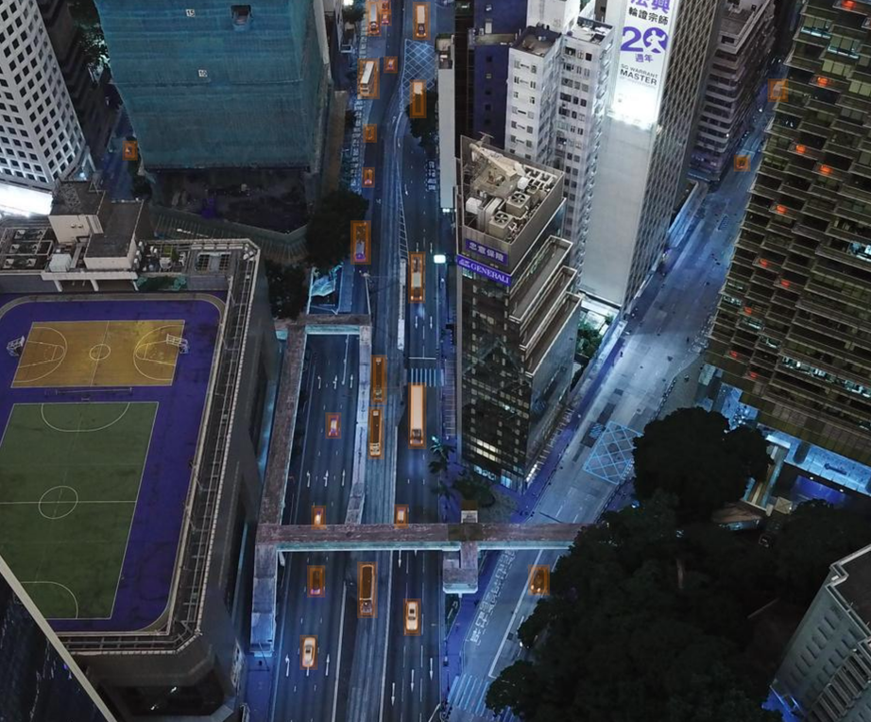 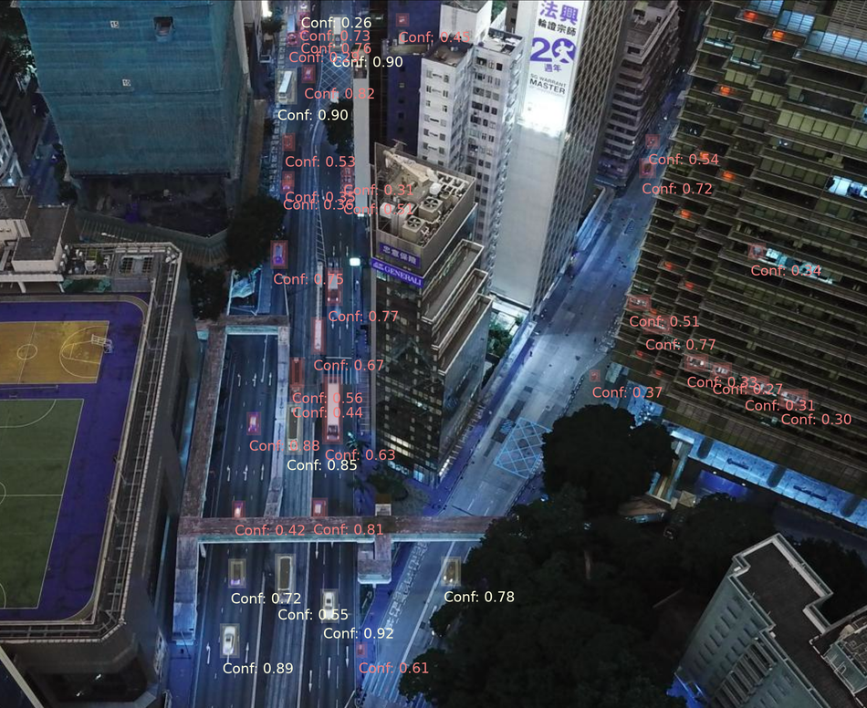
The ground truth image (left) with detections in orange compared to the finetuned model prediction (right). Note that correct predictions are yellow while incorrect predictions are red.

Finally, is also important to note the drop-off in metrics between the validation set and test sets. This decrease in accuracy is even more pronounced when the test images are compressed to the same aspect ratio as the validation images. This suggests that the model was overfitting and failed to generalize well. Considering that the model was convergent in learning, I believe this is due to a lack of training examples.

FUTURE CONSIDERATIONS
If given the opportunity to continue with this experiment, I would train a larger detection model with more data, given the evidence that the model was able to learn from the annotated data. As mentioned before, I would crop square images from the VisDrone dataset to avoid compressing the aspect ratio of the image before training. I would also expand the training data with a data augmentation strategy to avoid overfitting and to increase the amount of training data. I would augment the training examples with distortions intending to mimic differences in lighting and camera position.
If given more time, I would also incorporate more metrics into the model evaluation. Mainly, I would evaluate recall by object size and separate the detections into more sizes than just “small” and “large”, choosing a less arbitrary cut-off. I would also like to broaden the experiment from a single-class detection, first by grouping the VisDrone dataset into categories such as people, small vehicles and large vehicles. I would also like to compare that performance with that of a standalone recognition model, that accepts the output of the finetuned model and attempts to classify the prediction. I would have also liked to evaluate both the pre-trained model and the finetuned model on a set of sparse images with little to no detections. I believe that the pre-trained model would have performed better in that environment.
While I have experience accelerating mode inference with ONNX/TensorRT, I chose not to spend my time optimizing model inference and instead spent my time building evaluation frameworks and contriving metrics to better interpret the model behavior. If I were developing this model for a client, I would not prioritize the accuracy/latency trade-off of a model this point in development. In this phase of the project, my goal is to determine which metrics align with the client’s objectives, and what performance is necessary to incorporate this model into their current workflow.
NOTE ON THE USE OF GENERATIVE ARTIFICIAL INTELLIGENCE
In the development of this project, I consulted the free version of Microsoft Copilot, leveraging GPT-4. I primarily used the LLM for two purposes:
- Debugging some coding issues
- Creating a React template for the front-end of the project.
For the backend and model evaluation, I rarely consulted an LLM and wrote almost each line by hand. I consulted an LLM for things I would typically speak to a colleague about, mainly code review and debugging scripts. I consulted an LLM much more in developing the front-end, specifically in generating a React/CSS/HTML template, and in debugging my code during development. I would consult with an LLM when placing or moving features in the front-end, but I was mostly using the model as an extended search tool.

