About GitHub Wikis

Just as writing good code and great tests are important, excellent documentation helps others use and extend your project.

Every GitHub repository comes equipped with a section for hosting documentation, called a *wiki*.

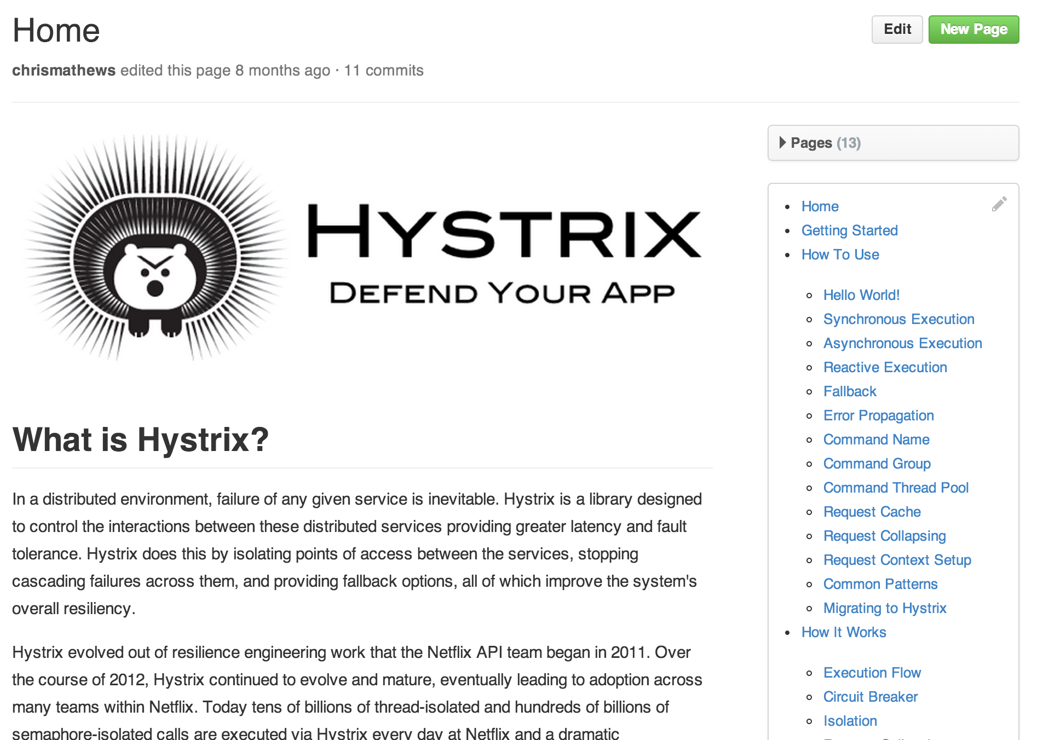

GitHub Wikis are a place in your repository where you can share long-form content about your project, such as how to use it, how it's been designed, manifestos on its core principles, and so on. Whereas a README is intended to quickly orient readers as to what your project can do, wikis can be used to provide additional documentation.

With wikis, you can [write content just like everywhere else on GitHub](https://help.github.com/articles/getting-started-with-writing-and-formatting-on-github). We use [our open-source Markup library](https://github.com/github/markup) to convert different formats into HTML, so you can choose to write in Markdown, RST, Textile, or any other supported format when you craft wiki pages.

Wikis can be edited directly on GitHub, or you can work with a text editor offline and simply push your changes. Wikis are collaborative by design. By default, only collaborators on your repository can make changes to wikis, but you can configure this to be enabled [for all users on public repositories](https://help.github.com/articles/changing-access-permissions-for-wikis).

# Test Word Doc 中文會不會亂碼

This document is for testing capabilities of msword2image.com. It contains multiple fonts, coloured text, tables & images. This word document is created with Microsoft Word 15. Try <http://msword2image.com> for free today!

| **Name** | **Position** | **Office** | **Age** | **Start** | **Salary** |
| --- | --- | --- | --- | --- | --- |
| Airi Satou | Accountant | Tokyo | 33 | 2008/11/28 | $162,700 |
| Angelica Ramos | CEO | London | 47 | 2009/10/09 | $120,000 |
| Ashton Cox | Technical Author | San Francisco | 66 | 2009/01/12 | $86,000 |
| Bradley Greer | Software Engineer | London | 41 | 2012/10/13 | $132,000 |
| Brenden Wagner | Software Engineer | San Francisco | 28 | 2011/06/07 | $206,850 |
| Brielle Williamson | Integration Specialist | New York | 61 | 2012/12/02 | $372,000 |
| Bruno Nash | Software Engineer | London | 38 | 2011/05/03 | $163,500 |
| Caesar Vance | Pre-Sales Support | New York | 21 | 2011/12/12 | $106,450 |

|  |  |
| --- | --- |
| Sed ut perspiciatis unde omnis iste natus error sit voluptatem accusantium doloremque laudantium, totam rem aperiam, eaque ipsa quae ab illo inventore **veritatis** et quasi architecto beatae vitae dicta sunt explicabo. Nemo enim ipsam voluptatem quia voluptas sit aspernatur aut odit aut **fugit**, sed quia consequuntur magni dolores eos qui ratione voluptatem sequi nesciunt. Neque porro quisquam est, qui dolorem ipsum quia dolor sit amet, consectetur, adipisci velit, sed quia non numquam eius. | http://www.aureliak.com/wp-content/uploads/2014/05/Gods-Beautiful-Garden.jpg |
|  |  |
| At vero eos et accusamus et iusto odio dignissimos ducimus qui blanditiis praesentium voluptatum deleniti atque **corrupti** quos dolores et quas molestias excepturi sint occaecati cupiditate non provident, similique sunt in culpa qui officia deserunt mollitia animi, id est laborum et dolorum fuga. Et harum quidem rerum facilis est et expedita **distinctio**. Nam libero tempore, cum soluta nobis est eligendi optio cumque nihil impedit quo minus id quod maxime placeat facere possimus, omnis voluptas assumenda est, omnis dolor repellendus. Temporibus autem quibusdam et aut officiis debitis aut **rerum** necessitatibus saepe eveniet ut! | |