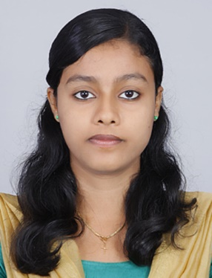
Resume
Josmi Joseph
D/O A.T Joseph
Alappatt [h], Kalladikode(p.o)
Palakkad[d.t] ,Pin: 6785 596

Phone : 9746414544,9745806289
Email : josmijosephalappatt@gmail.com

OBJECTIVE
To Work for the organization ,which can give a better boosting and prospect to my career and dedicate all my initiatives for the presentation for which I present my candidature .

ACADAMIC RECORD

QUALIFICATION | Name of the Institution | University/Board | Degree | Year of  completion | % of mark
POST -GRADUATION | Teams global village academy  Thalikode,Pattikad P.O Thrissur | Bharathiyar University | M.C.A | 2017(upto 4 rd sem) | 77%
GRADUATION | Ajk College of Arts and Sciences,  Coimbatore | Bharathiar University | BCA | 2014 |  | 70%
XII | L.S.N.G.H.S.S Ottapalam. | Higher Secondary Board Of Examination |  | 2011 |  | 60%
X | D.B.H.S  Thachampara. | Kerala State Board Of Public Examination |  | 2009 |  | 65%

SKILL POSSESED

Operating System : Windows 7,8

Languges : C, C++, Visual Basic , vb.net, HTML .

DataBase : My-Sql,sql

AREA OF INTEREST

Visual Basic , Vb.net , C++, HTML.

PERSONAL DETAILS

Date of Birth : 18-09-1993
Father’s name : A.T Joseph
Father ‘s Occupation : Farmer
Mother ‘s Name : Omana Joseph
Gender : Female
Marital status : Single
Nationality : Indian
Languages Known : English, Malayalam, Tamil
Interest & activities : Gardening , Listening Music, cooking.

DECLARATION

I Josmi Joseph here by declare that the above informations are true and correct to the best of my knowledge and belief.

Yours Truly

Place : palakkad
Date : Josmi Joseph

