RANJITH.P
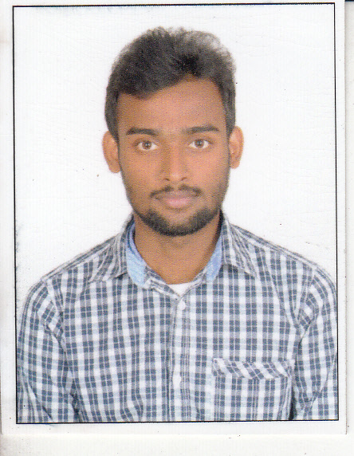  E-mail:  renjubdk@gmail.com  Address for Communication:  Malamkundu house  Bandadka po  Chengala via  Kasaragod Dist  KERALA  Pin - 671313  Mob: +91 7560885458  Personal Data:  Date of Birth : 27th Jun. 1991  Father’ name : A Gangadharan  Mother’s name : Rama P  Sex : Male  Nationality : Indian  Marital Status : Single  Languages Known : English,  Malayalam. | Objective  - Seek a challenging position in an organization providing the opportunity to contribute, by utilizing and expanding upon training and capabilities.  Education  - MCA  CMS College of Science and Commerce  (Bharatiar University)  - BCA  Kannur Universiy  (Kannur university)  Experience  - Worked as a Web devoloper with HTML5 and BOOTSTRAP in Sunbird Networks Pvt. Ltd. from 1th MAY 2016 to 31th JULY 2017 date.  Skills and Achievements  - Punctual and well presented.  - Able to work individually or in a team.  - Open minded and non-judgmental.  - Good listener and attention to detail.  - Adaptable to new situations.  Technical Expertise  Operating Systems : Windows XP/7,8  Languages : PHP , MySql  Framework: : Bootstrap  Web Programming : HTML5,JavaScript, CSS3

Academic Qualification
Year | Institution | Degree Name with Percentage of Marks
2015 | CMS college of Science and commerce, coimbatore | MCA  (Bharatiar University )  75%
2013 | Kannur Uniersity | BCA  (kannur university )  C grade(Grading Pattern)
2009 | G.H.S.S Kundamkuzhy | Plus Two  (Board of Higher Secondary Examination, Kerala )  50%
2007 | G.H.S.S Bandadka | SSLC  (Board of Public Examination, Kerala )  75%

Hobbies
- Listening Music
- Surfing net
- Playing Football
- Making new friends
- Adventure Travelling

Declaration

I here by declare that the above-furnished details are true to the best of my knowledge and belief.

Place: Bandadka Yours faithfully,

Date: Ranjith.P

