RESUME

NAME - ANANTHAKRISHNAN S

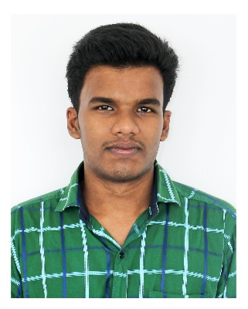
Residential Address: Panackaparambil (H),muhamma p.o
Alappuzha,Kerala,688525

Mobile: 7034828318

Date of Birth: 11 DEC 1993

Mail: ananthan8525@gmail.com

Nationality: INDIAN

CAREER OBJECTIVE

Imprint myself as a responsible citizen and strong follower of World’s dynamic development by working with an excellent firm, where my skills, personality and talents will be benefitted and my hard work will be highly valued.

EDUCATION HISTORY

CERTIFICATE | INSTITUTE | UNIVERSITY/BOARD | YEAR | PERCENTAGE
B.E(Electrical and Electtonics Engineering) | Cms college of engineering,  Namakkal | ANNA UNIVERSITY | 2015 | 65%(TILL S7)
CLASS XII | A.B.Vilasam Higher Secondary School,Muhamma | State board | 2011 | 77%
CLASS X | Mother teresa High School  ,Muhamma | State board | 2009 | 88%

PROJECT DETAILS

TOPIC : EMBEDDED BASED HOME AUTOMATION USING SMS.

OTHER SKILLS AND CERTIFICATES

Computer Skills:

- Microsoft applications (Word, Excel, Office, PowerPoint, ) – Advanced
- Basic Programming of c and c++.

Language Skills:

- Malayalam – (Native Tongue)
- English - (read,write and speak)
- Hindi-(read,write and speak)
- Tamil-(speak)

Other:
- Participated in Business English Certificate (BEC) in 2014.
- Completed electrical CAD course conducted by AUTODESK 2014 during academic year.
- Works as a programme commetty executive member of EUDORA(association of EEE) at
CMS COLLEGE OF ENGINEERING.

PERSONAL COMPETENCIES

- Ability to work in a fast-paced environment to set deadlines
- Hard working and result oriented.
- Highly organised with a creative flair for project work
- Enthusiastic self-starter who contributes well to the team
- Fast learning

INTERESTS AND ACTIVITIES

- Cricket
- Swimming
- Travelling
- Chess

PERSONEL DETAILS
Name : ANANTHAKRISHNAN S

Father’s Name : P.K SURENDRAN

Date of Birth : 11-12-1993

Nationality : Indian

Gender : Male

Blood Group : O +ve

Language Known : English, Malayalam, Hindi and Tamil

Permanent Address : Panackaparambil house
Muhamma (P.O),
Alappuzha (Dt.)
Kerala ,Pin- 688525
I Ananthakrishnan s, hereby approve myself that the above mentioned details are true to the best of my knowledge.

MUHAMMA
28.05.2015 ANANTHAKRISHNAN S

