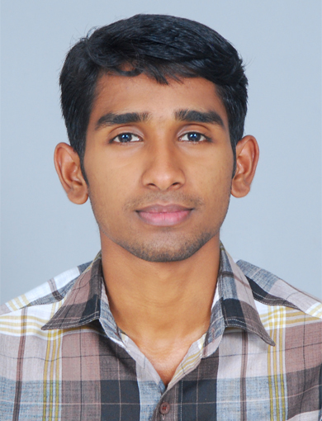 CURRICULUM VITAE

Ashik C.A Mobile No: +91 9961664525

Cochin Email: ashikca99@gmail.com

Objective

To obtain a challenging position in a dynamic organization and be an integral part of growth oriented company. To utilize and grow my analytical, research and technical skills in Systems Administration.

Professional Experience

Vodafone India Ltd. Cochin (IBM Project)
Payroll: Info Services Ltd. Chennai 
From: May 2015 to September 2016
Designation: Technical Support Engineer

Role and Responsibilities

- Configuration and troubleshooting Outlook issues
- Installation and troubleshooting Windows 7& 8.1 operating systems
- Monitoring ticketing tool BMC remedy.
- Maintained and support 225 desktops and 150 laptops network infra structure
- Handling and supporting Video Conferencing issues
- Maintenance day to day activities
- Vodafone application installation and troubleshooting
- Troubleshooting explorer application issues
- Configuring VPN and Group policy management
- Solid knowledge about TCP/IP, networking concepts, scripts, patch files, and security concepts such as authentication and authorization.
- Solid knowledge about Windows and Active Directory background, including familiarity with domain user accounts, domain vs. local user accounts, user profiles, and group membership.
- Experience performing clean Windows installations, upgrading Windows, and migrating user-related data and settings.
- Experience configuring and troubleshooting a wireless network connection, Windows 7 security, and permissions and other settings to allow access to resources and applications.
- Experience configuring settings to enable network connectivity

First source Solutions Ltd. Cochin (Anunta Project)
Payroll: Onward eServices Ltd. Mumbai 
From April 2014 to May 2015
Designation: Desktop Support Engineer

Role and Responsibilities

- Installation and Maintenance of Applications and reporting to the higher authorities for day-to-day activities of region support
- Taking care user end calls using IMS tools for Priority based within SLA
- Network Infrastructure management and maintained
- Avaya phone installation and Troubleshooting
- Creating and maintaining user accounts.
- Virtual Desktop Infrastructure management
- Asset management and ITAM Tool management
- Maintain and support Windows based operating system 15servers, 30 Desktops, 674 Thin Clients Network and Infrastructure,
- Troubleshooting the Thin client and desktop on remotely.
- checking for error and system log reports on daily basis
- Configuration Maintaining Ms Outlook and Outlook Express intranet packages.

Gautham computers - Cochin
From January 2014 to April 2014
Designation: Network service Engineer

Role and Responsibilities

- Provide Software, Hardware, Network Support and Operating System support to all locations
- Configuring Microsoft outlook for user and troubleshooting Mail Problem
- Handling Anti-virus software’s installation updating and maintenance
- Tested the IT networking systems, monitored the performance of network servers and maintained computer systems of the organization
- Configuring Microsoft outlook for user and troubleshooting Mail Problem

ABS TECH Systems - Cochin
From May 2013 to January 2014
Designation: Hardware & Network service Engineer

Role and Responsibilities

- Installation, Configurations, Monitoring and Maintenance of Desktops, Machines, Laptops, Printers and Scanners.
- Maintained the up to date operating procedures inside the IT department.
- Upgrading computer hardware and software
- Configuring network devices
- Assisted company personnel with desktop operation both hardware and software related issue
- Provide Support in Resolving Networks Problem and troubleshooting of LAN Connectivity issues.

Technical Knowledge

- Assembling of PC’s
- Installation & Troubleshooting of Software’s & Hardware Devices
- Installation & Troubleshooting of Operating System
- Configuration of Domain & Workgroup
- Configuration of ADS, DNS, Wins, DHCP, IIS, Profiles, Group Policy
- Configuration of Exchange Server, Users & Groups, OU, Cluster nodes
- Installation & Configuration of Router, Switch, Modem
- Configuration of VLan, VPN, Nat , RRAS , Sites etc
- Installation & Configuration of Wireless Access Point, Bluetooth

Academic

SSLC (2007)
PLUS TWO (2009)
B.COM COMPUTER APPLICATION (2012)

Technical Qualification


Master in Network Administrator from Logic institute Cochin

- Microsoft Certified System Engineer (MCITP). Transcript ID
(1013299) and the Access Code (ASHIKCA99), and direct them to
https://mcp.microsoft.com/authenticate/validatemcp.aspx
- Cisco Certified Network Associate (CCNA)

Personal Details

Name : Ashik C.A
Sex : Male
Date of Birth : 13.04.1991
Father’s Name : Ashraf C. M
Marital Status : Single
Nationality : Indian
Caste & Religion : Islam, Muslim
Languages Known : English, Malayalam

Declaration

I hereby declare that the above furnished information is authentic to the best of my knowledge.

Place: Cochin ASHIK

