ANOOP RAGHAVAN 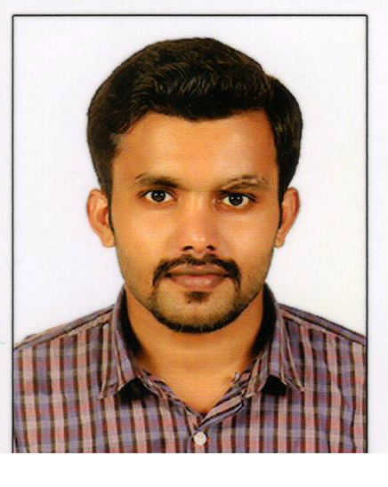

Anandabhavanam, Angadickal South P.O, Kodumon Pathanamthitta, Kerala, India 691555 | MB: 09656631196 | anooprakhavan89@gmail.com

SUMMARY

I would like to move myself to a well settled and highly professional organization and grab good
career advancement through large efforts and innovative work techniques, as I believe that I am
good enough to get into the next step of career with the experience in the areas mentioned
below.

WORK EXPERIENCE

12/2015 to Till now Senior Technical Support Executive
LMDI －Letmedoit
Android application support name IMAPP V2 .
On call resolve user Issues user registrations.
Handling high priority mails and resolve via on call.
GEO fenced Application.
6000 above user uses this application.
12 states using this application.
Imapp application provided to the company named INDUS TOWERS

07/2014 to 08/2015 IT Support Executive

Application Support/Hardware Support / Troubleshooting
- Diagnose and resolve technical hardware and software issues.
- Monitoring for key areas of a Softwares.
- Troubleshoot and fix problems independently.
- Developing the infrastructure and systems to meet the company’s requirements
- Install and configure new IT equipments.

04/2013 to 03/2014 Fino Paytech Ltd - RSBY Project
(Ministry of Labor and Employment, Govt. Of India)

Project name : Rashtriya Swasthya Bima Yojana
Designation : POS Technical Support
Application support/Technical Support/ Troubleshooting
- Understand user's issues and problems and suggest work around if possible.
- Configuring and managing backup & restore procedures. Maintaining a wide range of computer hardware and software's.
- Troubleshooting for IT Hardware, Printers, Laptops ,Smart Card Readers, Finger Print Scanners and other IT related Equipment & Maintain IT inventory
- Coordinate with central support team to resolve end users issues.
- Communicate application changes to users in coordination with Operations team
Keep strong follow-up with vendor for all assigned activities to ensure timely completion

EDUCATION

2012 BSC.IT MG University Kottayam
V.N.S COLLEGE OF ARTS & SCIENCE, Konni Pathanamthitta, Kerala

2008/09 12th grade(Science), MP BOARD
Leonard Higher Secondary School
Jabalpur,Madhya Pradesh

2006/07 10th grade , MP BOARD
Leonard Higher Secondary School
Jabalpur,Madhya Pradesh

INTERESTS

Interested in Sports(Football)
Listening music
Internet Surfing

PASSPORT DETAILS

Passport Details Passport No : L8298999 Date of issue : 08-04-2014 Date of expiry : 07-04-2024 Place of Issue : Trivandrum, Kerala

LANGUAGES

English, Hindi and Malayalam

ADDITIONAL INFORMATION

Father's Name : Raghavan Narayanan
Date of birth : 01-09-1990
Sex : Male
Nationality : Indian
Marital status : Single
Religion : Hindu
Current Address : Anandabhavan Angadickal South P.O Kodumon Pathanamthitta
Kerala Pin-691555

Contact no +919656631196

