Aby Kurien
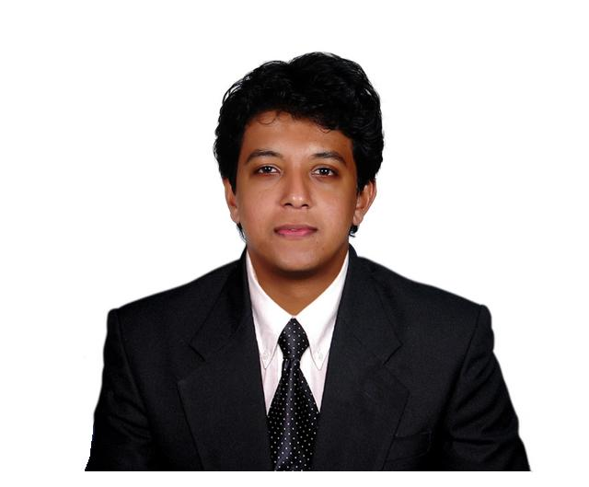
Panthaplakkal House, Morakkala, Kumarapuram P.O., Ernakulam Dist., Kerala, India. Pin – 683565
Contact No: +91-97456-24646, E-mail: get.to.aby@gmail.com

Professional Summary
B. Tech graduate with two years and four months of professional experience in system design, development and unit testing of web applications and four months professional experience as project lead adhering to company policies and meeting client expectations.

Experience Summary

- NOCME Technologies Pvt. Ltd., Trivandrum, Kerala, India
February 2013 – Present
Role: Project Lead, Software Engineer
- Project lead
Responsibilities
- Effort and schedule estimation.
- Prepare project plan, RAD and project profile.
- Client communication and approvals.
- Monitor project progress and send weekly status reports.
- Prepare test cases, quality checklists, bug tracker reports, incidents and escalation reporting.
- Responsible for deliverables.
- Team building activities, weekly meeting within team.
- Client feedbacks and maintain CSAT. 100% adherence.

Tools
- Microsoft office 2013
- Online project management tools like Bitrix24.

Projects
g20gbc – G20 Global Business Challenge
April 2014 – May 2014
G20 GBC is the first global graduate business case competition conducted as a partnership between some Australian universities and with support of government.
NOCME had acquired its website designing and website template development project.
Qatar based luxury group’s corporate, IT and international school websites
May 2014 – July 2014
WordPress based individual websites which show their divisions, resources, clients, policies, testimonials, services and products. The school website will have the additional features of pre-registration and admission process automated.

TOPS – Traccs Operations System
January 2014 – March 2014
A PHP framework based operations system portal that functions in a Middle East firm with features like mail daily clippings of relevant e-publication to their clients, acquire media rights, and so on.

MyPort
April 2014 – August 2014
A PHP framework based internal employee portal with features employee management, leave management, appraisal management, internal greetings, employee exit process module and events and organization announcements gallery.

Australian Institute of Packaging (AIP) website
April 2014 – May 2014
A CMS based university website. University sitemap, university organized events description and it’s booking facility with payment gateways and student management.

- Software engineer
Responsibilities
- Software development.
- Daily task picking and reporting at EOD.
- Adhering to company coding standards.
- Create unit test cases for cross browser and OS.
- Reporting and documenting bugs.
- Front end GUI enhancements.

Software
Languages - PHP, C, JavaScript, HTML
Database - MySQL, PostgreSQL
Framework - Codeigniter, Laravel, jQuery, Bootstrap 3.1, Semantic-UI
Tools - Microsoft office, SmartSVN, cPanel, FileZilla, phpMyAdmin, notepad++
CMS - ExpressionEngine, WordPress, Joomla.

Projects
Development of website TRACCS – Traccs Exchange
November 2013 – January 2014
A PHP framework based public relations services website that functions in the Middle East.
Development of website backup305.com
October 2013 – November 2013
A CMS based website for ordering and using backup services for business and home environment. Service ordering and client billing is carried forward using HostBill data and client management and billing software.
Enhancement/Rebuilt of websites sirasolutions.com and support305.com
August 2013 – October 2013
Websites are developed in Joomla CMS. They are support and consultation, company service websites for web hosting services in the US.
Development of website rackwizards.com
February 2013 – August 2013
A website developed in CMS ExpressionEngine 2.5.5, through which clients can order and use company’ internet hosting services - dedicated servers, virtual private servers, exchange hosting, managed servers and cloud hosting and business backup solutions. Client payments and order processing are completed through Ubersmith and HostBill billing softwares.

- Zayan InfoTech Pvt. Ltd., Trivandrum, Kerala, India
September 2011 – January 2013
Role: Software engineer

- Software engineer
Responsibilities
- Requirement analysis and system design.
- Handling complex PHP code, peer code reviewing.
- Server side scripting – PHP, End user interface enhancements – HTML, JavaScript, CSS.
- Cross-browser unit testing.

Software
Languages - PHP, JavaScript, HTML
Database - PostgreSQL
Tools - pgAdmin 3, KomPozer, Microsoft office 2010
Framework - jQuery
Billing and client management tools - Ubersmith, WHMCS, HostBill.

Projects
Web Application – Sales Account Management
November 2012 – January 2013
Web application in which sales person can generate invoice requests accordance to purchase order received from buyers and also raise purchase order for in-house requirements. Accountant takes forward these requests, generating invoice and maintaining records of sales and purchases. Performance evaluation can be made for each person.

Web Application – Blog, discussions and file sharing.
September 2012 – November 2012
An online web application where registered users can create posts (blogs/write ups), initiate discussions and share videos, audios and documents. Also they can view posts, take part in discussions and download shared files by other registered users. Unregistered users can view posts and take part in discussions. Commenting facility is enabled for both users.

Development of website therecruiterz.com
July 2012 – September 2012
A web application where employers can post job vacancies and job seekers can apply for the same. The highlight being the college zone, which works more like the placement office of a college, where the college gets updates of recruitment drives of various employers and they notify their students.

Human Resource Management - Training Management, Payroll and Leave modules
May 2012 – July 2012
An application which helps to schedule and manage the training programs of fresher’s as well as employees and manages employee’s leave records.

- Training in Open Source Application Development
October 2012 – March 2012

- Spectrum Soft-tech Solutions Pvt. Ltd. , Kerala, India
July 2011 – September 2011
- Process Associate
Responsibilities
- Outbound call - Hospitals, clinics, doctors in-person in USA
- Conduct survey.
- Filter leads to help sales team market Electronic Medical Recorder (EMR)

Academic Projects

- Parallel Web Server
This project was done as the main project during final year in B.Tech. This is used to find the servers with minimum load and redirect the client request to that server from the master server.

- Job Allocation and Monitoring in HPC using DRMAA
This project was done as the mini project during third year in B.Tech. This is a user friendly interface for allocating a job to HPC (High Performance Computer) and monitoring it.

Academic Record

Year | Course | College/Institute
2007-2011 | B.Tech (Computer Science) | Federal Institute of Science and Technology (FISAT), Ernakulam, Kerala, India
2005-2007 | XII – CBSE | TocH Public School, Ernakulum, Kerala, India
2004-2005 | X – CBSE | Don Bosco School, New Delhi, India

Personal Skills

- Ability to deal with people convincingly.
- Quick learning and problem solving ability.
- Composed, Patient, Observing, Adaptable.

Achievements

- Organized, managed and conducted a New Year party which had close to 100 attendees.
- Promoted as Project Lead.
- Nominated for Best Performer award for Q2, FY 2013.
- Visual presentation on the technologies used for website www.therecruiterz.com during its launch.
- Adjudged the best presenter at an intra office presentations session.
- Participated in the Indian IT Summit, 2012 organized by CII, held in Trivandrum, Kerala.
- Delegated a Country in the YLGC’09(Mock UN) held at PSG Tech, Coimbatore.
- Core committee member of college arts and cultural festival, Arangu‘10.

Hobbies

- Architecture & Interior design work.
- Internet surfing.
- Television and Movies.

References

- Mr. Faiz Abdu, Project Manager – Software, NOCME Technologies Pvt. Ltd., Technopark, Trivandrum, Kerala, India. Cell: +91-974522-2922 | Mail: faiz.abdu@nocme.com
- Mr. R Leonard Martin, Manager, Zayan InfoTech Ind. Pvt. Ltd., Pamba, Technopark, Trivandrum, Kerala, India.
Cell: +91-99957-66499 | Mail: r.leonardmartin@gmail.com
- Mr. Delano Fernandez, Team Lead- Process Associate, Spectrum Soft-tech Solutions Pvt. Ltd., Ernakulum, Kerala, India. Cell: +91-81294-16001 | Mail: Delano_fernandez@hotmail.com
- Mr. Unni Kartha G., Placement Officer, FISAT, Angamaly, Kerala, India. Cell: +91-98463-87772

