Shreeja Pillai
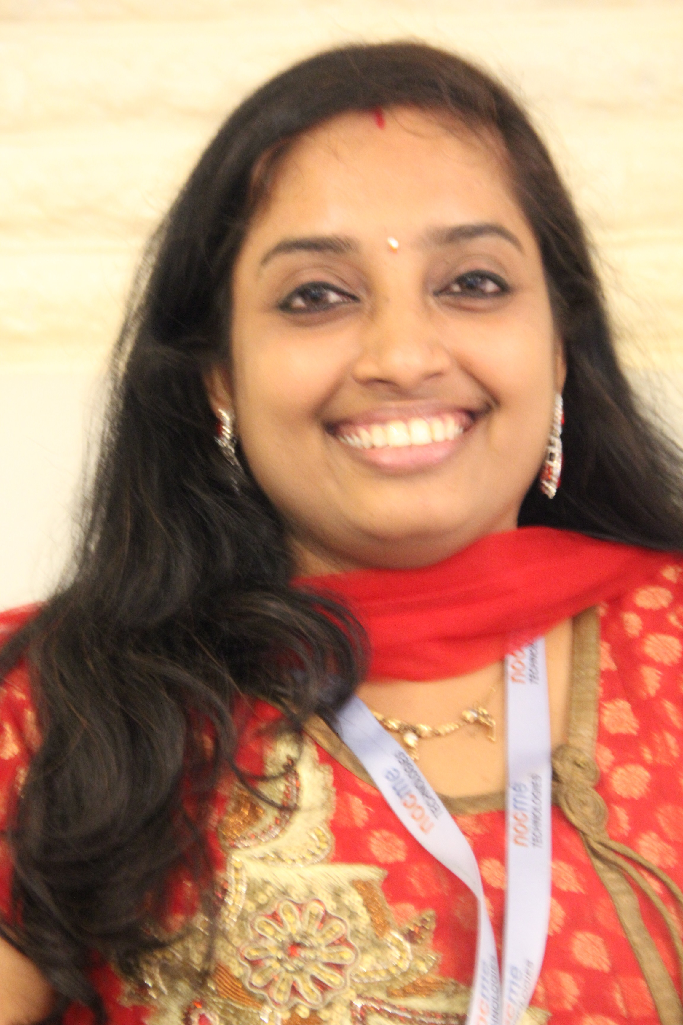

Phone : 9946131727
Email: shreejavijayan@gmail.com

Profile

Enthusiastic, results oriented HR and Admin professional with extensive experience in planning and directing all areas of Human Resources that includes (but is not limited to): employment law, employee relations, on-boarding, payroll, performance management, policy & procedures, recruitment, safety, supervision & training.

Strategic HR and Admin partner executing HR best practices to align the objectives of the organization while maximizing employee potential by fostering a positive work environment that promotes employee morale by developing interpersonal relationships within all levels of the organization utilizing attentiveness, trust, and respect.

Experience

Caremark Care Care Coordinator
Services Apr2016-Prsnt
        - Recruitment and placement of care workers
        - Handling all calls relating to enquiry and follow-ups for clients
        - Updating HCR and salary details for care workers
        - Administration and Vendor management

Admin Executive
Cronos Consulting India
Pvt Ltd
Nov2013- Apr2014
- Provide general administrative support
- Supervising the house keeping staff
- Coordinating acquisition of supplies, answering phone calls, handling all couriers and deliveries
- Bookings, scheduling meetings
- Supporting Finance Manager as required
- Maintaining all company assets and accurate filing of all documents
- Scheduling interviews, Induction / New joiner hand holding
- Cab management, Travel management, booking of flights and hotels for employee going onsite
- Employee Engagement, birthday mails, weekend tips mail
- Maintaining Employee Attendance report

Senior Executive- HR & Admin

Nocme Technologies Pvt Ltd
June2011-Aug2013

- Call handling, Vendor management, Attendance Register maintenance
- Regular coordination with the house keeping staff
- Co-ordination and management of employee compensation
- Preparation of employee contracts and letters of offer/rejection
- Serve as one point contact for all HR-related functionality
- Regular interaction with new joiners in order to solve any problems initially faced by them
- Organizing for Quarterly meetings and Top Performers awards
- Employee Engagement, Operational HR
- Supporting Management Accountants as required
- Daily inputting of sales & purchase invoices to the finance system
- Identifying and promoting cost-reducing measures
- Control of authorization and payment of purchase invoices
- Preparing reimbursement sheets for directors
- Assisting in the filing of TDS and Service tax
- Preparing various financial records and documents

Mindtrans Technologies Pvt Ltd
Feb2010-Feb2011

- All facets of financial and management reporting
- Review of payables/receivables/inventory report and payment/collection/order schedules
- Preparing payment advices for the all the expenses
- Preparing and Uploading of PF and ESI chellans
- End-to-end processing of company payroll
- Processed Cheque, credit card and cash payments through various accounts

Front Office Manager
- Front office management
- Handling calls, visitors
- Counseling students
- Administration and Vendor management

Academics & Credentials

- One Year Executive MBA (Dual Specialization in CRM & HRM) from NIBM- Trivandrum, Kerala ( Joined second year MBA)
- Medical Transcriptionist (Keltron)- Trivandrum, Kerala
- Diploma in General Nursing & Midwifery (Kerala Government School of Nursing)- Alappuzha, Kerala
- Senior Secondary from N.S.S College (Kerala University)- Pandalam, Kerala
- Higher Secondary from St. Theresa' Academy (I.C.S.E)-Ghaziabad , Uttar Pradesh

Skills
- Strong communication skills | - Good organizational skills
- Excellent ability to adapt to difficult situations | - Time Management
- Detail oriented, Multitasker | - Leadership Skills
- Capable problem solver
- Quick learner

Achievements

- Promoted from Front Office Executive to Sr. Executive HR & Admin immediately after completion of 1 and 1/2year of services in Nocme Technologies Pvt Ltd.
- Awarded “The Perfector” in the Annual Award function of Nocme for consistent performance in timely completion of tasks errorlessly
- Got appreciation certificates in school competitions for cultural and sports events
- Was offered to join Nocme Technologies back again in October 2014

Personal Details

Marital Status : Married
Passport : H5637270

Issue date : 18th Feb, 2010
Expiry date : 17th Feb, 2020
Issue location : Cochin
DOB : 1st March, 1979
Languages : English, Hindi, and Malayalams

Hobbies
I love dancing, reading, learning new things, playing badminton. Participated in many cultural items in school and college functions.

Declaration
The above mentioned details are true and correct to the best of my knowledge.

Date: 06.04.2017 (SHREEJA PILLAI)
Location: Kochi

