Eldho Mathew 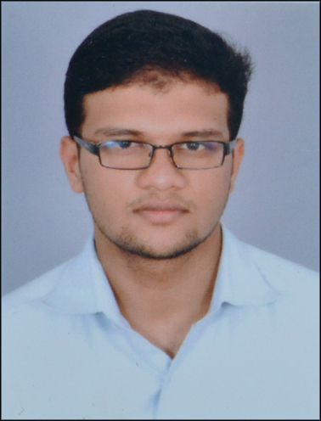
Contact
Mobile : 8943082588 E-mail : mathewninaneldho@gmail.com
Address :
Mnkuzhiyil H Kannara P.O,
Maraikkal, Thrissur
Pin: 680652

Career Objective
To work in a challenging environment demanding all my skills and efforts as a true management professional and contribute to the growth of the organization.

Educational Qualification
Year | Examination | Percentage | School/College
2017 | MBA (Marketing-HR) | - | Marian Academy Of Management Studies Kothamangalam
2015 | B.Com (Computer Applications) University of Calicut | 69 | Don Bosco College of Arts and Science Mannuthy Thrissur
2012 | HSE(+2) | 75 | Govt. Model H.S.S for Boys Thrissur
2010 | SSLC | 81 | Don Bosco H.S.S Mannuthy Thrissur

Academic Projects
- Organization Study at Elementz Engineers Guild PVT Ltd Trivandrum.
- Conducted Open survey as a part of degree 6th semester project on the topic “Is the modern life style a reason for cancer?”

Academic Pursuits and Achievements
- Coordinated Soth Indian Management fest named “CAERUS 2K16” Marian Academy of Management Studies Puthuppadi Kothamangalam.
- Worked as the member of MCCOYS marketing club at Marian Academy of Management Studies Puthuppadi Kothamangalam.
- Acted as the committee member of “ADASTRA 2K15” South Indian Management Fest at Don Bosco College Of Arts and Science Mannuthy Thrissur.

- Coordinated ethnic food fest “Dhee Kappa” at Marian Academy of Management Studies Puthuppadi Kothamangalam.

- Coordinated the Placement driven “ASPIRE 2K16” AT Marian Academy of Management Studies Puthuppadi Kothamangalam.
- Acted as the coordinator of “CHAYAMGAL” fine arts competitions at Marian Academy of Management Studies Puthuppadi Kothamangalam.
- Participated in the National Level Management fest “CALIGO2K15”(marketing game) at Marian International Institute of Management Studies Kuttikkanam Idukki.
- Attended the national level seminar on “Energy Conservation” held in Marian Academy of Management Studies Puthuppadi Kothamangalam.

Computer Proficiency
- Utilities : MS Office
- Operating Systems : MS Windows

Extra Curricular Activities
- Wrote screenplay for a short film “Ashradha orayusinte kanneeer” (2010)
- Listening Music
- Writing

Strengths
- Good Communication Skills.
- Proactive.
- Team Player.

Personal Details
- Father’s Name : M.N Mathew
- Nationality : Indian
- DOB : 16th January1994
- Gender : Male
- Marital Status : Unmarried
- Linguistic Proficiency : English, Hindi,(Reading, Writing and Speaking)
Malayalam (Speaking Only),Tamil(can understand)

Declaration
I hereby declare that all the information provided above is true to the best of my knowledge.
Eldho Mathew

References
Asst. Prof. Sebastian Joy Panattil
Head of the Department MBA ,
Marian Academy of Management Studies, Kothamangalam
Mobile: +919745320346
Prof. Marry Hormise ,
Head of the Department Commerce,
Don Bosco College Of Arts and Science
Mannuthy, Thrissur

