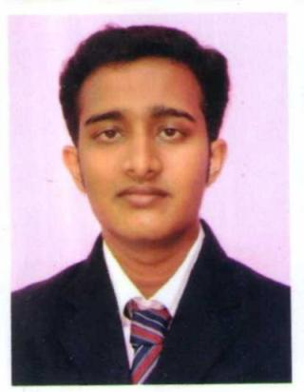

FIJO FRANCIS P

Peace Villa
Pallikkunnath House
P.O. Kanjany

Thrissur

Kerala-680612
Email: fijo1011@gmail.com
Ph. No: 8547550764
CAREER OBJECTIVE

Maintain and enhance human resources productively in an organization, developing strong manpower, identifying talent and deploying professional development programs in order to achieve organizational goals and fulfill employees’ needs.
EDUCATIONAL QUALIFICATIONS

- Pursuing MBA in Calicut University Specializing on Human Resource and Marketing.
- B-Tech IT from Karunya University.
- Plus Two from St. Aloysius Higher secondary school, Thrissur, in Bioscience.
- SSLC from St. Joseph EMHS School, Thrissur.

PROJECTS UNDERTAKEN

MBA minor project on Marketing.
- Title: A study on consumer satisfaction at SaNDS LAB PVT ltd Koratty, Info Park.
- Organization: SaNDS LAB PVT Ltd, Koratty, Info Park.
- Summary: From the study I used to know the influence of the Price, service and credit policy attributes on consumer satisfaction in case of SaNDS LAB products.

B-tech Project
- Title: Real time health monitoring using android device.
- Summary: The tele medical system focuses on the measurement and evaluation of vital parameters, e.g. heart rate, body temperature. Data acquisition in the Smartphone sensors & data storage, analysis and visualization on the Smartphone. Data are transferred via Bluetooth to an android based Smartphone.

ACTIVITIES

- Active participant in management fest conducted across Kerala.
- Organized management events in UG and PG.
- Websites Created for techfest.

CORE COMPETENCIES
- Excellent communication skills in written and oral.
- Good analytical skill.
- Ability to work in a team.
- Innovative and creative in projects.
- Passionate and optimistic approach towards any projects.
- Ability to deliver quality work.
- Flexibility and adaptability to work in any environment.
WORKSHOPS ATTENDED

- Seminars conducted by Ernest & Young.
- Project at Sands Lab Info park Thrissur with an internship of 21 Days.
- Out-Bound Training at Munnar by National Adventure Academy.
- Industrial visit at FACT.

TOOLS AND APPLICATIONS HANDLED

- Adobe Photoshop CS 5.0
- SPSS 16.0
- Active in web especially on LinkedIn.
PROFILE

- Date of Birth : 10-11-1992
- Languages : Malayalam, English and Tamil.
- Gender : Male
- Marital Status : Single

DECLARATION
I hereby declare that all the above mentioned information are true and best of my knowledge and it can be supported with relevant documents.
Date: FIJO FRANCIS P
Place: Thrissur

