Curriculam Vitae
GEETHU T C,BCA, MBA
(puthenvila veedu,karamcode(po)chathannoor,kerala)
Email:geethu2359@gmail.com,Mobile No:0091-9745661934.

CAREER OBJECTIVE: 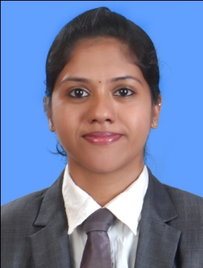
To secure a challenging position where I can effectively contribute my Technical and Managerial Skills as Professional through continuous research, learning and sheer hard work and to achieve my goals through my endeavors.

SKILL PROFILE

Managerial skills : Risk taking and decision making ability.
Good at working in a team and Interpersonal skills.
Good in negotiating by considering other persons point of view.
Effectively time management

Strengths : Adaptable and flexible to situation
Hardworking, Quick learner

Specialization : B.C.A
: MBA specialization – LOGISTICS and HR

Sl. No. | Degree / Course | College /  School | Board/  University | Year of Passing | Aggregate (in %)
1 | MBA | CAMS TVM | CUSAT | 2014- 2016 | Presently doing
2 | Software Testing | Keltron, Spencer Jn., Thiruvananthapuram | KELTRON | NOVEMBER2012 | B
3 | ASP.NET | Keltron, Spencer Jn., Thiruvananthapuram | KELTRON | MARCH2013 | B+
4 | B.C.A | S A S.SDNDP  YOGAM COLLEGE  KONNI | MG  University | 2011 | 57%
5 | Higher secondary | GHSS Chathannoor | Board of Higher Secondary Examination | 2008 | 63%
6 | SSLC | GHSS Chathannoor | Board of Public Examination | 2006 | 64%
EDUCATIONAL QUALIFICATIONS:

PROJECTS:
MBA
Organisation study on CAPEX KOLLAM
DP WORLD Vallarpadam ”A study on operational efficiency in transportation of goods in ICTT Vallarpadam with special reference to movement of hazardous goods”
B.C.A
Create a webpage for smart court in PHP

COMPUTER SKILLS:
Operating System : Windows XP/vista/7/8
Languages : C++, C#, java, Asp.net

Software packages : Ms-word, Ms-excel, Ms-PowerPoint

INTEREST AND HOBBIES:

- Listening to music.
- Driving
- Reading
- Glass painting
- Travelling

LANGUAGES KNOWN:
- English
- Malayalam
- Tamil
PERSONAL PROFILE:
Name : Geethu T C
Father’s Name : B.Thampi
Gender : Female
Date of Birth : 18/5/1991
Nationality : Indian
Permanent Address : Puthenvila Veedu,
Karamcode P.O.,
Kollam – 691579
Kerala

E-Mail : geethu2359@gmail.com

Mobile No : 0091- 9745661934(India)

Place: KOLLAM, India (GEETHU)

