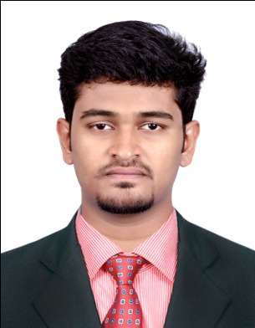
DEEPAK M
S/O MANIYAN
KARUKODI ( HO )
VADAKKANTHARA (PO) PALAKKAD-678012
PH + 919037002742

ABOUT ME

PROFESSIONAL ABRIDGEMENT
Looking forward to a Multinational Company that offers stimulating environment to work in and provide scope for long term personal development and career growth, whereby I can render my skill and knowledge in the field of Accounting & Finance And marketing & Service.
EDUCATIONAL QUALIFICATION
To build a strong attitude for bringing the perfection in everything for my organization I strive, with commitment and dedication which will help me to explore myself fully, realize my potential and contribute the best of me to the organization..
Degree / Course | University / Board | Year of Passing | AGGREGATE  MARKS
MBA | BHARATHIARTHIAR UNIVERSITY | 2015 | 57 %
B.COM | CALICUT UNIVERSITY | 2013 | 63 %
PLUS TWO | KERALA STATE BOARD | 2010 | 68%
SSLC | KERALA STATE BOARD | 2008 | 76%

PROFESSIONAL EXPERIENCE

Company Name : Muthoot micro fin Ltd.

Duration : Since October 2014

Job Profile : MSGB credit officer

Job Responsibility : Quality in business loans

TECHNICAL SKILL

- PGDCA
- TALLY ERP9
- Microsoft Excel, Word.

PERSONAL SKILL
- Positive attitude
- Self-motivated
- Good listener
- Flexible with situation
- Patient
- Maintaining consistency.
- Hard Working
Languages known: (to speak) : English, Malayalam, Tamil Hindi
(to read & write) : English, Malayalam Hindi

PERSONAL FORTE
Father’s name : MANIYAN N
Mother’s name : KRISHNA KUMARI
Date of Birth : 07/03/1993
Marital Status : Single
Sex : Male
Nationality : Indian
Religion : Hindu
Contact Details : +91 9037002742

E maid id : deepukkd457@gmail.com

HOBBIES
- Playing Cricket, football, chess, and indoor games
- Driving and Travelling
- Swimming

DECLARATION
I hereby declare that the information I given is correct and complete to the best of my knowledge and belief. I will be faithful to the firm and will try to improve my skills.
Date : Place :
DEEPAK M

