MOHAMMED SHAMEEM K.E  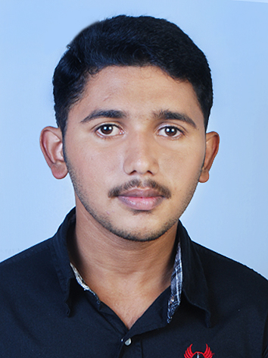  Permanent Home Address:  KAROTTUMANGALASSERIL HOUSE  VELLATHOOVAL P.O S.SELLIAMPARA via: IDUKKI,KERALA , INDIA  PIN: 685563  Mob No. +91 – 9497152902  mohammedshameemke@gmail.com  Personal Data:  Date of Birth : 24-May-1995.  Sex : Male  Marital Status : Single  Nationality : Indian | CURRICULUM – VITAE  Career Objective  Filled with motivation and passion, I am seeking a challenging position in a dynamic organization, where my dedicated attitude and character can be utilized for the betterment and success of the organization and provides ample scope for my career growth.  Educational Qualification  Software proficiency  Projects  BCA  - A mini project on “GAS AGENCY MANAGEMENT SYSTEM”.  The front end of mini project was MS Visual Basic 6 and the back end was MS Access 2000.  - A main project on “TRAVEL MANAGEMENT SYSTEM”. The front end of main project was ASP.NET and the back end was Microsoft SQL SERVER 2008  MCA  - A mini project on “GLOBAL MEDI FILE” .The front end of mini project was ASP.NET MVC Framework and the back end was SQL Server 2012.  - A main project on “OTP AUTHENTICATOR”. The client side of main project was Android and server side was JAVA.  Achievements  - Participated in UGC Sponsored National Seminar on Recent Advances in Signal and Image Processing organized by, Department of Computer Application NSS College, Rajakumari  Personality Attributes & Skills  - Good Communication Skills  - Positive Attitude and always willing to learn and develop my skills.  - Pleasing Personality, Honest, Sincere and Reliable Team Player.  Language Skills  - English - Fluent written and conversational  - Hindi - Fluent written and conversational  - Malayalam - Fluent written and conversational  - Tamil - Fluent conversation.  Strengths  Excellent problem solving and interpersonal skills and able to work effectively in a diverse team environment, hard worker can work under pressure and self motivated individual.  Interests  Playing games, traveling, Surfing on the internet  Declaration  The information stated herein above is true and correct to the best of my knowledge and belief.  YOURS FAITHFULLY  MOHAMMED SHAMEEM K.E
  Course | Institution | University | Year of passing | % Marks scored / cgpa.
  MCA | MES-AIMAT  Marampally | MG University | 2017 | 60%
  BCA | NSS college Rajakumari | MG University | 2015 | 67%
  Senior Secondary | S.N.V.H.S.S  NR City | State | 2012 | 83%
  Secondary | C.M.H.S  Mankadavu | State | 2010 | 79%
  SL. NO. | SKILL | Remark
  1. | Operating System | Linux, Android, Windows8.1, Windows 8 , Windows7, Windows Vista, Windows XP, Windows 10
  2. | Language | C , C++,Visual Basic6 ,JAVA, SQL, ASP .NET,PHP, Android
  3. | Software | MS Visual Basic 6, MS Access, SQL server management studio, Adobe Photoshop CS 6, Microsoft Visual Studio, Android Studio,Netbeans

