JOHN CHANDY 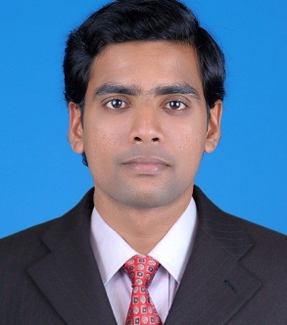 Padayatty House,
Thuravumkara p o
Kanjoor,Pin 683575 Ernakulam Dist ,Kerala,India
Mob: +919846893223
Mob: +918075634345
Email : johnchandypadayatty@gmail.com
Career Objective:
To pursue a challenging career in the field of Human Resource Management, Marketing, finance and operations associate with an organization that offers me opportunity to grow.
WORK EXPERIENCE
CURRENTLY WORKING AT: AUTO CON INDIA ASSISTANCE AND ADMINISTRATION PVT LTD (Sales Officer)

TERATECH MACHINES PVT LTD:
[Officer- Marketing] [November 4 2013—may 4 2016) [2.6 years]
. It's a company which is dealing with manufacturing and Distributing of Bottle caps
- Marketing and Sales,
- Identify potential buyers and deliver goods on time.
- Business support and Achievement of targets.
- Act as a middle man between firm and clients.
- Performs clerical tasks, collection of payment in the form of cash and cheque.
- Proper handling and excellent service to customers.
- Additional duties may include answering telephones and data entry.
- Researching and reporting on external opportunities.
- Filing, copying and faxing, Maintain financial files and records
AXIS BANK:
[OFFICER-SALES][Joined as an executive and based on the good performance, promoted as office] [1.4years]
- selling the banking products like savings account current account, life insurance, General insurance, mutual funds, Sale of gold, Deposits, and other cross sale products etc.
- Customer handling and Service
- Identify new customers and generate leads and fix appointment.
- Achieving monthly targets.

EASY TECH COMPUTERS
[SALES EXECUTIVE] [From 17-05-2010 to 25-05-2012] 2 years]
- Maintaining and developing relationships with existing customers in person and via telephone calls.
- Customer calling to arrange meetings with potential customers to prospect for new business.
- Maintaining relationship with target customers.
- Proper execution of order and dispatch item on time.
- Follow up for payment
- After sales service and Proper handling of walk in customers.

SKILLS:
MARKETING, SALES, OPERATIONS,HR, Administration,Competent ,Productive, Adaptability,interpersonal, Creative thinking, Teamwork, Tolerant and flexible to different situations, Ability to work under pressure, honesty, ,Service, Accurate and
Dedication.

Educational Qualification:
MBA [HR-MARKETING] [ASIET kalady] Mahatma Gandhi University 2010
B.COM: [Computer Application and TAXATION], Naipunnya college 2008 [Calicut University]
Other courses: Tally [Manvish academy Aluva four months]
Achievements: Conducted a training programme for the employees of Apollo tyres Ltd [perambra unit] regarding the topic IMS [Integrated management system].

Personal Details
Date of birth: 15/05/1987
Sex : male
Marital status: single
Languages known
English, Hindi, Malayalam
Reference: Available on request

DECLARATION:
I do here by declare that the above information are true and correct to the best of my knowledge
. JOHN CHANDY

