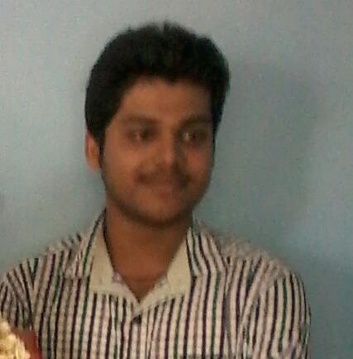
Mithun Nair
Software Engineer
Mob: +918281684663
Email:Mithun.nair.in@gmail.com

Career Summary
- 1 year experience in web development with B.Tech in InformationTech.
- Strong Object Oriented concepts for software design and implementation.
- Strong knowledge of Web Applications and Web services.
- Experience in developing the web based applications using Php, Web services and MS-SQL Server.
- Strong interpersonal and communication skills with an ability to lead a team and keep them motivated

Employer
- Working as a Software Engineer with a reputed IT Company since November-2013 at Cochin

Objective

To establish a position in which I can utilize my skills and abilities in the field that offers professional growth while being resourceful innovative and flexible

Professional Summary

- Having good knowledge in JAVA/J2EE, Php
- Hibernate Mapping, Java Beans, HTML and JavaScript.
- Good knowledge in Core java, Collection framework.
- Excellent knowledge in OOPS (Object Oriented Programming Structure).
- Good knowledge in programming JDBC, Servlets, JSP and JSTL.
- Knowledge in writing simple SQL queries using RDBMS.
- Very good verbal and written communication skills.

Job Responsibilities
- Interacting with client to define business requirements and scope of the project.
- Creating GUI Screen and implementing business logics for them.
- Compiling and running the software.
- Executing test cases and fixing bugs through unit testing.
- Generating daily progress reports
- Co-ordinating with other programmers in the team to ensure that all the modules complement each other well.
- Involved in developing UIs using Java Server Pages and HTML.
- Developed Business logic using JavaBeans, Servlets, and Collections.
- I worked on designing of database using oracle
Technical Skills
- Languages : Java, C, C++ , Java Script, JQuery,php
- Object-oriented Design
- Operating Systems : MS-DOS, Windows XP, Linux
- GUIs : Java Swing, Servlets, JSP, HTML
- Database : SQL Server,
- Web/App servers : Apache Tomcat

Certification Course Completed

• Core java programming from NIIT.

Educational Qualifications

- Graduation (B.Tech -IT) with Ist division:Jyothi Engineering College(JEC), Thrissur, Kerala

- Intermediate: St.Mary’s Convent School, Dewas, MP (CBSE) -67%

- Matriculation: St.Mary’s Convent School, Dewas, MP (CBSE)- 86%

Personal Details

Father’s name : K. Unni Krishnan
Date of Birth : 07.06.1991
Nationality : Indian
Gender : Male
Marital status : Single
Language known : English, Hindi, Malayalam
Permanent Address : Manchery house Pilakkad, Varavoor PO ,680585

I hereby declare that the information furnished above is true to the best of my knowledge.

Place : Aluva

Date 17/03/2015
Mithun Nair

