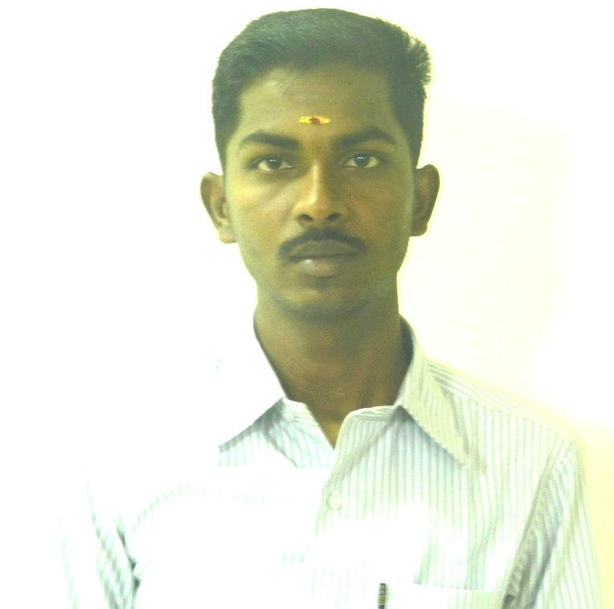
R.RAMESH
E- Mail id:rameshmsw89@gmai.com, ramesh.ramu.in@gmail.com
Contact no: 9787172162

OBJECTIVE:
To acquire a position to utilize my skills and abilities in the industry and to seek every opportunity that offers professional growth, while being creative, resourceful and flexible.

PROFESSIONAL EXPERIENCE:
Totally 1.5 years experience in HR, Welfare, Safety, General Administration, Statutory Compliance and Recruitment.
Now Working As HR OFFICER in K.P.R Mill Limited (A Public Limited Company which employed 10000+ employees overall), Sipcot, Perundurai, Erode Dist from May 2013 to till now.

ROLLS AND RESPONSIBILITY:
- Continually doing daily factory rounds and making queries on all the defaults.
- Daily Attendance Maintained.
- Personal File Handling.
- Payroll Process.
- ESI Upload of Online Function.
- ESI Claim functions.
- PF Upload of Online Function.
- PF Claim functions for online and offline.
- Statutory Record Maintenance.
- Training and Development Functions.
- IF Records Preparation Function.
- Successfully doing the timely recruitment in all categories.
- Maintaining conducive rapport with statutory offices such as EPFO, ESIC, and IF.
- Conducting Daily Routine Management meeting to all the subordinates and participating on HODs meeting daily to propose the defaults raised while at factory rounds.
- Successfully administering the housekeeping, Canteen, Garden and Security.
- To check the status and compiling the Inspector of Factories Registers, half yearly returns, annual returns and Factory License renewal.
- Ensuring providing PPEs to all operators and training them to use the PPEs properly.
- Ensure availability of PPEs, First aid kits and Fire extinguishers at work place.
- Monthly Report for Vehicle Cost & Mess Costing Report for Head Office.

ACTIVITIES INTERESTED:

- Observing the individual response towards their environment.
- Providing recreational refreshment to the employees.
- Arranging periodical motivational programme.

ACADEMIC RECORDS:
Masters in Social Work (2011 – 2013), Jamal Mohamed College, Trichy.
- Passed with 73%(A++ Grade)
- Specialization in Human Resources Management
Bachelor’s Degree in Computer Application (2007 – 2010), St. Joseph’s College, Trichy.
- Passed with 63%
- Major in Computer Application
Higher Secondary (2007) State Board, Govt. Higher Secondary School, Krishnarayapuram.
- Passed with 61%
S.S.L.C (2005) state board, Govt. Higher Secondary School, Krishnarayapuram.
- Passed with 66%
PGDCA -Post Graduate Diploma in Computer Application

RESEARCH PROJECT:
A study on Emotional Intelligence Among The Executives at TamilNadu Newsprint And Papers Ltd., Karur .

FIELD WORK EXPERIENCE:
- Placed for concurrent Block Placement Training at MG COTTON COMPANY PVT LTD Avinashilingapalam for one month.(March 2013)
- Placed for concurrent Field Work Training at EID PARRY PVT LTD (INDIA) Pettavaithalai .(3 months)
- Placed for concurrent Field Work Training at RANE BRAKE LINING, veeralimalai (3 months).
- Placed for concurrent Field Work Training at TMSSS, Tiruchirappalli for Mentally Retarded School. (3 months)

EXTRA CURRICULAR
- Conducted Mentally Retarded programme.
- As a Camp Leader Experience in rural camp programme.
- To be PPT presented the paper for Emotional Intelligence at Saranathan Engineering College Tiruchirappalli.
- To be PPT presented the paper for women empowerment for the Trichy District for Bon Secure College at Tanjure.

PERSONAL DETAILS
- Name : R.RAMESH
- Father’s Name : M.RAMU
- Date of Birth : 22 December 1989
- Marital Status : Single
- Nationality : Indian
- Languages : English & Tamil
- Permanent Address : 8-Kudi St, Pitchampatti,
Krishnarayapuram (TK),
Karur-Dist.

DECLARATION:
I hereby declare that all the above-cited information is true and correct to the best of my knowledge and authenticity.

Place:karur Yours Sincerely, 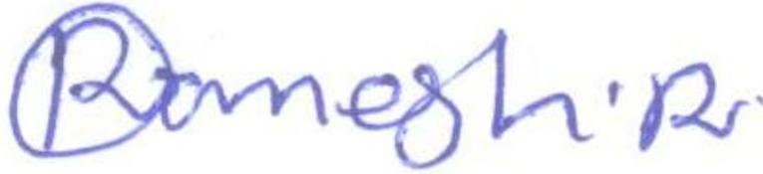
Date:24.09.2014 (R.RAMESH)

