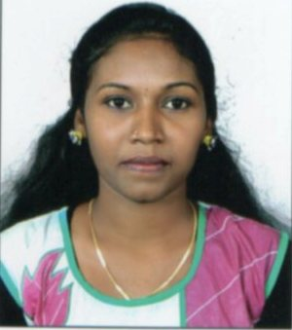

ARCHANA K G

Email:fgzachus@gmail.com

MOB NO : +919747787827

PERSONAL INFORMATION:

Name : Archana K G
Age : 23yrs
Date of Birth : 27/05/1992
Gender : Female
Nationality : Indian
Marital Status : Single

Languages known : English
: Hindi
: Malayalam
: Tamil

ADDRESS:

PermanetAddres :Murali Bhavanam
Veliyil kulangara
Mission compound
Assramam
Kollam
Pin:691002

Looking for a career in an organization and there by investing my skills and knowledge in a recognized organization to achieve organizational goal.

POST GRADUATION
Field of Study : Master of Business Administration
Institute : Conspi Academy of Management
Studies Trivandrum
University : CUSAT

UNDER GRADUATION
Field of Study : B.com
Institution : SNCW Kollam
University : Kerala

HIGHER SECONDARY
Field of Study : Commerce
Institution : Govt.model boys HSS, Kollam
Board : Kerala State Educational Board

HIGH SCHOOL
Institution : St.Joseph Convent Girls HSS,kollam
Board : Kerala State

- Finance
- Human Resources.

- United Electricals Industry, Kollam
- BHEL Banglore

- M.S Office, basic computer applications

CAREER OBJECTIVE

EDUCATIONAL QUALIFICATION

FIELD OF INTEREST

INDUSTRIES VISITED

COMPUTER SKILLS

Computer Skills

PROJECTS /RESEARCH

- Analysis of financial performance through ratios, comparative balance sheets , trend
analysis of UEI
- Organization study
SEMINARS

- National seminar on “budding entrepreneurs: Challengers and Opportunities in Kerala”
- National seminar on the topic “ Make in India”

ADDITIONAL SKILL

- Organizing Skills
- Co-ordination(Microtech Events)
- Team Work
- Creative thinking ability
- Presentation Skill
- Technical Skill: MS-Office package

HOBBIES

.
- Listening to music
- Travelling
- Dancing
- Group activities.

DECLARATION

I here by declare that all the details furnished above are true and best of my knowledge.

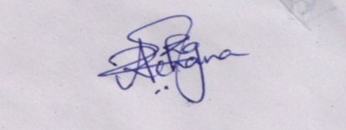
Place : ARCHANA K G
Date :

