ARUN TOMY
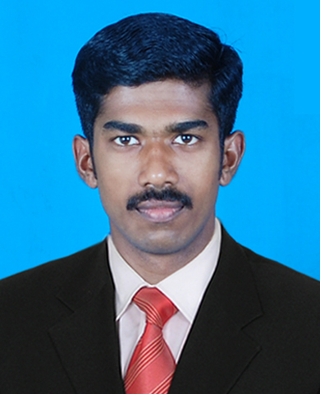
Contact
Mobile : +91 9539765226 E-mail : aruntomy1992@gmail.com
Address :
Ettiekattil [H] Mundanmudi P O
Vannapuram, Thodupuzha 685 607

Career Objective
To work in a challenging environment demanding all my skills and efforts as a true management professional and contribute to the growth of the organization.

Educational Qualification
Year | Course | School/College | Score
2015 | BBA | JPM Arts and Science College,  Labbakada | 80%
2010 | +2 | St.Dominic’s HSS Kanjirapilly | 72%
2007 | SSLC | St. Sebastian’s HSS Pottenkadu | 65%
Additional Qualification:
- Professional Diploma in Computerised Financial Accounting (Kerala State Rural Electronics Industrial Cooperative Federation Ltd.)

Computer Proficiency
- MS Office
- Computerized Financial Accounting
Academic Projects
- Project Study on the topic “Change Management” at Eastern Condiments Pvt. Ltd. Adimaly

Academic Pursuits and Achievements
- Participated in UGC sponsored national seminar on “Emerging Trends in Banking and Finance”.
- Participated in national seminar on “Ecology, Development and human rights”.
- Participated in Marketing Game in “Caligo 2015”, national level management fest at Marian International Institute of Management, Kuttikanam.
- Participated in “Lakshya 2015”, management fest conducted by Marian Academy of Management Studies, Puthupady.
- Participated in state level campus leader’s camp “UNARVU 2014”, organized by NSS and Kerala State Youth Welfare Board
- Coordinated and participated in “Lakshya 2014”, Management fest conducted by JPM Arts and Science College, Labbakada
- Professional Diploma in Computerized Financial Accounting

Extra Curricular Activities
- Volunteer Secretary of National Service Scheme ,JPM College of arts and science
- Permanent member in the college volleyball team
- Permanent member in the college football team

Strengths
- Adaptability
- Timeliness
- Stability
- Team Player.

Personal Details
- Father’s Name : Tomy John
- Nationality : Indian
- DOB : 4th March 1992
- Gender : Male
- Marital Status : Unmarried
- Linguistic Proficiency : English, Malayalam (Reading, Writing and Speaking)

Declaration
I hereby declare that all the information provided above is true to the best of my knowledge.
Arun Tomy

References
Asst. Prof. Sebastian Joy Panattil
Head of the Department MBA
Marian Academy of Management Studies, Kothamangalam
Mobile: +919745320346

Prof. Athul T Ravi
Faculty of BBA Department
JPM Arts and Science College
Mob: 9539368199

