RESUME
ASHISH TYAGI Address:
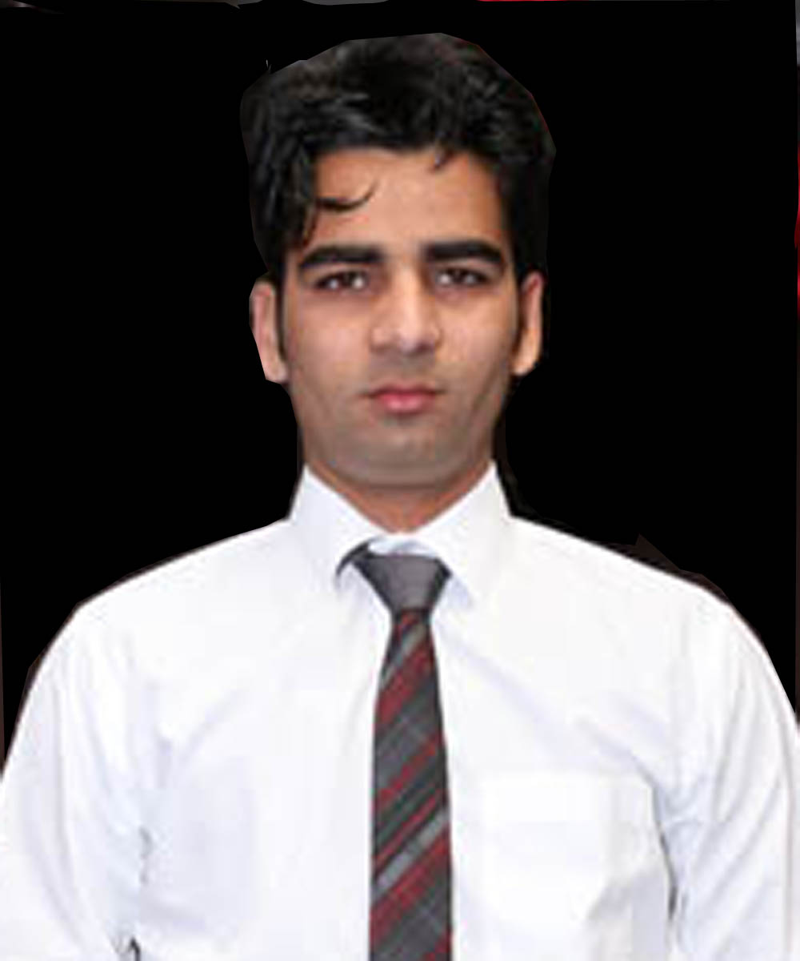
B-273 Nandgram,
Ghaziabad, Uttar Pradesh
India
Mobile:- +91-9720302085
E-mail:-ashishtyagi2609@gmail.com

Career Objective

I look forward to the opportunities where I can utilize my skills and I want to improve to the best of my knowledge with your organization.

Education

Qualifications | Duration | College | Board/University | Percentage
MCA | 2015 | Madan Mohan Malaviya Engineering College Gorakhpur | U.P.T.U. | 65.65
B.Sc. (Computer Science) | 2013 | Meerut College  Meerut | CCS University | 65.5
Intermediate | 2010 | G.S.D.N Inter College  Parikshit Garh | U.P. Board | 57.8
High School | 2008 | P.G. Inter College  Parikshit Garh | U.P. Board | 51.16

Technical Skills

Programming Languages | PHP ,Core Java, C
Database | MySQL.
Web Technologies | HTML, CSS, Java Script, jQuery, AJAX
CMS | Smarty template, WordPress, Magento
Operating System | Windows

Area of Intrest

- Megento (eCommerce platforms)
- Core PHP Projects.

Work Experince

COMPANY | Creative Technoweb Solution
DESIGNATION | Working as Web Developer (Since 1 OCT 2016 )
DESCRIPTION | Web development for online booking system.
WORK PLATFORM | http://www.bluelagoongroup.com  http://kapetanioshotels.com/  http://islandhotelcy.com/  http://www.kanikahotels.com/
RESPOSIBILITIES | Participated in requirement gathering session involved in the analysis, design and development and create the Data Base.

COMPANY | Gleaming Media
DESIGNATION | Working as Web Developer (Since November 2015 to 1 May 2016)
DESCRIPTION | Web development
WORK PLATFORM | http://altshred.com/  http://www.americasfg.com/  http://dorainschalleng.com/
RESPOSIBILITIES | Used computer languages such as PHP, HTML5, Word Press MySQL to develop projects.  Assistance to the technical Head for the projects.  Designing new programs as per the requirements.

Training

COMPANY | EY (Ernst &Young)
DESIGNATION | Working as a Tester
DURATION | Since January 2015 to 1 May 2015
WORK PLATFORM | Used languages such as C# .Net and ASP .Net to Test projects
RESPOSIBILITIES | Used computer languages such as C# .Net and ASP .Net to Test projects  Assistance to the technical Head for the projects.  Analytical and logical thinking.  The ability to apply basic and fundamental knowledge.

Projects

PROJECT | Fee Management System
TECHNOLOGY | Core Java,Servlets,JSP, Oracle 10g,Myecllipse,Tomcat
DESCRIPTION | Web application developed for storing the information fee categarised according braches. Online payment and notification of successfull fee submission is available for student.
Duration | 6 month project as part of curriculum of MCA 6th semester.
RESPOSIBILITIES | Participated in requirement gathering session involved in the analysis, design and development and create the Data Base.

Extra-Curricular Activities

- Participated & won in intercollegiate cricket in class 11th.
- Participated the chess competition.

Personal Details

Fathers Name : Munendra Tyagi
Date of Birth : 26/09/1993
Permanent Address: Moh. Raja Gate Parikshit Garh dist- Meerut (Uttar Pradesh)
pin: 250406
Language Known : Hindi, English
Interests : Cricket, listening to Music.
Strengths : Hardworking, Positive Thinker, Willingness to learn

Declaration

I hereby declare that the information furnished above is true to the best of my knowledge and understanding.

Date: 30/01/2018
Place: Noida (Ashish Tyagi)

