CURRICULUM VITAE

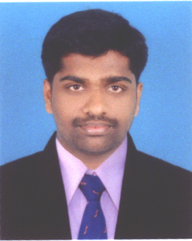

ANOOP GEORGE
KALAPURACKAL (H)
THOPRAMKUDY P.O
IDUKKI DISTRICT
KERALA-685515
Mobile: 9496338398
E-mail:anoopgeorge2008@gmail.com

. OBJECTIVE
Apply innovate ideas to achieve the desired targets for group and personal development and work with systematic planning and hard work to bring a good name & fame for the company and for myself and adjust to company ethics and work in harmony with others.

Personal Details

Date of birth : 10/04/1988
Father’s name : George
Sex : Male
Nationality : Indian
Religion : Christian
Martial Status : Single
Mother Tongue : Malayalam
Strength : God fearing, Confidence, Creative thinking
Long working nature, Quick learner
Language known : Malayalam, English, Hindi
HOBBIES
Listening to music, Reading news paper, playing cricket, Photography, Traveling

EDUCATIONAL BACKGROUND

Academic : S.S.L.C., Plus Two, B.Com.
Additional Qualification : MS office

COURSE | UNIVERSITY | PERCENTAGE OBTAINED | DURATION AND YEAR OF PASSING
MBA | Bharathiyar University | Result waiting
B.Com  with co-operation | MG University | 52% | 3 years,  2008
Plus two | Higher secondary board | 57% | 2years,  2005

ADDRESS FOR COMMUNICATION

ANOOP GEORGE
KALAPURACKAL (H)
THOPRAMKUDY P.O
IDUKKI DISTRICT
KERALA-685515
Mobile: 9496338398
E-mail:anoopgeorge2008@gmail.com

PROFESSIONAL EXPERIENCE

4.5 year’s experience in pharma sales (Currently Working as a Marketing executive in Zydus Cadila (German Remediies Respiratory Div)at Thodupuzha HQ )

DECLARATION

I hereby declare that all the statements made by mean in my curriculum vitae are correct to the best of my knowledge and belief. I understand that if any of the above mentioned information found false or incorrect my candidature will be cancelled as a result thereof.

Place: THODUPUZHA
Date :6/12/2013
ANOOP GEORGE

