**GUNJAN GOSWAMI** 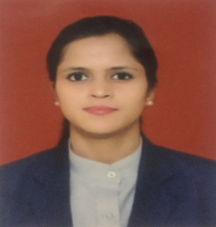

H.No. 107, Block-WZ, 2nd Floor, Sri Nagar Colony, Delhi, India 110034 | (M) 91-11-8851918212

(E) gunjan.goswami1988@gmail.com

**CAREER OBJECTIVE**

A suitable & challenging position an organization that draws upon my strengths & allows me to rise above the routine. To learn & grow at every given opportunity & there by prove to be an asset to which ever organization I am associated with and enhance my legal and secretarial skills.

**PROFESSIONAL SUMMARY**

Motivational Office Manager adept in training, developing and leading multidisciplinary and interdepartmental teams, offers key strengths in office and customer management systems operation and implementation.

**SKILLS**

* Team Leadership
* Excellent Communication Skills
* Punctual and Disciplined
* Calm under Stressful Situations
* Dependable and Responsible
* Ability to Make Quick Decisions
* Good Team and People Management Skills
* Creative and Interactive
* Documentation and Reporting
* Inventory Management
* Microsoft office Specialist Certification
* Customer and Client Relations
* Ability to Multitask and Prioritize to Meet the Deadlines
* Good in co-ordination an Team Building
* Self-Motivated & Quick Learner
* Meeting Minutes
* Executive Presentation Development
* Customer-Service Oriented

**WORK HISTORY**

**JANUARY 2011 - CURRENT**

***Front Office Manager | Hotel Ajanta | New Delhi, India***

* Established and developed highly-efficient and dependable administrative team by delivering ongoing coaching and motivation while providing opportunities for career acceleration through achievements.
* Corresponded with clients through email, telephone or postal mail.
* Aggregated and prepared documentation and reports for office meetings, distribution, and filing.
* Trained new employees on multiple programs and data entry, software.
* Prepared meeting minutes and edited subcontractor proposals for organizational support.

**APRIL 2009 - DECEMBER 2010**

***Front Office Manager cum Cashier | Hotel B B Palace | New Delhi, India***

* Greeted incoming customers in a professional manner and provided friendly, knowledgeable assistance.
* Sorted, received, and distributed mail correspondence between departments and personnel, including parcel packaging, preparation, and efficient shipping.
* Corresponded with customers through email, telephone, or postal mail.

**EDUCATION**

10th | CBSE | Delhi, India

12th | National Institute of open Schooling | Delhi, India

Graduation | Bachelor of Arts

Indira Gandhi National Open University | Delhi, India

Continuing Education Master of Arts (English)

Indira Gandhi National Open University | Delhi, India

**ACCOMPLISHMENTS**

* Won customer’s appreciation verbally and via appreciation letter also.
* Active participant in giving ideas with regards to process improvements.
* Selected as a Star Employee of the Year.