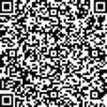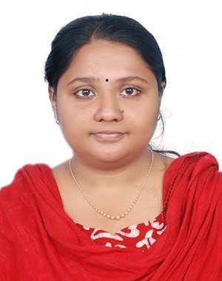



Linkedin.com/in/aynaselvan



aynaselvan21@gmail.com

**AYNA SELVAN T**

MEAN STACK TRAINEE



9562818376

**ABOUT ME**

Ayna Selvan T, Software trainee (MEAN Stack) with Expertzlab Technologies, Kochi. Have done course on MEAN Stack Technology, affiliated to National Council for Technology and Training certification (NACTET). B.Tech(Bachelor of Technology from MG University in the year 2017



**Education**

|  |  |  |  |  |
| --- | --- | --- | --- | --- |
| Qualification | Institution | Board/University | Year of passing | Percentage |
| BTech. | SNGIST,Manjaly | Mahatma Gandhi university | 2017 | CGPA 65% |
| Plus Two | ST.Francis School,Aluva | Higher Secondary Board | 2013 | 73% |
| SSLC | St.Teresa’s convent Girls High School, Ernakulam | Board of Examination | 2011 | 70% |



**CERTIFICATIONS**

**MEAN Stack Expertise Program, NACTET 2017**



**PROJECT UNDERTAKEN**

**Mentoring System**  
Front end:HTML

Back end:MYSQL,PHP  
This project the “Mentoring System” provides us simple interface for maintaining student information in an effective manner.It can be used by educational institution to maintain the records of students easily. This project provides facilities such as online registration and profile creation of faculty & student along with mentoring details and semester wise result

**Todo list app using angular cli**



**Skills**

**Programming Languages :** C

**Other Technical Skill :** Microsoft Office

**Web Technologies :** HTML, CSS, PHP, JavaScript, Typescript

**Frameworks :** Angular JS, Node JS, Express, Foundation Class

**Database :** MySQL, MongoDB

**IDE :** Net Beans, IntelliJ

**Repository :** Git

**Operating System :** Windows, LINUX.



**REFERENCE**

Gireesh Babu

Director & Trainer at Expertzlab Technologies, Kochi

Mob: 70256032



**Languages**

* Malayalam
* English



**RESPONSIBILITIES**

Responsible for understanding user requirements

Major portion of designing and developing the application with HTML, CSS and Angular JS support.

Involved in the development of presentation for GUI of HTML pages

Used angular js to interact with Mongo DB Database



**Personal Details**

* **Date of Birth :** 21-06-1995
* **Father’s Name :** Selvan Mathew T.
* **Mother’s Name :** Anna Ancy V T
* **Permanent Address :** Thoppil House
* **Contact :** [aynaselvan21@gmail.com](mailto:aynaselvan21@gmail.com)

**9562818376,949656528**

**Declaration**

I, AYNA SELVAN T, hereby declare that the information contained herein is true and correct to the best of my knowledge and belief.

Yours Faithfully,

Ayna Selvan T