Why SeekEasy RMS?

SeekEasy RMS is a custom build CRM software for recruitment industry which can be customizable based on any client requirement.

It is a comprehensive solution for any kind of HR Consultancy.

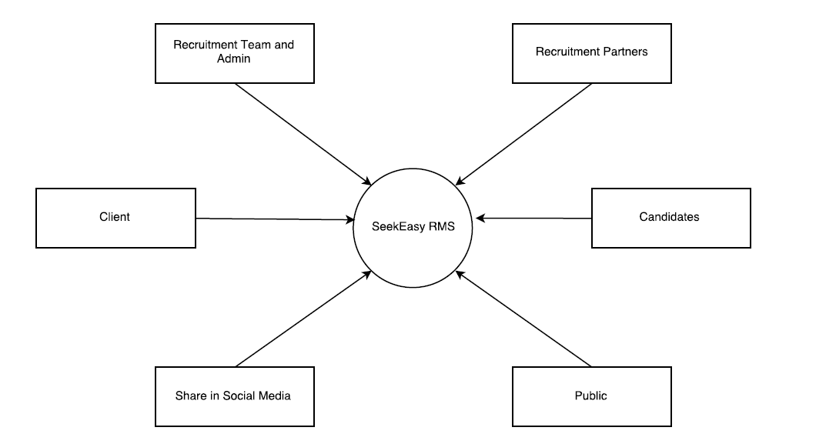SeekEasy Environment

* Recruiters/Admin can register clients and add jobs
* Recruitment partners can access SeekEasy RMS
* Jobs can be shared on Social Media sites
* Clients can login and interact with SeekEasy, can view candidate profile
* Candidates can register, login, update personal details and apply for jobs
* Public can view jobs list and share job details in social media

How easy we can post a Job?

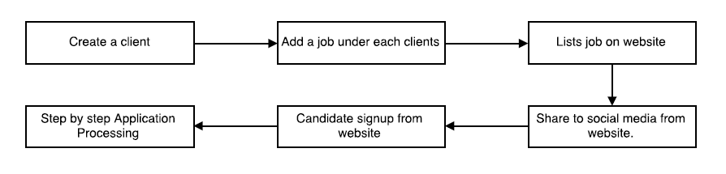

How Application Process works?

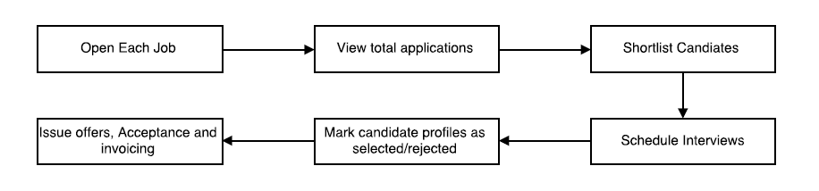

How Task works?

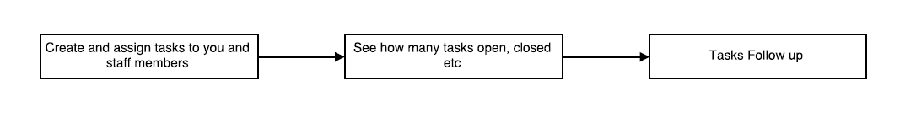

How SeekEasy helps in Business development?

* We can Create clients, edit, delete, update status, create tickets/tasks so that it can be followed up in future
  + - Import existing clients from Excel in a single click
    - Record client calls and updates
    - View the number of calls made to each client/ candidate
    - Schedule a client call to a future date and set a reminder to follow up
    - Can view all clients with openings and the total number of openings

Requirements

* + - Add and edit job description for each company
    - View the number of applicants for each job
    - View the number of rejections in each job
    - Unlist the jobs that are done with the requirements
    - Manage each jobs and track the activities in each job

Job listing on website

* + - View the job list
    - Register and apply for interested jobs
    - Upload CVs
    - Share in social media and job boards
    - Apply for multiple jobs
    - Easy to find the required job with the help of filters
    - Verify candidate identity using SMS or email verification

Candidate registration and Job application

* + - Candidates can login and apply for desired jobs

Update Candidate details / education / profession

* + - Candidates can login to their profiles and update details

Requirements management

* + - Manage each application
    - Edit profile
    - Provide a client feedback
    - Shortlist / reject / change job

Send list to client

* + - Create a list of candidates and send it to clients
    - Let client select and view profile
    - Reject / accept candidates with comments or feedback

Interview

* + - Schedule interview and update it on the calendar in RMS
    - Multiple interviews – HR, face to face, technical
    - Change interview date
    - Select / reject

Selection list

* + - Create selection list
    - Issue offer for selected candidates

Offer acceptance / Reject

* + - Candidates can accept and reject offer
    - Candidates can negotiate CTC

Invoice

* + - Invoicing of clients and candidates as required.

My Office

* + - All Tasks
    - Interviews
    - Announcements
    - Testimonials
    - News Ticker

Reports

* + - Requirements summary i.e. no of requirements form each client, no of candidates who has applied for each job, no of candidates who got selected etc.
    - Consultant activity report i.e. no of feeds, leads, clients created etc.
    - Client status summary i.e.no of leads and feeds converted to client, no of candidates hired
    - Reports on no of offered letter issued

Paid Candidate Services

* Paid Job Search
* Paid Job Alert
* Paid CV Writing

**Cost:** **Starts from ₹ 15,000/-**

Summary of Features

|  |  |  |  |  |
| --- | --- | --- | --- | --- |
| **Structure of RMS** | | | | |
| Manage Clients | Manage Candidates | Manage Jobs | Reports | Accounts |
|  |  |  |  |  |
| Create Client | Create Candidates | Create Job | Requirements Summary | Total income |
| Add Client Status | Add Candidates to a job | Assign Job to a Recruiter | Process Summary | Pending Payments |
| Create Client Login | Search Candidates | Track requirements | Activity Summary | Collected Payment |
| Assign Client to a BDE | Change job Status | Schedule interview | Interview Calendar | Total Expenses |
| Create Task / Follow up | Assign Candidates to a recruiter | Generate Invoice | Offer Letter Issued |  |
| Give Approval to view Candidate Profile | Send Email | Search Candidates | Invoice Generated |  |
|  | Send Notification | Add candidates to Job | View Dashboard |  |
|  |  | Send Candidate Profile to Client | View All Tasks |  |
|  |  | Candidate Job Status | Task assigned to recruiter |  |
|  |  | Consultant feedback |  |  |
|  |  | Call Status |  |  |
|  |  | Last Profile Update date |  |  |
|  |  | Profile Completion Status |  |  |
|  |  |  |  |  |
| Job Site | Candidate Login | Company / Client Login | Freelancer | Mobile Application |
|  |  |  |  |  |
| Job Listing | Edit Profile | Add Jobs | View Jobs | Job Listing |
| Job Details | Add Education | Search Candidates | Add Candidates/CVs | Apply for Jobs |
| Share in FB,Twitter, Linked IN | Add Skills | Request for candidate info | View Job Status | View Job Status |
| List Walk-Ins | Add Language | Requirements Tracking | View Remuneration | Get Notifications |
| List Events | Add Professional History | Schedule interview | View Total Contribution |  |
| List Co-Working | View Jobs |  | Report on total works done |  |
| List Accommodation | Applied job Status |  |  |  |
|  | Get Notifications |  |  |  |