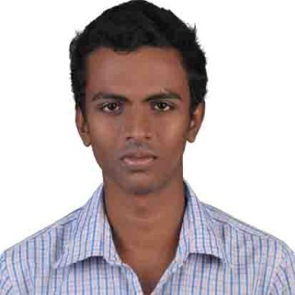Jithu T. S

Thazhathumuppathu (H), Kizhathiri P.O. Ramapuram,

Kottayam, Kerala.

Contact: +91 9744704145 | [jithuts4@gmail.com](mailto:jithuts4@gmail.com)

# CAREER OBJECTIVE

To obtain a challenging and rewarding position with an organization of repute that will provide ample opportunities to develop and utilize my skills and knowledge contributing to the overall achievement of organizational goals.

# profile

* An MBA fresher with dual specialization in Logistics and Marketing
* Possess good communication skills and time management skill
* Ability to work independently and with the team with a positive attitude
* Flexibility and Adaptability to work in any environment
* Result oriented with willingness to accept any challenge

# Education

|  |  |  |  |  |
| --- | --- | --- | --- | --- |
| **CLASS/COURSE** | **NAME OF THE INSTITUTION** | **BOARD OF STUDY** | **YEAR OF PASSING** | **%** |
| **MBA** | Hindusthan College of Arts & Science, Coimbatore | Bharathiyar University | 2016 | 67.40 |
| **B.com** | Mar Kuriakose Arts & Science College, Puthuveli | MG  University | 2014 | 60.25 |
| **XII** | Govt. H.S.S Puthuveli | Board of Education,  Kerala | 2011 | 64.75 |
| **X** | St. Augustine H.S.S Ramapuram | Board of Education,  Kerala | 2009 | 67 |

# extra curricular activties

* Completed the Domestic Data Entry Operator conducted by National Skill Development Corporation
* Active Member in Mahatma Yuvajan Society, Ramapuram
* Successfully conducted an Organ Donation Program in Ramapuram
* Attended workshops conducted by career cell in the college level

# technical proficiency

* Operating Systems : Windows
* Technical Knowledge : Internet, E-mail, MS Office
* Accounting Packages : Tally 9

# Experiance

* NGA HR Kochi : Trainee Associate (Payroll)

# Personal skills

* Committed, confident and hardworking with a positive attitude.
* Able to innovative and execute ideas
* Fast learner with a strong desire to learn
* Resourceful and with good sense of humor

# PERSONAL PROFILE

* Date of Birth : 01-12-1993
* Gender : Male
* Fathers Name : Surendran T.G
* Fathers Profession : Merchant
* Religion : Hindu
* Nationality : Indian
* Languages Known : English, Malayalam and Tamil
* Interest & Hobbies : Travelling, Listening Music

I hereby declared that the above mentioned information is correct up to my knowledge and bear the responsibility for the correctness of above mentioned particulars.

**Place: Kottayam Jithu T.S**