**RESUME**

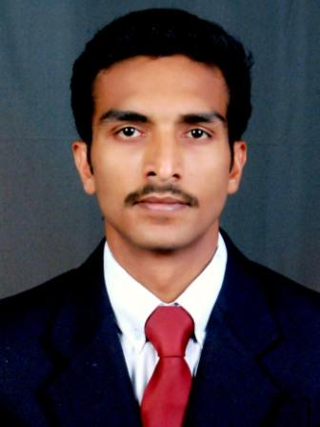

**ARUN.T.P**

**Sayoojyam (House)**

**Akavalappil, Muttungal West (PO)**

**Vatakara, Kozhikode(District)**

**Pin-673106**

**Phone: 0496-2516174**

**Mob: 9447336843,9895131399**

**Email:** [**aruntp.tp@gmail.com**](mailto:aruntp.tp@gmail.com)

**CAREER OBJECTIVE**

**To build a career in a reputed firm wherein I can enhance my skills and knowledge and use it for the betterment of the company. I promise to be a dedicated team player never compromising on any of the objectives of the firm.**

**PERSONAL ATTRIBUTE**

**Highly organized, action oriented, flexible and versatile team player who will work hard and excel in any environment. Dedicated and committed, willing to take care on challenging roles, tough assignments and work to tight deadlines**.

|  |  |  |  |
| --- | --- | --- | --- |
| **COURSE/BOARD** | **INSTITUTION** | **YEAR OF COMPLETION** | **MARKS**  **%** |
| **M.B.A/M. G. University.** | **Fisat Business School, Angamaly** | **2010** | **62** |
| **BSc. Bio-Technology/ Bharathiyar University** | **C.M.S College of Science & Commerce, Coimbatore** | **2007** | **65** |
| **Higher Secondary / State Board** | **G.V.H.S. Vatakara** | **2004** | **55** |
| **Secondary School / Kerala State Board** | **B.E.M. High School Vatakara** | **2002** | **70** |

**EDUCATIONAL QUALIFICATION**

**AREA OF INTEREST:**

1. **Marketing / Administration section of the reputed companies.**
2. **Sales /Operations/division of Retail, Logistic and supply chain companies.**
3. **Marketing/ Operations division of Event Management/Advertisement firm.**

**CURRENT STATUS: Working for Bharathi cement corporation pvt.Ltd, As Junior Officer Marketing at Kannur district, Kerala. Taking care of entire Sales and marketing operations of the Bharathi Cement at Kannur district.**

**WORK EXPERIENCE: More than Three years of experience in the Marketing division of reputed Cement Companies. (42 Months)**

1. **One Year and Nine month of experience in The Bharathi Cement Corporation Pvt.Ltd (VICAT Group Of Companies-France) as Jr. Officer Marketing.( 02-07-2012- Present)**
2. **One year and Eight month experience in India Cements Ltd. As Marketing executive. (18-10-2010 To 30-6-2012)**

**ROLES AND RESPONSIBILITIES:**

1. **Managing sales.**
2. **Business development through building new dealer network.**
3. **Stock Management / Meeting the logistic requirement.**
4. **Planning and implementing new Marketing initiatives.**

**PROJECT DETAILS:**

* **Conducted project work at MILMA (Kannur) the project titled, “The Consumption pattern of Milk and Milk powder and the factors affecting the Consumption of Milk powder among the consumers in Kannur district”. For a period of about Three month.**
* **Conducted organizational study at Rubco Huat Woods (pvt) Ltd, for the period of about one month.**

**COMPUTER PROFICENCY:**

**Environments : Windows XP, Windows 7**

**Packages : MS Office (MS Excel, MS Word, MS PowerPoint.**

**PERSONAL PROFILE**

**Date of Birth : 1-June-1987**

**Sex : Male**

**Nationality : Indian**

**Mother tongue : Malayalam**

**Father : Surendran .T.P,(Rtd Assistant District lottery officer)**

**Mother : A.G. Anitha Kumari (Lecturer DIET)**

**Sister : Minnu.T.P( Student)**

**HOBBIES:**

* **Travelling**
* **Photography**
* **Reading**

**STRENGTHS:**

* **Adapts to different situations with ease.**
* **Quick learner**

**LANGUAGES KNOWN:**

|  |  |  |  |
| --- | --- | --- | --- |
| **LANGUAGES KNOWN** | ***READ*** | ***WRITE*** | ***SPEAK*** |
| **MALAYALAM** | **YES** | **YES** | **YES** |
| **ENGLISH** | **YES** | **YES** | **YES** |
| **HINDI** | **YES** | **YES** | **YES** |
| **TAMIL** | **NO** | **NO** | **YES** |

**DECLARATION:-**

**I do hereby declare that all the above furnished data are true to my knowledge.**

**Place: kozhikode Arun.T.P (Kerala)**