Assignment 1

Ben Fu (byf69)  
INF 385T – Personal Informatics

# Human Subjects Research

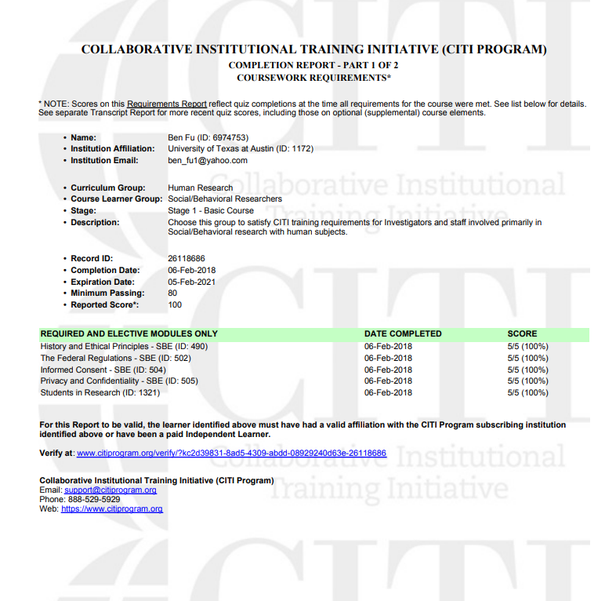

# Designing an Experiment

I would suggest the two-group design since Mark just wants to test whether or not consuming peanut butter sandwiches will yield better performance in swimmers. The independent variable is consuming peanut butter sandwiches, and the two conditions are those who do and those who don’t. To recruit participants, I would need two swim competitions. In the first one, I will not have participants consume peanut butter sandwiches. In the second one, I will ask the participants to all consume a peanut butter sandwich before competing (within subject).

# Statistical Analysis

We should use the paired difference t-test because we are trying to see the before and after effects of surgery on weight, so we are trying to compare the population means of two different groups.

# Double-Blind Experiments

In double blind experiments, the subjects and the researchers both do not know which group they are in. This method is used to ensure impartiality and reduce bias. This makes sense for medical experiments because there could be a strong bias for researchers wanting their drug to work, and there is an obvious bias and placebo effect if the subject knows if they are taking the drug. This differs from what we studied in class because we did not take into account the subject and researcher bias both for any of our experimental methods.